Abstract—This document presents the design process for a signal path in photosensing applications and develops an approach to easily compare solutions.

Low-Noise Wideband Transimpedance Amplifier
Kevin Egedy

INTRODUCTION
THIS document explores the limits of noise minimization in wideband photosensing applications. It highlights transimpedance challenges and common practices for balancing gain, noise, and bandwidth.

Design Steps
The design process is ordered chronologically to emphasize certain parameters and or decisions.

System Architecture
Photosensing applications range widely in performance, making it difficult to find a one-solution fits all. Across several papers, favorable practices included regulated cascodes stages and bootstrapping stages. Ultimately a source follower bootstrap was chosen based on the noise figure.

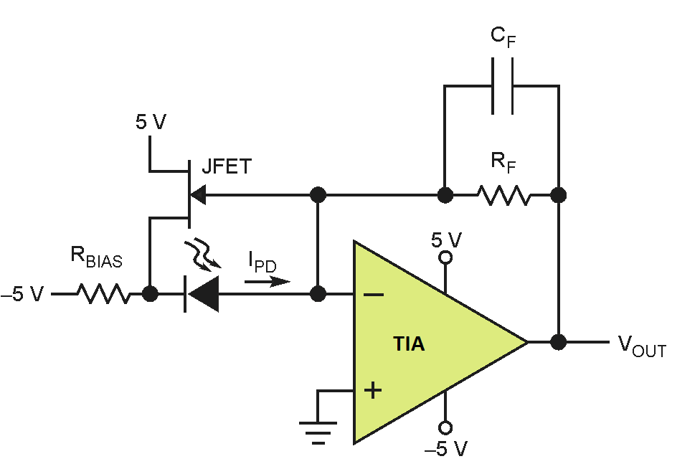
Figure 1: Top Level Architecture

The top level specifications are provided as a reference.

Parameter | Specification
Transimpedance gain (full signal path) | 1
Transimpedance bandwidth () | 1
Minimum photodiode current () | 2
Photodiode capacitance () | 150
Closed-loop gain magnitude peaking | 0
Noise figure () | 0.5
Power dissipation () | Optimize
Cost-per-unit (1000 units) | Optimize $

BJT vs. MOSFET
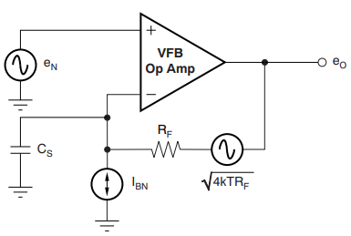
Figure 2: TIA Noise Contributions

The first major design decision should be choosing the TIA technology, primarily BJT or MOSFET. Texas Instruments’ document Transimpedance Considerations for High-Speed Amplifiers solves this question. By minimizing the input-referred noise current, an appropriate transimpedance gain threshold is determined. c
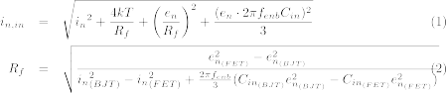

The paper compares OPA846 (BJT) and OPA657 (FET). Note, thresholds will vary among different devices but will yield similar conclusions because the order of magnitudes for each technology is consistent.

Name | GBW | e_{n} | i_{n} | C_{in} =
OPA846 | 1750 MHz | 1.2 | 2.8 | 153.8
OPA657 | 1600 MHz | 4.8 | 1.3 | 155.2

Solving for , the total input-referred noise is lower for the FET for any gain greater than . Further generalizations can be made that FETs are capable of higher transimpedance gain, whereas BJTs have greater bandwidth but limited gain. This relationship is seen in the following figure.
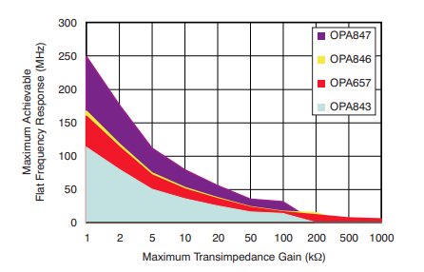
Figure 3: Gain-vs-Bandwidth
From the figure, some of the application requirements can be realized. The 1 MHz bandwidth is easily achievable among many devices, however the gain is not possible for all BJTs, including OPA846. Due to the noise and gain requirements, a MOSFET is necessary for the design. Since the paper was written, a performance upgrade to OPA818 has been released and is also considered in the design.

Highlights of the upgraded amplifier include much lower voltage noise density and lower input capacitance.

Name | GBW | e_{n} | i_{n} | C_{in} =
OPA657 | 1600 MHz | 4.8 | 1.3 | 155.2
OPA818 | 2700 MHz | 2.2 | 3.0 | 151.9

Input-Referred Noise

Parameter | Specification
Noise figure | 0.5
Minimum photodiode current () | 2

As previously mentioned, MOSFETs will yield lower input-referred noise. In the design process, the TIA is analyzed in a single stage to understand its performance and discover how far it is from the noise target. From the specifications, the tolerated input-referred noise can be determined.
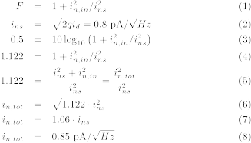
Given the photodiode current, the input shot noise is found to be 0.8 . Thus, in order to remain under 0.5 rms, the total input current to the TIA has to be less than 0.85 .

Noise Densities wrt Gain

Parameter | Specification
Transimpedance gain | 1 = 1000 K

In designing transimpedance amplifiers, minimal complexity is desired. The gain of the TIA should be maximized without sacrificing noise performance. Analysis of the TIA transfer function is seen as a 2nd order filter multiplied by a gain constant.
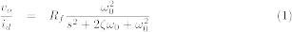

Thus, full gain of the application is achieved by choosing . The input-referred noise is reviewed again to ensure noise has not increased with respect to gain. Ignoring the noise across the input capacitance, the input-referred noise is defined:

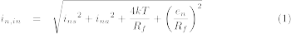

The photodiode current noise density is 0.8 regardless of the gain. Likewise, the op amp’s current noise is independent of gain. The input-referred thermal noise density and op amp noise are summarized in the table.

Input-Referred Density | R_{f} = 100 K | R_{f} = 1000 K
Thermal Noise: | 0.41 | 0.13
Op Amp Noise:  and e_{n} = 2.2 | 0.022 | 0.002

Op Amp voltage noise density is related to and thermal noise density is related to . So choosing , meets the gain requirements and improves noise performance.

Note, voltage noise density is not constant due to the feedback components of the TIA. More to come on this later. Assuming constant voltage noise density and signal bandwidth, the output voltage is calculated.
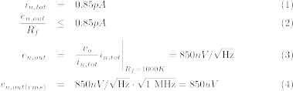

TIA Filter Design

Parameter | Specification
Closed-loop gain magnitude peaking | 0
Transimpedance bandwidth () | 1

Previously discussed, the transfer function of the TIA is recognized as a 2nd order filter. The application specifies 0 peaking in the filter response such that , yielding a Butterworth response. The following values for and are solved using the OPA818 parameters.
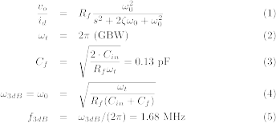

By enforcing 0 peaking, the 3 bandwidth is violated with new cutoff frequency of 1.68 MHz. This is not a major design concern since a low pass filter stage can always be added. Also assuming , then the ideal MOSFET with no additional stages would have gain bandwidth of 955 MHz.

Single Stage AC Analysis

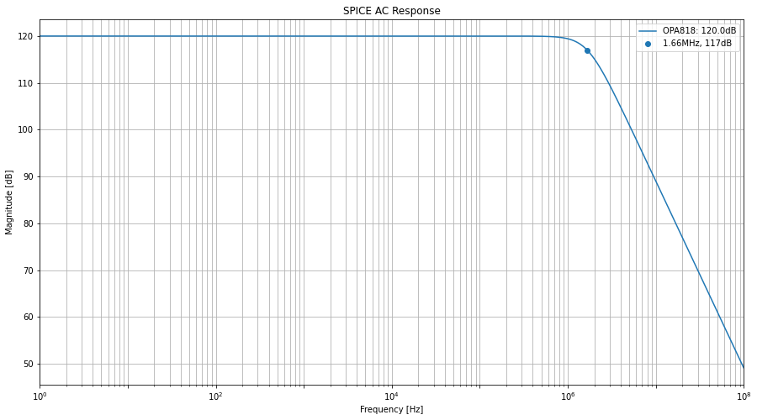
Figure 4: OPA818 AC Response

The cutoff frequency matches exactly what we calculated in the filter design section. This part of the requirements is relaxed and is improved slightly with an additional stage.

Single Stage Noise Performance

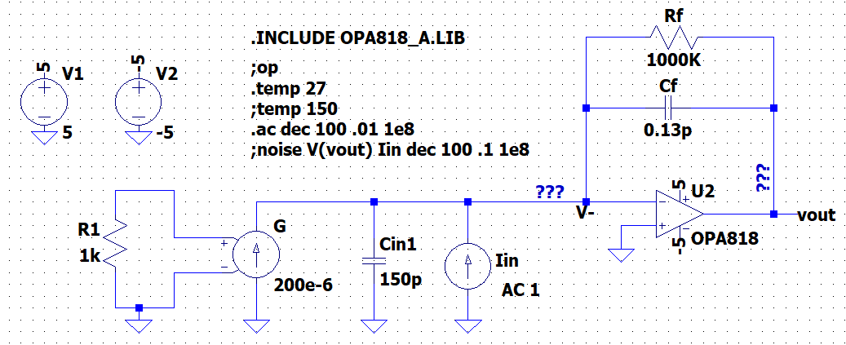
Figure 5: Single Stage Design

In this section, noise performance is reviewed to determine the op amp for the application. The input-referred noise and noise figure is plotted for OPA657 and OPA818.

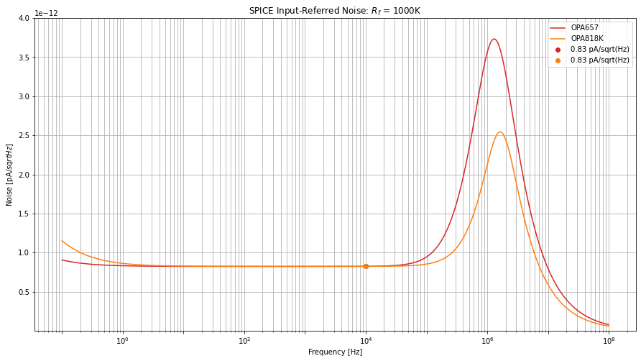
Figure 6: TIA Single Stage Noise Figure

Input-Referred | 10 kHz [] | 1 MHz []
OPA657 | 0.83 | 3.56
OPA818 | 0.83 | 2.12

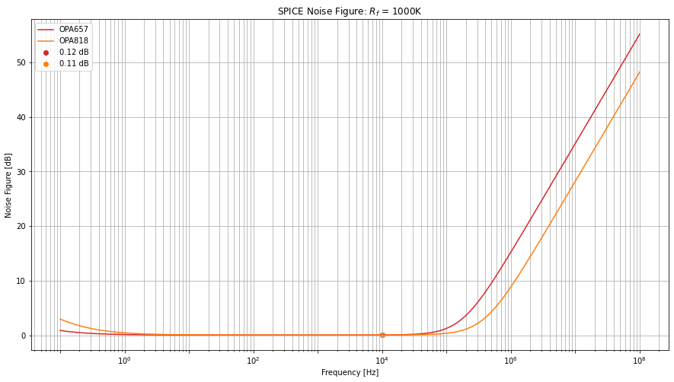
Figure 7: TIA Single Stage Noise Figure

Noise Figure | 10 kHz [] | 1 MHz []
OPA657 | 0.12 | 15.27
OPA818 | 0.11 | 8.91

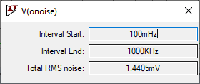
Figure 8: TIA Single Stage RMS

Both amplifiers pass the application specs at low frequencies. However, large peaking occurs around 1 MHz due to the noise transfer function of the TIA. RMS is provided and demonstrates the need to reduce peaking in the signal bandwidth.

The upgraded op amp, OPA818, is clearly the favorite in this design in order to achieve the 0.5 noise figure. For applications with lower bandwidths, OPA657 could suffice.

More analysis is needed to understand the peaking effect. The noise gain of the TIA is defined:

Peaking rises with frequencies greater than the zero defined as

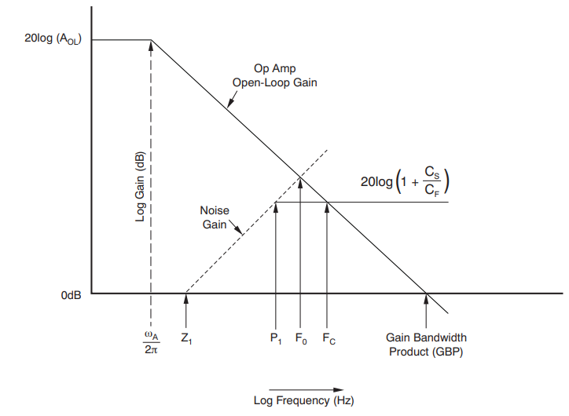
Figure 9: Noise Stability Analysis ()

To improve noise performance, the feedback impedance needs to be decreased in order to push the zero to higher frequencies. Assuming , the following table demonstrates this relationship.

C_{in} [pF] | Z₁ [Hz]
150 | 1061
15 | 10610

Source Follower Bootstrap

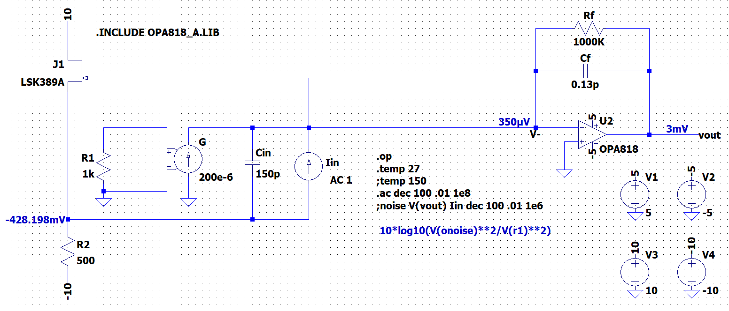
Figure 10: Source Follower Bootstrap + TIA

Name | e_{n} | C_{amp}
LSK389A | 1.3 | 25

I found Glen Brisebois’ article Low Noise Amplifiers for Small and Large Area Photodiodes very helpful.

Bootstrap + TIA AC Response
In the filter design section, the cutoff frequency is defined:

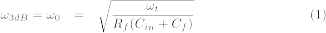
The bootstrap changes the input impedance seen by the feedback resistor such that it is nearly infinite. The cutoff frequency for this solution is 1.25 MHz.

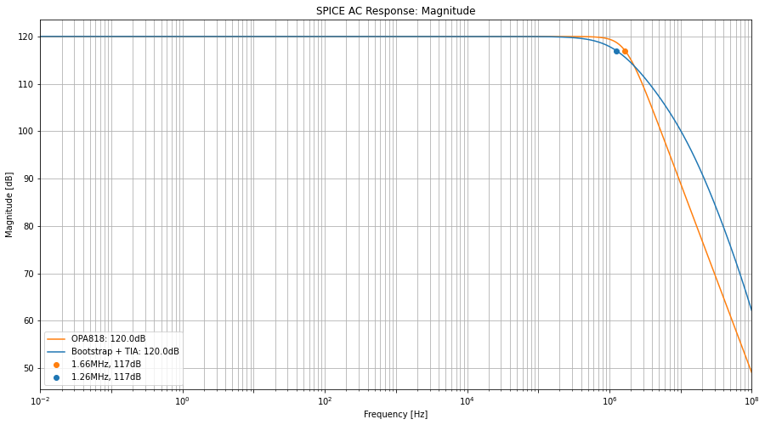
Figure 11: Bootstrap and TIA Magnitude Response

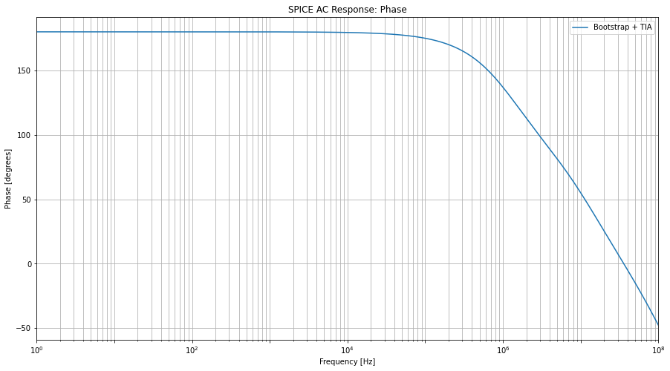
Figure 12: Bootstrap and TIA Phase Response

Bootstrap + TIA Input Impedance

Analyzing the input impedance shows how much the noise gain has been improved. The design goal is to decrease input resistance to push the zero frequency beyond the signal bandwidth.

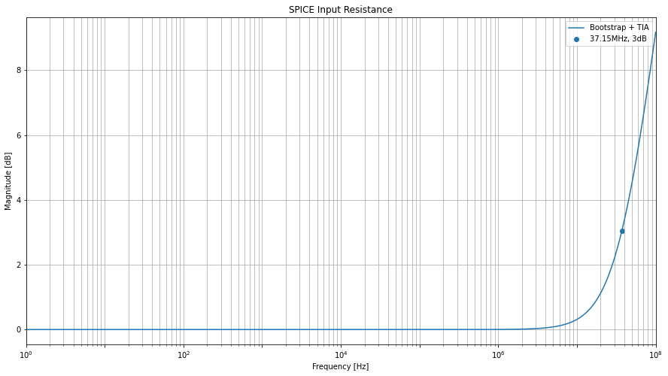
Figure 13: Bootstrap and TIA Input Resistance

The input resistance at low frequencies is 0dB = ~1. The input impedance 3 occurs at 37MHz.

Bootstrap + TIA Noise Response

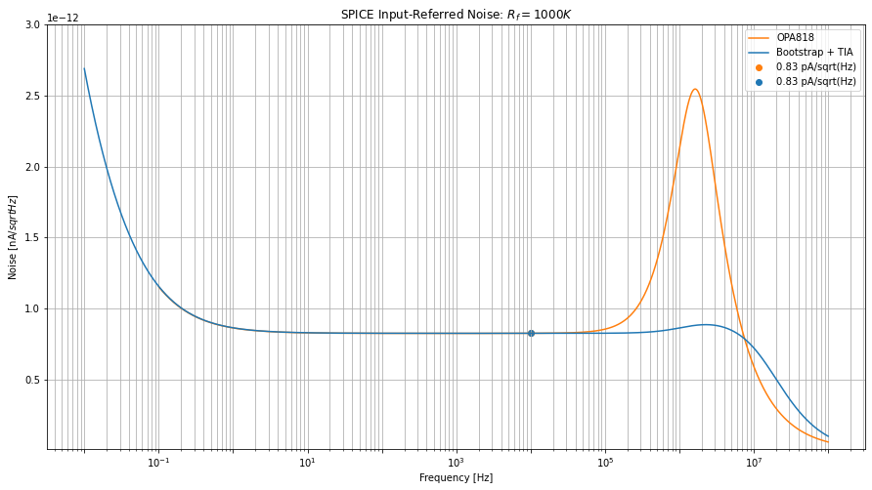Figure 14: Bootstrap and TIA Input-Referred Noise Response

Input-Referred | 10 kHz [] | 1 MHz []
OPA818 | 0.83 | 2.12
LSK389 + OPA818 | 0.83 | 0.86

The bootstrap almost completely smooths out the peaking seen by the transimpedance amplifier. The feedback resistor now only sees the input resistance and capacitance of the JFET
(25 ).

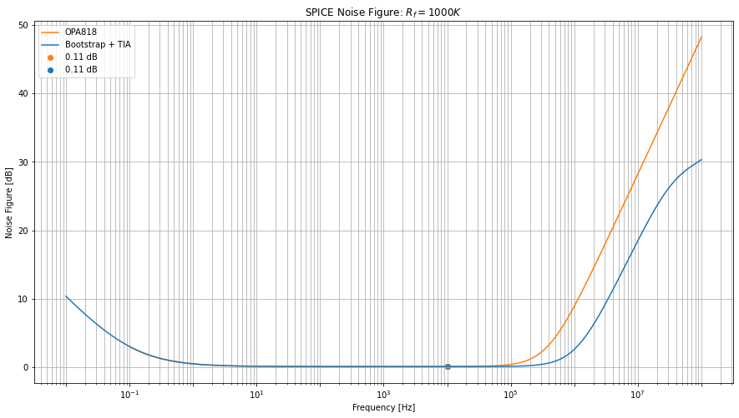
Figure 15: Bootstrap and TIA Noise Figure

Noise Figure | 10 kHz [] | 1 MHz []
OPA818 | 0.11 | 8.91
LSK389 + OPA818 | 0.11 | 2.62

The bootstrap and TIA solution passes the 0.5 threshold at 345 kHz. This is still quite far from the 1 MHz signal bandwidth but we have greatly improved from the single stage TIA.

Noise Figure | 10 kHz [] | 1 MHz []
OPA818 | 0.11 | 8.91
LSK389 + OPA818 | 0.11 | 2.62

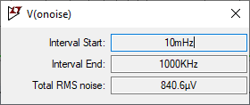
Figure 16: Bootstrap and TIA RMS

Bootstrap + TIA Transient Signal

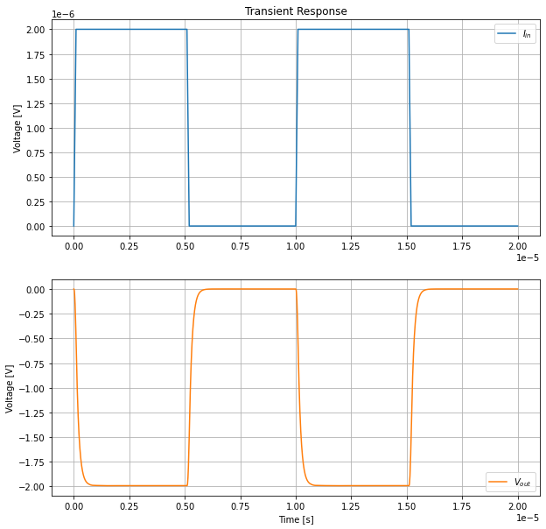
Figure 17: Transient Response for 2 Input Pulse

The solution is working exactly as intended. It is an inverting amplifier so the output voltage is the inverse of the input. The expected output equals the transimpedance gain multiplied by the input. So .

Application Power
Total power of the application is 477 mW.

Power Dissipation
Product | I_{DD} (mA) | V_{CC} + V_{EE} | # | Power (mW)
TIA OPA818 | 27.7 | 5+5 | 1 | 277
Bootstrap LSK389A | 10 | 10+10 | 1 | 200
Total |  |  |  | 477 mW

Application Costs
Total sum of the application is $0.32 + $7.97 = $8.29

Bill of materials Components
Product | Tolerance (%) | Quantity | Price (1000+)
500 Ohms | 1.0 | 1 | 0.018
1000K Ohms | 1.0 | 1 | 0.019
0.13p Farads | 7.7 | 1 | 0.28
Total |  |  | $0.32

Bill of Materials Amplifiers/Transistors
Product | Price ($)
Transimpedance Amp OPA818 | 3.10
Bootstrap JFET LSK389A | 4.87
Total | $7.97

References

Brisebois, Glen. Low Noise Amplifiers for Small and Large Area Photodiodes. Linear Technology, Sept. 2006,
https://www.analog.com/media/en/reference-design-documentation/design-notes/dn399f.pdf.

HOBBS, PHILIP. Photodiode Front Ends The REAL Story. Optics & Photonics, Apr. 2001,
https://www.electrooptical.net/static/oldsite/www/frontends/frontends.pdf.

Ramus, Xavier. Transimpedance Considerations for High-Speed Amplifiers. Texas Instruments Incorporated, Nov. 2009,
www.ti.com/lit/an/sboa122/sboa122.pdf.

