Abstract—This document discusses the approach and design process for measuring sensors with low noise constraints. The methods in this design are for a strain-gage and can be used in solving similar applications.

Strain-Gage Low Noise Signal Conditioning
Kevin Egedy

INTRODUCTION
THIS document describes signal conditioning a low noise strain-gage. The op amps mentioned are relevant at the time this document was created.

Design Steps
The design process is ordered chronologically to emphasize certain parameters and or decisions.

System Architecture
The architecture used in measuring the strain-gage is amplify, filter, sample. The signal should always be amplified first in order to prevent any signal distortion or loss of information. The top level specifications are provided as a reference.

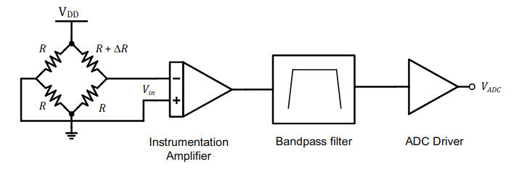

Parameter | Specification | Unit
Supply voltage () | 1 – 5k | Hz
Signal-to-noise ratio | 76 | dB
Passband gain @ 2.5 kHz | 40 | dB
Power dissipation () | Optimize | mW
Cost | Optimize | $

Strain-Gage Equivalent Circuit
The strain-gage determines the differential signal into the system. It is easier to understand by converting it into its Thevenin equivalent for each differential terminal. Given each resistor at 1000 Ohms, the equivalent resistance is

.

From each differential terminal, the resistance is half of the Thevenin equivalent resistance. Likewise the common mode voltage for each terminal is 2.5V. To simplify this further, the sensor is replaced by a balun with at the end of each output terminal. The diagram includes thermal noise voltage. See the SPICE model for an explicit example.

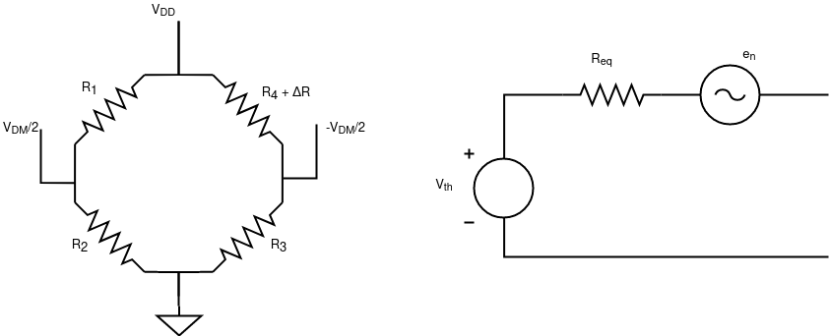

Instrumentation Amplifier Design
The instrumentation amplifier is chosen for this design because it provides large input resistance to reduce loading, high CMMR, and relatively large gain.
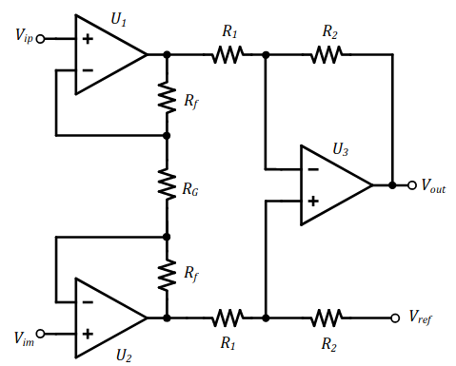

The spec provides the system input and output peak-to-peak voltages. The gain is calculated as

= 40dB.

The instrumentation amplifier has a response

.

In this design, all of the gain is implemented in the first stage such that
= 100.

Thus, the ratio between and is 49.5. I chose resistor values to be in the range from 1K to 100K and achieved the desired ratios with the E192 resistor series. Due to manufacturing constraints, is chosen at 49.9K. The resulting gain is

.
Parameter | Design | Actual | Tolerance
 | 49.5K | 49.9K | 0.1%
 | 1K | 1K | 0.1%
 | 100K | 100K | 0.1%
 | 100K | 100K | 0.1%

The E192 series is manufactured to have tolerances from 0.5% to 0.1%. In order to meet the CMMR for the spec, the tolerance for the resistors were chosen at 0.1% tolerance.

The CMMR for each stage is calculated as followed:
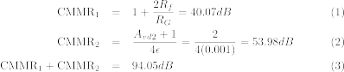

Thus the instrumentation amplifier meets the system requirement of 90dB common mode rejection ratio.

Operational Amplifier Selection
Choosing an op amp can seem like a daunting task with the numerous options in today’s catalogs. I found Analogue Device’s product selection table incredibly useful. It categorizes the op amps based on application and specific constraints.

Initially, I chose the ADA4528-2 precision amplifier with voltage offset less than 1mV. Minimizing the offset voltage is critical in analyzing the differential signal from the strain-gage. The input signal amplitude is 20m which makes it sensitive to noise and voltage offset. Another category that would apply for this project are low noise amplifiers due to the SNR constraint. I created this query to find a subset of amplifiers with characteristics I was looking for.

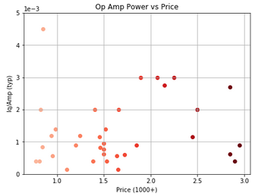

From the query, I compared price vs power for each op amp. I was surprised to see that power consumption was mostly uniform across price. The result is that price is not a function of power consumption. I also compared voltage noise density vs flicker noise. In this plot, more expensive op amps are clustered towards lower voltage density and lower flicker noise. As both axis increase, the price of the op amp decreases. To optimize price and power consumption, I chose an op amp that minimizes both, located in the lower left corner of the first comparison. Ultimately, I chose the OP1177 amplifier. Samples are color coded so that darker colors are more expensive.

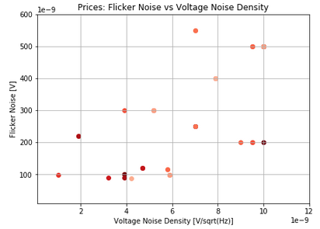

Input Referred Noise
The system requires a signal to noise ratio of 77dB. Given the input voltage of the system, the maximum noise tolerance is computed as

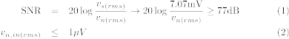

So the total input noise observed in the system bandwidth has to be less than 1V. Then the input-referred voltage noise density is calculated as
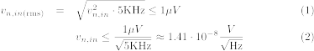

The target noise density should be referenced in determining which op amps to use in the design. The noise generated from the instrumentation amp and strain-gage must be less than 14.1 .

The noise contributions are a function of the specified op amp voltage () and current () noise densities. To determine the total input RMS noise, the sum of all noise contributions are calculated at the output of the instrumentation amp.

Strain-Gage:
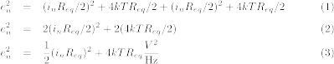

Instrumentation Amp 1st Stage:

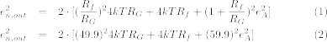

Instrumentation Amp 2nd Stage Inverting:

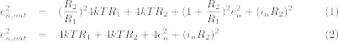

Instrumentation Amp 2nd Stage Non-Inverting:

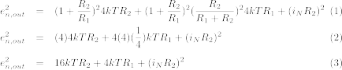

Comparing all the sources, the instrumentation 1st stage has the greatest noise contribution due to the gain at this stage. Summing all the contributions results in the RMS noise at the output of the instrumentation amplifier. The input voltage noise density can be inferred by dividing the output noise by the gain of the amplifier.

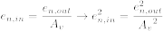

Note, it is important to be cautious of the flicker noise when determining the noise calculations. The input-referred voltage noise density and input RMS noise (1-5kHz) are evaluated using the OP1177 amplifier.

Measurement | Input-Referred [] | Total RMS [V]
Design | 14.1 | 1.0
SPICE | 12.6 | 0.891

Instrumentation Amplifier Response
This section discusses the performance of the isolated instrumentation amplifier.

Input-Referred Voltage Noise Density (1Hz - 5kHz)
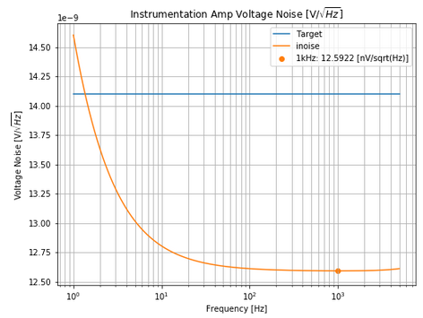

Input RMS Noise (1Hz – 5kHz) : 890 nV
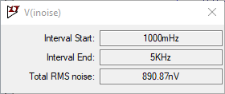

The input RMS Noise is less than the design of 1s. Note, the OP1177 is pushing the limits of the system SNR spec at approximately 1Hz. Since it drops beneath the input referred voltage noise density quickly, before 2 Hz, it is still a good choice for this design.

Output Referred Noise (0.01Hz - 100MHz)
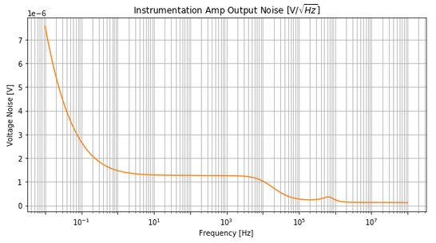

Output RMS Noise (0.01Hz – 100MHz) : 1.29 mV
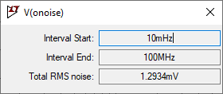

Schematic and DC Operation
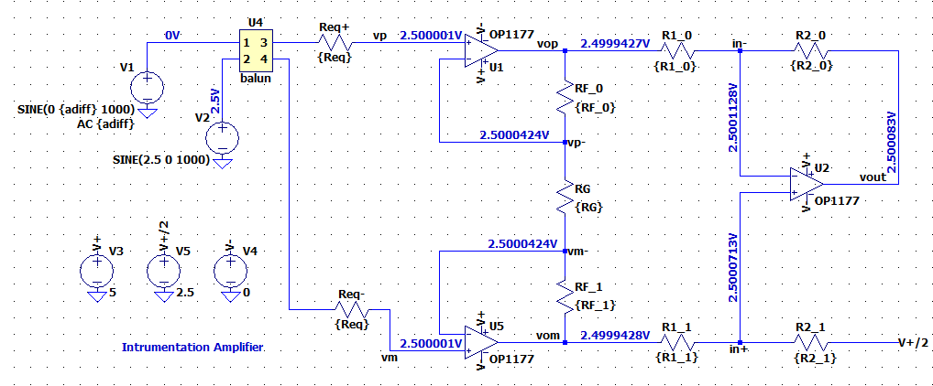

Component Values
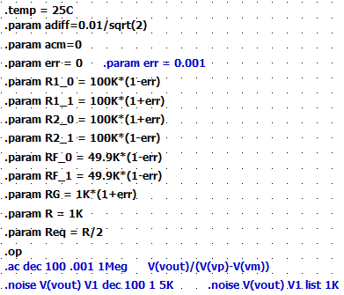

Frequency Response (0.01Hz – 100MHz)
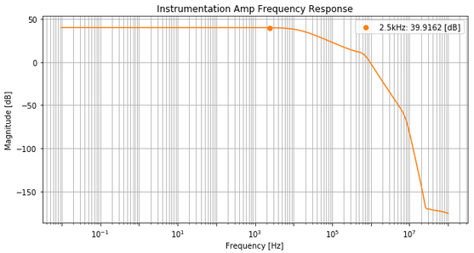

In my op amp selection, I chose an op amp that attenuates a small amount in the passband. In the next iteration of this design, slightly larger resistor values for should be chosen to compensate for this loss. Another solution is to choose an amplifier with output resistance that doesn’t increase as quickly.

Bill of materials
Product | Tolerance (%) | Quantity | Price (1000+)
1 kOhms | 0.1 | 1 | 0.17733
49.9 kOhms | 0.1 | 2 | 0.17500
100 kOhms | 0.1 | 4 | 0.17733
op1177 | - | 3 | 0.81
Total |  |  | $2.05

Bandpass Filter Design
After the instrumentation amplifier, a 4th order 1dB Chebyshev filter is implemented to set the bandwidth of the signal between 1Hz and 5kHz. Chebyshev filters are ideal because they provide a sharp transition and a wide passband defined where the response exits the ripple band.

Parameter | Specification | Unit
Signal passband | 1 – 5k | Hz
Max passband attenuation | 3 | dB
Max passband ripple | 1 | dB
Stopband attenuation | 40 @ 50kHz | dB

Texas Instruments provides a useful guideline for choosing low pass frequency scaling factors and Q factors.

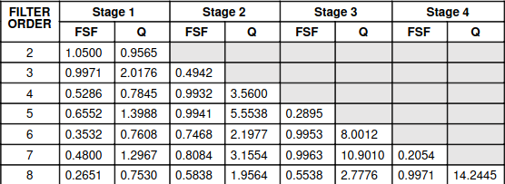

The Sallen-Key filter design is used to find the values of the passive components. The bandpass filter is designed with cascaded 2nd order filters. By choosing a combination of ratios and components, the following system of equations is solved:

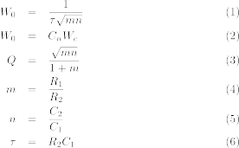

The table provides values for the low pass filter. The remaining values are chosen as . The resulting passive components are:

Parameter | Design | Actual
 | 6.58K | 6.49K
 | 6.58K | 6.49K
 | 2.73nF | 2.7nF
 | 10nF | 10nF

In order to calculate the high pass filter, the same FSF and Q factors are used and the following system of equations are modified such that

.

I chose . The passive components are:

Parameter | Design | Actual
 | 283K | 284K
 | 77.3K | 77.7K
 | 1F | 1F
 | 1F | 1F

In both calculations, the cutoff frequency was adjusted so the passband cutoff aligned with the requirements. The theoretical response is attached including passband cutoffs and stopband attenuation at 50kHz.

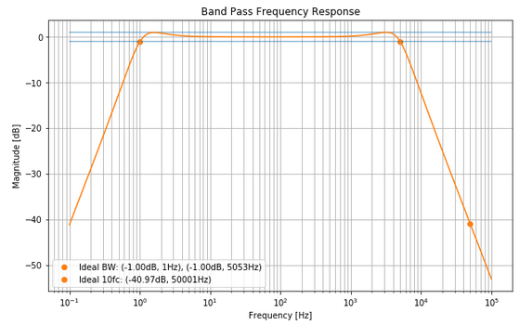

The high pass and low pass filters meet meet the spec requirements. The low pass cutoff is just over the 5kHz spec. If more precise passive components are available, then this can easily be achieved.

Bandpass Filter Performance
This section discuses the performance of the isolated Sallen-Key bandpass filter.

Schematic and DC Operation
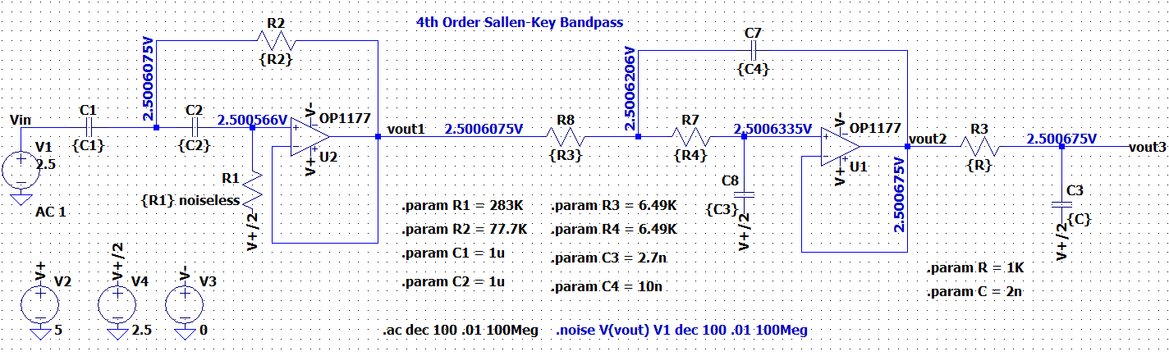

Frequency Response
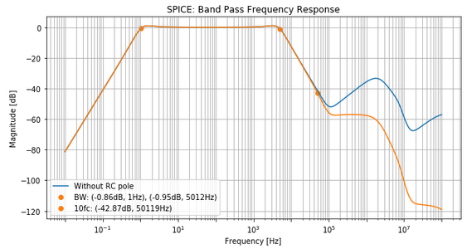

In analyzing the response of the bandpass filter, there is an increase in the frequency response after the stopband. This is largely due to the increasing output resistance of the op amp. To minimize this effect, I included an additional RC filter at the inflection frequency 90kHz.

,

Bill of materials
Product | Tolerance (%) | Quantity | Price (1000+)
1 kOhms | 0.1 | 1 | 0.17733
6.49 kOhms | 0.1 | 2 | 0.17120
77.7 kOhms | 0.1 | 1 | 0.25920
284 kOhms | 0.1 | 1 | 0.25850
1 uFarad | 1.0 | 2 | 0.70000
2000 uFarad | 1.0 | 1 | 0.44000
2700 pFarad | 1.0 | 1 | 0.43500
0.01 uFarad | 1.0 | 1 | 0.18600
op1177 | - | 2 | 0.81000
Total |  |  | $5.12

ADC Driver Design
The ADC component is not provided in this design, however this section discusses the driver requirements for the ADC. The design enables flexibility so that any ADC can be implemented with less than 5s and precision of at least 0.1%. A unity gain buffer is used to meet these requirements.

Parameter | Specification | Unit
ADC driver settling precision | 0.1 | %
ADC driver settling time | 5 | s

The settling precision of the driver is a function of the closed-loop time constant . Also the time constant is a function of the 3dB cutoff frequency. Thus, an op amp with a great enough cutoff frequency will meet the desired requirements.
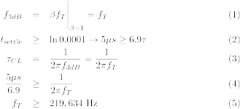

From the calculations, an op amp with unity gain bandwidth of at least 220kHz will suffice. Most general purpose op amps can achieve this spec as long as the slew rate is fast enough. Lower bandwidth op amps need to have faster slew rates in order to meet the settling time. The settling time can be rewritten as

Initially I chose to the OP1177, because it is a robust amplifier with gain bandwidth of 1.3MHz. It meets the driver requirements at a reasonably low cost. Ultimately, this was not a good choice for the system because it greatly attenuated the signal.

Top Level Frequency Response with OP1177 ADC Driver
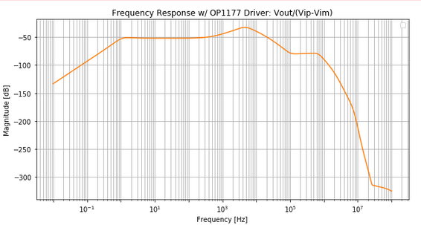

I am still investigating why the op amp is behaving this way, so I’ve chosen to use my original design choice ADA4528-2.

ADC Driver Response
This section discusses the response of the isolated ADC driver using the ADA4528-2 amplifier.

Schematic:
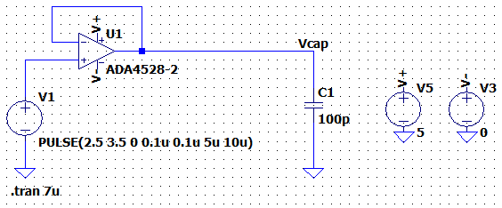

Transient Response 7 s
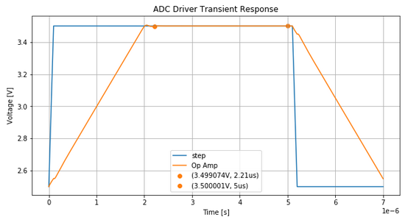

The ADA4528-2 op amp has closed-loop bandwidth of 6.2MHz and slew rate of 0.5V/s. The settling time with 0.1% precision is approximately

The actual settling time for 0.1% precision is 2.21 s.

Top-level Design
This section analyzes the output of all the components previously discussed.

Output-Referred Voltage Noise Density (0.01Hz – 100MHz)
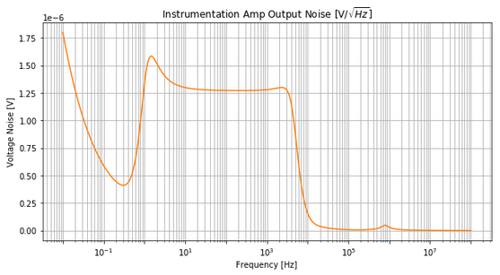

Output RMS Noise (0.01Hz - 100MHz): 98.5 V
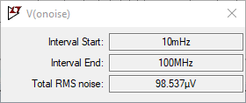

Earlier, the input RMS noise target was calculated to be 1V to achieve 77dB SNR. Thus, the total output RMS target is just the gain multiplied by this value.

The spec gives flexibility up to 1dB of SNR reduction. The output RMS is measured at 98.5 V and maintains 77dB SNR. It is observed that the noise from the filter and ADC driver did not violate the spec. Also note that the output RMS is smaller at the end of the system than at the end of the instrumentation amp. The bandpass filter greatly reduces noise.

Frequency Response
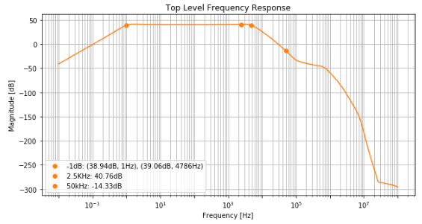

Unfortunately, the top level performance is not as good as I expected. The high pass filter is close to the design however the low pass cutoff is at approximately 4.8kHz. In the next iteration, the filter design would be updated to accommodate for the OP1177 amplifier. The pass band gain at 2.5kHz is 40.76dB.

Transient Signal
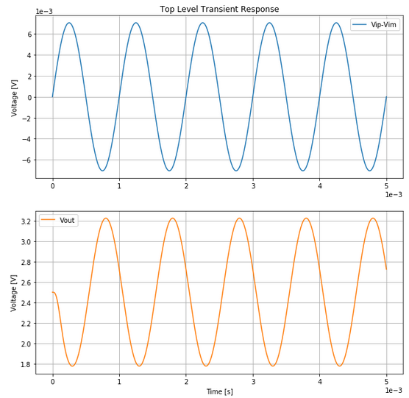

The output has a clean response in accordance to the SNR requirements. The common mode voltage is 2.5 volts and is within the 2V peak to peak range.

Bill of Materials
Product | Price ($)
Instrumentation Amplifier | 2.05
Bandpass Filter | 5.12
ADC Driver | 1.52
Total | $8.69

Power Dissipation
Product | Current (mA) | Quantity | Power (mW)
Instrumentation Amp
OP1177 | 0.400 | 3 | 2.00
Bandpass Filter
OP1177 | 0.400 | 2 | 2.00
ADC Driver
ADA4528-2 | 1.400 | 1 | 7.00
Total |  |  | 17mW

Key improvements are observed in the op amp selection, filter tuning, and additional RC poles.

Designing the circuit for low noise sensors is an iterative approach. Understanding the benefits of op amp selection can greatly improve power dissipation and price. In the current design, power dissipation was 17mW vs 42mW if I used my original design. Also the current design price was $8.69 vs $12.95 using the original design.

 

