TECHNICAL SPECIFICATIONS

MP3 Player

DATE: March 15, 2020
AUTHOR: Kevin Egedy

Feature Set Description

All features for the MP3 player are listed in the CommandEnum. Features that begin with INPUTCOMMAND are driven by the touch driver. The touch buttons are PREV, PLAY, and NEXT and are the only inputs for the system. These buttons send all instructions to CommandTask, the overlying task that controls the display and streaming tasks.

typedef enum {
INPUTCOMMAND_NONE,
INPUTCOMMAND_NEXTSONG,
INPUTCOMMAND_PLAY,
INPUTCOMMAND_PREVSONG,
SONG_COMPLETE,
} CommandEnum;

INPUTCOMMAND_NONE: command when a touch input is not mapped to any of the buttons defined. It has no assigned tasks however it is a useful command for debugging.

INPUTCOMMAND_PREVSONG: command mapped to the PREV button. It brings the streaming buffer pointer pStream to the beginning of the current song defined in curNode. Future task: if the PREV button is hit twice quickly, then go back one song in list. If PREV button is held for 1 second, then rewind. Also requires doubly linked list.

INPUTCOMMAND_PLAY: command mapped to the PLAY button. This button toggles music streaming defined by STREAMING and rxFlags. Bit 1 in OSFlagGroup should be set if STREAMING is true. It is the only input that can start or stop streaming.

INPUTCOMMAND_NEXTSONG: command mapped to the NEXT button. It brings the streaming buffer pointer (pStream) to the beginning of the current song, and increments to the next song defined in the linked node list. Future task: if the NEXT button is held for 1 second, then fast-forward.

SONG_COMPLETE: command mapped to the streaming task. Once streaming task completes (curNode→data.pos == curNode→data.size), send a message to the command mailbox mboxCommand. Streaming continues to the next song defined in the linked node list.

Input Buttons follow the Spotify design. The play button toggles from pause to play depending if a song is streaming. Streaming is defined by the global variable STREAMING (OS_FALSE/OS_TRUE) and bits 0/1 in rxFlags. The PREV and NEXT buttons blink to provide user feedback. Display tasks are more significant than streaming tasks and prevent streaming to continue until it is finished. Before a display task is called, bit 0 in OSFlagGroup should be set.

All of the features are achieved using the attached tasks and OS events.
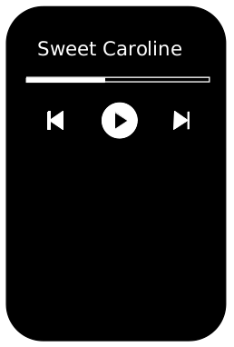Figure 1: Buttons & Display

// Task prototypes
void CommandTask(void* pdata); // priority 5
void ProgressTask(void* pdata); // priority 6
void Mp3Task(void* pdata); // priority 7
void ProgressTask(void* pdata); // priority 8
void DisplayTask(void* pdata); // priority 9

// OS Events
mboxCommand = OSMboxCreate((void*)NULL);
mboxProgress = OSMboxCreate((void*)NULL);
mboxDisplay = OSMboxCreate((void*)NULL);
rxFlags = OSFlagCreate((OS_FLAGS)0, &err);

Streaming & Song Management

Streaming and song management is defined by structs SongGroup and Node. The SongGroup holds the information necessary per song for the display and streaming tasks. Struct Node enables each song to be linked to the next. Each song only knows the song in front of it via the next pointer. An example is provided.

struct SongGroup{
char *title;
INT32U size;
INT32U pos;
INT8U *pStart;
INT8U *pStream;
};

struct Node {
SongGroup data;
Node* next;
};

struct SongGroup group0;
struct Node *curNode;
struct Node node0;
struct Node node1;

group0.title = "Train Crossing";
group0.size = sizeof(Train_Crossing);
group0.pos = 0;
group0.pStart = (INT8U*)Train_Crossing;
group0.pStream = group0.pStart;
node0.data = group0;
node0.next = &node1;

curNode = &node0;

The streaming task grabs 32 bytes every iteration and uses variable curNode→data.pos and curNode→data.pStream to track its position. Once streaming completes, curNode→data.pos == curNode→data.size, then curNode updates to the next node (curNode = curNode→next). After the last song completes, the node list wraps back to the beginning.

Overall, the system uses mailboxes to send its instructions, however rxFlags is used to toggle streaming. In most mailboxes, the task pends (OSMboxPend) until a message is received in order to perform an instruction. In Mp3Task, I wanted to achieve the opposite effect. I designed the streaming task to continue unless told otherwise. I implemented this design using the OSFlagPend method and OS_FLAG_WAIT_CLR_ALL for bit0 and bit1.

The generator for the progress bar feature is also included in this task. In every iteration, curNode→data.pos is sent to mboxProgress as an 8 bit integer. ProgressTask contains the mailbox and calls DrawProgress to accurately draw the song progress
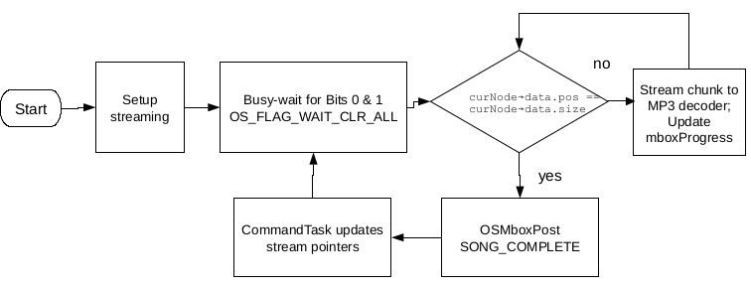Figure 2: MP3 Task
Input & Display Task

The TouchInputTask is the generator for the system and creates messages for the CommandTask. Similar to the Mp3Task, rxFlag is necessary to suspend touch polling until display instructions are finished. This prevents duplicate commands from being processed and provides a good user experience. If no input is received, a non-block time delay OSTimeDly is used before polling again.

In the design, I chose ProgressTask to be separate from DisplayTask. They both update the display, but I created the addition task due to the receive message type. ProgressTask receives INTU8 messages and DisplayTask receives CommandEnum messages. CommandTask is the handler that provides instructions for all the remaining tasks, however ProgressTask receives its instructions from the Mp3Task directly.

Structs Point, and Grid were implemented to maintain the display layout. The CommandTask calls DrawLcdContents to draw the initial layout of the screen. This function uses the attached helper functions in order to achieve this. As mentioned before, the display task handles the instructions from CommandTask and then clears bit 0 in rxFlag so that streaming and touch polling can continue.

// DEFINE LOCATIONS FOR INPUTS
typedef struct{
int16_t X, Y;
} Point;

typedef struct{
Point Title; // Song Title
Point Progress; // Song Progress
Point TL, TM, TR; // Button Layout
} Grid;
static Grid grid;

// Define Grid; (X,Y) is middle of container
grid.Title.X = 120; grid.Title.Y = 30;
grid.Progress.X = 120; grid.Progress.Y = 80;
grid.TL.X = 50; grid.TL.Y = 120;
grid.TM.X = 120; grid.TM.Y = 120;
grid.TR.X = 190; grid.TR.Y = 120;

// Helper functions
void DrawTitle(char *title);
void DrawProgress(int8_t percentage);
void ResetProgress(void);
void TogglePlayBtn(void);
void DrawNextBtn(void);
void DrawPrevBtn(void);
void DefineBtns(Adafruit_GFX_Button *buttonCtrl, int16_t x,
int16_t y, CommandEnum CMD);

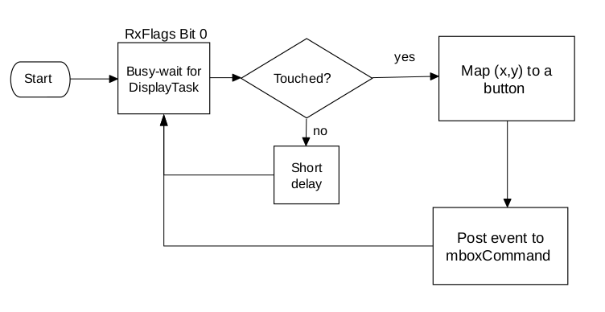Figure 3: Input Task
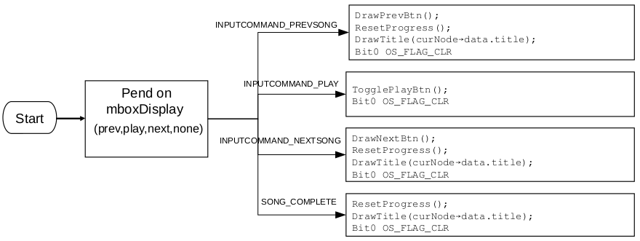Figure 4: Display Task
Command Task

The main purpose of CommandTask is to update rxFlags and update the streaming pointers. It pends on mboxCommand to receive instructions from InputTask and performs a pattern of operations. In every command, Bit0 in rxFlags is set to turn off touch inputs. Then if the command is INPUTCOMMAND_NEXTSONG,INPUTCOMMAND_PREVSONG,or SONG_COMPLETE, it uses the attached code to update the streaming pointers.

// update streaming pointers
curNode->data.pos = 0;
curNode->data.pStream = curNode->data.pStart;
curNode = curNode→next;

If the command is INPUTCOMMAND_PLAYSONG, then Bit1 in rxFlags is toggled according to STREAMING status. Lastly, all commands forward their instruction to mboxDisplay. See Figure 4 to find how each display instruction is handled. Also, it is important to understand the distinction between CommandTask and Mp3Task. The Mp3Task does the work to decode the file, and CommandTask updates the curNode pointer for Mp3Task to read.

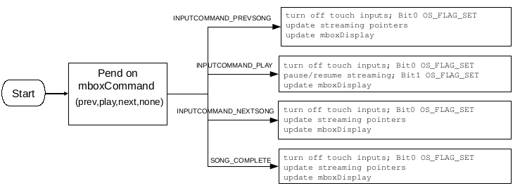Figure 5: Command Task

