EE 452 – Power Electronics Design
Experiment 1 Pre-lab Assignment: Part B
Department of Electrical & Computer Engineering
University of Washington

Introduction
The purpose of this assignment is to prepare you to conduct Experiment 1B. Please make sure you have read and understand the experimental procedure before attending your designated lab section.
This assignment will be due at the beginning of your lab section. Like your homework, you will submit the prelab assignments through Canvas. For each problem, please provide written analysis where appropriate, show your work, and clearly label all plots, if any.

Parts
Experiment 1 will be done on the protoboard using the following parts. In the electronic version of this document, you may click on the hyperlink embedded in the “Part number” column to bring up the data sheet for a given part. In addition to the components below, this experiment will also require resistors and capacitors of your choosing.

Description | Manufacturer | Part number
PWM Controller | Texas Instruments | UC3525AN

Prelab tasks
- PWM controller familiarization (5 pts). Using datasheet for UC3525AN, give the range of switching frequency possible with this PWM controller.

Max switching frequency: 100Hz - 500kHz
Over free air switching frequency: 120Hz -400kHZ

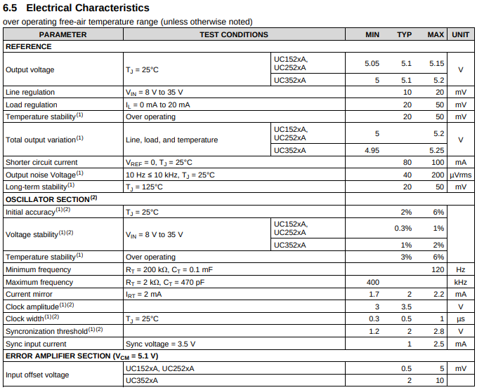
- PWM controller familiarization. [Optional for undergrads] (5pts) Study the UC3525AN PWM controller datasheet. This component has an oscillator whose frequency dictates the switching frequency. Assuming you are given external components CT = 0.01µF and RD = 0Ω,
what value of RT will give you a 50kHz oscillator frequency?
8.3.2.1
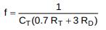
= 2857 Hz

