EE 452 – Power Electronics Design
Experiment 1 Pre-lab Assignment: Part C
Department of Electrical & Computer Engineering
University of Washington

Introduction
The purpose of this assignment is to prepare you to conduct Experiment 1C. Please make sure you have read and understand the experimental procedure before attending your designated lab section.
This assignment will be due at the beginning of your lab section. Like your homework, you will submit the prelab assignments through Canvas. For each problem, please provide written analysis where appropriate, show your work, and clearly label all plots, if any.

Parts
Experiment 1 will be done on the PCB using the following parts. In the electronic version of this document, you may click on the hyperlink embedded in the “Part number” column to bring up the data sheet for a given part. In addition to the components below, this experiment will also require resistors and capacitors of your choosing.
Description | Manufacturer | Part number
Power MOSFET | Infineon Technologies | IRFB4615PbF
Power MOSFET | Texas Instruments | CSD19535KCS
Half-bridge Gate driver | Infineon Technologies | IRS2184PBF
PWM Controller | Texas Instruments | UC3525AN

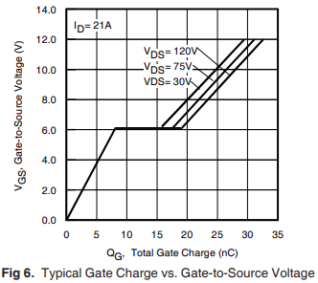
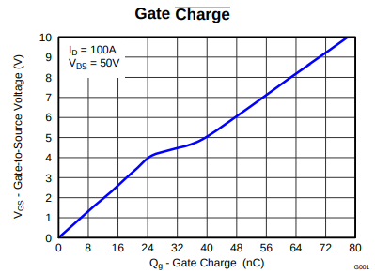

Prelab tasks
Component familiarization. Using the applicable data sheets, determine the following (10 pts):
    - The drain-to-source resistance of both power MOSFETs in the on state.
Power MOSFET | Drain-to-Source Resistance
IRFB4615PbF | 32 m
CSD19535KCS | 3.4 m

    - The threshold gate-to-source voltage of the power MOSFETs.
Power MOSFET | Gate-to-Source Voltage
IRFB4615PbF | 3 V
CSD19535KCS | 2.7 V

    - The rated drain current of the MOSFETs.
Power MOSFET | Drain Current (@25C)
IRFB4615PbF | 35 A
CSD19535KCS | 150 A

    - The gate charge of both power MOSFETs
Power MOSFET | Total Gate Charge (@ V_{GS} = 10V)
IRFB4615PbF | 26 nC
CSD19535KCS | 78 nC

- The rise and fall times of both power MOSFETS
Power MOSFET | Rise Time | Fall Time
IRFB4615PbF | 35 ns | 20 ns
CSD19535KCS | 15 ns | 5 ns

- The minimum logic high input voltage of the gate driver.
V_{IH} = 2.5V
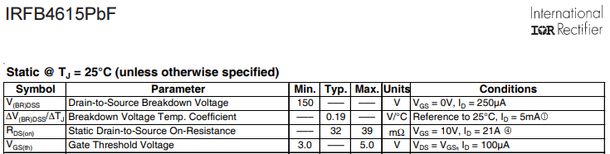
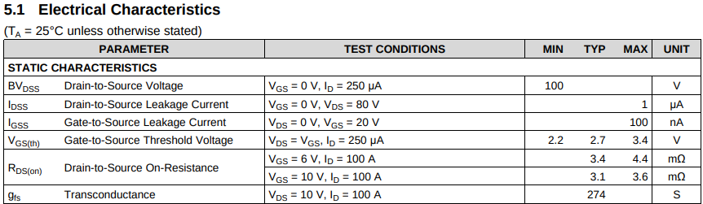
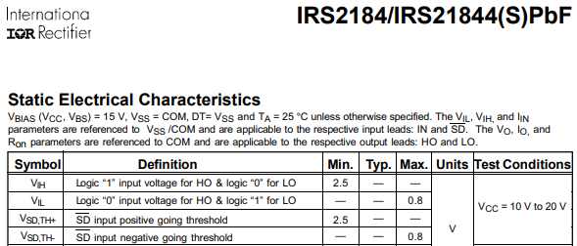
CSD19535KCS
Possible PWM frequency (5 pts) Using data from q1, compute the maximum possible switching frequency for both MOSFETS.
[skip]

GRAD STUDENTS REQUIRED: Bootstrap circuit design. (10pts) Study the UCC27712 gate driver datasheet. This datasheet has better guidance than the IRS 2184.
Compute the following for each MOSFET with a 5% boot capacitor ripple voltage.
  - Bootstrap capacitance
  - Bootstrap resistance (assuming a boostrap diode peak current of 3A)
  - Consider: why do we need a bootstrap capacitance? (just for learning)
5% ripple voltage of 12V = 0.6V
Bootstrap capacitance used in circuit will be at least twice as large as calculated
values as mentioned in datasheet.

Power MOSFET | Boot Capacitance | Boot Resistance
IRFB4615PbF
CSD19535KCS

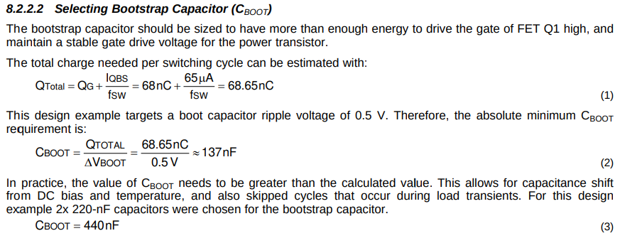
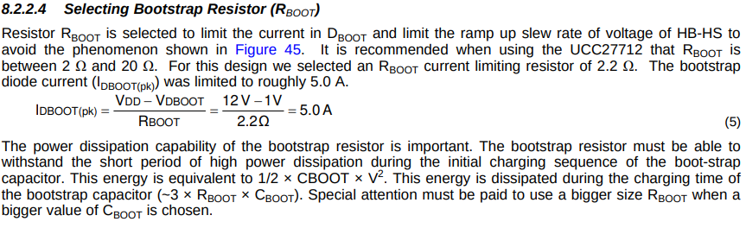
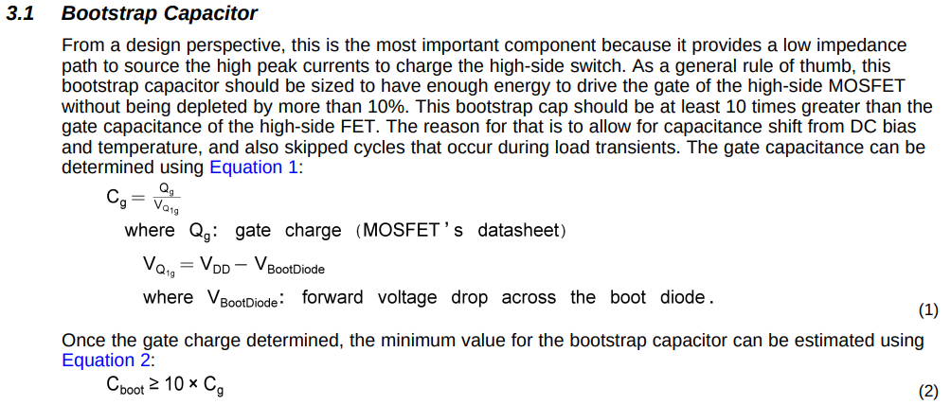
UCC27712
TI Bootstrap Circuitry

