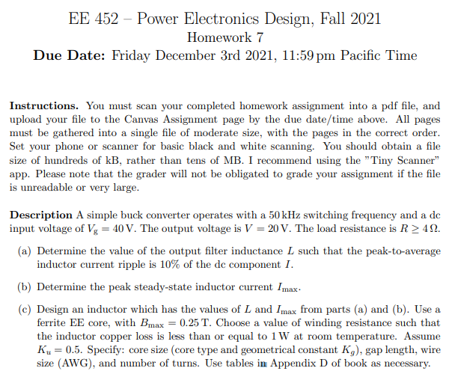
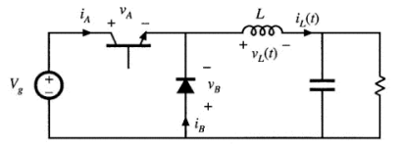

Constants | Value
 | H/m
Buck Converter | Requirement
 | 50 kHz
 | 40 V
 | 20 V
R
 | 10%
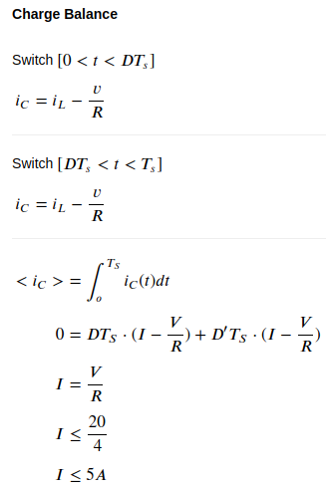
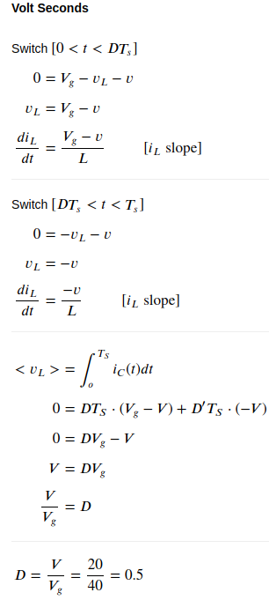
a.)

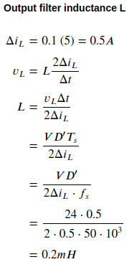

b.) is the sum of the inductor current I, the ripple current (10%), and a safety factor (15%).

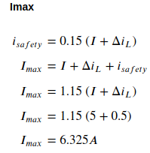

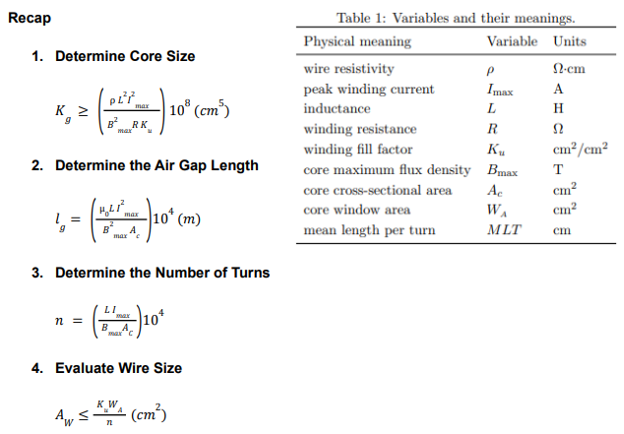
c.)

Inductor | Requirement
 | 0.25 T
 | 0.5
 | 1W

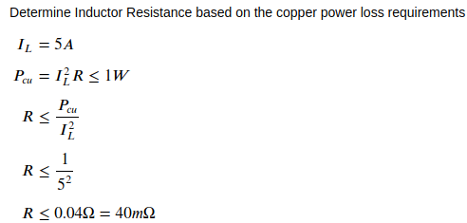
1.

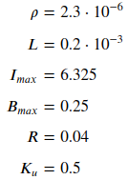
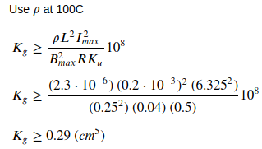

Core size must be greater than 0.29 (cm⁵).

2. Air gap is dependent upon the core cross-sectional area . Due to the core size constraint, the possible cores are EE30, EE50, EE60, and EE70/68/19.

For this design, core EE30 is chosen with cross section area 1.09 cm².

 | Geometric Constant (Kg) | Cross-sectional Area (Ac) | Core Window Area | MLT
EE30 | 0.857 cm⁵ | 1.09 cm² | 0.476 cm² | 6.6 cm

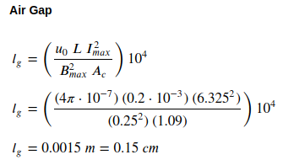

3. Plug in values from previous steps.

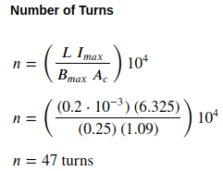

4. Design uses the largest wire size given constraints. The wire size is calculated to be less than or equal to 0.005 cm², so a 21 AWG wire is chosen.

