EE473/538 CAD Lab1
Due Tuesday, Jan. 25th, 2022

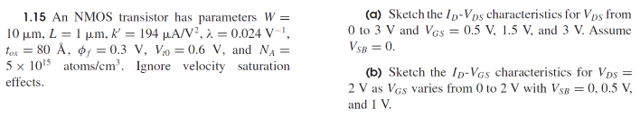

The NMOS transistor drain current in saturation is modeled as .
The drain current in triode region is modeled as .
Device parameters are , , , and .

Given , the threshold voltage is simplified to . The drain current is rewritten with the above parameters such that . This can be further simplified to for this sweep.

At , the device is turned off.
At the device first enters the triode region, then moves to saturation when .
Figure 1: NMOS Drain Current: VGS=[0.5, 1.5, 3]V

The body voltage is no longer neglected. The threshold voltage is modeled as
.

The drain currents will be less than the previous plots for the same values of .

Figure 2: NMOS Drain Current: VSB=[0, 0.5, 1]V

