EE 473/538 Linear IC Design
HW2 February 11, 2022
Kevin Egedy
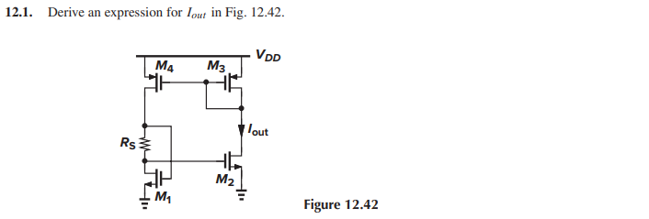
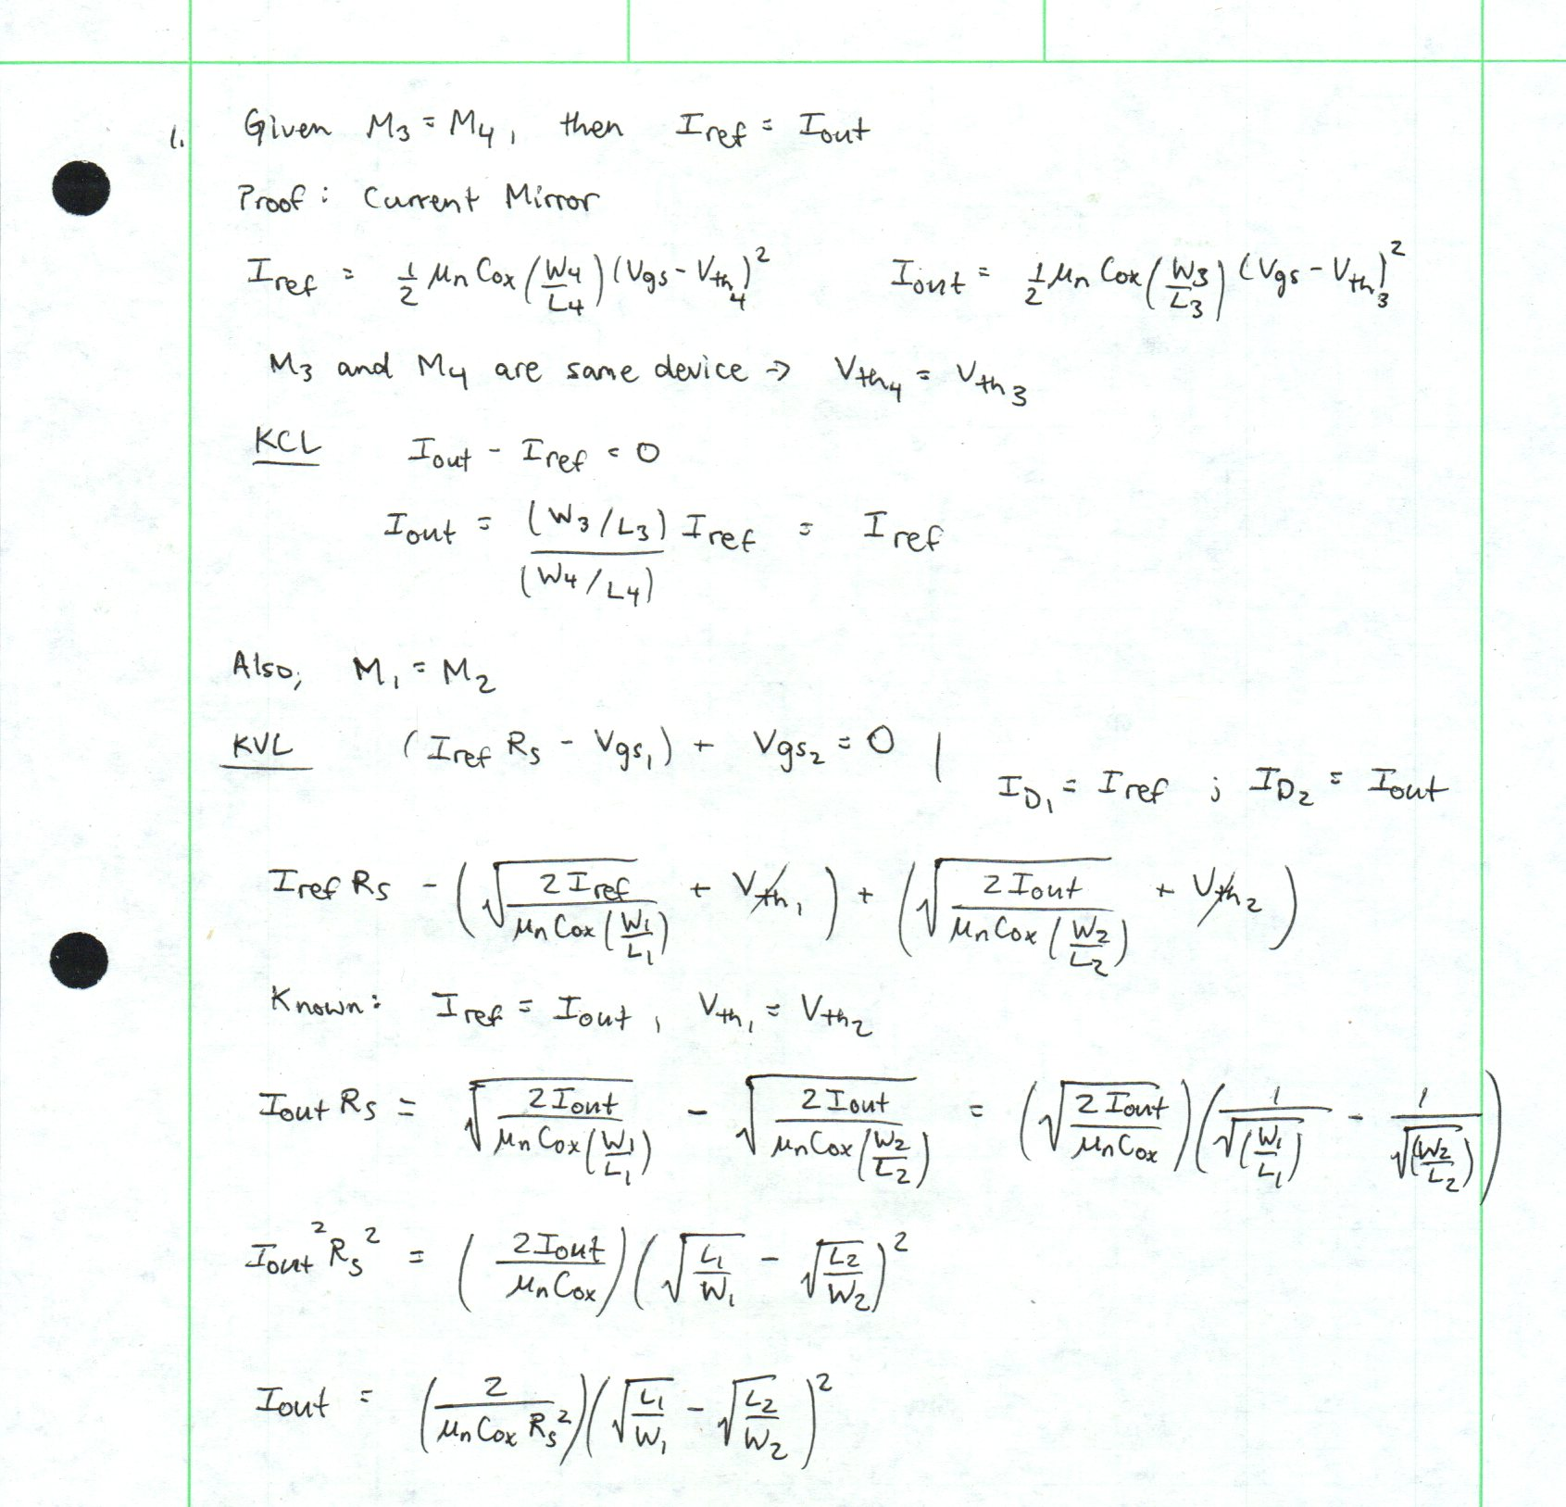

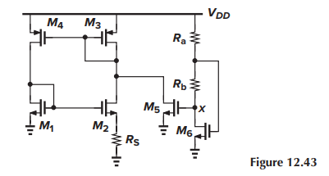

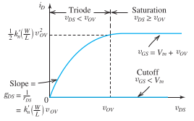

Figure: Sedra Smith Microelectronic Circuits

Define at the point between and .
Initially, all channels are closed because and no current runs through and .
increases such that .
The channel is no longer pinched and allows current.
Both and turn on and the drain current through turns on the remaining circuit.
Now the channel is induced and keeps increasing, allowing more drain current through .
The voltages at and are defined as
and .
As continues to grow, decreases and also decreases.
It is guaranteed that when
where
