AdcaRegs.ADCCTL2.bit.PRESCALE pg(1463,1465,1501)

Def: Sets the ADC clock. EE533: ADC clock = system clock

AdcaRegs.ADCCTL2.bit.PRESCALE = 0;

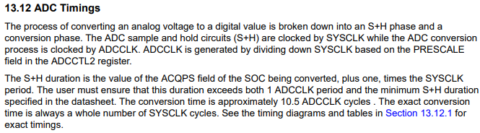
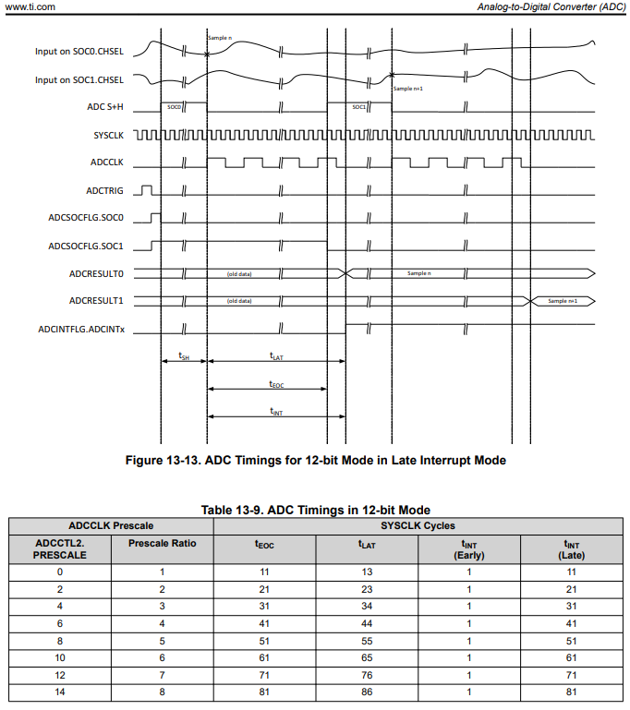

AdcaRegs.ADCSOCxCTL.bit.CHSEL pg(1445,1449,1467)

Def: selects the ADC channel
EE533: Configure ADCINA3, ADCINA5,ADCINA6 to convert on SOC0, SOC1 and SOC2 respectively

AdcaRegs.ADCSOC0CTL.bit.CHSEL = 3; //SOC0 will convert ADCINA3
AdcaRegs.ADCSOC1CTL.bit.CHSEL = 5; //SOC0 will convert ADCINA5
AdcaRegs.ADCSOC2CTL.bit.CHSEL = 6; //SOC0 will convert ADCINA6

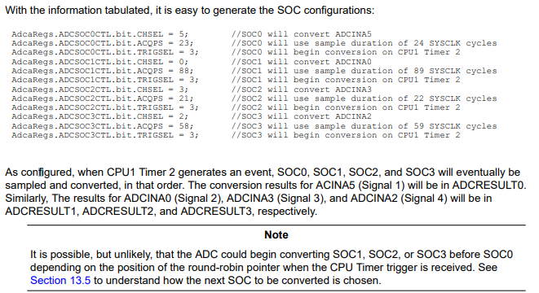

AdcaRegs.ADCSOCxCTL.bit.ACQPS pg(1446,1448)

Def: Selects ADC sample window based on number of cycles of ADC clock
EE533: 100ns sample window

Acquisition window = (ACQPS + 1)∙(System Clock (SYSCLK) cycle time)
100E-9 = (ACQPS + 1)∙(100MHz)
ACQPS = 9

AdcaRegs.ADCSOC0CTL.bit.ACQPS = 9;
AdcaRegs.ADCSOC1CTL.bit.ACQPS = 9;
AdcaRegs.ADCSOC2CTL.bit.ACQPS = 9;

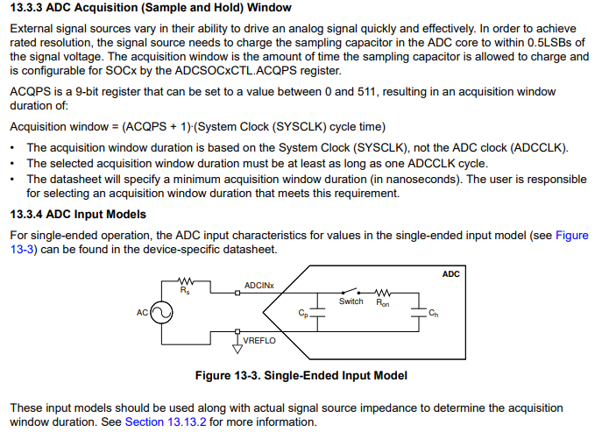

AdcaRegs.ADCSOCxCTL.bit.TRIGSEL pg(1446,1534)

Def: Selects trigger for ADC SOC
EE533: Trigger on EPWM1 SOCA

AdcaRegs.ADCSOC0CTL.bit.TRIGSEL = 0b05;
AdcaRegs.ADCSOC1CTL.bit.TRIGSEL = 0b05;
AdcaRegs.ADCSOC2CTL.bit.TRIGSEL = 0b05;

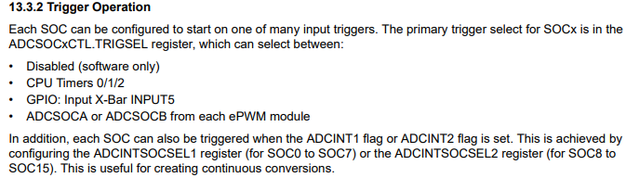
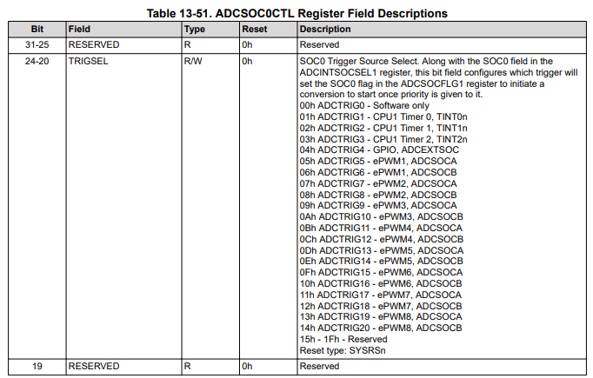

DacaRegs.DACCTL.bit.DACREFSEL pg(1635,1639)
Def: DAC Control Register
EE533:
- DACREFSEL: set to ADC reference
- LOADMODE: update DAC value on SYSCLK
- MODE: set Gain=2

DacaRegs.DACOUTEN.bit.DACOUTEN pg(1642)
Def: DAC Output Enable Register
EE533: Enable output

DacaRegs.DACVALS.all pg(1641)
Def: DAC Value Register - Shadow
EE533: Clear to start

void initDAC(void); //line82

initDAC(); //line144

void initDAC(void) //line360
{
EALLOW;
DacaRegs.DACCTL.bit.DACREFSEL = 0b1;
DacaRegs.DACCTL.bit.LOADMODE = 0b0;
DacaRegs.DACCTL.bit.MODE = 0b1;
DacaRegs.DACOUTEN.bit.DACOUTEN = 0b1;
DacaRegs.DACVALS.all = 0b0;
EDIS;
}

