EE 458/533 – Power Electronics Controls
Homework 2
Due Date: Thursday January 20th 2021

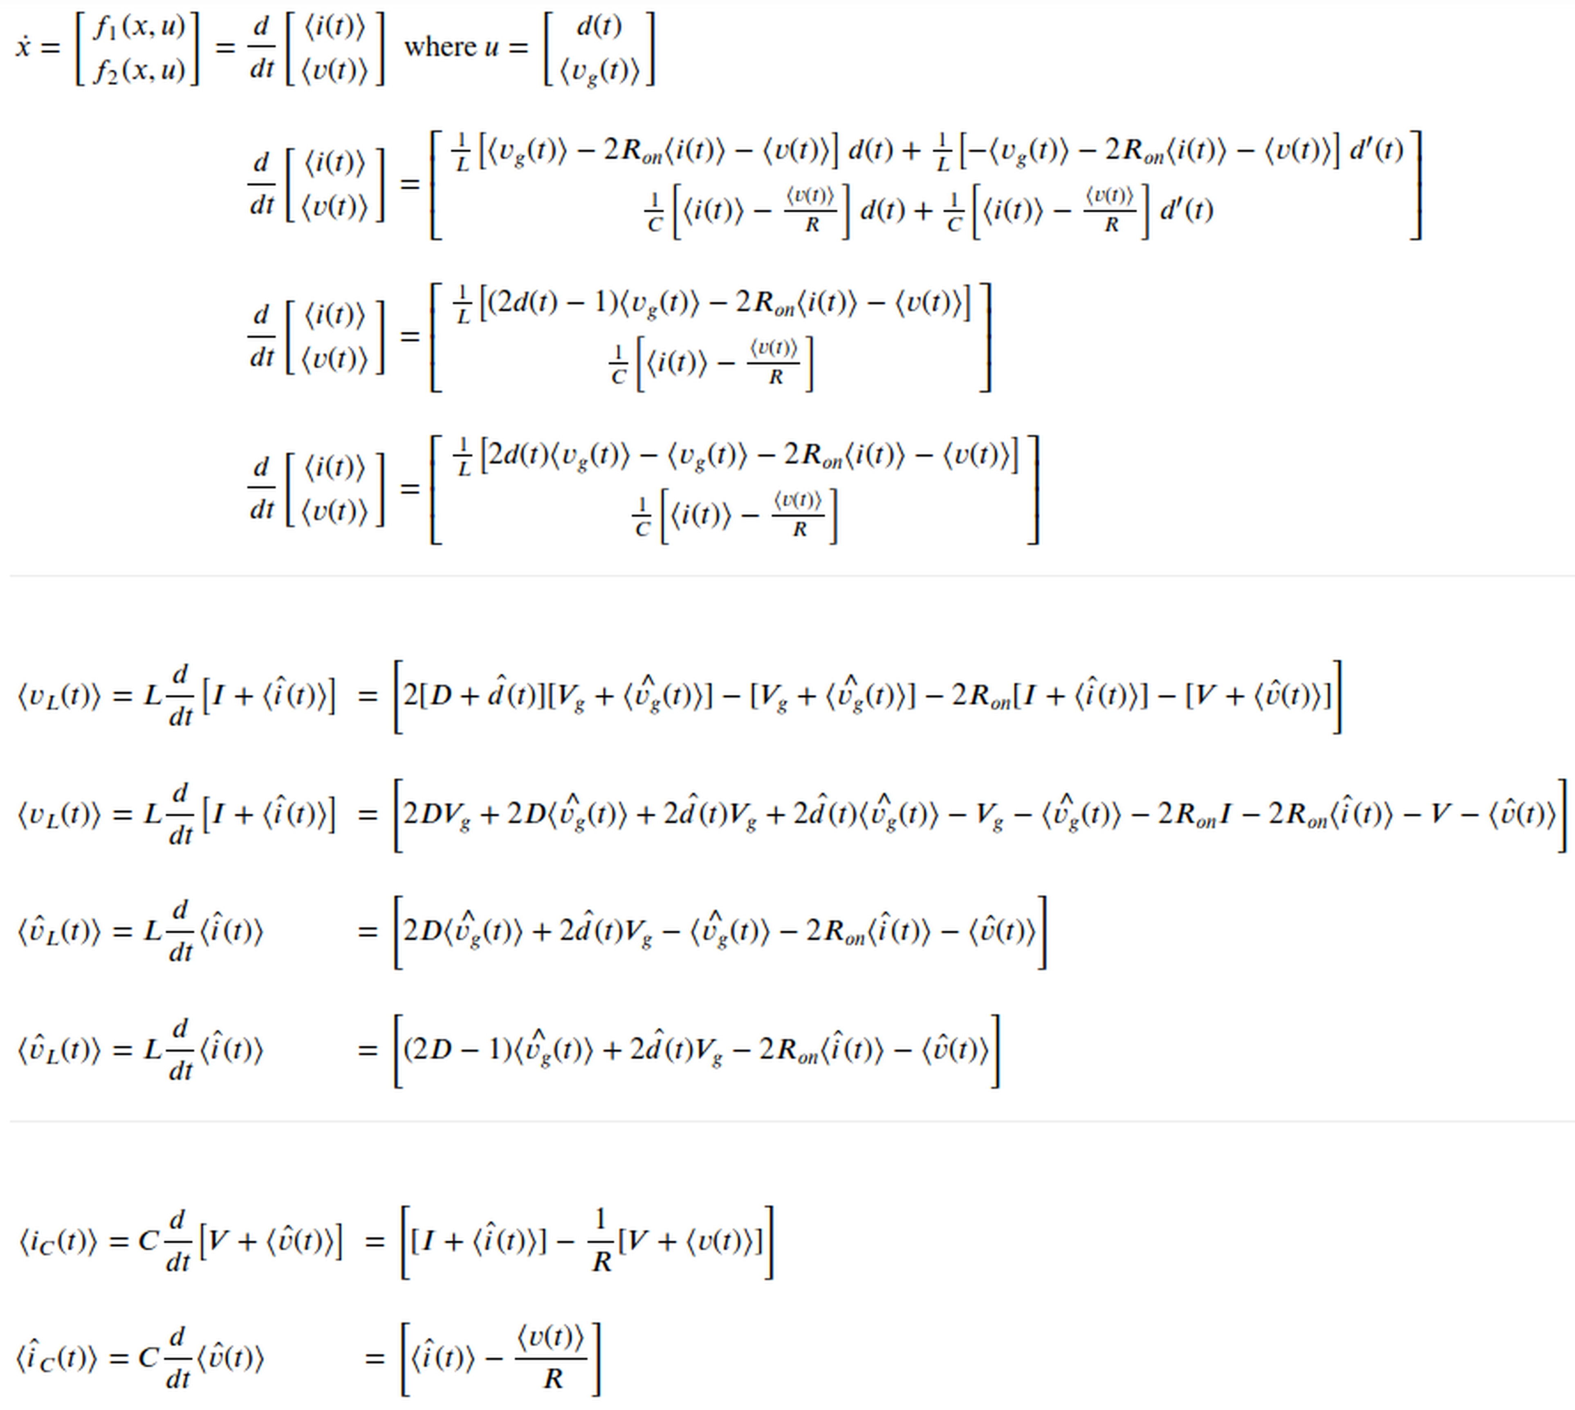

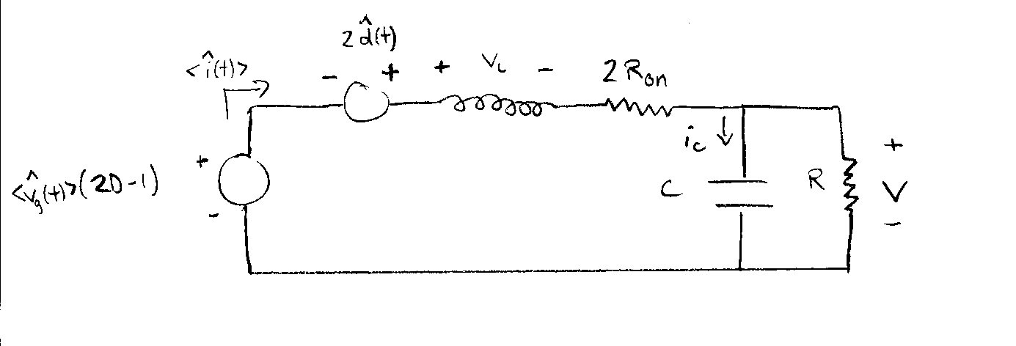

- Taking the derivative with respect to x₁ and x₂, the same values for A and B are found such that .

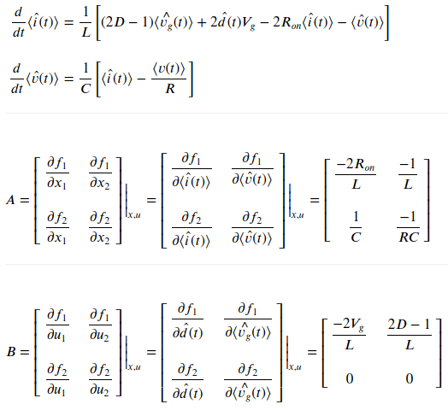

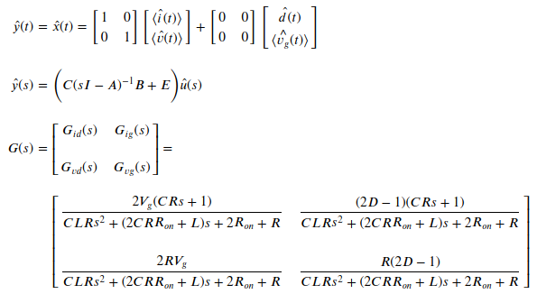
- Given d=0.5, G_{ig}(s) and G_{vg}(s) will have no response since they have terms of (2D-1).
Half the switching frequency is 25kHz/2 = 12.5kHz, however the cross over frequencies occur at frequencies much greater than this.

The system is stable due to large positive phase margin in G_{id}(s). Phase margin shows how much the system gain can be increased before it is unstable. There is also small positive phase margin in G_{vd}(s).

TF | GM (dB) | PM (deg) | WG (Hz) | WP (Hz) | Stability
G_{id}(s) | inf | 90.01 | nan | 106,182 | yes
G_{ig}(s) | inf | inf | nan | nan | yes
G_{vd}(s) | inf | 2.25 | nan | 41,180 | yes
G_{vg}(s) | inf | inf | nan | nan | yes

