Project Report Template with Explicit Formatting Rules
MS Word .doc or .docx format, an Adobe Acrobat .pdf format version, and PLECS files are required.
For main text, use 12 pt Times or Time-Roman font and 12 pt Symbol font for math characters.
For text, use 18 pt line spacing with 6 points after each paragraph. Indents are not needed.
Use 1” margins all around.
Use a header formatted as in this document (0.5" from the top with lower border). It should contain your name, course, project #, semester, page #, and project title as shown above.
For figures, use MS Word tables (with invisible or shaded borders).

 | 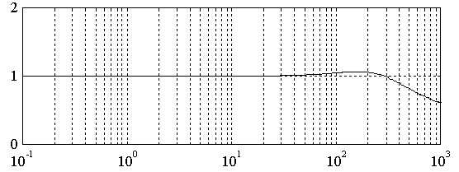 | Legend:
∠ [deg] | 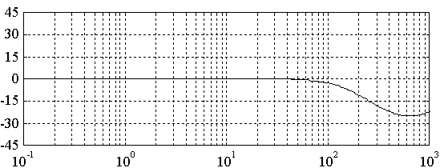 | Parameters:  For tables and figures, use single line spacing with no points before or after.  Use 10 pt fonts for axis labels.
 | Frequency, Hz
Fig. 1. Current estimation accuracy frequency response (use technically accurate titles)

The period at the end of sentences should be followed by two blank spaces, i.e. std. USA format.
Report Content Guidelines
A four (4) page maximum length report is be turned in via electronic copies of 1) the report .doc file, 2) a .pdf version of the report, and 3) all Math package files.
Do not repeat the assignment statements as part of the report. Graphical representation of results and insightful discussion of results should be the primary focus.
Graphics should be imbedded in the report as figures with accurate figure titles and figure numbers. Graphical overlays using colors (designated in legend) are strongly suggested for comparisons.
For graphical models, such as state block diagrams, please use graphic editors such as Visio or Canvas (Windows or Mac). Do not use overlayed text boxes to create graphical images.
Use the "Equation Field Codes" or Equation Editor in Word for equations such as (1), (2), (3) and (4).
= (1)
Jp = mem(t) - bp ωm(t) (2)
Lf = ei(t) - eo(t) - Rf if(t) (3)
= if(t) (4)
Please use this document as the template for your work.

