Current Regulation in DC Machines
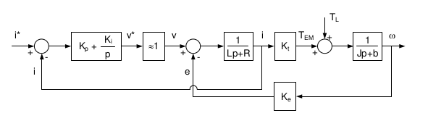
Fig. 1. Analyzing Current Regulator at Locked Rotor

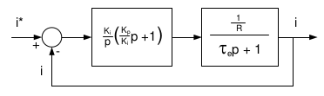
Fig. 2. Current Loop
Tuning the current loop at locked rotor decouples the effects of Back EMF. The current loop in the DC machine is rewritten with constants , and . The current loop is simplified by setting . Note, an additional gain constant should be included after the controller. Further simplifying the current regulator, the transfer function response is
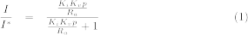
Given the response of the current regulator, the gain coefficients can be determined at the desired 1000Hz bandwidth. Ra and La are provided in the spec sheet.

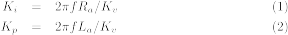

The coefficients are listed in Table 1.
 | Ki | Kp
MGFQK 063-32 | 51.6515 | 0.1432
MGFQK 160-22 | 0.8316 | 0.1432

Table 1. Current Regulator Coefficients

The controller determines the magnitude as frequency is varied in the command current. Frequencies operating at the bandwidth have -3dB attenuation and 45 degree phase shift.
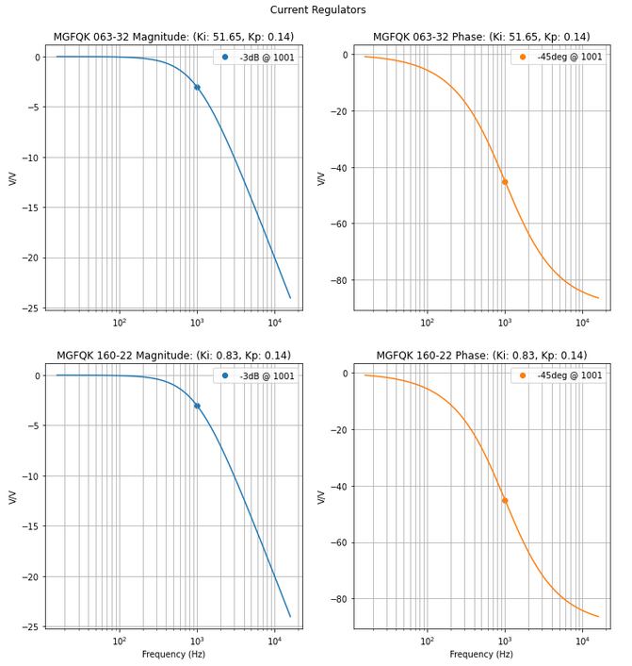
Fig. 3. Current Regulator Frequency Response

Locked Rotor Current Regulator
The next section simulates the motors at locked rotor conditions and ideal voltages. The command and response currents are measured with varying frequencies. The command current is defined as
(1)
where Io = 5A and fc = 1, 10, 100, 1000 Hz.
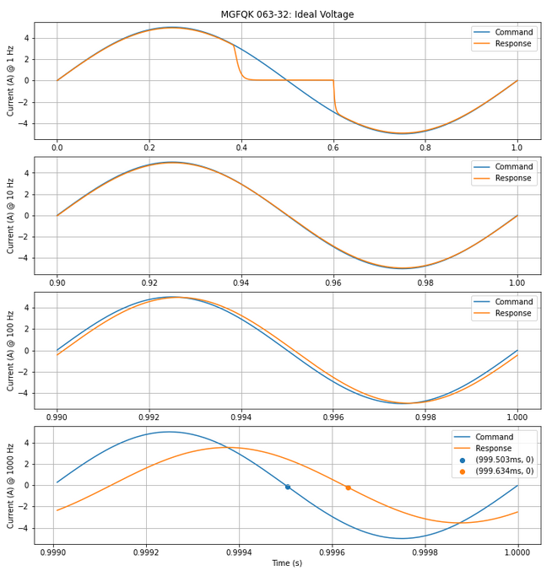
Fig. 4. MGFQK 063-32: PI Controller

1 Hz | 10 Hz | 100 Hz | 1000 Hz
5.0000 | 4.9999 | 4.9612 | 3.5366

Table. 2. MGFQK 063-32: PI Controller (A)

1 Hz | 10 Hz | 100 Hz | 1000 Hz
5.0000 | 4.9999 | 4.9753 | 3.5279

Table. 3. MGFQK 160-22: PI Controller (A)

The peak voltage of the small motor operating at 1000Hz is 3.54V, equivalent to -3dB. The phase is 131 s, equivalent to 46.8 degrees. Both motors have similar responses, however the larger motor doesn’t clip at locked rotor.

Locked Rotor Performance
The rotor is locked so speed doesn’t change and remains at constant zero.

Hz
1 | 0 | 0 | -6.24 | 6.24
10 | 0 | 0 | -6.24 | 6.24
100 | 0 | 0 | -6.21 | 6.21
1000 | 0 | 0 | -4.41 | 4.41
Table 4. MGFQK 063-32:
Speed (rad/s) and Torque (Nm)

Hz
1 | 0 | 0 | -7.32 | 7.32
10 | 0 | 0 | -7.32 | 7.32
100 | 0 | 0 | -7.28 | 7.28
1000 | 0 | 0 | -5.17 | 5.17
Table 5. MGFQK 160-22:
Speed (rad/s) and Torque (Nm)

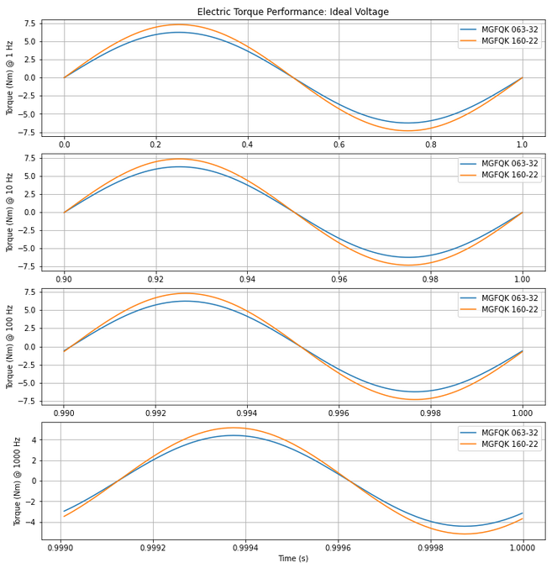
Fig. 5. Locked Rotor: Response (Nm)

Locked rotor produces greater electric torque than the unlocked rotor. (Discussed later)
Unlocked Rotor Current Regulator
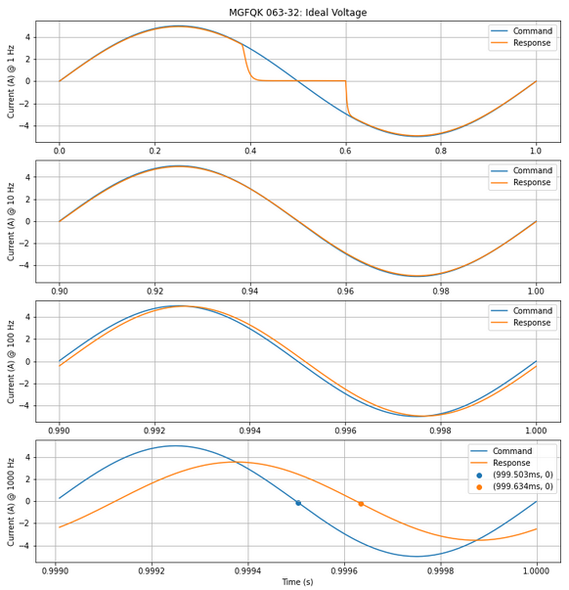
Fig. 6. MGFQK 063-32: PI Controller (A)
Near the 0 crossing at 1Hz, the small motor experiences clipping. The current regulator produces a voltage that reaches the upper limit of the saturation block (680 volts) and clips the armature voltage. The current agrees with the frequency response from Figure 3. At 1000Hz, the response current has a peak voltage of 3.54V, equivalent to -3dB. The phase is 131 s, equivalent to 46.8 degrees. Note, measurements must be in steady state otherwise they will provide values from transient response. Both motors have very similar responses, however the larger motor doesn’t clip.
1 Hz | 10 Hz | 100 Hz | 1000 Hz
4.9319 | 4.9335 | 4.9612 | 3.5366

Table. 6. MGFQK 063-32: PI Controller (A)

1 Hz | 10 Hz | 100 Hz | 1000 Hz
4.9242 | 4.9485 | 4.9747 | 3.5283

Table. 7. MGFQK 160-22: PI Controller (A)

Unlocked Rotor Performance
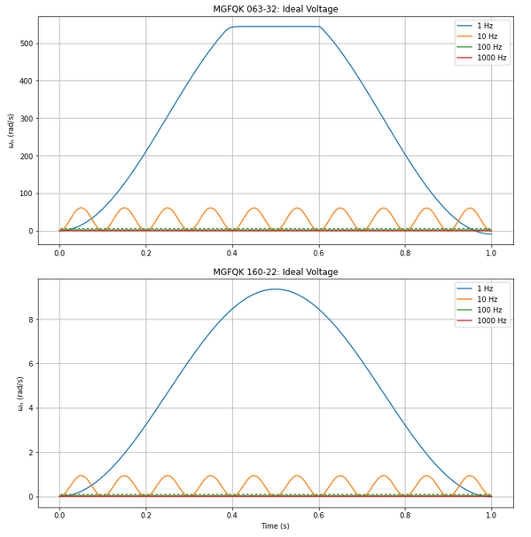
Fig. 7. Unlocked Rotor: Response (rad/s)
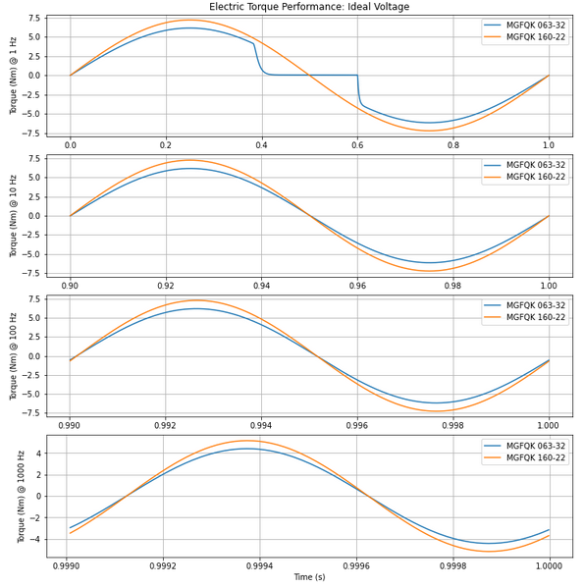
Fig. 8. Unlocked Rotor: Response (Nm)
Hz
1 | 0 | 544.35 | -6.16 | 6.16
10 | 0 | 61.22 | -6.16 | 6.16
100 | 0 | 6.15 | -6.20 | 6.20
1000 | 0 | 0.53 | -4.42 | 4.42
Table 8. MGFQK 063-32:
Speed (rad/s) and Torque (Nm)
Hz
1 | 0 | 9.35 | -7.21 | 7.21
10 | 0 | 0.94 | -7.25 | 7.25
100 | 0 | 0.094 | -7.28 | 7.28
1000 | 0 | 0.0081 | -5.17 | 5.17
Table 9. MGFQK 160-22
Speed (rad/s) and Torque (Nm)
At lower frequencies, the unlocked rotor generates smaller torque than the locked rotor. Comparing 1Hz, the locked rotor generates max peak 7.32 Nm vs. 7.21 Nm from the unlocked rotor. The cause of this difference is back EMF.
Performance Improvements
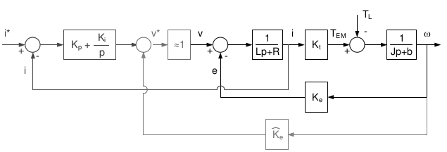
Fig. 9. DC Machine:
Current Regulator and Back EMF Decoupling
Decoupling back EMF offsets the mechanical system and improves performance. As seen in the unlocked rotor, torque decreases due to back EMF. Applying decoupling, the torque response is improved to values seen in the locked rotor.
H-Bridge Performance
The PWM has a carrier frequency of 20kHz and tracks the command current well. Note, there is still clipping at 1Hz. A low pass filter is applied for approximate torque values. H-bridge source has slightly smaller values.
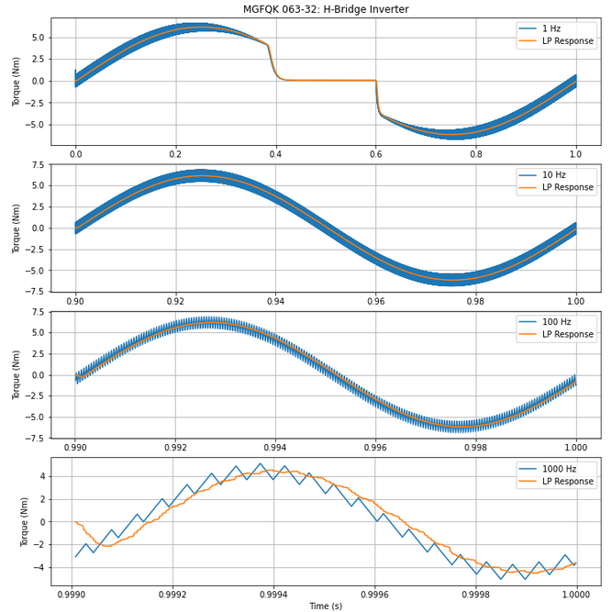
Fig. 11. Unlocked Rotor: Response (Nm)

Hz
1 | 0 | 544.35 | -6.16 | 6.16
10 | 0 | 61.22 | -6.15 | 6.15
100 | 0 | 6.16 | -6.19 | 6.19
1000 | 0 | 0.56 | -4.33 | 4.33
Table 10. MGFQK 063-32
Hz
1 | 0 | 9.35 | -7.70 | 7.70
10 | 0 | 0.94 | -7.19 | 7.19
100 | 0 | 0.01 | -7.30 | 7.30
1000 | 0 | 0.016 | -5.11 | 5.11
Table 11. MGFQK 160-22

