The state equations listed in Figure 4 of the appendix are implemented in PLECS. Responses from the stator phase currents, rotor phase currents, rotor speed, and electromagnetic torque are provided.
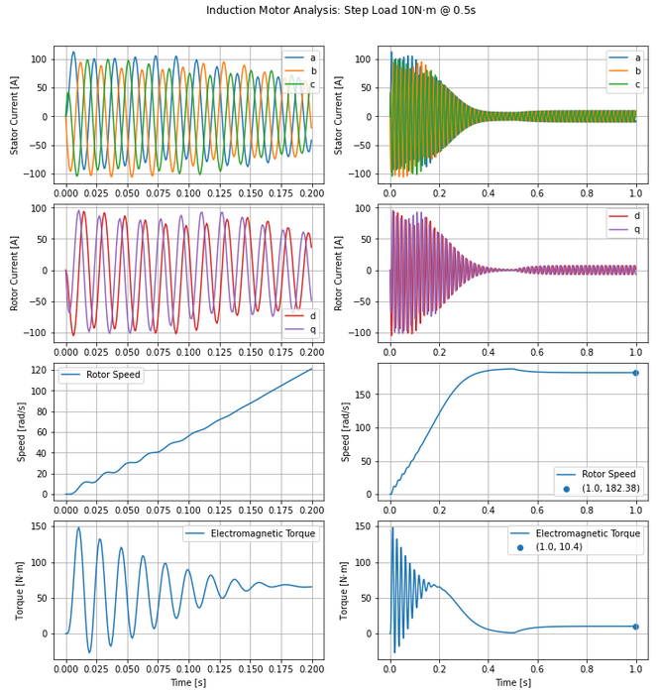
Fig. 1. State Equations Induction Motor: Step Load 10Nm at 0.5 seconds

In Figure 1, the transient response is shown on the left side and the step response (with transient) is shown on the right. The stator phase currents are phase shifted by 120 degrees as expected. Also, the dq rotor currents are separated by 90 degrees as expected. The rotor speed ramps up with small oscillations and follows an underdamped response. The steady state rotor speed is 182.38 rad/s. The electromagnetic torque oscillates greatly before 0.2 seconds and then follows an underdamped response. The steady state torque is 10.4 Nm.
The previous analysis is compared with the induction motor provided by PLECS.

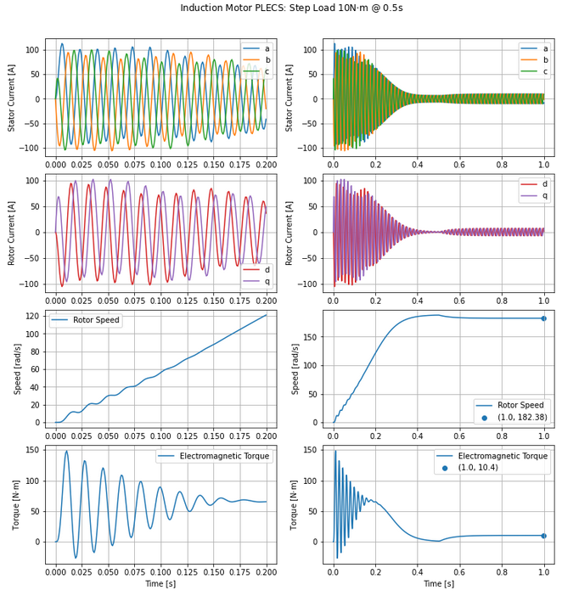
Fig. 2. PLECS Induction Motor: Step Load 10Nm at 0.5 seconds

The simulations from the PLECS models strongly agree with the previous analysis. Both the rotor speed and the electromagnetic torque follow an underdamped response. The steady state rotor speed is 182.38 rad/s and the steady state electromagnetic torque is 10.4 Nm. Note, these are the same values found in the analysis previously. Comparing the rotor phase currents, the analysis currents are shifted 180 degrees from the PLECS model. This is an expected result due to the abc - dq transformation.
(1)
The transient rotor phase currents are provided for comparison.

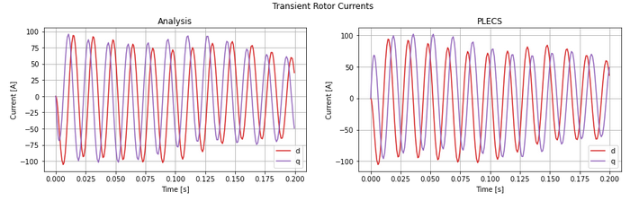
Fig.3 . Transient Rotor Phase Currents (dq)

All abc – dq transformations were calculated using the Clarke transformations.
Appendix

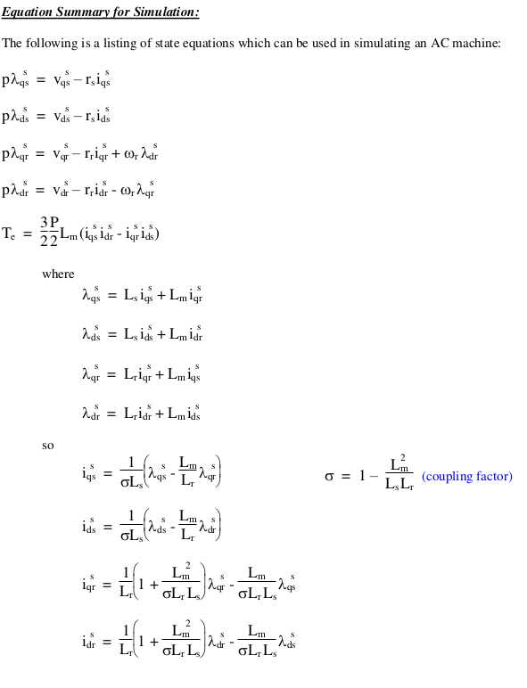
Fig. 4. AC Machine State Equations

