Analysis and Modeling of a Wound Field DC Machine and Drive

The consulting company that you are working for has been hired by an industrial manufacturer which has used DC motors for the past 100 years. This company is not interested in changing their motor technology, and has asked you to analyze/simulate the performance of these machines in new applications. They have selected the two motors from Lenze, one small machine (1 kW) and one large machine (90.8 kW). The data for each motor is given in the appendix.

Selected Motors:
Lenze Motor | MGFQK 063-32 – 1 kW | MGFQK 160-22 – 90.8 Kw

In order to evaluate the performance of the motors, you will look at the following properties:
- Speed vs. Torque Curves (that you generate from the given data)
- Start-up Transient Behavior with Ideal Voltage Source
  - Eigenvalue Analysis
  - Step Response
- Compare the behavior of the DC Motor with a PWM DC Drive to the analysis above.

To do:
  - Develop the analytical speed vs. torque curves for both motors (speed on the y-axis).
  - Assume the field current is initially at its rated value and apply a step (zero to rated voltage) to the armature. Using an ideal voltage source, simulate the following conditions:
Lenze Motor | MGFQK 063-32 – 1 kW | MGFQK 160-22 – 90.8 Kw
Armature Voltage | 170V | 460V
Load Torque – case 1 | 0.1 Nm | 1 Nm
Load Torque – case 2 | 7 Nm | 300 Nm

Simulate:
    - The armature current
    - The speed of the motor
    - The electromagnetic torque
  - Calculate the eigenvalues of each motor. Does the step response yield the expected shape?
  - Using a PWM controlled H-bridge inverter, simulate the motor operation at the conditions of part b and compare.
Simulate:
    - An H-bridge inverter with a bus voltage of 680Vdc.
    - Control the inverter using pulse width modulation to achieve the required armature voltage for each motor.
    - Plot the steady state speed and armature current.
    - Does the speed and current correspond with the analysis above?

Hand in:
- Appropriately detailed discussion of important results and comparative findings not to exceed 4 pages. Use appendices for derivations, these are not counted toward the limit.
- Include plots detailing the analysis and simulation.
- Your PLECS model.

Motor I

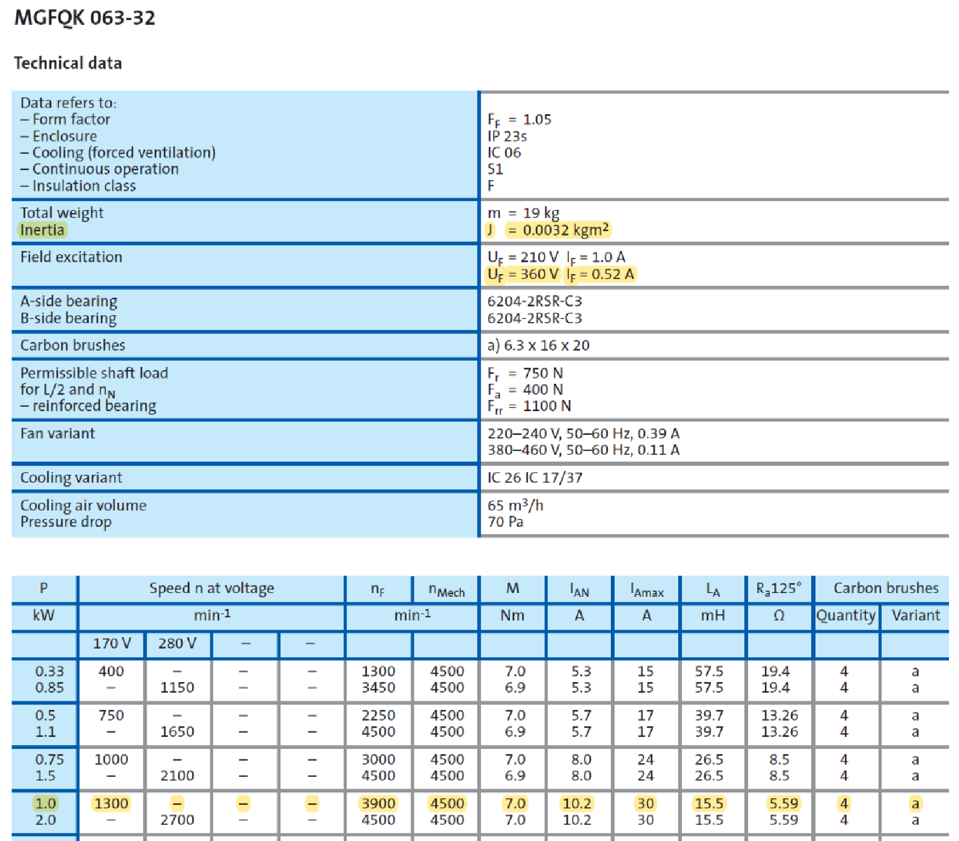

Assume a field inductance of 15 mH and a motor damping 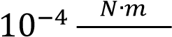 𝑟𝑎𝑑⁄𝑠𝑒𝑐

Motor II

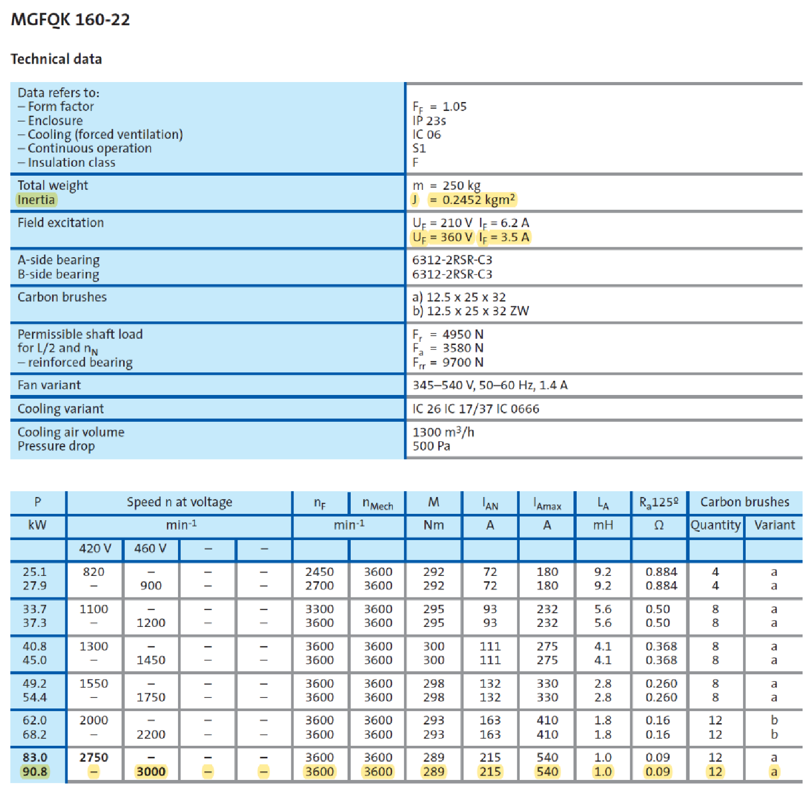

Assume a field inductance of 150 mH and a motor damping 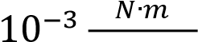 𝑟𝑎𝑑⁄𝑠𝑒𝑐

