Overview
Indirect field oriented control is used to command the Tesla induction motor.
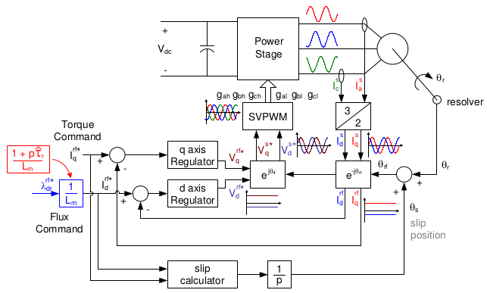
Fig. 1 . IFOC Overview

Synchronous Frame
Control is achieved by converting the stator currents to the synchronous reference frame.
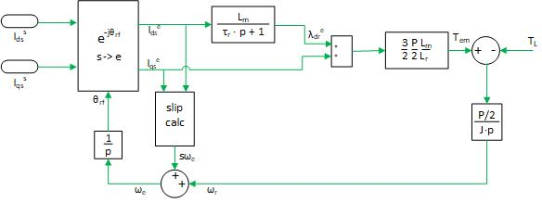
Fig. 2. Rotor Flux
Rotor flux is the integral of the combined slip frequency and rotor electric speed.
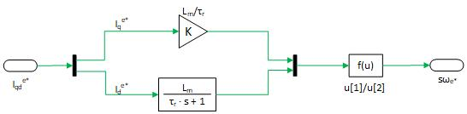
Fig. 3. Slip Calculation
Using rotor flux position, the stator currents are transformed to the synchronous frame such that they changing with the power supply. In this frame, the currents can be regulated to drive the induction motor.
Flux and Torque Commands
The flux command is maintained at a constant rated flux of 0.125 Wb. In the steady state response, the stator d-axis sync current is
.(1)
By keeping the d-axis flux constant, the motor can be driven with any torque command and the associated q-axis stator current. Max-rated toque is provided at 100Nm.
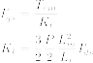 (2)

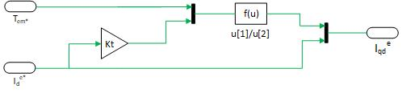
Fig. 4. Commanded Stator Currents
In Figure 4, is rewritten as .
Current Regulator
The induction motor receives space vector PWM voltages that are determined by the IFOC regulator. The sync stator voltages supplied are summarized as
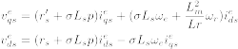
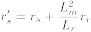 (3)
Similar to current regulator of a DC motor, the gains are solved using zero/pole cancellation at locked rotor conditions. This approach decouples sync frame and back emf effects.
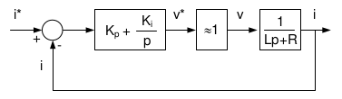
Fig. 5. DC Current Regulator
Then substitute the equivalent induction motor parameters.
 | K_{i} | K_{p}
q-axis
d-axis
Table 1: Tesla Current Regulator Gains
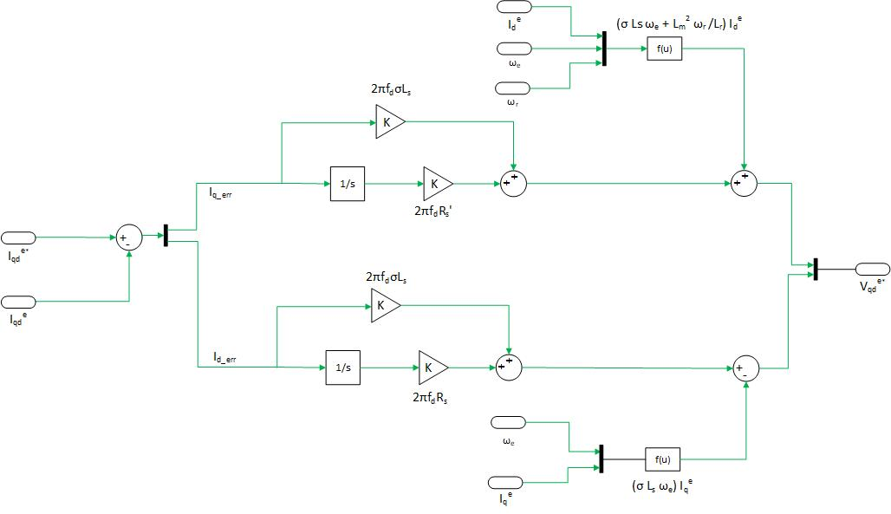
Fig. 6. Q-Axis PI Controller
with Sync Frame Coupling and Back EMF
Fig. 7. D-Axis PI Controller
with Sync Frame Coupling
The q and d axis regulators are tuned to 1kHz bandwidths such that . Note, the back EMF only effects the q-axis current.
Tem Step with Locked Rotor
Step command of a 100Nm is applied at 0.25 seconds. Commands are denoted with *.
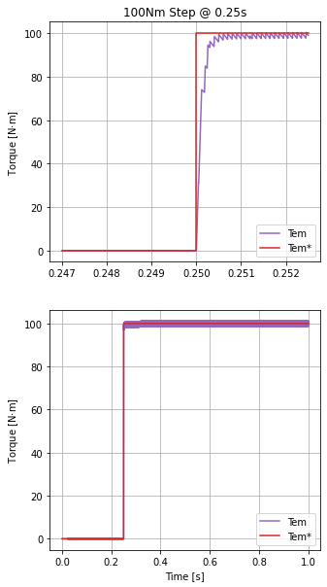
Fig. 8. T_{em} Step Response: Locked
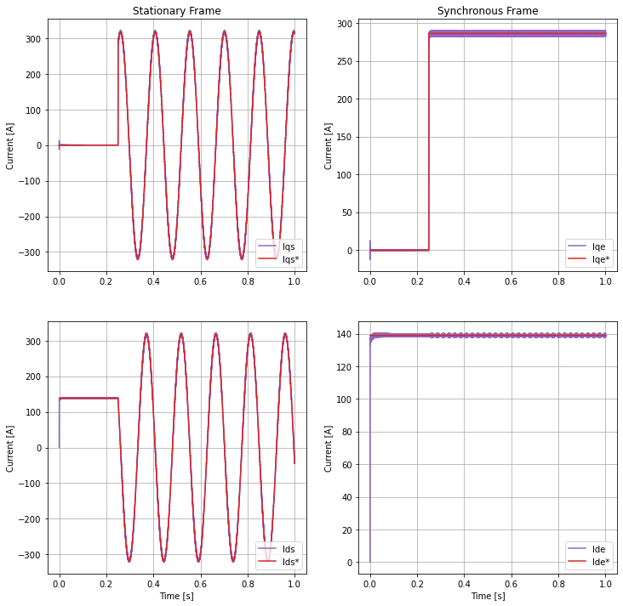
Fig. 9. Current Step Response: Locked
Tem Sine with Locked Rotor
Sine waves at 10Hz, 100Hz, 1000Hz are applied with rated toque and locked rotor.
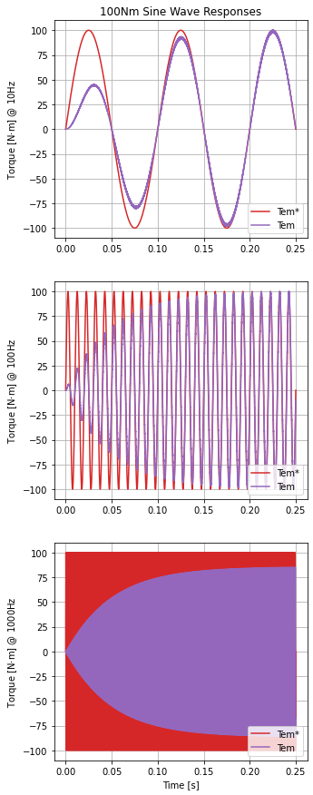
Fig. 10. T_{em} Sine Wave Response: Locked
Measured responses agree at 10Hz and 100Hz. However, at 1000Hz the measured torque envelope ramps to max value of ~85 Nm.
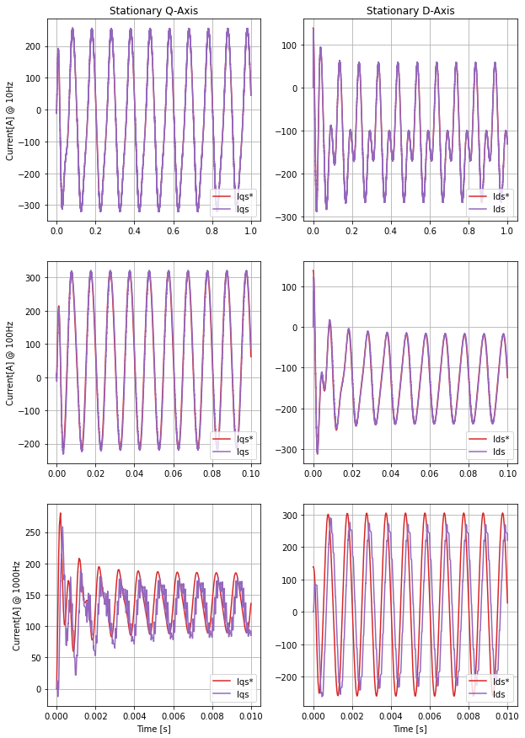
Fig. 11. Stationary Current Response: Locked
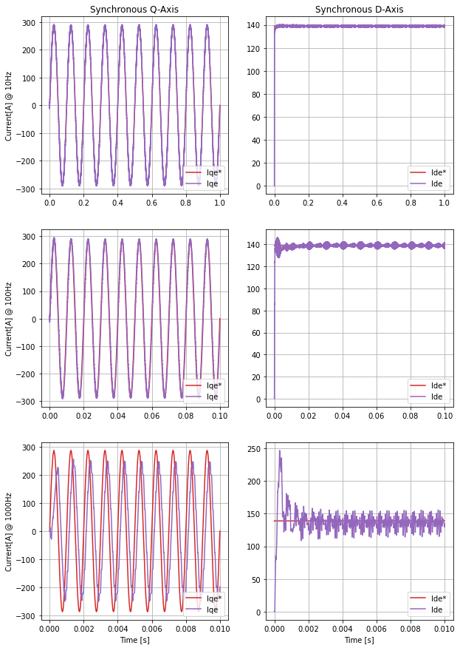
Fig. 12. Sync. Current Response: Locked
Speed Control
Speed control of the Tesla motor is identical to DC machines with ideal torque regulators.
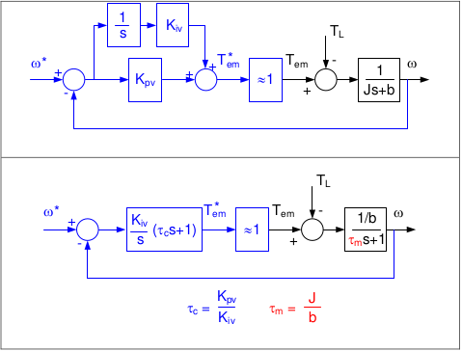
Fig. 13. DC Machine Speed Control
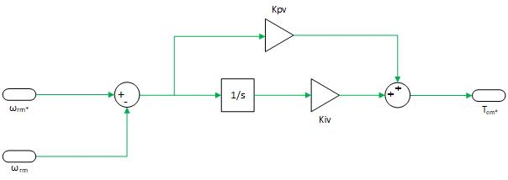
Fig. 14. Tesla Speed PI Controller
The gains are solved and tuned to 50Hz bandwidth.
K_{i} | K_{p}
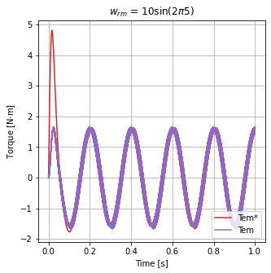
Table 2: Tesla Speed Loop Gains
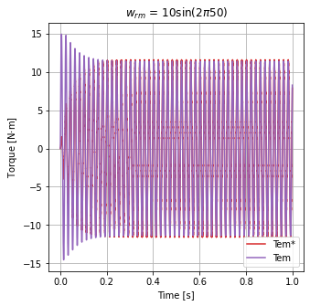
Fig. 14. Torque Response from Speed Cmd: Unlocked Rotor
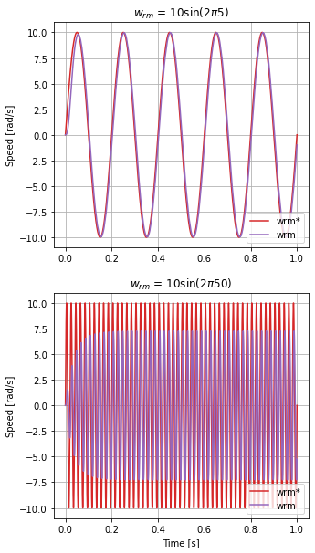
Fig. 15. Speed Response from Speed Cmd:
Unlocked Rotor
As expected, the measured magnitude is -3dB less than the commanded at 50Hz.
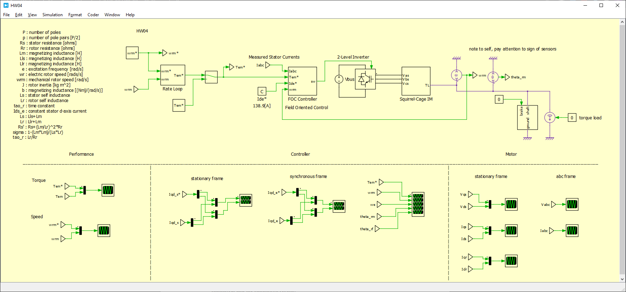
Appendix

