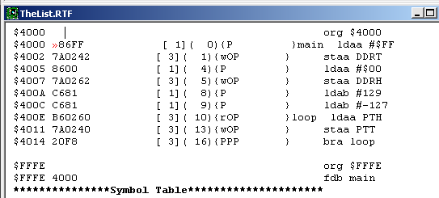Kevin Gilbert

Kog89

30 August 2012

Professor Gerstlauer EE319K