Kevin Gilbert

Professor Gerstlauer EE319K

20 February 2012

Homework 4

Test inputs: 10, 15, 55

Included a newline feed at the end of every subroutine call to differentiate text lines between input values.

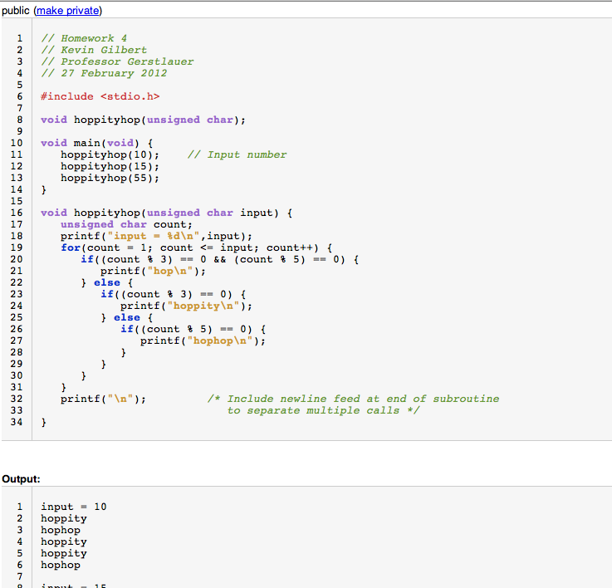

Gilbert 2

