Kevin Gilbert, kog89

9-04-2012

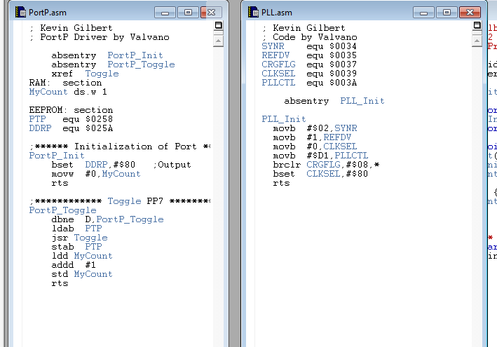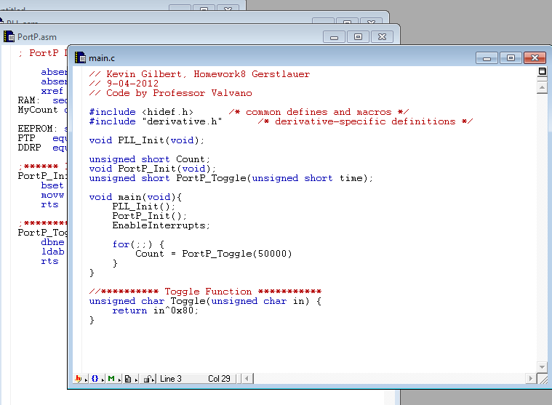

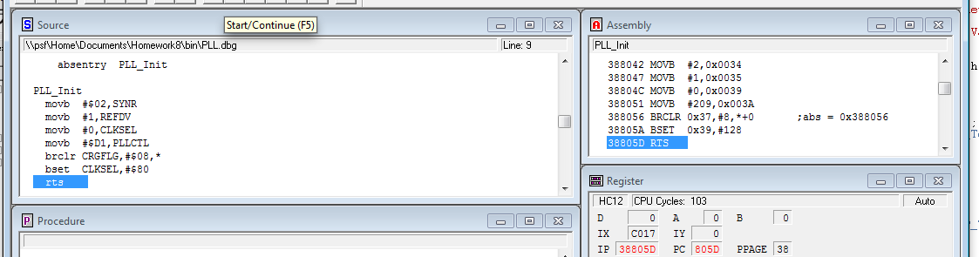

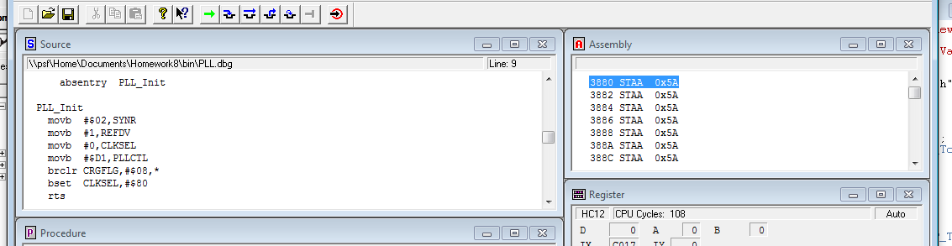

When I ran the code, after the rts from the PLL_Init the code would jump to blank memory. When I transferred by code to a friend’s computer and ran it, it had the same issue. Copying his working code into my projects, the same problem occurred. I could not figure out what had happened with my project, but the code would not return from the sub routine.