Kevin Gilbert and Graham Gilvar

Professor Gerstlauer, 4:30-4:45 Tuesday Lab

EE319K

21 February 2012

Lab 3

1.) Assembly Code:

; \*\*\*\*\*\*\*\*\*\*\*\*\*\*\*\*\*\*\*\*\*\*\*\*\*\*\* Lab 2 \*\*\*\*\*\*\*\*\*\*\*\*\*\*\*\*\*\*\*\*\*\*\*\*\*\*\*

; Grahan Gilvar and Kevin Gilbert

; Date Created 4 February 2012 6:30PM

; Last Modified 6 February 2012 1:00PM

; Lab Time: ACA 4:30-4:45 1.106

; Main program turns on LED if switch is open, toggles on/off

; at rate of 1ms if switch is pressed via a subroutine

; I/O Directories:

PTH equ $0260

DDRH equ $0262

PTP equ $0258

DDRP equ $025A

PTT equ $0240

DDRT equ $0242

; \*\*\*\*\*\*\*\*\*\*\* Main \*\*\*\*\*\*\*\*\*\*

Main org $4000

lds $4000 ; Initialize Stack Point

bset DDRP,#$02

loop ldaa PTP

anda #$01 ; Check switch, if pressed, branch to delay subroutine

bne Delay64ms

ldaa PTP ; Switch was not pressed, turn LED on

oraa #$02

staa PTP

bra loop

anda #$02 ; Test LED if on or off

bne LEDoff ; if on toggle off

bra LEDon ; if a off toggle on

bra loop

LEDoff ldaa PTP

anda #$FD ; set bit 1 to zero (LED off)

staa PTP

bra loop

LEDon ldaa PTP

anda #$FD

oraa #$02

staa PTP

bra loop

Delay64ms ldab #62

Delay1ms ldy #2000

delayloop dey

bne delayloop

decb

bne Delay1ms

ldaa PTP ; Check if LED is on or off

anda #$02

bne LEDoff

bra LEDon

org $FFFE

fdb Main

2.) PCB Diagram

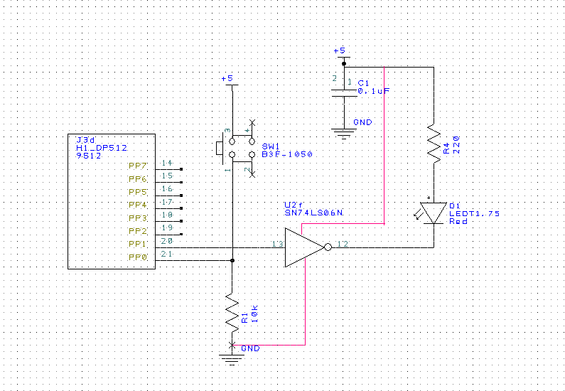

3.) Measurements:

Switch:

Resistance 10k Ohm 9.89k Ohm

V +5 Source 4.9V

V PP0 0V

Current across R 0V/9.89k = 0mA Calculated/0mA Measured

V PP0 (pressed) 5V

Current across R (pressed) 4.9V/9.89k = .495mA Calculated/.49mA Measured

LED:

PP1 = 0 [new program, DDRP = $02, bclr PTP,#$02 ; Make PP1 output, =0]

V PP1 .018V

V k- 3.6V

V a+ 4.96V

V LED 1.3V Calculated/ .26V Measured

I LED (5V-(.018V))/219ohms = 22.7mA Calculated/

\*0mA Measured in series\*

PP1 = 1 [Original program]

Resistance 220 ohm 219 Ohm

V +5 Source 4.9V

V PP1 5V

V k- .13V

V a+ 2V

V LED 2V - .13V = 1.87V Calculated/1.89V Measured

I LED (5V – 1.89V)/219 = 14.2mA Calculated/12.7mA Meas.