Kevin Gilbert, kog89

EE319K Professor Gerstlauer

26 March 2012

Homework 7

<http://codepad.org/n1tq4q83>

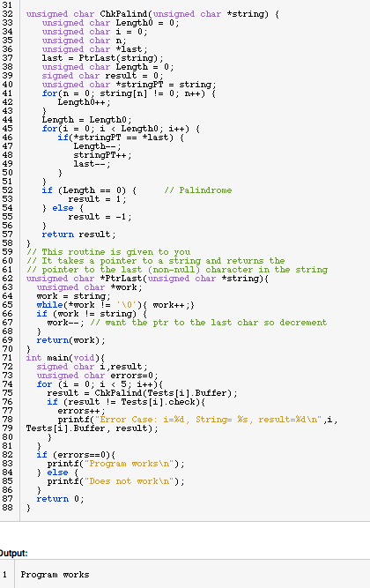

<http://codepad.org/q02UpwFN>

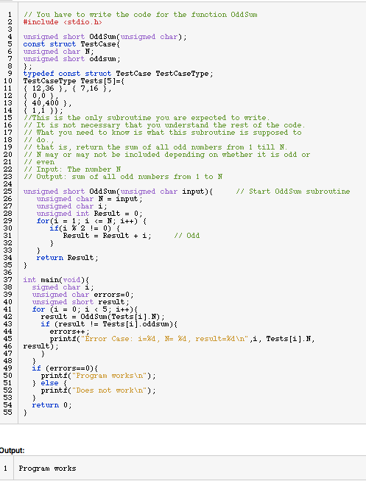

<http://codepad.org/wWUJvf80>

