Kevin Gilbert and Graham Gilvar

11-04-2012 EE319K

Lab 7

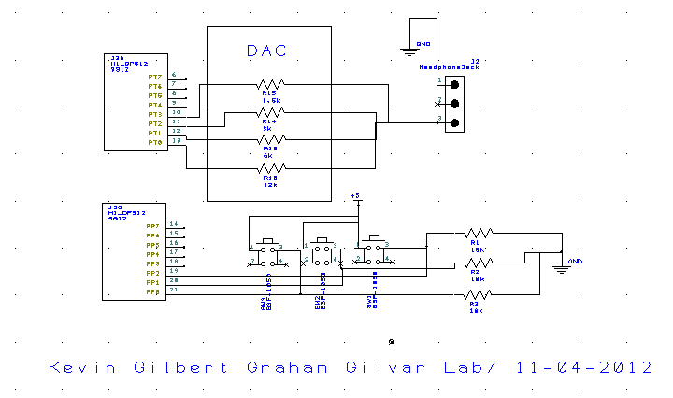

b.) Buttons 🡪 initialization (start interrupts) 🡪 piano interface 🡪 main 🡪 loop back to piano

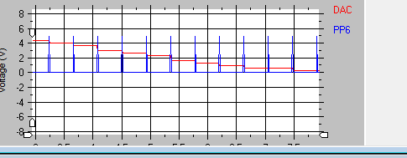

Measurements Data:

.33 .34

.66 .67

1.00 .99

1.33 1.37

1.66 1.65

2.00 2.02

2.33 2.35

2.66 2.68

3.00 3.01

3.33 3.37

3.66 3.66

4.00 3.98

4.33 4.32

4.66 4.64

5.00 4.98

\*software in .zip folder