Kevin Gilbert, Graham Gilvar

28 February 2012

EE319K

Tuesday Lab Section 4:30-4:45

Lab4

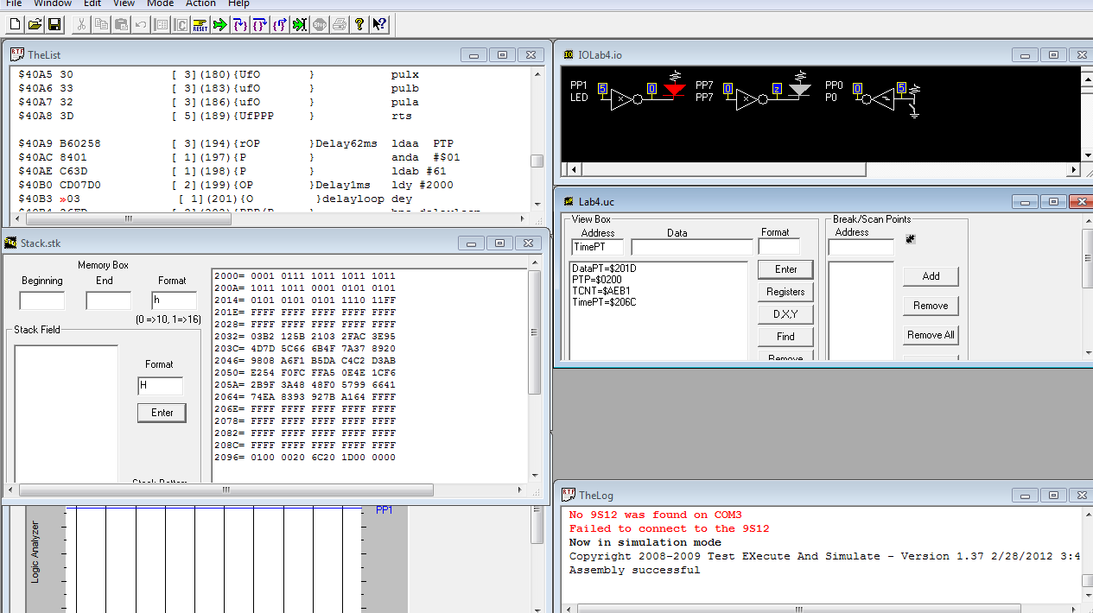

b.) 71 cylces * 125ns = 8.875 microseconds for the debugging sub routine

e.) PTP 🡪 $10 - $11, TCNT = $B5DA, $C4C2

$C4C2 - $B5DA = decimal 3,816 * 16 microseconds = 61.02ms

; *************************** Lab 2 ***************************

; Grahan Gilvar and Kevin Gilbert

; Date Created 4 February 2012 6:30PM

; Last Modified 28 February 2012 3:30PM, dump functions

; Lab Time: ACA 4:30-4:45 1.106

; Main program turns on LED if switch is open, toggles on/off

; at rate of 62ms if switch is pressed via a subroutine, dump included

; I/O Directories:

PTH equ $0260

DDRH equ $0262

PTP equ $0258

DDRP equ $025A

PTT equ $0240

DDRT equ $0242

TSCR1 equ $0046

TSCR2 equ $004D

TCNT equ $0044

; Global Variables

org $2000

Databuffer rmb 50

Timebuffer rmb 100

RegB rmb 1

RegD fdb 1

TimePT rmb 2

DataPT rmb 2

; *********** Main **********

Main org $4000

lds #$4000 ; Initialize Stack Point

bset DDRP,#$82

jsr Debug_init

loop jsr Debug_Capture

ldaa PTP

anda #$01 ; Check switch, if pressed, branch to delay subroutine

bne ShortDelay

Delay62ms2 ldaa PTP

anda #$01

ldab #60

Delay1ms2 ldy #2000

delayloop2 dey

bne delayloop2

decb

bne Delay1ms2

ldaa PTP ; Switch was not pressed, turn LED on

oraa #$02

eora #$80 ; Heartbeat

staa PTP

bra loop

Debug_init psha ; Save Registers

pshb

pshx

pshy

ldx #Databuffer

stx DataPT

ldab #50

ldaa #$FF

ldx DataPT

loop1 staa 0,X

inx

dbne B,loop1

ldx #Timebuffer

stx TimePT

ldab #100

ldaa #$FF

ldx TimePT

loop2 staa 0,X

inx

dbne B,loop2

movb #$80,TSCR1

movb #$07,TSCR2

puly ; Restore Registers

pulx

pulb

pula

rts

Shortloop bra loop ; Extended branches

ShortDelay bra Delay62ms

; Debug_Capture Routine, 71 cycles*125ns = 8.875 microseconds

Debug_Capture psha ; Save Registers

pshb

pshx

pshy

ldx DataPT ; Check to see if array full

ldab 0,X

cmpb #$FF

blo return

ldaa PTP

ldab PTP

anda #$01 ; Switch

andb #$02 ; LED

asla

asla

asla

asla

lsrb

stab RegB

oraa RegB ; %000(Switch)000(LED), $01: SwtOff LEDOn, $11: SwtOn LEDOn, $10: SwtOn LEDOff, $00: SwtOff LEDOff

ldx DataPT ; Store I/O values into Data Array

staa 0,X

inx

stx DataPT ; Save incremented pointer value

ldx TimePT ; Store Counter value into Time Array

ldy TCNT

sty 0,X

inx

inx

stx TimePT ; Save incremented pointer value

return puly ; Restore Registers

pulx

pulb

pula

rts

Delay62ms ldaa PTP

anda #$01

ldab #61

Delay1ms ldy #2000

delayloop dey

bne delayloop

decb

adda #0 ; Set condition codes

beq end

addb #0 ; Set condition codes

bne Delay1ms

ldaa PTP

eora #$82 ; Heartbeat function

staa PTP

end bra Shortloop

org $FFFE

fdb Main