Kevin Gilbert and Graham Gilvar

EE319K Lab 4:30 Tuesday

17-04-2012

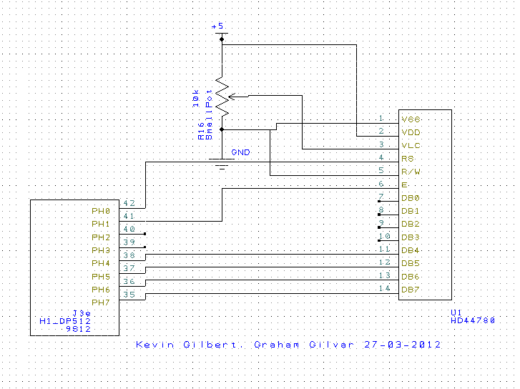

🡪 Into PAD2 is the signal wire from the slide pot., other than that this is the circuit

