Kevin Gilbert and Graham Gilvar

25 April 2012

Professor Gerstlauer EE319K

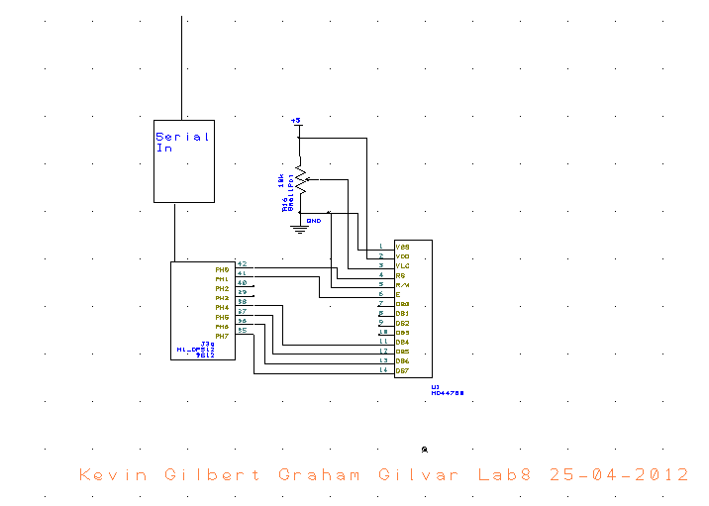Lab 9

Computer 2 (Rec)

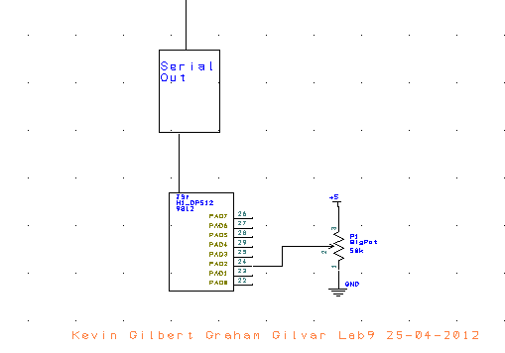

Computer 1 (Transmitter)