First:_______________ Last:_____________________

Procedure
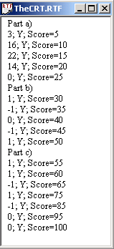
First, you will log onto the computer and download files from the web as instructed by the TAs. Please put the three starter files called Exam2A.rtf Exam2A.uc Exam2A.io into the temp folder on drive D. You are not allowed to archive this exam. Within TExaS open these files, put your name on the first comment line. Before writing any code, please assemble and run the system. You should get output like this figure on the right (but a much lower score). Each time you assemble, TExaS will create a backup version of your program. If you wish to roll back to a previous version, simply open one of the backup versions. If you do roll back, I suggest you perform a SaveAs, so a new sequence of backup files will be started.
My main program will call each of your subroutines five times and will give your solution a performance score of 0 to 100. You should not modify my main program or my example data. When you have written your subroutines, you should run my main program, which will output the results to the TheCRT.rtf window. You are allowed to create additional global variables. After you are finished, raise you hand and wait for a TA. The TA will direct you how and when to print your source code. You will run your program in front of the TA, who will record your performance score on your exam paper. Please sort all materials in this order: 1) this paper, 2) software source code printout, and 3) all scratch work. These papers will be stapled together and turned in. The scoring page is the only work that will be returned to you.
Result codes: Y (correct), N (output wrong).

Part a) The first subroutine, called Size, determines the number of 8-bit ASCII characters in a null-terminated string. The same string format will also be used for the third subroutine. The null character, used to signify the end of the string, is NOT one of the characters. Look at the source code to see all five sets of test data. One data set is the following:
String1 fcb "cat",0 ;size=3
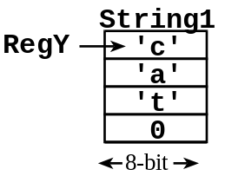
Input parameter: A pointer to the string is passed into your program in RegY.
Output parameter: The number of data characters returned in RegX.
Error conditions: If the string is empty, return RegX=0.
A typical calling sequence is
ldy #String1 ; pointer to the null-terminated string
jsr Size ; should return RegX=3

Part b) Write the second assembly language subroutine, called Compare, which compares two ASCII characters. You do not convert upper case to lower case or convert lower case to upper case. Rather, you simply compare 8-bit unsigned values.
Input parameter: RegA is the first and RegB is the second 8-bit ASCII character.
Output parameter: RegA = -1 if the first is greater than the second, RegA = 0 if the first equals the second, and RegA = +1 if the first is less than the second
Error conditions: none.
A typical calling sequence is
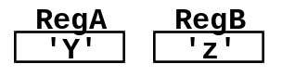
ldaa #$79 ; first is letter ‘y’
ldab #$5A ; second is letter ‘Z’
jsr Compare ; should return RegA=-1, because $79 > $5A

Part c) Write the third assembly language subroutine, called StringCompare, which compares two strings. If the two strings are equal, return 0. To be equal, all letters must match and the strings must be the same length. If the first string is alphabetically before the second string return +1. If the first string is alphabetically after the second string return -1. You do not convert upper case to lower case or convert lower case to upper case. Rather, you simply compare the 8-bit unsigned values in each string from beginning to end, stopping at the end of either string or if a letter is not equal. Empty strings are alphabetically before all strings except another empty string. Consider these test cases
First string | Second string | Result
cat | dog | +1 because first letter ‘c’< ‘d’
cattle | cobra | +1 because second letter ‘a’< ‘o’ (length doesn’t matter)
horse | hose | +1 because third letter ‘r’< ‘s’ (length doesn’t matter)
cat | cattle | +1 because all letters of the first string match, but the first string is shorter (length does matter)
horse | horse | 0 because the strings are equal

Input parameter: A pointer to the first string is passed into your program in RegX.
A pointer to the second string is passed into your program in RegY.
Output parameter: The result is returned in the RegA
Error conditions: none
First2 fcb "cattle",0
Second2 fcb "cobra",0
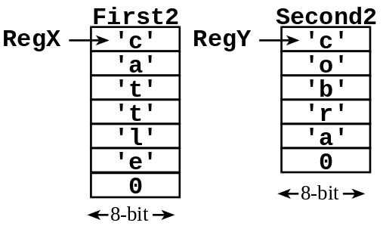
A typical calling sequence is
ldx #First2 ; pointer to the null-terminated string
ldy #Second2 ; pointer to the null-terminated string
jsr StringCompare; should return A = +1

Your subroutines should work for all cases shown in the starter file. The input strings, however, may be empty. Handle the simple cases first and the special cases last.

First:_______________ Last:_____________________

Scoring
Your grade will be based both on the numerical results returned by your program and on your programming style. In particular, write code that is easy to understand, easy to debug, easy to change. Please employ good labels, pretty structure, and good comments.

Program style,
rtf file printed by TA
labels
pretty structure
comments,
name on RTF
Performance score, S=
Run by TA at the checkout
total

I promise to follow these rules
This is a closed book exam. You must develop the software solution using the TExaS simulator. You have 55 minutes, so allocate your time accordingly. You are allowed to bring only some pencils (no books, laptops, cell phones, hats, disks, CDs, or notes). You will have to leave other materials up front. Each person works alone (no groups). You have full access to TExaS, with all the TExaS examples and the TExaS help. You may use the Window’s calculator. You sit in front of a computer and edit/assemble/run/debug the programming assignment. You do not have access the Freescale manuals, just the help system in TExaS. You may not take this paper, scratch paper, or rough drafts out of the room. You may not access your network drive or the Internet. You are not allowed to discuss this exam with other EE319K students until Thursday.

The following activities occurring during the exam will be considered scholastic dishonesty:
0) reading, writing or viewing any file outside of test files on the desktop
1) running any program from the PC other than TExaS or the Windows calculator,
2) communicating to other students by any means about this exam until Friday,
3) using material/equipment other than a pen/pencil.
Students caught cheating will be turned to the Dean of Students.

Signed: ____________________ October 2009

http://users.ece.utexas.edu/~valvano/Exam2A
user LED password red

