First:_______________ Last:_____________________ TA: _______________

Scoring The correct output values are shown in the figure on the right.
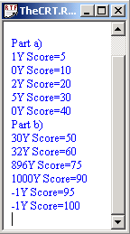
Your grade will be based both on the numerical results returned by your program and on your programming style. In particular, write code that is easy to understand, easy to debug, easy to change. Please employ good labels, pretty structure, and good comments.

Program style
labels
pretty structure
comments
Performance score, S=
total
Result codes: Y (correct), N (output wrong).
I promise to follow these rules
This is a closed book exam. You must develop the software solution using the TExaS simulator. You have 30 minutes, so allocate your time accordingly. You are allowed to bring only some pencils (no books, laptops, cell phones, hats, disks, CDs, or notes). You will have to leave other materials up front. Each person works alone (no groups). You have full access to TExaS, with all the TExaS examples and the TExaS help. You may use the Window’s calculator. You sit in front of a computer and edit/assemble/run/debug the programming assignment. You may access the Freescale manuals. You may use code from any of the TExaS example files. You may not take this paper, scratch paper, or rough drafts out of the room. You may not access your network drive or the internet. You are not allowed to discuss this exam with other EE319K students until Friday after 1pm.

The following activities occurring during the exam will be considered scholastic dishonesty:
1) running any program from the PC other than TExaS, a calculator, or the PDF viewer,
2) communicating to other students by any means about this exam until Friday after 1pm,
3) using material/equipment other than a pen/pencil.
Students caught cheating will be turned to the Dean of Students.

Signed: ____________________ March 2008
Procedure
First, you will log onto the computer and download files from the web as instructed by the TAs. Please put the three starter files called Exam2E.rtf Exam2E.uc Exam2E.io into a temporary folder. Within TExaS open these files, put your name, and your TA on the first comment line and do a SaveAs name1.rtf, creating a second copy of the starter file. Before writing any code, please assemble and run the system. You should get output like the figure on page 1 (but a much lower score). Each time you edit, assemble, and run your program that gets any score at all, do a Save then a SaveAs name2.rtf, name3.rtf…to create multiple versions of your program as you develop code.
My main program will call your subroutines multiple times, and will give your solution a performance score of 0 to 100. You should not modify my main program or my example data. When you have written your subroutines, you should run my main program, which will output the results to the TheCRT.rtf window. After you are finished, raise your hand and wait for a TA. The TA will direct you how and when to print your source code. You will run your program in front of the TA, who will record your performance score on your exam paper. Please sort all materials in this order: 1) this paper, 2) software source code printout, and 3) all scratch work. These papers will be stapled together and turned in. The scoring page is the only work that will be returned to you.

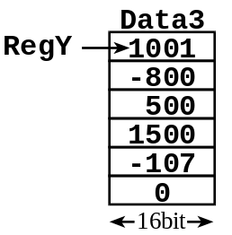
Part a) The first subroutine, called CountOdd, that counts the number of odd numbers in a 16-bit array. The array terminates with a zero. The zero itself is NOT one of the data points. Your subroutines should work for all cases shown in the starter file.
Input parameter: Reg Y points to the null-terminated array of 16-bit numbers.
Output parameter: The number of odd numbers is returned in RegX.
Error conditions: none.
A typical calling sequence is
ldy #Data3 ; pointer to an array
jsr CountOdd ; should return RegX = 2 (1001, -107 are odd)

Part b) There are two arrays of 8-bit unsigned integers, called Buf1 and Buf2. Both arrays terminate with a 0. The zero itself is NOT one of the data points. Look at the source code to see all sets of test data. Write a subroutine, called DotProduct, which calculates (Buf1[0]*Buf1[0])+ (Buf1[1]*Buf1[1])+… The dot product is returned in Reg D. The multiply can be 8 by 8 into 16 bits, but the addition needs to be 16-bit. You may assume the data values are small enough that 16-bit overflow will not occur on the additions. Return an error (RegD = -1 or 65535), if the arrays are different sizes. It is OK to add global variables. The following is an example with equal-length arrays.
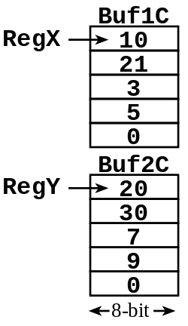
Buf1C fcb 10,21,3,5,0
Buf2C fcb 20,30,7,9,0 ;10*20+21*30+3*7+5*9=896
Input parameter: RegX points to one array, RegY points to the other.
Output parameter: RegD is the dot product = sum(Buf1[i]*Buf2[i]).
Error conditions: Return RegD = -1 if the arrays are different sizes
A typical calling sequence is
ldx #Buf1C ; pointer to one array
ldy #Buf2C ; pointer to other array
jsr DotProduct ; should return RegD = 896
Handle the general cases first and the special cases last.

