1. Grading students

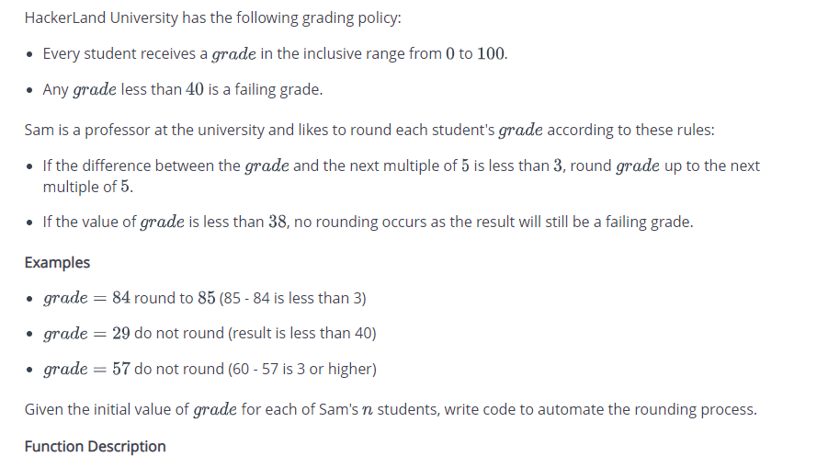

function gradingStudents(grades) {

// Write your code here

let multiofFive = [40, 45, 50, 55, 60, 65, 70, 75, 80, 85, 90, 95, 100];

if (grades < 38){

return grades;

}

let mark = 0;

for (let i = 0; i < multiofFive.length; i++){

if(multiofFive[i] < grades){

mark++;

}

}

if ((multiofFive[mark] - grades) < 3) {

grades = multiofFive[mark];

return grades;

}

return grades;

}

console.log(gradingStudents(68));

1. Sales by Match

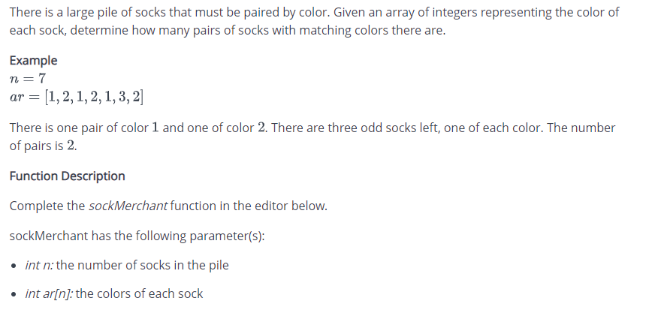

1. Counting Valleys

