Mark Davis, Justin Shiflett, Kelsey Hecker, Wyatt Campbell

2/7/17

Requirement Analysis Document

Pick-up Sports

1. Introduction
   1. Purpose of the system: to create an android application that will allow many different people to play pick-up sports in a location of their choosing.
   2. Scope of the System: We will create an android app that will have a login screen that will store username and login information in a SQL database. After logging in, google maps will be loaded up. There will be a couple of options. There will be a pin (marker) on google maps that you can click on and a list will show up of what sports are being played at that location. There will also be an option to add a new pin on the map. If they choose to add a new pin, then they will be able to add a sport a date and a time to that specified location.
   3. Objectives and Success Criteria of the project: The objectives of this project are to create a usable android application for the common android owner, and will allow the owner to either create or participate in a pick-up sporting event.This project will be a success if the pins are able to stay in google maps for other users to find, if people are able to edit their events, and if people are able to see which events they have joined.Proposed System
   4. Overview: Our app will allow users to login and go to a map to search for pickup games in their area, or create one by pinning a location and adding what type of game it will be.  We will store usernames and passwords in a SQL database, and the games will also be in the database. When users go to the map, which we will integrate Google Maps into the app to use, the users will be able to look around their current location to find preplaced markers for pickup games or create a pin in a location to create a game for others to see.
   5. Functional Requirements:
      1. Enter their username and password into the app
      2. Verify username and password with SQL database.
      3. Open the map and use their current location to find the pickup games near their location by tapping the pins on the map.
      4. Allow users to pick a location and create a game at that location for other users to see.
      5. The pickup games should automatically delete themselves after the event is over.
   6. Nonfunctional requirements:

* **Usability** - The app will be easy to use and operate for users over the age of 8. Users will be able to easily learn how to use and navigate the interface.
* **Interface** - The interface itself will be user friendly, visually appealing, simple, and not over complex.
* **Performance** - The performance of the app is quick; users will be able to find and or host an activity in under one minute using the app.
* **Reliability** - The app will be reliable and we will aim for a 99% reliability rate by predicting network and server issues.
* **Compatibility** - This app will be compatible with android phones only, there is no current plan to integrate with apple products.
* **Introduction** - This app will be available to download for free at the end of the semester on the Android Marketplace.

User case stories

USER CASE 1: Login/Create account

**User:** Event Planner/Participant

**Case:**  A person wishes to use the sports app to create and join sports games for his/her friends, but needs to be able to be identified by those friends in the app.

**Solution:** Allow new users to create a username for others to identify by and a password to protect account activity and settings.

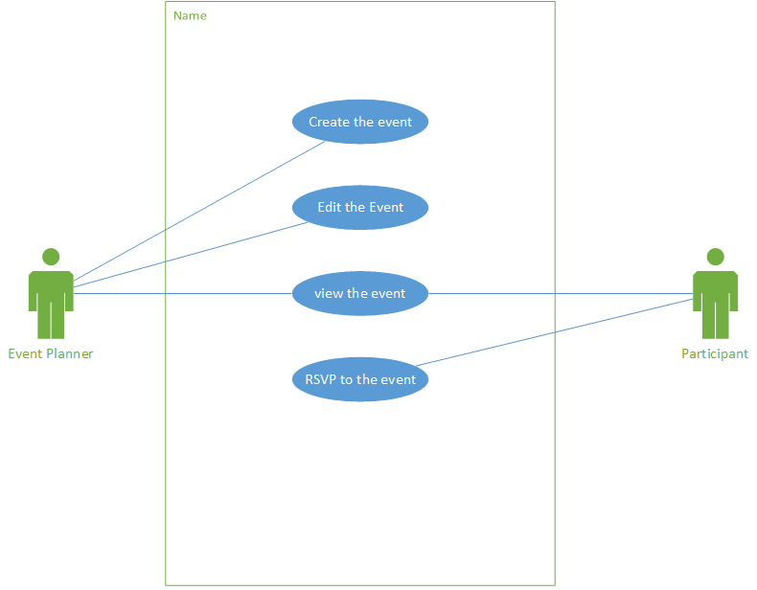

USER CASE 2: Create and host games

**User:** Event Planner

**Case:**  A local man wishes to get him and his friends together near a local park to play a game of football, but he doesn’t wish to contact everyone one at a time. This man needs a faster, simpler way to let all of his friends know that he is hosting a game for others to join.

**Solution:** Create an app that allows an individual to pin a location on a GPS map that displays a sport/activity and a time to meet for others to view and potentially join.

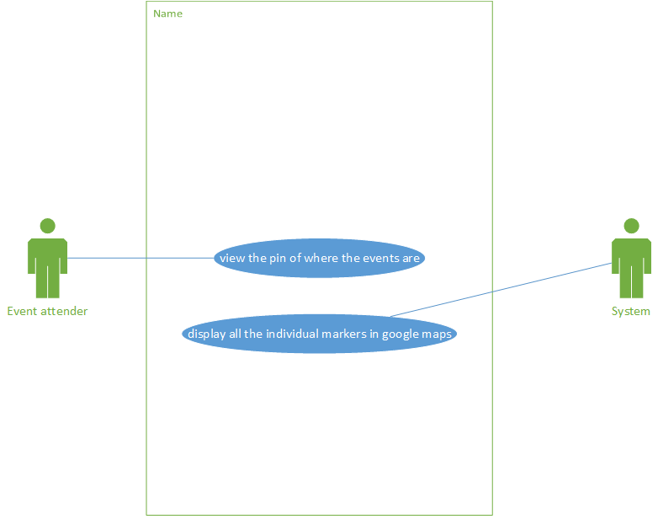

USER CASE 3: View map and search games

**User:** Event Planner/Participant

**Case:** A sports enthusiast wants to know if any of his friends in the local area wish to play a sport, but he has multiple friends who hold different games at different times. He needs a way to know when and where games are being held at any given time without the need to contact each individual for information.

**Solution:** In the same app, allow users to view a GPS map of all local games with their time and location. Allow the user to put their name in the game to let others know they will join that game.

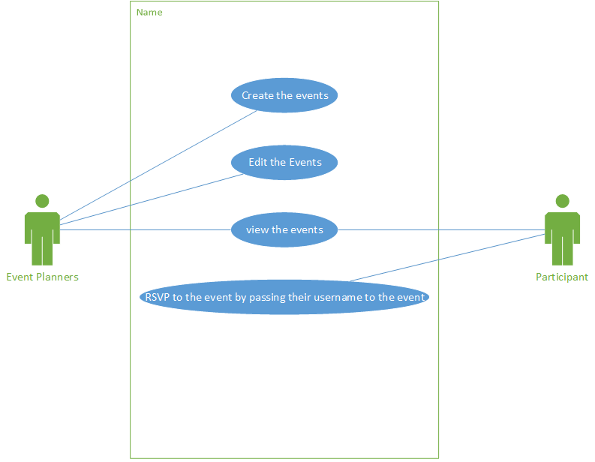

USER CASE 4: Join game

**User:** Participant

**Case:**  A sports enthusiast was invited to a soccer game in a local area, but the host has many people joining and can’t remember who is dedicated to go. There needs to be a way for the host to know/remember that the enthusiast is a dedicated participant.

**Solution:** In the app that allows individuals to find a particular game on a GPS map and join a queue to indicate that they are dedicated to participate in the game.

