Software installation
Installed: Flutter, Android Studio, Git, Java, Python, VScode, and Node.js
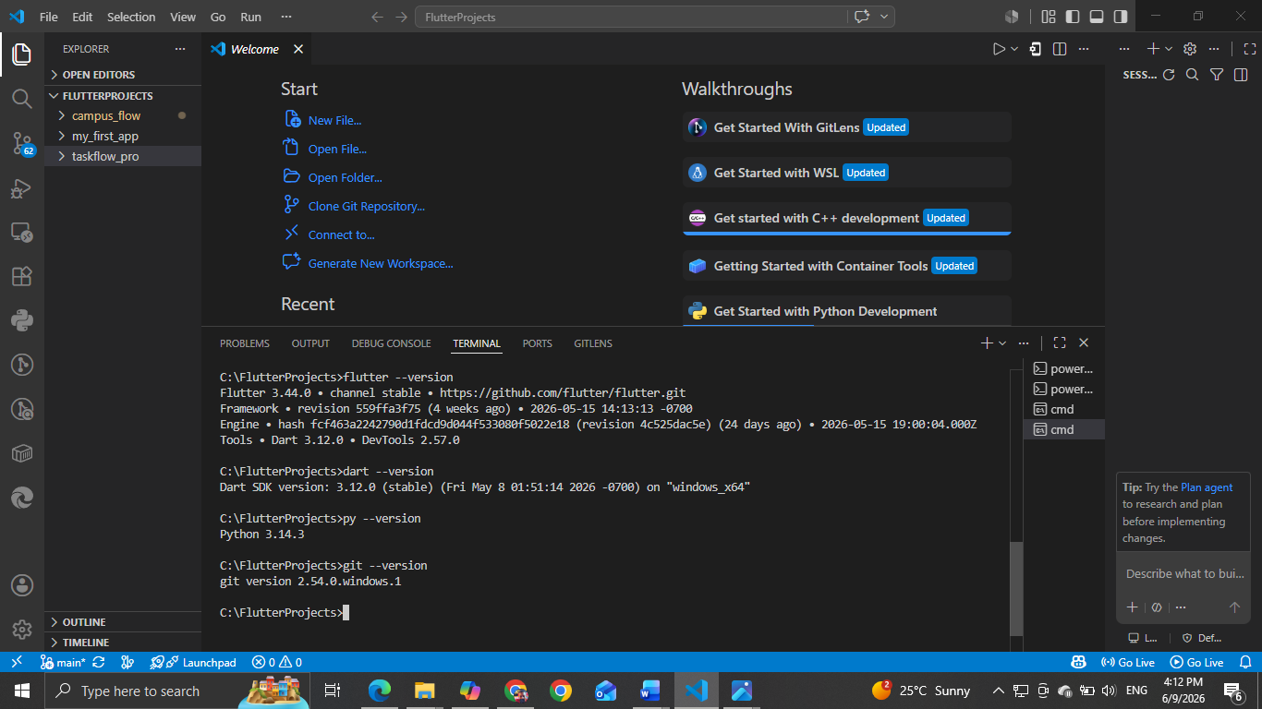
Source Code for flutter app: changes (app title, background color-amber and fontsize -28)
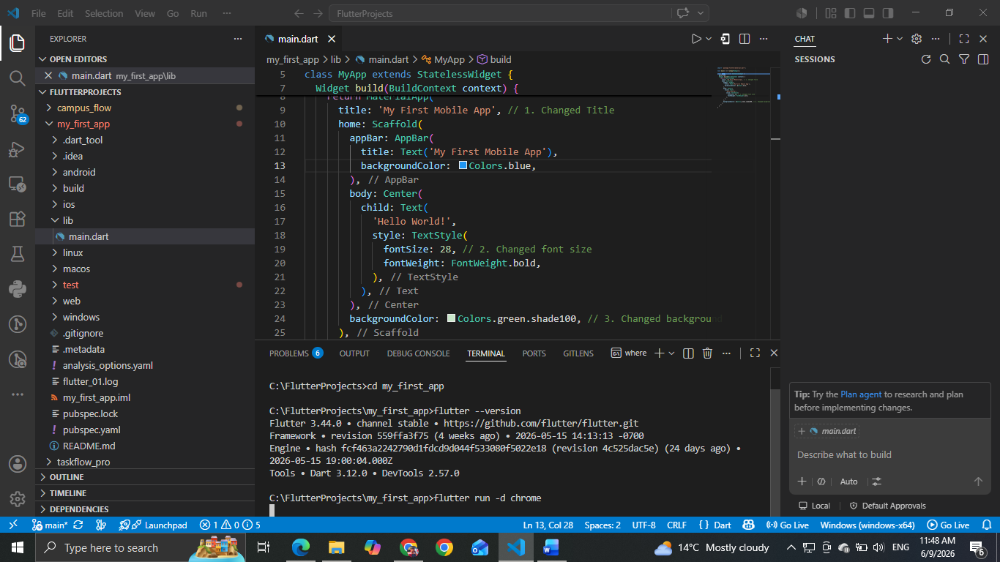
Final outcome for my_first_app project
