Software installation
Installed: Flutter, Android Studio, Git, Java, Python, VScode, and Node.js
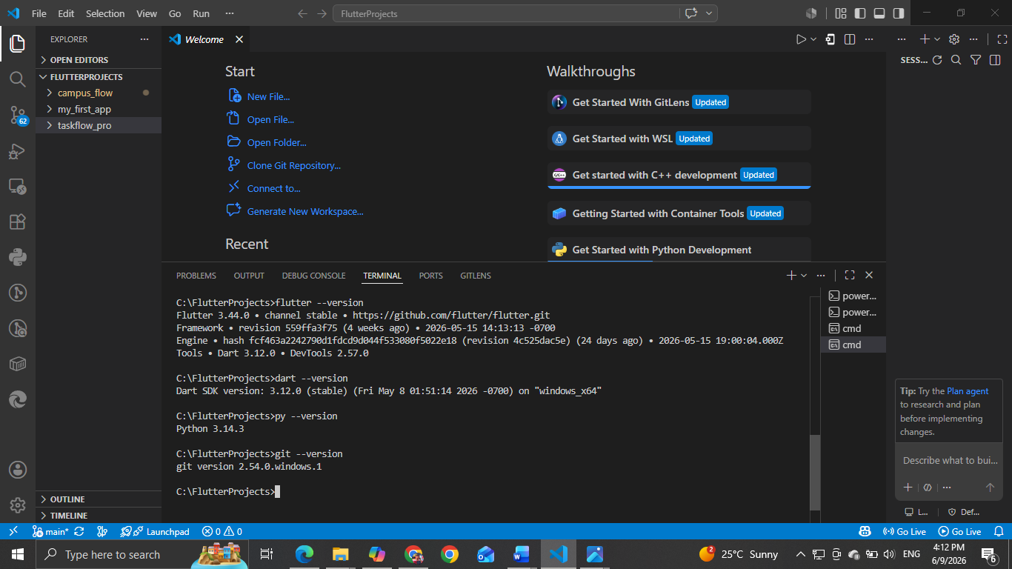
flutter app: changes (app title, background color-amber and fontsize -28)
