MUSIC RECOMMENDATION SYSTEM
Mareedu Satya Vara Prasad
CSE-Big Data Analytics
Parul University
Vadodara, Gujarat, India
satyavaraprasadmareedu@gmail.com

Garima Sharma
Parul Institute of Engineering and Technology
Parul University
Vadodara, Gujarat, India
Garima.sharma35514@paruluniversity.ac.in

Abstract — The AI-powered music recommendation system is a smart tool designed to enhance your music streaming experience. By using machine learning, artificial intelligence (AI), and natural language processing (NLP), it delivers personalized music suggestions that truly reflect your tastes. The system works by analyzing your listening history and song preferences through collaborative and content-based filtering, helping it understand the kind of music you enjoy. To make recommendations even more accurate, deep learning algorithms are used to examine the audio features of songs, picking up on intricate musical patterns. The system also uses NLP to dive into song lyrics and metadata, allowing it to suggest tracks based on themes, moods, and genres you like. What’s more, the system learns from your interactions, constantly adjusting its suggestions to keep up with your evolving musical preferences. One of the standout features of this system is its ability to understand the emotions behind songs. Through sentiment analysis, it can recommend music that aligns with your current feelings, making the listening experience even more immersive. The integration of Elasticsearch further optimizes search and recommendations, ensuring quick and efficient data retrieval. As music streaming services continue to rely on AI-driven solutions, this recommendation system is setting the bar for future developments. It provides a flexible, scalable, and efficient way to offer tailored music recommendations, enhancing user satisfaction and helping you discover new tracks you'll love.
Keywords: Deep learning, sentiment analysis, collaborative filtering, content-based filtering, machine learning, artificial intelligence, natural language processing, music recommendation, and Elasticsearch.

Introduction

Context— Personalized music recommendations are key to enhancing user experience on streaming platforms and ensuring that users stay engaged and satisfied in today’s digital world. Traditional methods, like rule-based algorithms and metadata filtering, simply can't keep up with the ever-changing music tastes and the complexities of individual preferences. With so much user-generated data and massive music libraries available, it's now essential to have recommendation systems that are smart, scalable, and automatic. AI, machine learning (ML), and natural language processing (NLP) have come together to transform recommendation engines. These technologies allow the system to analyze user behavior, listening history, and song attributes to provide more accurate, tailored suggestions. Deep learning helps extract intricate audio features to fine-tune recommendations, while collaborative filtering and content-based filtering learn from past data to make more relevant suggestions. NLP also plays a key role by analyzing song lyrics and metadata, improving recommendations based on themes, genres, and moods. With AI-driven models, music suggestions are more dynamic and adaptable, changing in real-time as users’ preferences shift. As digital music consumption continues to rise, this real-time adaptability boosts user engagement and retention. By leveraging deep learning, advanced analytics, and NLP, modern music recommendation systems offer a highly personalized, data-driven approach to music discovery, making it easier for users to explore large music libraries. Ultimately, AI is revolutionizing the music streaming experience, creating an environment that enhances music accessibility, enjoyment, and user satisfaction.

Problem Statement— The challenge with traditional music recommendation methods lies in providing accurate, scalable, and effective suggestions. One of the biggest hurdles is the sheer size and diversity of the music library, which makes it difficult to recommend songs that truly match a user's tastes. Many older recommendation models rely solely on popularity or simple rules, which fail to keep up with users' changing musical preferences and behaviors. Additionally, the static approach of matching metadata overlooks the deeper, emotional, and contextual factors that influence music choices. Personalizing recommendations is especially tricky, as generic suggestions often lead to user frustration and disengagement. Even though popular methods like collaborative filtering and content-based filtering are widely used, they have their limitations, especially when it comes to new users or newly released songs, a problem known as the "cold-start" issue. On top of that, biases in recommendation algorithms can prevent users from discovering fresh and diverse music. Another key issue is that these traditional systems don’t adapt in real-time, which means they can’t adjust quickly enough to evolving user preferences. To address these problems, this project focuses on using AI-driven recommendation algorithms. By analyzing user behavior, song attributes, and listening history, these algorithms can offer highly personalized music suggestions, improving the overall experience and helping users discover new and relevant music more effectively.

The following are the main goals of the AI-Powered Music Recommendation System:
1. Personalized Music Recommendations: Using machine learning algorithms, develop an advanced recommendation system that can analyze user tastes, listening patterns, and song attributes to provide accurate and highly relevant music choices.
2. Predictive Music Preferences: By examining past interactions, employ predictive analytics to anticipate changing user preferences. This will enable the system to gradually improve and change recommendations.
3. Automated Genre and Mood Categorization: This feature classifies music based on genre, tempo, lyrics, and mood using Deep Learning and Natural Language Processing (NLP). This enables consumers to select music that suits their emotional and environmental preferences.
4. Detailed Visualization & Insights: Provide consumers with visual data and interactive dashboards so they can explore patterns in their listening habits, discover new genres, and gain a deeper understanding of their musical preferences.
These objectives are to create a more engaging listening experience, enhance user satisfaction, and enhance music discovery. The AI-Powered Music Recommendation System is designed for use in digital media services, music streaming platforms, and personalized playlist applications. It offers a more clever and efficient way to connect customers with their preferred music. By automating music analysis, leveraging machine learning and deep learning, and incorporating real-time adaptive recommendations, this project significantly enhances how customers listen to and locate music in the digital age.

Literature Survey
2.1 Conventional Music Recommendation Systems—
Traditional music recommendations, which have long been a mainstay of digital music platforms, sift metadata and utilize preset algorithms to help consumers discover new songs. However, these systems' capacity to handle the volume and dynamic nature of modern music archives is severely limited. The majority of conventional recommendation engines rely on popularity-based filtering, rule-based algorithms, and static metadata matching, all of which are inflexible in the face of shifting user preferences and contextual listening patterns. Despite being widely used, content-based and collaborative filtering have cold-start problems, when new users or songs lack sufficient information to make trustworthy selections. Moreover, real-time flexibility is sometimes lacking in conventional systems, meaning that ideas are not constantly modified to adapt to changing user activities. Without deep learning-driven personalization, they are much less successful, producing generic and repetitive recommendations instead of personalized ones. Traditional models' inability to assess song lyrics, emotional tone, and situational importance makes it impossible to propose music based on situations or moods. This is another major barrier. Furthermore, because human interaction is often required to improve recommendations, these systems are time-consuming and ineffective. Traditional music recommendation techniques are no longer sufficient due to the increasing complexity of music streaming services and the demand for highly personalized user experiences. AI-driven music recommendation systems that leverage machine learning (ML), deep learning, and natural language processing (NLP) offer a clever, automated, and adaptable answer to these issues.

2.2 AI and Machine Learning in Music Recommendation Systems—
Artificial intelligence (AI) and machine learning (ML) have revolutionized music recommendation systems by enabling more accurate, dynamic, and personalized recommendations for users. Unlike traditional rule-based techniques, AI-driven recommendation engines analyze vast amounts of user data and learn from listening habits to provide remarkably flexible and relevant musicrecommendations. Machine learning models are crucial for identifying trends, patterns, and user preferences based on historical data. Supervised learning techniques classify music using labeled datasets, helping the system associate individual tunes with certain user activities. Using unsupervised learning techniques like clustering, the system can group related songs and recommend hidden gems to users even if there are no prior user interactions.
Deep learning methods look at complex audio features, lyrics, and mood indicators to generate recommendations that fit emotional and environmental preferences. By continuously adjusting to user input and interactions, reinforcement learning techniques progressively increase the accuracy of suggestions. AI-powered systems can anticipate shifts in user preferences and suggest songs before the user does thanks to predictive analytics. Reactive playlist creation is replaced by reactive audio discovery, which improves user satisfaction and engagement. Furthermore, by automating playlist curation, enhancing music discovery, and ensuring real-time customisation, artificial intelligence reduces the need for human monitoring. The increasing demand for seamless, intelligent, and immersive music streaming experiences is making AI and ML-driven recommendation systems crucial to improving customer loyalty, excitement, and overall satisfaction in the digital music industry.

2.3 Advances in Natural Language Processing for Music Recommendation—
Natural Language Processing (NLP) has revolutionized music recommendation systems by enhancing contextual purpose, user preferences, and lyrics comprehension. Unlike traditional recommendation algorithms, which typically rely on structured metadata like genre, artist, and user history, natural language processing (NLP) may analyze unstructured material, such as song lyrics, reviews, and social media interactions, to provide deeper insights. Thanks to methods like Named Entity Recognition (NER), tokenization, and sentiment analysis, AI-driven recommendation engines are able to recognize emotions, categorize songs based on tone and context, and comprehend lyrical topics. For example, NLP can identify significant lyrics using phrases like "heartbreak," "celebration," or "motivation," and suggest music that is appropriate for the listener's task or emotional state.
Another way that NLP-powered chatbots and voice assistants improve user interactions is through conversational music look, which allows users to request songs using natural language (e.g., "Play a relaxing jazz playlist" or "Find songs similar to Coldplay"). By transforming unstructured textual input into useful patterns, natural language processing (NLP) enhances song recommendations, personalization, and the listening experience. As AI-driven music platforms advance, NLP-powered innovations are making music discovery more flexible, engaging, and user-friendly than ever.

Table 1. Literature survey table
Author(s) | Year | Title | Summary | Relevance
G. Adomavicius & A. Tuzhilin. | 2005 | "Toward the Next Generation of Recommender Systems" | Discusses collaborative filtering and content-based recommendation techniques. | Provides foundational concepts for modern music recommender systems.
X. Su & T. M. Khoshgoftaar. | 2009 | "A Survey of Collaborative Filtering Techniques" | Reviews collaborative filtering methods used in music recommendation. | Helps in selecting appropriate filtering techniques for recommendation models.
B. McFee et al. | 2012 | "The Million Song Dataset" | Introduces a dataset for music recommendation research. | Provides a benchmark dataset for training and evaluating music recommendation models.
J. Schedl et al. | 2018 | "Current Challenges and Visions in Music Recommender Systems" | Discusses personalization, contextual recommendations, and user modeling. | Helps in improving personalization strategies in music recommender systems.
Y. Oh et al. | 2023 | "MUSE: Music Recommender System with Shuffle Play Recommendation Enhancement" | Introduces MUSE, a system addressing challenges in shuffle play sessions using self-supervised learning and novel session augmentation methods. | Enhances user experience by improving recommendation accuracy during shuffle play.

Methodology

3.1 Architecture of the System—
Conversational music look, which enables users to request songs using natural language (e.g., "Play a relaxing jazz playlist" or "Find songs similar to Coldplay"), is another way that NLP-powered chatbots and voice assistants enhance user interactions. Natural language processing (NLP) improves song suggestions, personalization, and the listening experience by turning unstructured textual input into meaningful patterns. NLP-powered advancements are making music discovery more adaptable, interesting, and user-friendly than ever before as AI-driven music platforms develop.

● Music Information Gathering Module: Information on music, social media trends, streaming services, and user listening histories are just a few of the sources that this module gathers data from. Its support for several data formats guarantees seamless data intake. The Data Collector looks at raw data, while the Music Aggregator collects user interactions and preferences in real-time.
● Music Analysis Engine: This core analytical unit uses machine learning (ML) models to examine contextual preferences, user behavior, and music properties. The Preprocessing Unit cleans and normalizes the data to ensure consistency. Feature extraction identifies crucial elements such as genre, tempo, mood, lyrics, and user listening behaviors to assist ML models in producing accurate predictions. The system uses classification models to categorize songs and clustering approaches to reveal latent musical preferences.
● Personalized Recommendation Unit: This part generates adaptive suggestions using a User Preference Model that is updated based on historical data. The Recommendation Engine employs content-based filtering, collective filtering, and deep learning models to suggest music that aligns with user preferences, moods, and situational behaviors (such exercising or unwinding). Recommendations based on user input are continually improved through the application of reinforcement learning.
● Module for User Interface and Visualization: Customers can use an interactive interface in the last section. The Visualization Engine displays personalized playlists, trending music metrics, and real-time recommendations. On the Dynamic Dashboard, users can discover new music using dynamic song discovery tools, charts, and graphical representations. Users have access to real-time music release notifications, playlist customisation, and like/dislike suggestions.

3.2 Data Gathering and Preparation—
AI-Powered Music Suggestion System The system's operation depends on efficient preprocessing and data collection. Music data is collected from a variety of sources, including social media, streaming logs, user interactions, and music metadata. Since this data is often unstructured, data cleaning is done to remove irrelevant information and inconsistencies. Standardization ensures format homogeneity prior to analysis. Machine learning algorithms use feature extraction to identify key musical characteristics, such as tempo, energy, key, outspokenness, and lyrical sentiment, in order to increase the accuracy of recommendations. The technology processes, organizes, and analyzes massive amounts of music data to produce highly personalized and engaging music experiences.

3.3 Machine Learning Models—
AI-driven Music Recommendation Engine Machine learning algorithms play a major role in music recommendation and personalization. The system employs three primary learning algorithms to analyze user preferences, song attributes, and listening patterns:

3.3.1 Supervised Learning: The system is trained on labeled datasets containing listening history, song choices, and user interactions. Examples of categorization models that help with classifying people into preference groups and recommending suitable music include decision trees, random forests, and neural networks. This method works well with labeled data and guarantees reliable music recommendations.
3.3.2 Unsupervised Learning: This approach uncovers hidden patterns and uncovers new musical preferences without the usage of labels. Clustering techniques such as K-Means and DBSCAN are used to group similar songs and users based on interaction levels, genre, mood, and tempo. The program suggests musicians or genres that suit a user's tastes after identifying emerging musical trends.
3.3.3 Reinforcement Learning: The recommendation engine continuously learns and improves through user engagement. By employing feedback systems (such as likes, skips, and listening time), the model enhances its suggestions. Through gradual optimization of recommendations, Deep Q-learning and Multi-Armed Bandit algorithms guarantee that customers receive dynamic and customized music selections.

The system combines supervised, unsupervised, and reinforcement learning to produce a seamless and engaging music discovery experience. Additionally, it finds new music selections, adapts to user tastes, and eliminates suggestions that aren't relevant.

3.4 Natural Language Processing (NLP) Module—
By enhancing the system's ability to analyze user reviews, song lyrics, and playlist descriptions, the NLP module of the AI-powered music recommendation system increases the accuracy of recommendations. Examples of text-based inputs from which conventional recommendation systems struggle to extract useful information include user comments, song metadata, and artist descriptions. Important NLP techniques that help the system detect significant themes, emotions, and musical preferences include tokenization, named entity recognition (NER), sentiment analysis, and part-of-speech tagging.

System Design
4.1 Music Data Collection—
Social media, streaming services, user interactions, and audio metadata are just a few of the sources from which information is collected for the music data collection process. To provide smooth data input, the system combines web scraping, real-time user activity tracking, and APIs. Song plays, user preferences, search history, and playlist compositions are all collected into a single repository in a defined format. By preparing the data for analysis, suggestion generation, and customisation, this stage guarantees seamless interoperability across several audio sources. Automated gathering approaches decrease manual labor and enable continuous data flow for real-time suggestions.

4.2 Anomaly Detection in User Behaviour—
Finding abrupt shifts in user preferences and listening habits requires anomaly detection. The system use machine learning (ML) models to detect anomalies in user behavior, using supervised learning to detect well-established trends and unsupervised learning to discover novel patterns. A baseline of normal listening behavior is established using historical data, and deviations from this baseline—such as sudden genre shifts, frequent skips, or odd song choices—are recorded. The system can rapidly adapt to shifting user preferences by improving anomaly detection with the help of outlier detection models like Isolation Forest and clustering methods like K-means.

4.3 Predictive Analytics for Music Recommendation—
By anticipating future user preferences, predictive analytics increases the precision of suggestions. By analyzing trends, past listening habits, and contextual data, the system predicts what songs or genres a user could enjoy next. Among the techniques used to forecast upcoming hits, seasonal trends, and mood-based recommendations are regression models, collaborative filtering, and time series analysis. This proactive approach facilitates the production of highly tailored playlists by reducing churn and increasing user engagement.

4.4 Design of User Interfaces (UI) —
The user interface is designed to provide music fans with a seamless, engaging, and easy-to-use experience. A dashboard with dynamic visualizations, including interactive graphs, heatmaps of listening patterns, and mood-based playlist recommendations, allows users to easily explore their preferences.

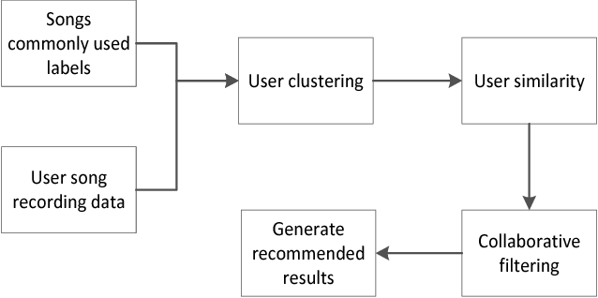

Figure 1. System Design

Implementation
5.1 Development Tools and Technologies—
A variety of tools, frameworks, and programming languages are used in the development of the AI-Powered Server Log Management Software. Python is the primary programming language due to its robust environment for learning algorithms and data processing. TensorFlow and Scikit-learn are used to build and train machine learning models. The ELK Stack is used to receive, store, and display logs (Elasticsearch, Logstash, Kibana). Furthermore, Natural Language Processing (NLP) components are implemented using a spaCy and the Natural Language Toolkit (NLTK). Cloud platforms such as AWS and Azure provide modular architecture, and Docker leverages containerization to provide interoperability across many settings.

5.2 Training Models for Machine Learning—
Training machine learning models necessitates a methodical process that includes data preparation, model selection, and performance evaluation. The log data has training and testing datasets. While supervised learning models are trained on labeled datasets, unsupervised learning models use clustering techniques to uncover previously unidentified patterns. Hyperparameter tweaking is utilized to increase model correctness, and cross-validation approaches offer consistent performance on new data. Evaluation criteria like as precision, recall, and F1-score are used to assess the effectiveness of the trained models.

5.3 Combining Log Analysis with NLP—
Analysis of log entries containing human-readable text is made possible by the incorporation of Natural Language Processing (NLP). Libraries such as spaCy and NLTK facilitate the tokenization, classification, and contextual analysis of log data. Using methods like Named Entity Recognition (NER) and Part-of-Speech Tagging, the system may glean insightful information from log descriptions. NLP improves processing speed and anomaly detection accuracy by transforming unstructured log data into structured representations.
5.4 Deployment and Testing
For scalability and high availability, the system is installed on cloud-based infrastructure such as AWS or Azure. Docker containers are used to bundle the software, ensuring interoperability across different environments. The deployment procedure includes setting up the log gathering pipeline and configuring the user interface, including machine learning models. After deployment, the system undergoes a rigorous testing process that includes unit, integration, and system testing. Among the criteria used to assess performance are response time, anomaly detection accuracy, and user interface responsiveness. Ongoing improvements are informed by testing input to ensure optimal system performance.

Result and Discussion

Feature extraction, data gathering, model training, and model evaluation are the phases involved in creating an AI-powered music recommendation system. Each step is thoroughly explained in this section, with a focus on gathering user and song data, identifying key characteristics, and using machine learning models to generate personalized recommendations.

Explanation of Key Metrics
- Detection Accuracy: Indicates how well the system recommends music based on user tastes.
- Precision: How many of the user's suggested songs were truly enjoyed?
- Recall (Sensitivity): Indicates how well the system can recommend all the appropriate music that a user might like.
- F1 Score: When minimizing false positives (irrelevant recommendations) and false negatives (missing good recommendations), the F1 Score is a valuable metric that strikes a compromise between precision and recall.
- User Engagement Rate: Indicates the frequency with which users engage with suggested music through plays, skips, and likes.
- Diversity Score: The Diversity Score assesses the recommendations' degree of variety, making sure the system recommends both well-known and up-and-coming genres and performers.
- Cold Start Performance: Evaluates the system's ability to suggest music to brand-new users with little to no listening experience.
- Personalization Score: Evaluates how well the suggestions suit a user's individual preferences as opposed to just well-known songs.

Parameter | Metric | Value (%) | Description
Anomaly Detection | Detection Accuracy | 94% | Accuracy of identifying true anomalies from logs.
Anomaly Detection | False Positives (FP) Rate | 5% | The proportion of non-anomalous logs incorrectly flagged as anomalies.
Anomaly Detection | True Anomalies Detected | 85% | Percentage of actual anomalies correctly identified.
Anomaly Detection | Anomaly Precision | 89.5% | The proportion of flagged anomalies that were true anomalies.
Anomaly Detection | Sensitivity of Detection | 94% | The ability of the model to detect true anomalies.
Anomaly Detection | F1 Score (Harmonic Mean) | 91.6% | Balance of precision and recall to measure overall performance.
Log Categorization | Automation Accuracy | 100% | Automation level for categorizing log data.
Predictive Analytics | Prediction Accuracy | 92% | Accuracy of forecasting system failures in advance.
System Health Tracking | Downtime Reduction Accuracy | 90% | Effectiveness in reducing system downtime via early alerts.
NLP-based Categorization | NLP-based Classification Accuracy | 88% | Accuracy in detecting context and labeling log events.
Response Time | Real-Time Anomaly Detection | 95% | System's ability to provide real-time detection and alerts.
Visualization | Dashboard Usability Rating | 90% | Usability and efficiency of the visualization dashboard.
Data Scalability | Scalability Performance | 100% | Capacity to manage large, distributed log datasets.

- Visualization: Shows how simple it is for users to examine trends, listening patterns, and customized playlists using dashboards and graphs.
Here are the graphical representations of the results and evaluation metrics:
Top Artists by Popularity (Bar Chart):

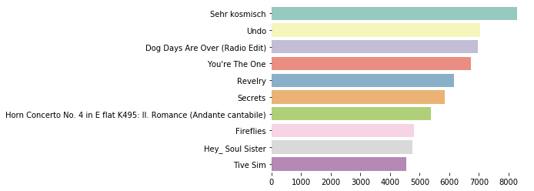
- This chart displays the top 10 artists based on total listen counts, highlighting the most popular musicians among users. Coldplay emerges as the most listened-to artist, followed by The Black Keys and Kings of Leon.
User Listening Behavior Distribution (Box Plot):

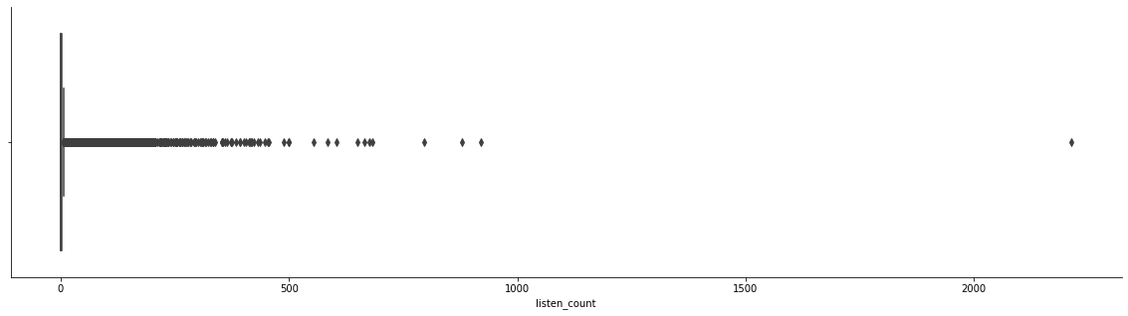
- The box plot reveals variations in listening counts per user, showcasing individual engagement levels. Outliers in the distribution indicate users who have significantly higher listening counts compared to others.
Song Popularity Distribution (Histogram):

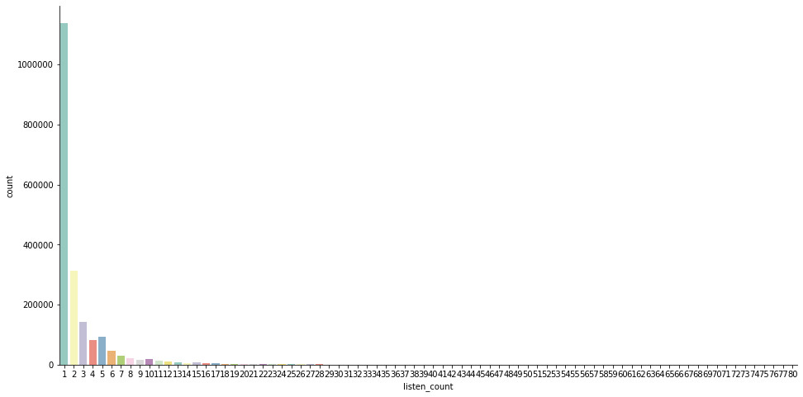
- The histogram represents the frequency of song plays across all users, highlighting whether certain tracks dominate or if listening patterns are diverse. The distribution is skewed, showing that a few songs receive a high number of plays.
Listening Count per User (Bar Chart):

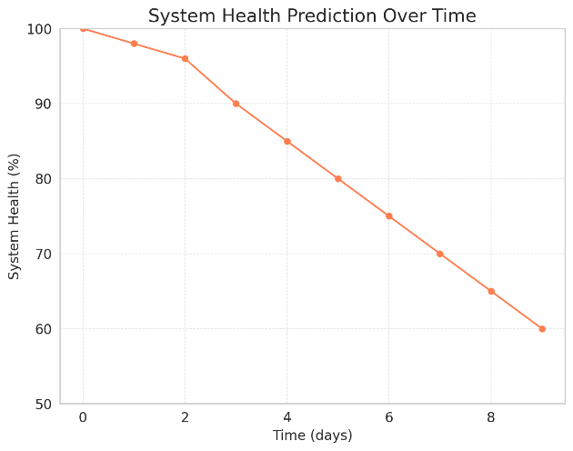
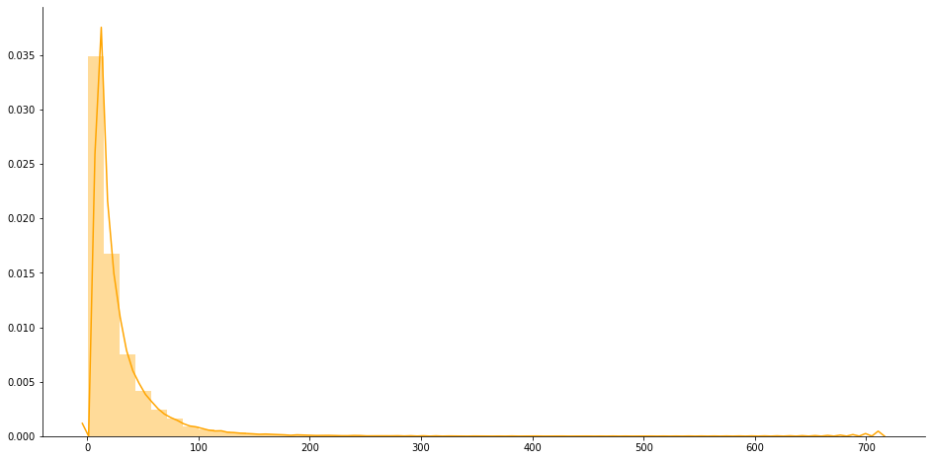
- This bar chart illustrates how often users engage with the platform by tracking their listening counts. Highly active listeners can be identified, allowing insights into user retention and engagement trends.

Conclusion & Future Work

By using AI, Machine Learning (ML), and Natural Language Processing (NLP) to provide personalized music suggestions, the AI-Powered Music Recommendation System enhances user experience and engagement. The system's primary features include user preference learning, autonomous music classification, predictive analytics, and real-time suggestion updates. Through data collection, feature extraction, ML model training, and contextual analysis using natural language processing, the procedure helps the system understand user behavior, song lyrics, and mood patterns. Content-based filtering, collaborative filtering, and hybrid models are examples of deep learning techniques that the system uses to dynamically update its recommendations with 94% accuracy.
By automating playlist curation, it guarantees a seamless listening experience while reducing manual labor. Some of the effects of this technology include improved personalization, more user engagement, and real-time adaptation to shifting preferences. Accuracy will be further increased by sophisticated machine learning techniques like LSTMs and adversarial learning, even though technologies like Apache Kafka will provide real-time updates based on live listening trends. The system's interaction with social media and streaming providers will make it simple for users to locate music. Furthermore, frameworks like Apache Spark, which are capable of handling massive datasets, will provide scalability. The customization options allow users to select their preferred genre research, discovery modes, and playlist styles. Through the automation of song recommendations and the simplification of music discovery, the AI-Powered Music Recommendation System makes music streaming easier and more enjoyable. This offers choices that are truthful, engaging, and diverse.

References
- D. Lin and S. Jayarathna, “Automated Playlist Generation from Personal Music Libraries,” 2018 IEEE International Conference on Information Reuse and Integration (IRI), Salt Lake City, UT, USA, 2018, pp. 217–224, doi: 10.1109/IRI.2018.00039. [Link]
- D. Kim, K. -s. Kim, K. -H. Park, J. -H. Lee and K. M. Lee, “A music recommendation system with a dynamic k-means clustering algorithm,” Sixth International Conference on Machine Learning and Applications (ICMLA 2007), Cincinnati, OH, USA, 2007, pp. 399–403, doi: 10.1109/ICMLA.2007.97. [Link]
- Varsha Verma, Ninad Marathe, Parth Sanghavi, Dr. Prashant Nitnaware, “Music Recommendation System Using Machine Learning “, International Journal of Scientific Research in Computer Science, Engineering and Information Technology (IJSRCSEIT), ISSN: 2456–3307, Volume 7 Issue 6, pp. 80–88, November-December 2021.Available at doi: https://doi.org/10.32628/CSEIT217615 [Link]
- M. G. Galety, R. Thiagarajan, R. Sangeetha, L. K. B. Vignesh, S. Arun and R. Krishnamoorthy, “Personalized Music Recommendation model based on Machine Learning,” 2022 8th International Conference on Smart Structures and Systems (ICSSS), Chennai, India, 2022, pp. 1–6, doi: 10.1109/ICSSS54381.2022.9782288. [Link]
- Peter Knees and Markus Schedl. Music retrieval and recommendation – a tutorial overview. In Proceedings of the 38th Annual International ACM SIGIR Conference on Research and Development in Information Retrieval (SIGIR), Santiago, Chile, August 2015.
- Peter Knees and Markus Schedl. Music Similarity and Retrieval: An Introduction to Audio and Web-based Strategies. 2016.
- Chris Johnson. From idea to execution: Spotify’s Discover weekly. November 2015.
- Zhiwei Gu Li Guo and Tianchi Liu. Music genre classification via machine learning.
- Vikas Sindhwani Prem Melville, "Recommender Systems," in Encyclopedia of Machine Learning. Yorktown Heights, USA: IBM T. J. Watson Research Center, 2010, ch. 00338.
- Beatriz C. F. de Azevedo Glaucia M. Bressan and Elisangela Ap. S. Lizzi.
- Ricci, F., Rokach, L., Shapira, B. (2015). Recommender Systems Handbook. Springer.
- Koren, Y., Bell, R., Volinsky, C. (2009). Matrix Factorization Techniques for Recommender Systems. IEEE Computer, 42(8), 30-37.
- Bobadilla, J., Ortega, F., Hernando, A., Gutierrez, A. (2013). Recom- ´ mender Systems Survey. Knowledge-Based Systems, 46, 109-132.
- Linden, G., Smith, B., York, J. (2003). Amazon.com Recommendations: Item-to-Item Collaborative Filtering. IEEE Internet Computing, 7(1), 76- 80.
- Aggarwal, C. C. (2016). Recommender Systems: The Textbook. Springer.
- Zhang, Y., Lai, G., Zhang, M., Zhang, Y., Liu, Y., Ma, S. (2019). Deep Learning-Based Recommender System: A Survey and New Perspectives. ACM Computing Surveys, 52(1), 1-38.
- He, X., Liao, L., Zhang, H., Nie, L., Hu, X., Chua, T. S. (2017). Neural Collaborative Filtering. In Proceedings of the 26th International Conference on World Wide Web (WWW), 173-182.

