Katon Minhas – 904733555

Psych 186B Homework 1

Problem 1:

1. 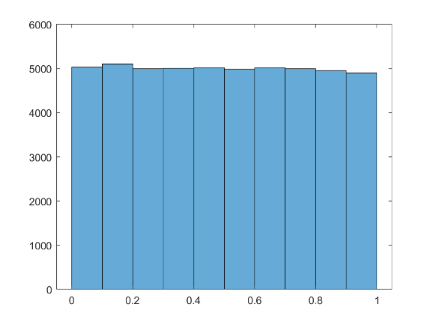I used the standard rand() function to generate my set of uniformly distributed random numbers.
2. The histogram shown to the right was generated using the code found in hw1_prob1.m

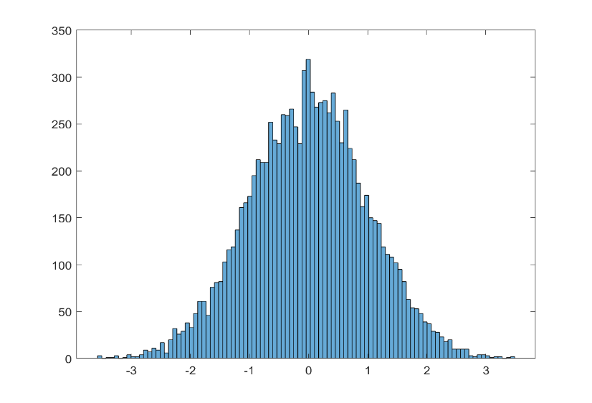Problem 2:

The histogram shown to the right displays the normal distribution generated by hw1_prob2.m

A comparison of my generated values with the actual values expected can be found in the comments of hw1_prob2.m

Problem 3:

1. The dot product of 2 normalized (unit) vectors represents the cosine of the angle between formed by the vectors.
2. The following histograms were generated by hw1_prob3.m (note the changes of scale on the x-axis):

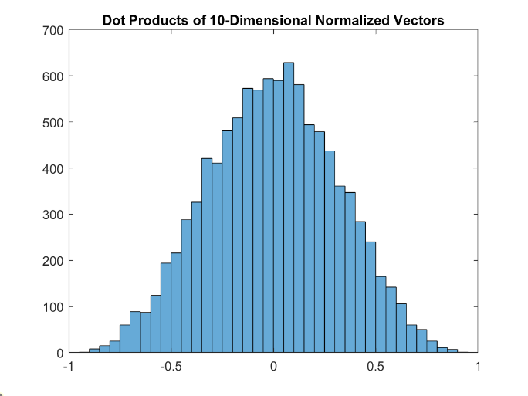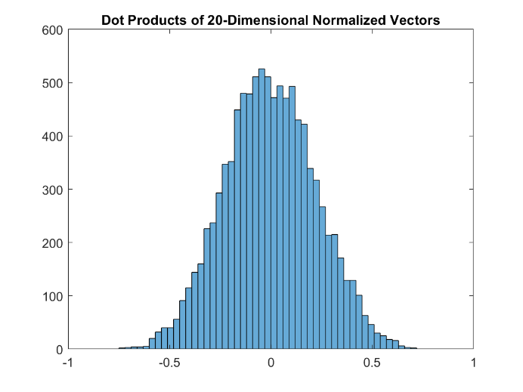

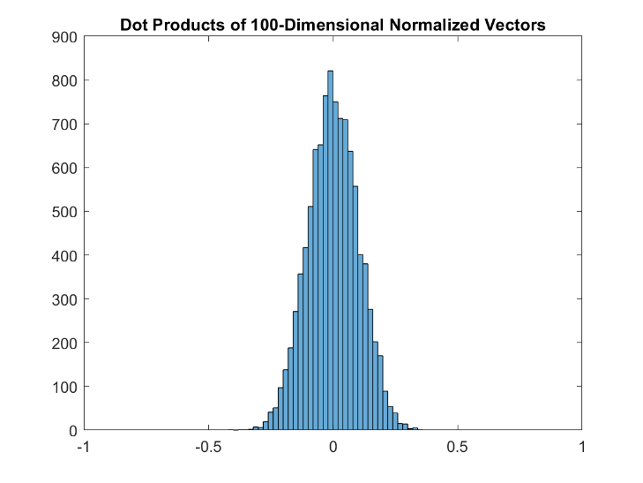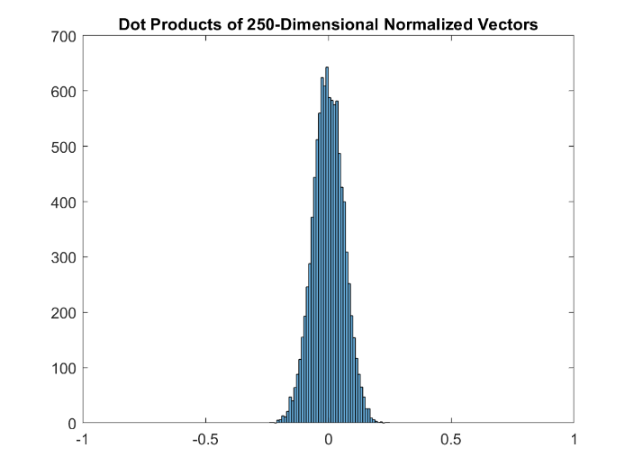

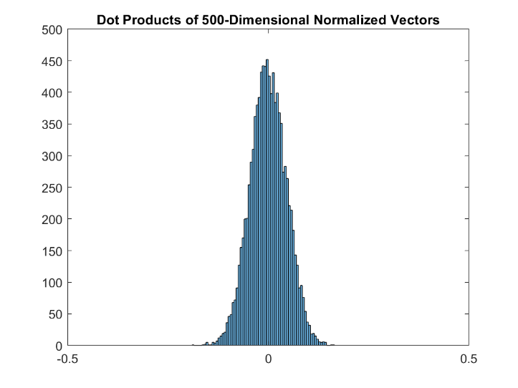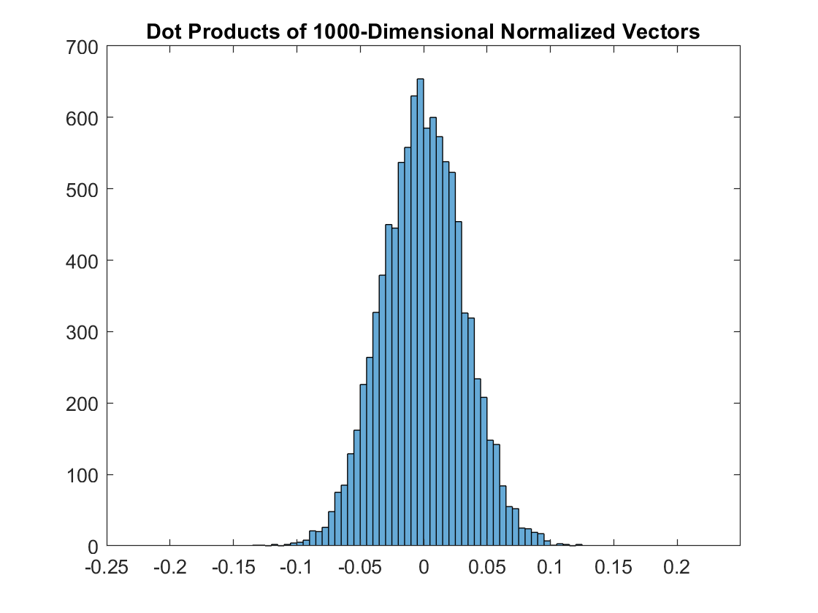

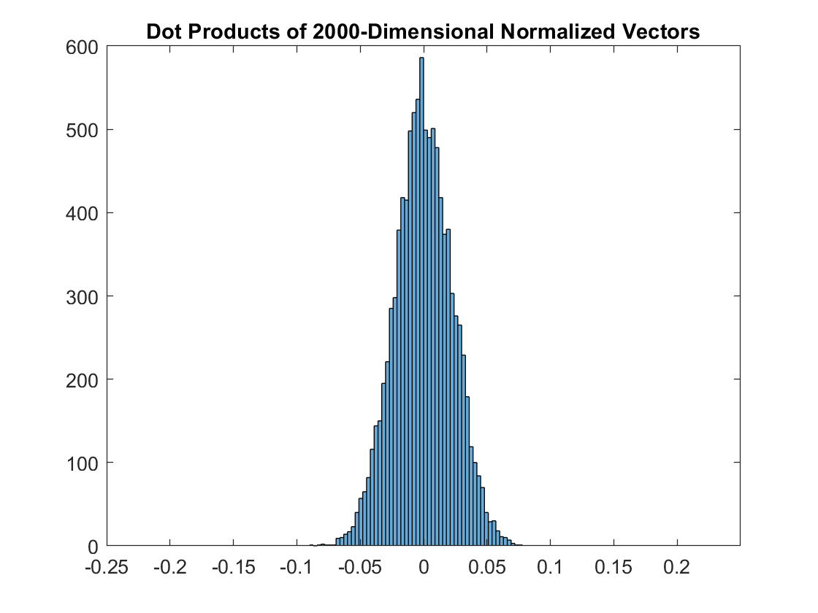

1. The mean of a distribution of dot products of normalized vectors should be 0. This is because dot products represent (by the definition of the cosine rule) cos(A), where A is the angle between the 2 vectors being multiplied. Since arccos(0) = π/2 (a 90 degree angle), the resultant dot product of 2 normalized vectors represents (on average) an orthogonal projection.

e) Using my data, the standard deviation appears to converge to 0 as the dimensionality of the vectors approaches ∞. A graph depicting this trend is shown below.

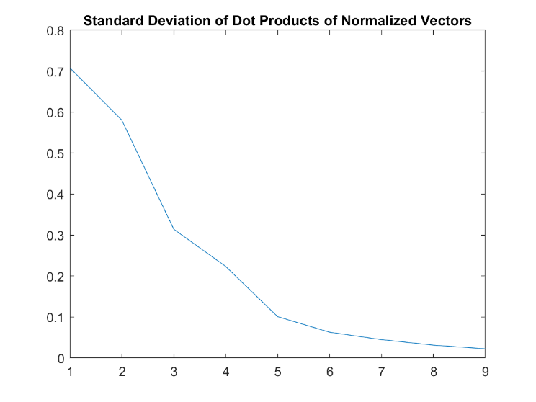

As seen on the graph, a 2-D vector has a standard deviation of roughly 0.7 while a 2000-D vector’s standard deviation is less than 0.1

This effectively means that as the dimensions of a normalized vector approach 0, it’s dot product with other normalized vectors is much more likely to be very close to 0, representing a right angle with the other vector.

Problem 4:

My estimates of pi proved reasonably close to the actual value, obviously increasing in accuracy when computed with larger sample sizes.