**Keiana Snell**

**PSYCH 186B**

**HW5 Writeup**

**In your write-up, explain:**

* *Representation of ship features (f vectors): how you decided which features to use*
  + I decided to classify the ships based on six different feature representations. They were identified by the bipolar values of **($has_value =1$, $not_value =-1, unknown=0$** ).
  + I used the seventh dimension of the f vectors (in the testing data) to represent which planet of origin the ship was from. This was to be utilized for the training process.
  + These classifications were then saved into a .csv file to be read into the program.
* *Representation of ship origin (g vectors): what each dimension represents, how you coded them*
  + The g vector is the mean of the ships from a specific planet.
* *Procedure for missing data: your thought process for how to replace missing data* 
  + Missing data is represented by a 0 in a bipolar grading system (-1, 0, 1).
* *Learning process:*
  + **Training**
    - In each trial (out of 10,000), one f vector from the training set of data was selected at random; then, the g vector was determined by the planet origin of the ships in the f vector.
    - I then computed the overall connectivity matrix **A** and applied the Widrow-Hoff function to update the A matrix.
  + **Testing**
    - For testing, one f vector from the noisy set of data was selected to generate a predicted g vector. It was used to compare to the mean vectors of ships from each planet. Whichever comparison produced the smallest difference (closest match) was chosen as the origin planet for each noisy data ship.
  + **Error correcting**
    - number of features: 7
    - number of trials: 10,000
    - learning constant: 0.1
* *Output classifications:*

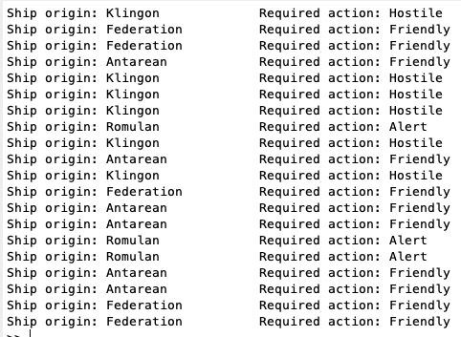

There may be error due to my initial predictions of classifications of the ships in the noisy data.

**Your write-up should include:**

* *clearly stated, the dimensions of your f and g vectors*
  + Both f and g vectors were dimension 7 x 20 matrices.
* *a table containing the ship features you used, in the format:*

|  |  |  |  |  |
| --- | --- | --- | --- | --- |
| $$f$$ | **Name of Feature** | **Definition of feature** | **Coding scheme** | **How you dealt with missing data** |
| **1** | Does the ship name start with an A or an E? | **($yes =1$, $no =-1$** ) | binary | unknown=0 |
| **2** | Does the ship name have two consonants as the first characters? | **($yes =1$, $no =-1$** ) | binary | unknown=0 |
| **3** | Is the ship’s warp drive  >= 7.0? | **($yes =1$, $no =-1$** ) | binary | unknown=0 |
| **4** | Is the ship’s hailing transponder >= 1000.0? | **($yes =1$, $no =-1$** ) | binary | unknown=0 |
| **5** | Is the ship color black/white greyscale, or colored? | **($yes =1$, $no =-1$** ) | binary | unknown=0 |
| **6** | Is the ship’s axis ratio  >= 1.5? | **($yes =1$, $no =-1$** ) | binary | unknown=0 |
| **7** | Planet of origin | K=1, R=2, A=3, F=4 | standardized | unknown=0 |