User guide distance.pl

A tool implemented in Perl that calculates and returns the nearest 3G site for each given 2G site using the great circle distance algorithm and the coordinates of the sites. This can generally apply for any points of interest that might need looking up the shortest distance. These could for example apply to other Operator towers (collocations) , institutions, polling stations, etc etc. The tool is meant for Windows environment but can easily be customized for \*nix machines.

Below is how to use the script. Ensure you have Perl installed on the machine you’re working from.

1. Create a folder on your D drive called MultiRAT
2. Export the list of 2G sites from Atoll with the IEs of Name, Longitude and Latitude. (You can optionally include another descriptive column, like Site Name, Area or such). This list must be saved as CSV and call 2G.csv. If the source list is not from Atoll then it must strictly be in the same format as is from Atoll.
3. Export the 3G sites same as in step 2. Note that this could be a list of anything as long as it geocoded properly with accurate Longitude and Latitude information. Name the file as 3G.csv
4. Save the Perl script in any easily accessible location on your machine.
5. To run the script, open a CMD window and type the full path of the scripts location ending with the script name distance.pl. The extension has to be explicitly defined. For example;

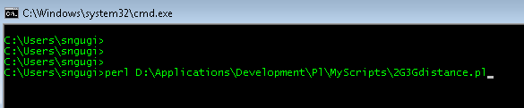

1. Depending on the size of the input files, it will run for some time and give an output file called MINPAIR.csv. This file gives the result. Another file SITES.csv is an intermediate output used by the script in the computation.

Known bugs;

1. The result will not be correct if the 3G list is longer than the 2G list. This will be rectified soon.