User guide patternsAtoll.pl

A tool implemented in Perl to unzip Atoll format antenna pattern files and rename them according to the Planning DB antenna name format. The files from the antenna vendor are in .txt format, the tool simply formats some given fields and renames the files to the correct name for import. For the unzip to work, the machine needs to have WinZip or WinRAR installed.

1. Create two folders called ‘Patterns’ and ‘Imports’ respectively on your D drive
2. Copy all your zipped Atoll.txt antenna files into the Patterns folder
3. Save the Perl script in any easily accessible location on your machine.
4. To run the script, open a CMD window and type the full path of the scripts location ending with the script name distance.pl, the extension has to be explicitly defined. Ensure the Perl executable is included in your PATH environmental variable. For example;

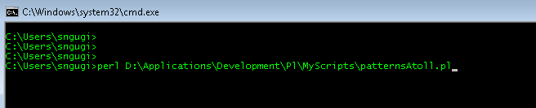

1. Depending on the number of files, the script will unzip and rename for a given period of time (not more than 1 min). The result will be in a folder within ‘Imports’ called ‘Atoll_Imports’.

Known bugs;

Not extensively tested, so no obvious bugs at the moment.

User guide msi.py

A tool implemented in Python to unzip .msi format antenna pattern files and rename them according to the Planning DB antenna name format. This is an improved version that removes repetitive files and defines more spectrum ranges. The files from the antenna vendor are in .msi format, the tool simply formats some given fields and renames the files to the correct name for import. For the unzip to work, the machine needs to have WinZip or WinRAR installed.

1. Create two folders called ‘Patterns’ and ‘Imports’ respectively on your D drive
2. Copy all your zipped .msi antenna files into the Patterns folder
3. To run the script, open a CMD window and type python.exe followed by the full path of the scripts location ending with the script name msiV4.py, the extension has to be explicitly defined. Ensure the python executable is included in your PATH environmental variable. For example;

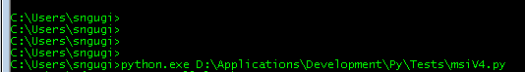

1. Depending on the number of files, the script will unzip and rename for a given period of time (not more than 1 min). The result will be in a folder within ‘Imports’ called ‘Import_Pattern’.