**Project Chosen: StoryBook (**[**GitHub Repo)**](https://github.com/storybookjs)

* Storybook is a frontend workshop for building UI components and pages in isolation. Thousands of teams use it for UI development, testing, and documentation.
* I chose this project because I thought the name was pretty cute and the project sounds cool!
* The documentation for this project is really well maintained, though I did have a bit of a challenge understanding the structure of the project at the beginning. But I was able to find the UI components after a deep search!
* It is interesting because each component has a .tsx file and respective .stories.tsx which is an object that describes how to render the component.

**Interfaces:**

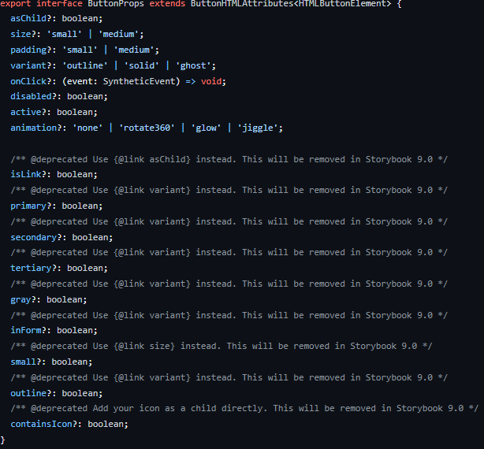

This first interface ensures that when the button component is used in other projects, the correct props are passed! This is important as different button components and even the react native button component can be very different! The interface makes sure

**Decorators:**

**Generics:**