Fajutagana, Kimberly A
BSIT 2F2

Exercise #9
- List the minimum perks package.
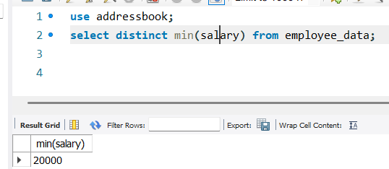
- List the maximum salary given to a “Programmer”.
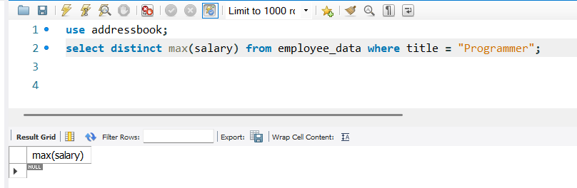
- Display the age of the oldest “Marketing Executive”
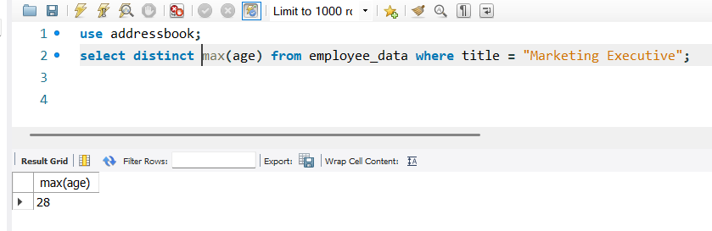
- Find the first and last names of the oldest employee.
