# What are *EV charging strategies, and how can connected mobility help you make the best of it?

## Introduction

In a previous [entry/post,](https://blog.astaraconnect.com/blog/transicion-flota-combustion-a-vehiculo-electrico) we discussed the benefits of adopting electric vehicles (EVs). Their lower annual mileage costs compared to fuel-based ones and lower CO2 emissions are just some of their many benefits. That blog post also listed factors that hinder EVs' widespread adoption. As discussed in the post and the scientific literature, their higher purchase prices and the uncertainty of fulfilling mobility needs are the main obstacles behind their modest penetration rate [1-2]. The latter relates to their range, charging time, and charging station availability.

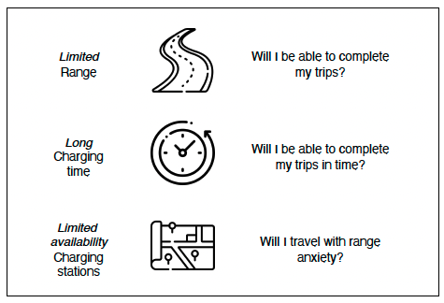

Figure 1. To be improved (flaticon figures)

Currently, several efforts are aimed at tackling these issues: newer EVs with greater ranges, fast and portable charging technologies, and the installation of charging stations and facilities are increasing worldwide.

In addition, there is also research aimed at optimizing our vehicles' driving, idle, and charging times while satisfying our mobility demands [3]. These are charging strategies.

## What are charging strategies anyway?

Charging strategies can refer to two things. The first defines planning or actions destined to achieve optimal distribution of the charging capacity among a series of vehicles. In plain English, strategies to charge vehicles without draining the electricity grid's capacity. They are planned and executed by the charging station administration. They could set the same load to every vehicle, assign higher power to those that arrive first, or give preference to specified vehicles like in Fig. 1.

Figure 2 Imagen que no es mia

The other meaning associated with charging strategies, and the one with utmost interest for us, is the one that defines the **series of actions destined to optimize the use of the EV**. These strategies focus on the individual behavior of users (individual EVs or fleets) and are applied by the final user. It answers the question: How can I organize my trips and charging time to get the most out of my EV?

*From here, things are going to get interesting :D.*

One thing in common between fleet coordinators and individual EV owners is the desire to satisfy their transport demands within their economic and time constraints. In this case, the financial constraints refer to the vehicle's total cost of ownership (TCO), which is all the critical costs of owning and running a vehicle, from purchasing to maintenance, insurance, etc. Time constraints are defined by the purposes of our trips and the timing we have available to carry them out.

What economic challenges do EVs pose compared to internal combustion engine (ICE) vehicles? The first one is the already mentioned initial cost. This burden might be easier to overcome by medium or big-sized companies than lower-medium-income families. Additionally, commercial vehicle fleets have higher annual mileage than private cars; hence, savings in running costs are more significant [4]. Many governments have implemented programs to provide funds or incentives for the renewal of the stock of cars with specific incentives for EVs and Plug-in hybrid electric vehicles (PHEVs) [5-7].

The second challenge relates to the vehicle’s longevity. For ICE, the critical challenge is to cover a considerable number of kilometers traveled without any major technical failure. EVs add to these considerations the battery’s state of health (SoH). Expanding the battery life of the EVs means balanced driving, charging, and idle time.

An efficient charging strategy would help us meet our mobility needs while implementing a charging strategy to preserve the battery’s SoH. It is an optimization task where mobility KPIs are to be accomplished with a reduced range and set

## How can charging strategies be implemented?

Implementing charging strategies requires

## How can connected mobility help you plan your charging strategies?

Cost-optimized charging

To our knowledge, the most detailed contribution to the topic was made by the scientific article “Charging strategies for economic operations of electric vehicles in commercial applications” by Schücking et al. The authors presented and discussed different charging strategies

## Conclusions

Common reasons to replace ICE vehicles with electric ones are cost savings and reduction of externalities.