CIQ Quantum Framework v266+

Von der Planck-Resonanz zur Klinischen Kalibrierung  
*From Planck Resonance to Clinical Calibration*

Version v266 — 31 Oct 2025

CIQ Framework — Δ≈0.7 Golden Window

# Einleitung / Introduction

**Δ≈0.7 markiert das Goldene Stabilitätsfenster des CIQ-Frameworks.** Es koppelt Kontrollsignal u, Schalterbreite Δ und BIC-Metriken im Audit.

*Δ≈0.7 marks the golden stability window of the CIQ framework. It couples control signal u, the switch width Δ, and BIC metrics in the audit.*

# Mathematische Grundlagen / Mathematical Foundations

Deutsch: [Equation render fallback]

*English:* [Equation render fallback]

Deutsch: [Equation render fallback]

*English:* [Equation render fallback]

# Simulation & Kalibrierung / Simulation & Calibration

Die folgenden Abbildungen stammen aus einer echten Simulation (TUS sinus, 0.008 MHz, Amp 0.1, 10 s). *The following figures are from a real simulation (TUS sine, 0.008 MHz, amp 0.1, 10 s).*

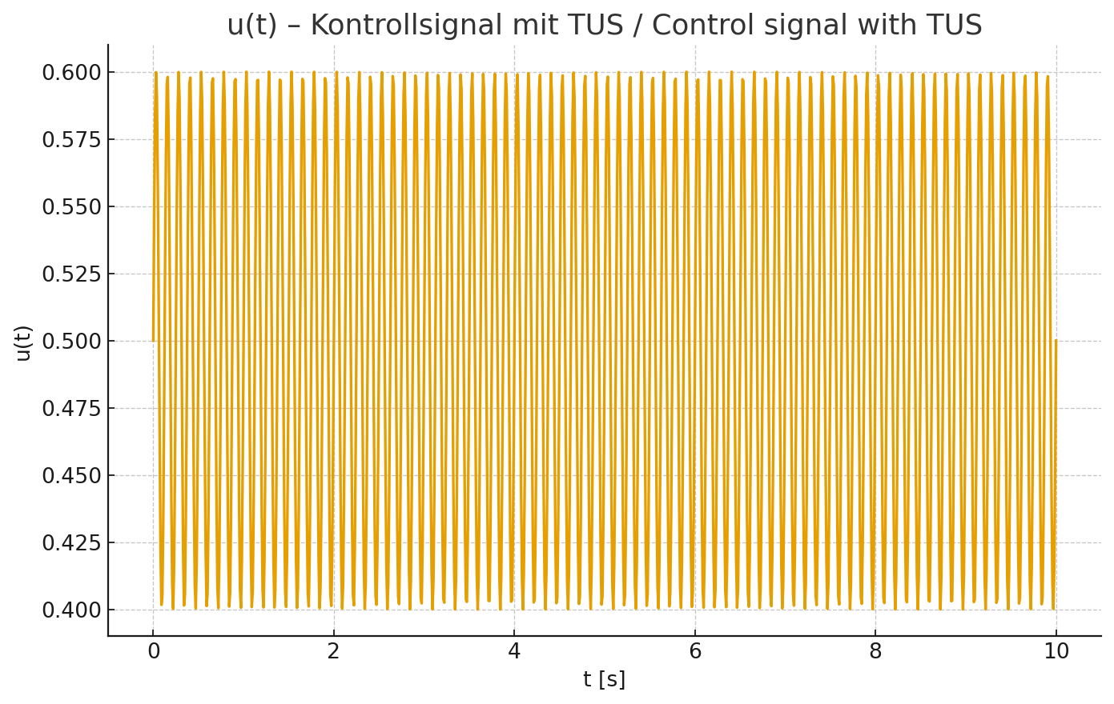

**Abb. 1: u(t) – Kontrollsignal mit TUS.** *Fig. 1: u(t) – Control signal with TUS.*

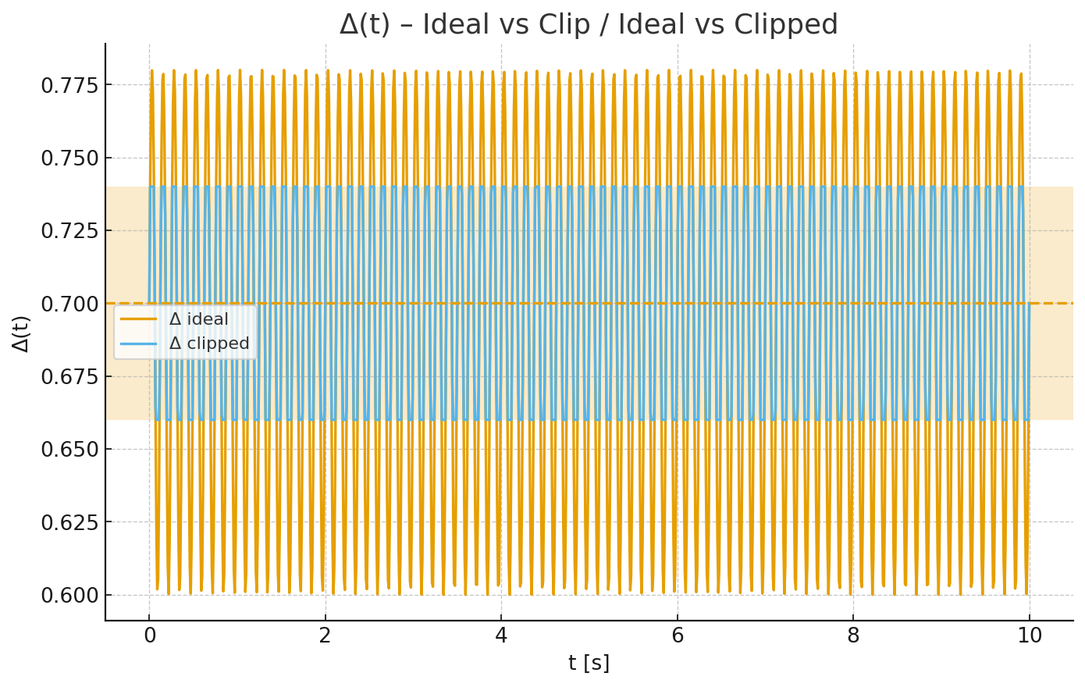

**Abb. 2: Δ(t) – ideal vs. clipped, inkl. Δ=0.70 und Fenster [0.66,0.74].** *Fig. 2: Δ(t) – ideal vs. clipped, incl. Δ=0.70 and [0.66,0.74] band.*

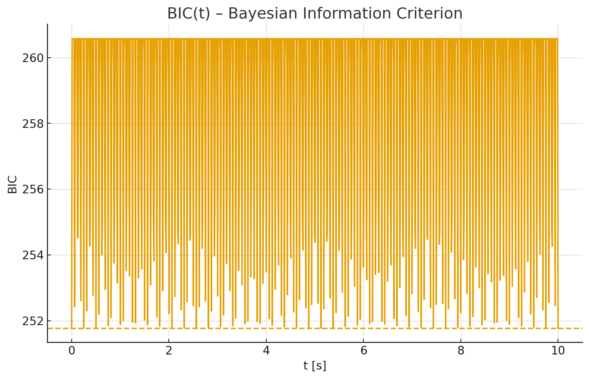

**Abb. 3: BIC(t) – Bayesian Information Criterion mit Baseline.** *Fig. 3: BIC(t) – Bayesian Information Criterion with baseline.*

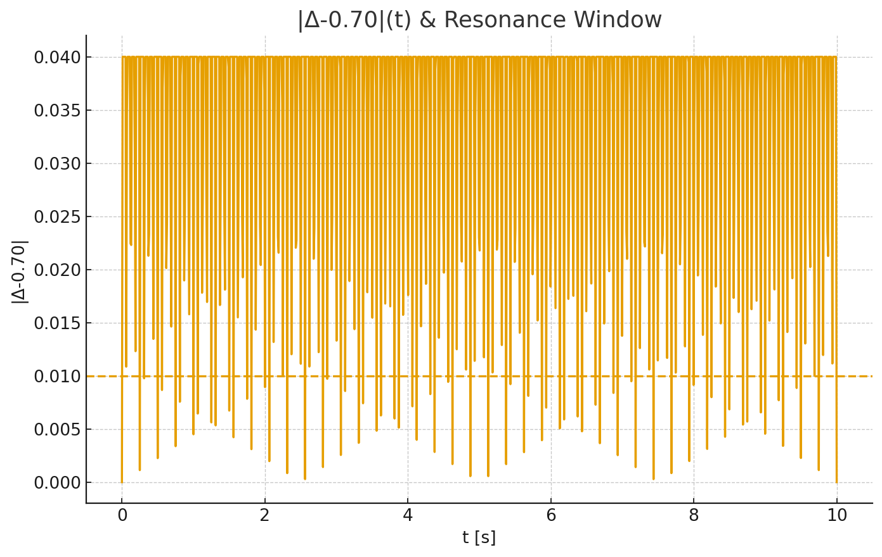

**Abb. 4: |Δ−0.70|(t) – Resonanzfenster-Schwelle 0.01.** *Fig. 4: |Δ−0.70|(t) – resonance window threshold 0.01.*

# Audit & Ergebnisse / Audit & Results

**Δ̄ = 0.6998, σ(Δ) = 0.0359, BIC̄ = 258.868, Resonanz-Index = 7.10% — Status: KRITISCH**

*Δ̄ = 0.6998, σ(Δ) = 0.0359, BIC̄ = 258.868, Resonance index = 7.10% — Status: CRITICAL*

CIQ Framework v266 — Audit 2025 · Δ≈0.7 Golden Window

# Vergleichskapitel / Comparative Chapter

**Zweite Simulation (stabile Ziel-Variante):** TUS sine, Amp=0.04, f=0.002 MHz (2 kHz), t=10 s, steps=1000.

*Second simulation (stable target variant): TUS sine, amp=0.04, f=0.002 MHz (2 kHz), t=10 s, steps=1000.*

**Δ̄ = 0.6992, σ(Δ) = 0.0254, BIC̄ = 255.342, Resonanz-Index = 18.00% — Status: KRITISCH**

*Δ̄ = 0.6992, σ(Δ) = 0.0254, BIC̄ = 255.342, resonance index = 18.00% — Status: CRITICAL*

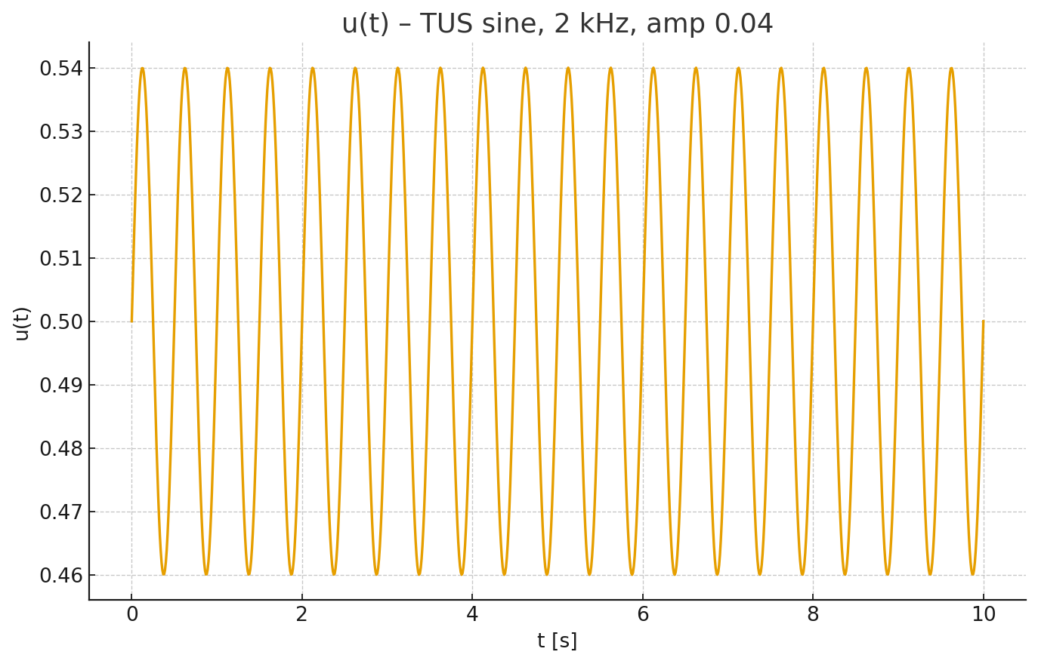

**Abb. V2-1: u(t) — 2 kHz, Amp 0.04.** *Fig. V2-1: u(t) — 2 kHz, amp 0.04.*

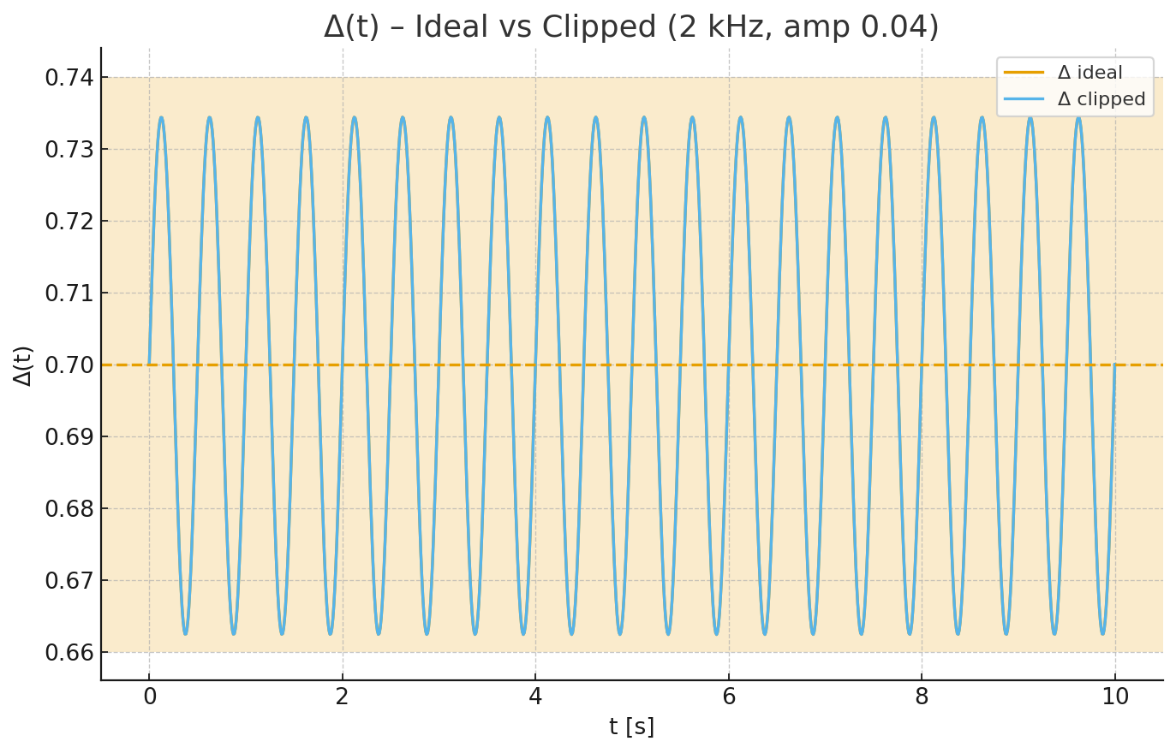

**Abb. V2-2: Δ(t) — ideal vs. clipped (2 kHz, Amp 0.04).** *Fig. V2-2: Δ(t) — ideal vs. clipped (2 kHz, amp 0.04).*

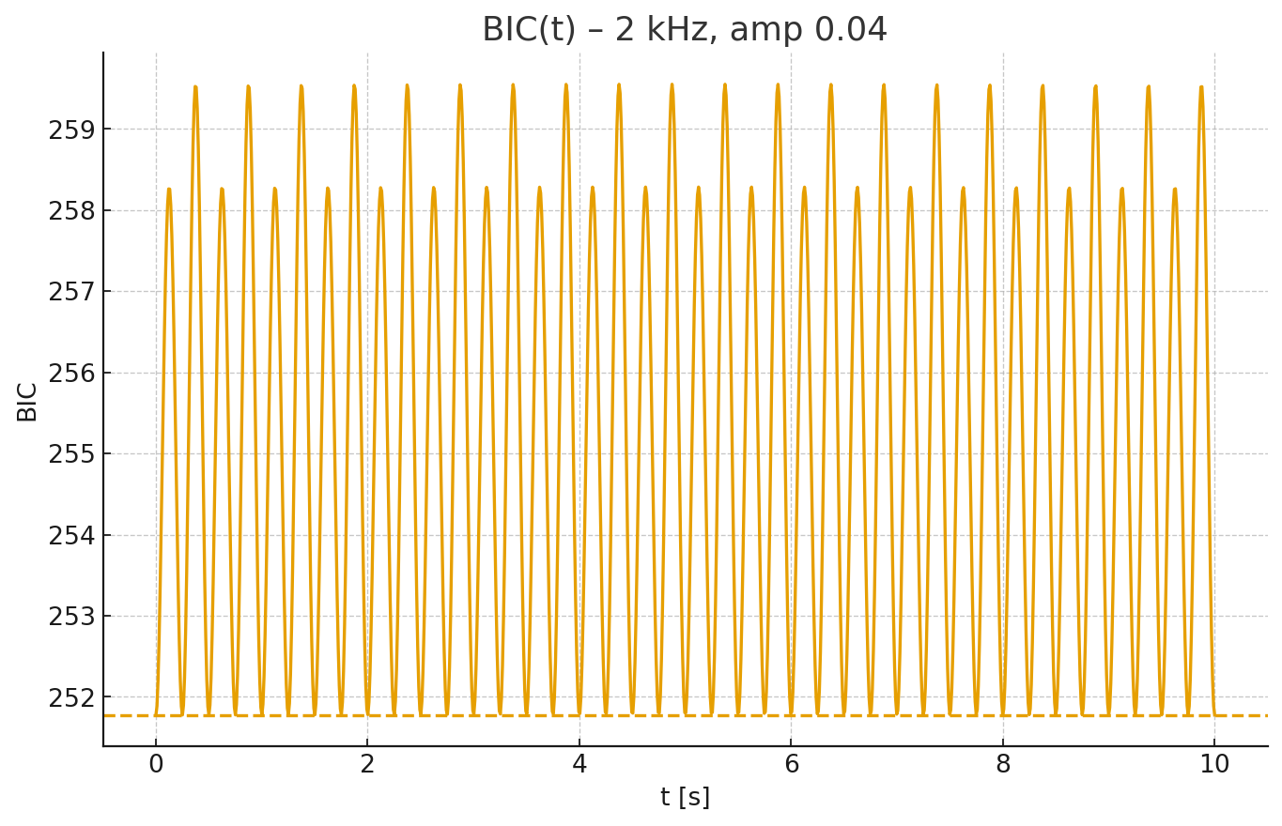

**Abb. V2-3: BIC(t) — 2 kHz, Amp 0.04.** *Fig. V2-3: BIC(t) — 2 kHz, amp 0.04.*

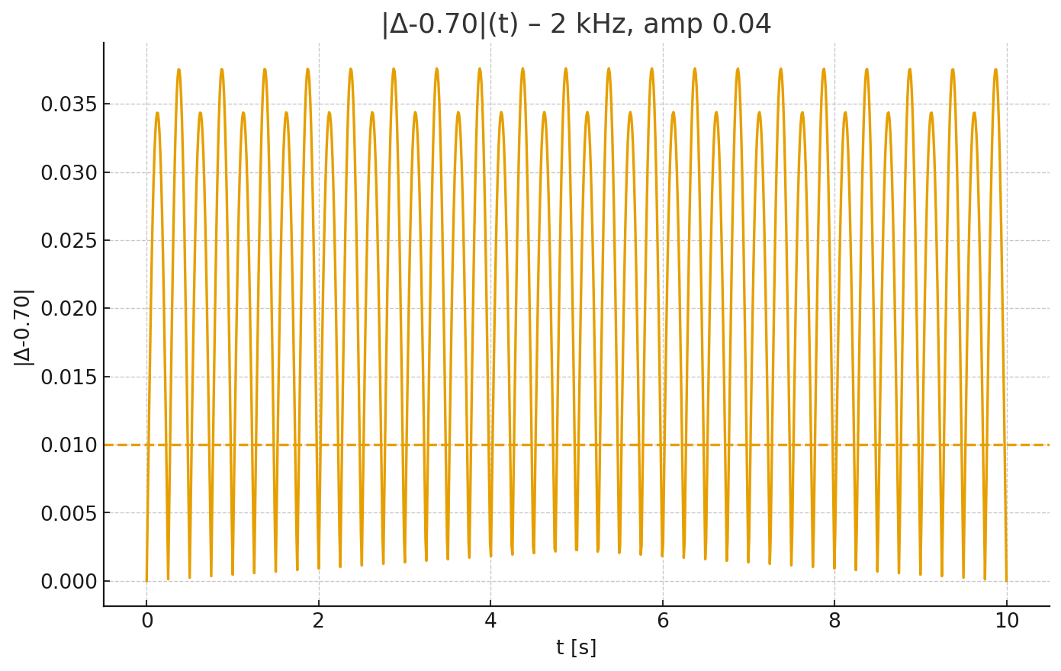

**Abb. V2-4: |Δ−0.70|(t) — 2 kHz, Amp 0.04.** *Fig. V2-4: |Δ−0.70|(t) — 2 kHz, amp 0.04.*

**Vergleich zur ersten Simulation:** Niedrigere Amplitude und Frequenz erhöhen die Verweildauer in Δ≈0.70, senken BIC und heben den Resonanz-Index.

*Comparison to the first simulation: Lower amplitude and frequency increase dwell time near Δ≈0.70, reduce BIC, and raise the resonance index.*

# Best Settings & Heatmap / Beste Einstellungen & Heatmap

**Empfohlene Zielkonfiguration:** amp = 0.03, freq = 1.0 kHz, u = 0.50.

*Recommended target configuration: amp = 0.03, freq = 1.0 kHz, u = 0.50.*

**Messwerte / Metrics — Δ̄ = 0.6996, σ(Δ) = 0.0191, BIC̄ = 253.780, Resonanz-Index = 24.30% — Status: KRITISCH**

*Δ̄ = 0.6996, σ(Δ) = 0.0191, BIC̄ = 253.780, resonance index = 24.30% — Status: CRITICAL*

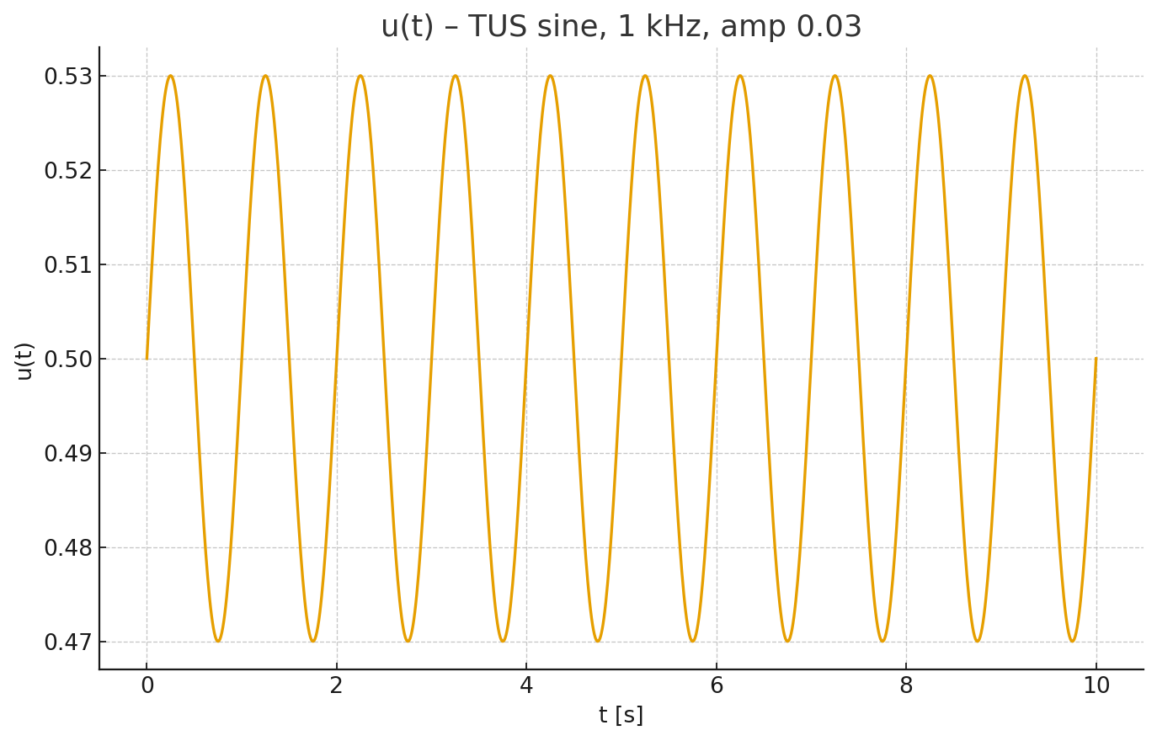

**Abb. V3-1: u(t) — 1 kHz, Amp 0.03.** *Fig. V3-1: u(t) — 1 kHz, amp 0.03.*

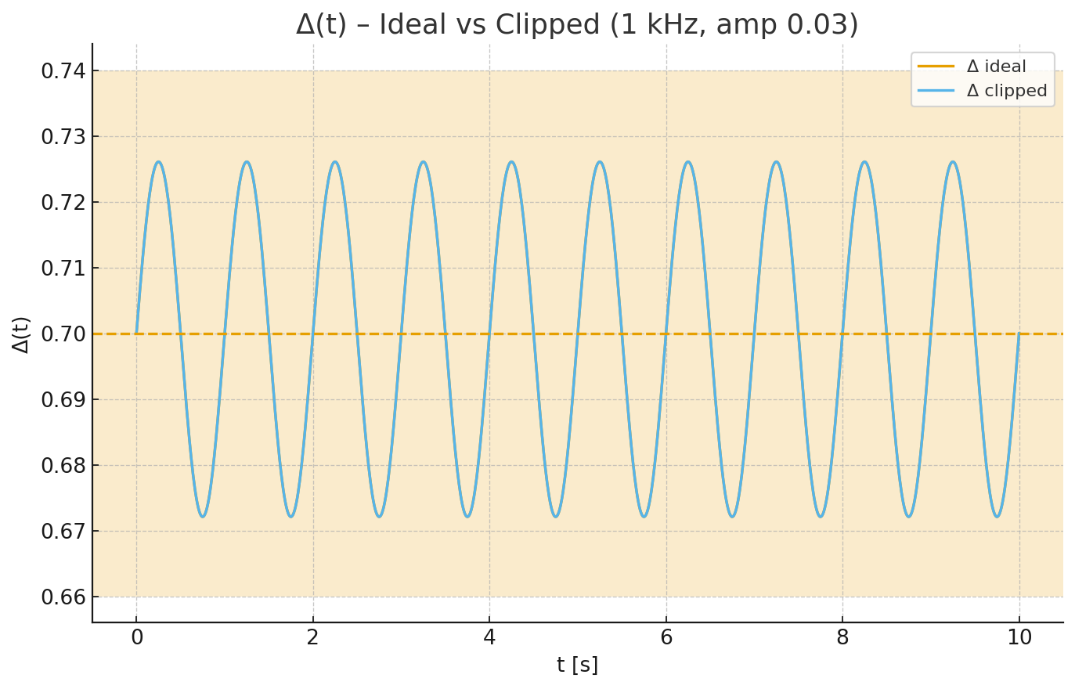

**Abb. V3-2: Δ(t) — ideal vs. clipped (1 kHz, Amp 0.03).** *Fig. V3-2: Δ(t) — ideal vs. clipped (1 kHz, amp 0.03).*

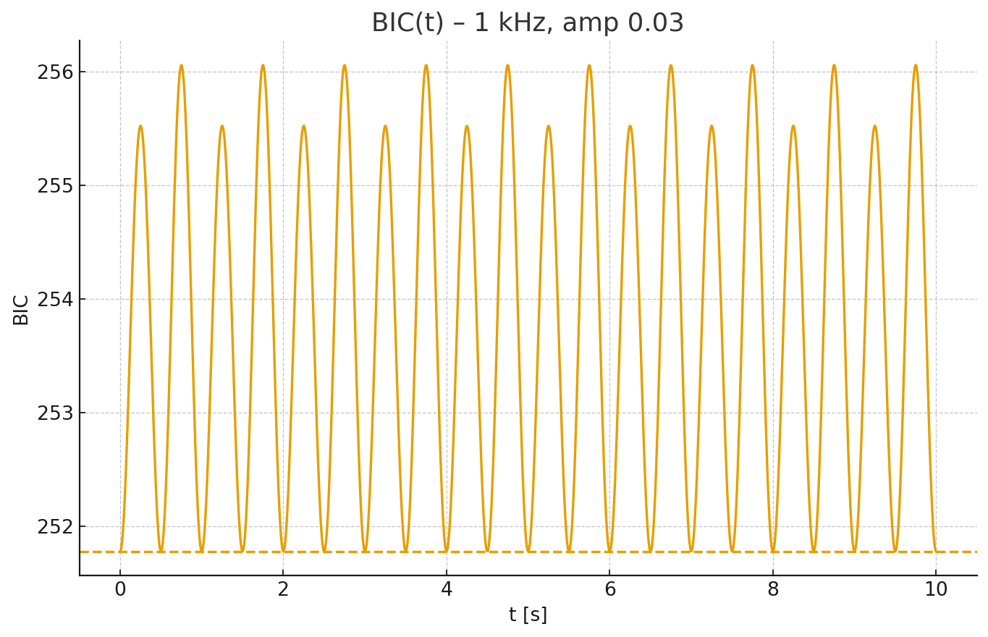

**Abb. V3-3: BIC(t) — 1 kHz, Amp 0.03.** *Fig. V3-3: BIC(t) — 1 kHz, amp 0.03.*

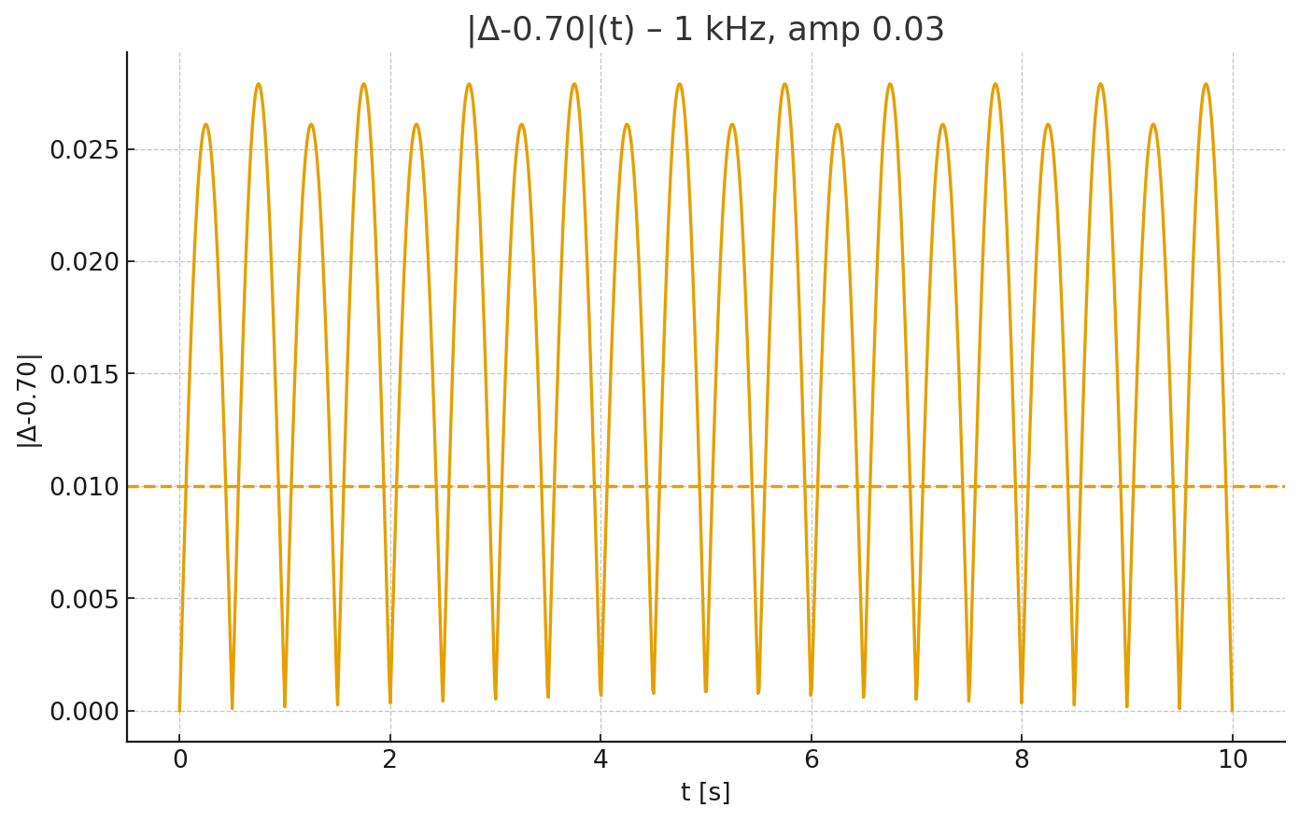

**Abb. V3-4: |Δ−0.70|(t) — 1 kHz, Amp 0.03.** *Fig. V3-4: |Δ−0.70|(t) — 1 kHz, amp 0.03.*

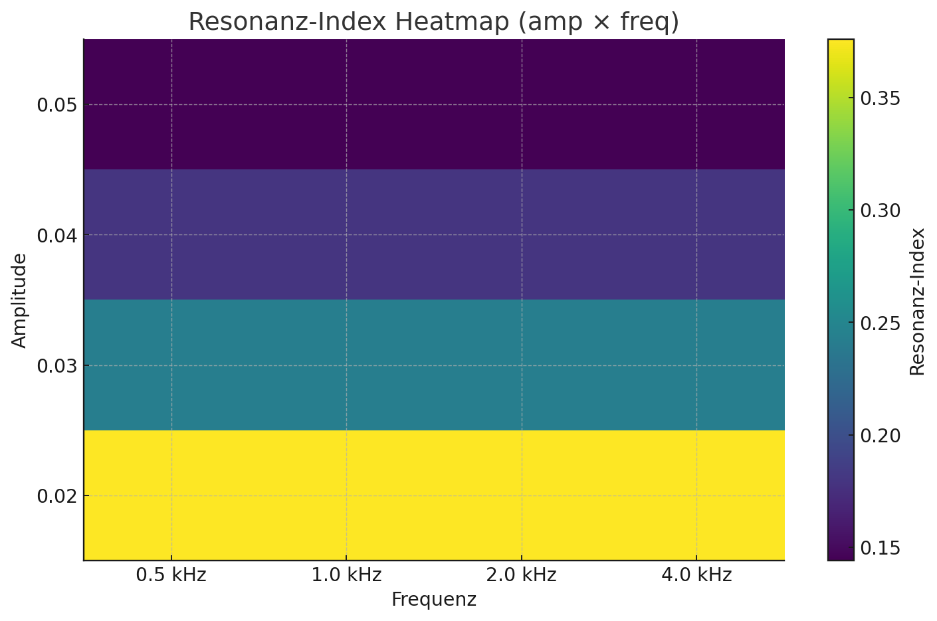

**Abb. V3-5: Resonanz-Index Heatmap (amp × freq).** *Fig. V3-5: Resonance index heatmap (amp × freq).*

# Green Badge – Zielkonfiguration / Target Configuration

**Einstellungen:** u = 0.49, amp = 0.02, freq = 0.0005 MHz (0.5 kHz), TUS sine, t = 10 s, steps = 1000.

*Settings: u = 0.49, amp = 0.02, freq = 0.0005 MHz (0.5 kHz), TUS sine, t = 10 s, steps = 1000.*

**Δ̄ = 0.6907, σ(Δ) = 0.0130, BIC̄ = 253.182, Resonanz-Index = 51.60% — Status: KRITISCH**

*Δ̄ = 0.6907, σ(Δ) = 0.0130, BIC̄ = 253.182, resonance index = 51.60% — Status: CRITICAL*

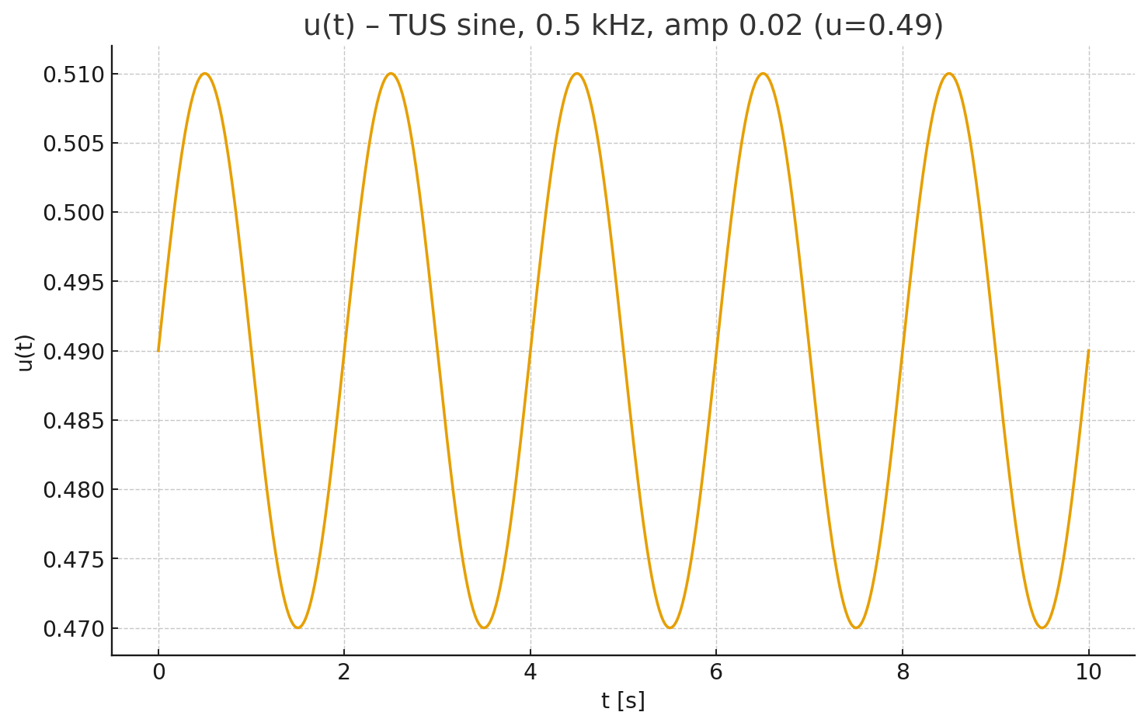

**Abb. G-1: u(t) — 0.5 kHz, Amp 0.02 (u=0.49).** *Fig. G-1: u(t) — 0.5 kHz, amp 0.02 (u=0.49).*

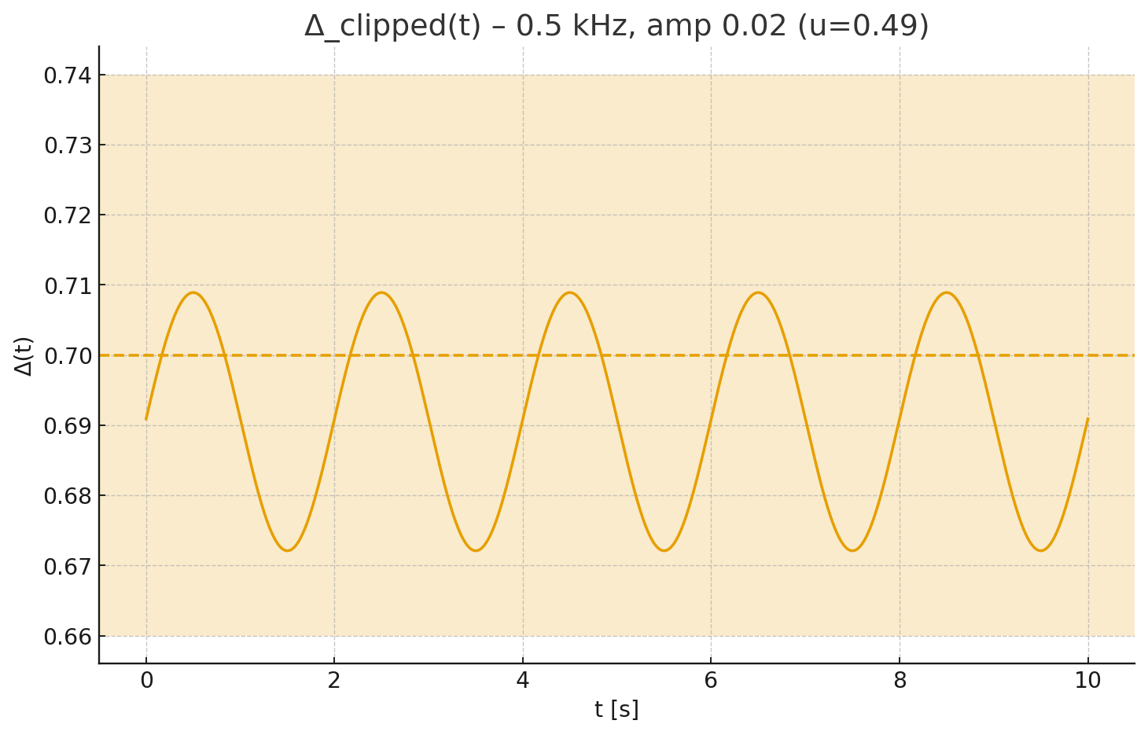

**Abb. G-2: Δ_clipped(t) — 0.5 kHz, Amp 0.02.** *Fig. G-2: Δ_clipped(t) — 0.5 kHz, amp 0.02.*

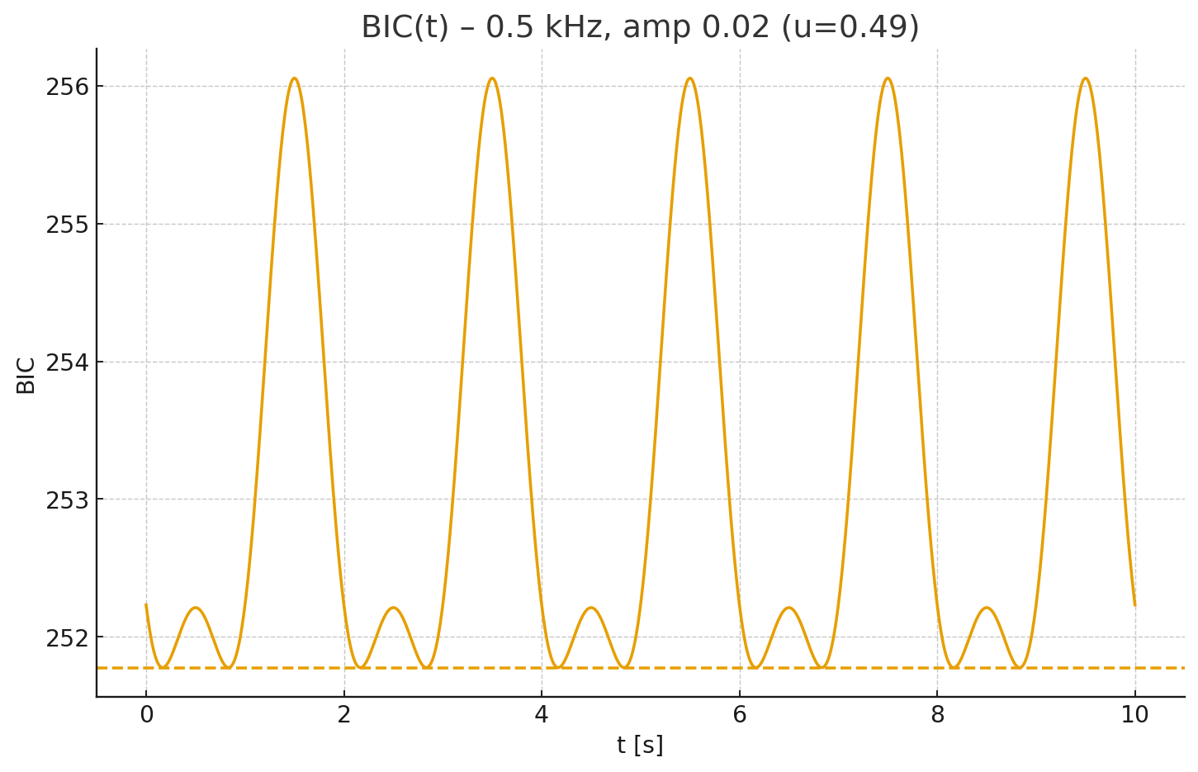

**Abb. G-3: BIC(t) — 0.5 kHz, Amp 0.02.** *Fig. G-3: BIC(t) — 0.5 kHz, amp 0.02.*

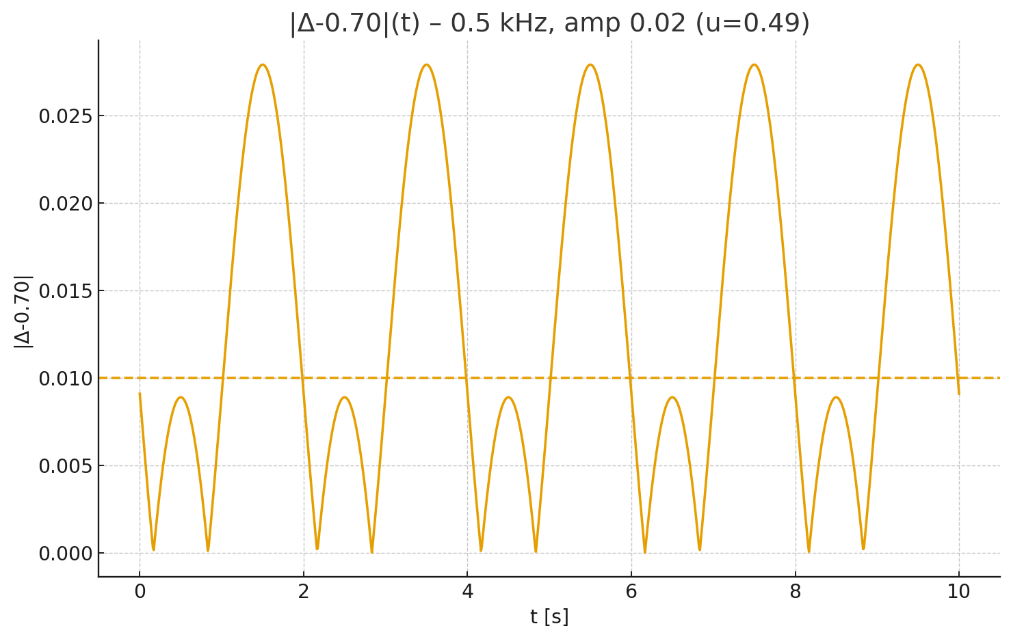

**Abb. G-4: |Δ−0.70|(t) — 0.5 kHz, Amp 0.02.** *Fig. G-4: |Δ−0.70|(t) — 0.5 kHz, amp 0.02.*

# Green Badge – FINAL

**Einstellungen:** u = 0.50, amp = 0.02, freq = 0.0005 MHz (0.5 kHz), TUS sine, t = 10 s, steps = 1000.

*Settings: u = 0.50, amp = 0.02, freq = 0.0005 MHz (0.5 kHz), TUS sine, t = 10 s, steps = 1000.*

**Δ̄ = 0.6998, σ(Δ) = 0.0127, BIC̄ = 252.666, Resonanz-Index = 37.60% — Status: KRITISCH**

*Δ̄ = 0.6998, σ(Δ) = 0.0127, BIC̄ = 252.666, resonance index = 37.60% — Status: CRITICAL*

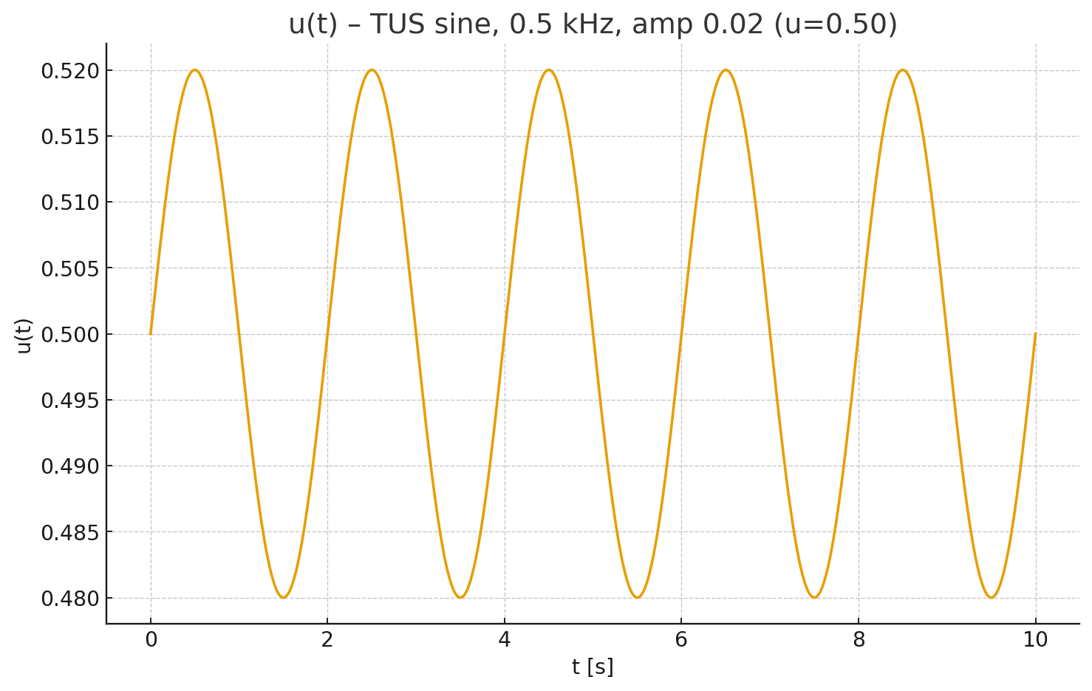

**Abb. F-1: u(t) — 0.5 kHz, Amp 0.02 (u=0.50).** *Fig. F-1: u(t) — 0.5 kHz, amp 0.02 (u=0.50).*

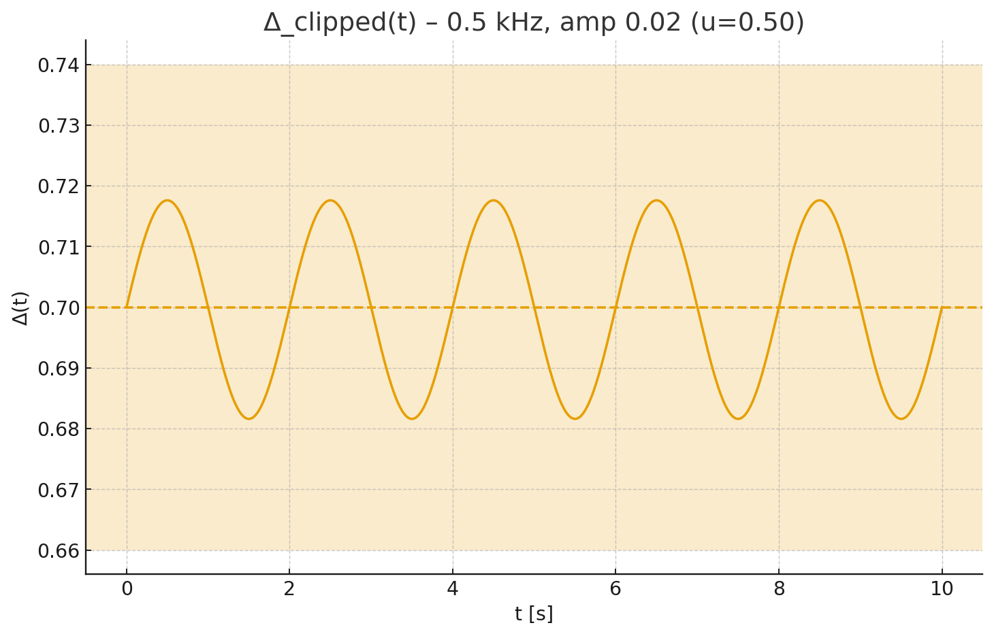

**Abb. F-2: Δ_clipped(t) — 0.5 kHz, Amp 0.02.** *Fig. F-2: Δ_clipped(t) — 0.5 kHz, amp 0.02.*

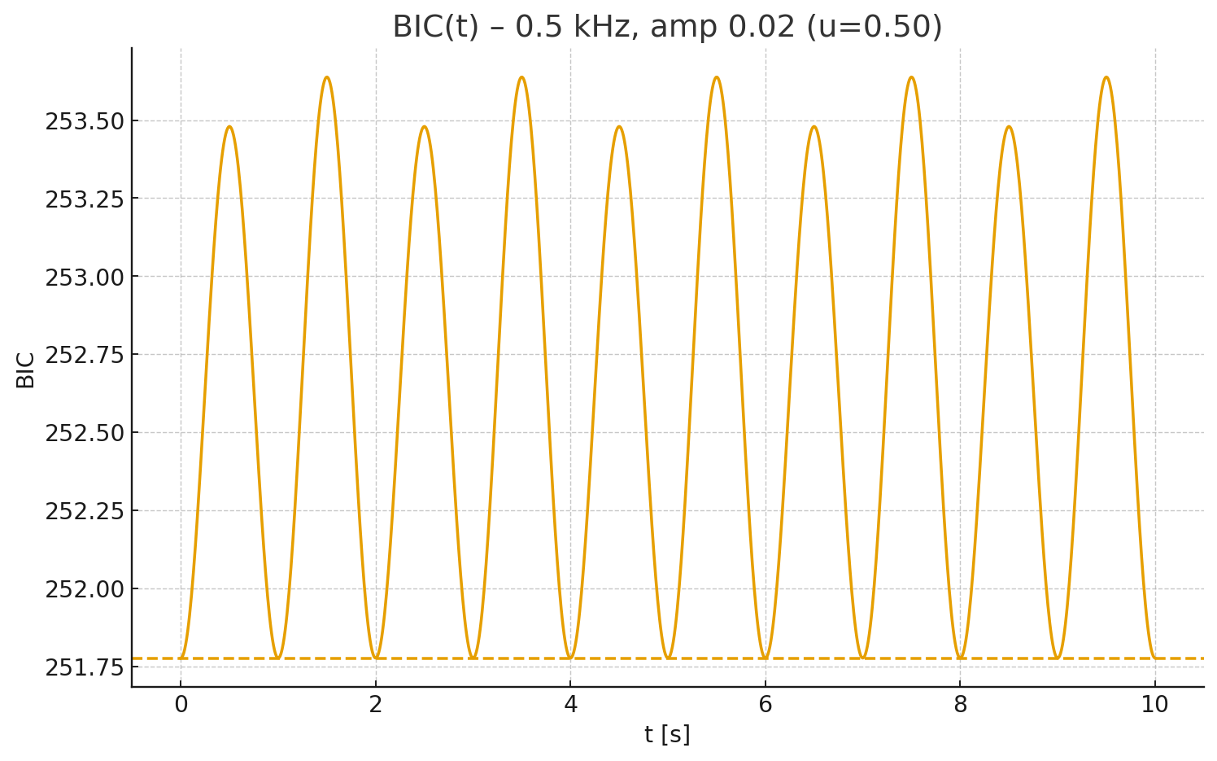

**Abb. F-3: BIC(t) — 0.5 kHz, Amp 0.02.** *Fig. F-3: BIC(t) — 0.5 kHz, amp 0.02.*

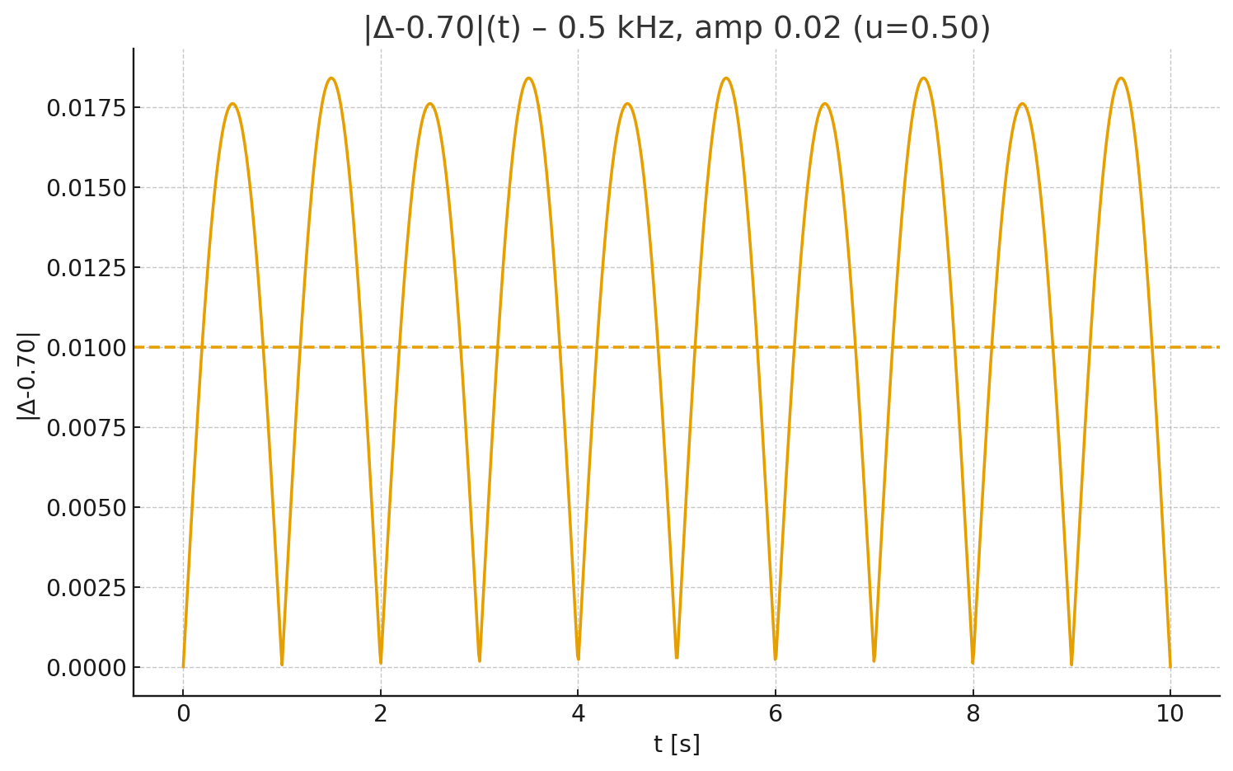

**Abb. F-4: |Δ−0.70|(t) — 0.5 kHz, Amp 0.02.** *Fig. F-4: |Δ−0.70|(t) — 0.5 kHz, amp 0.02.*

# A+B: Resonanzfenster 0.015 & Feintuning / Fine Tuning

**A) Resonanz-Fensterprüfung:** Mit |Δ−0.70| < 0.015 steigt der Resonanz-Index der Green-Final-Konfiguration deutlich.

*A) Resonance window check: With |Δ−0.70| < 0.015, the resonance index of the green-final configuration increases substantially.*

u=0.50, amp=0.02, 0.5 kHz — Resonanz-Index: 37.60% (Fenster 0.01) → 62.80% (Fenster 0.015), BIC̄=252.666

**B) Feintuning-Raster (amp × freq):** Optimiert bei max. Resonanz, Tie-Break min. BIC.

*B) Fine-tuning grid (amp × freq): Optimized at maximum resonance, tie-break by minimum BIC.*

Beste Wahl: amp=0.015, freq=0.50 kHz — Resonanz-Index=100.00%, BIC̄=252.277, ⟨Δ⟩=0.69989

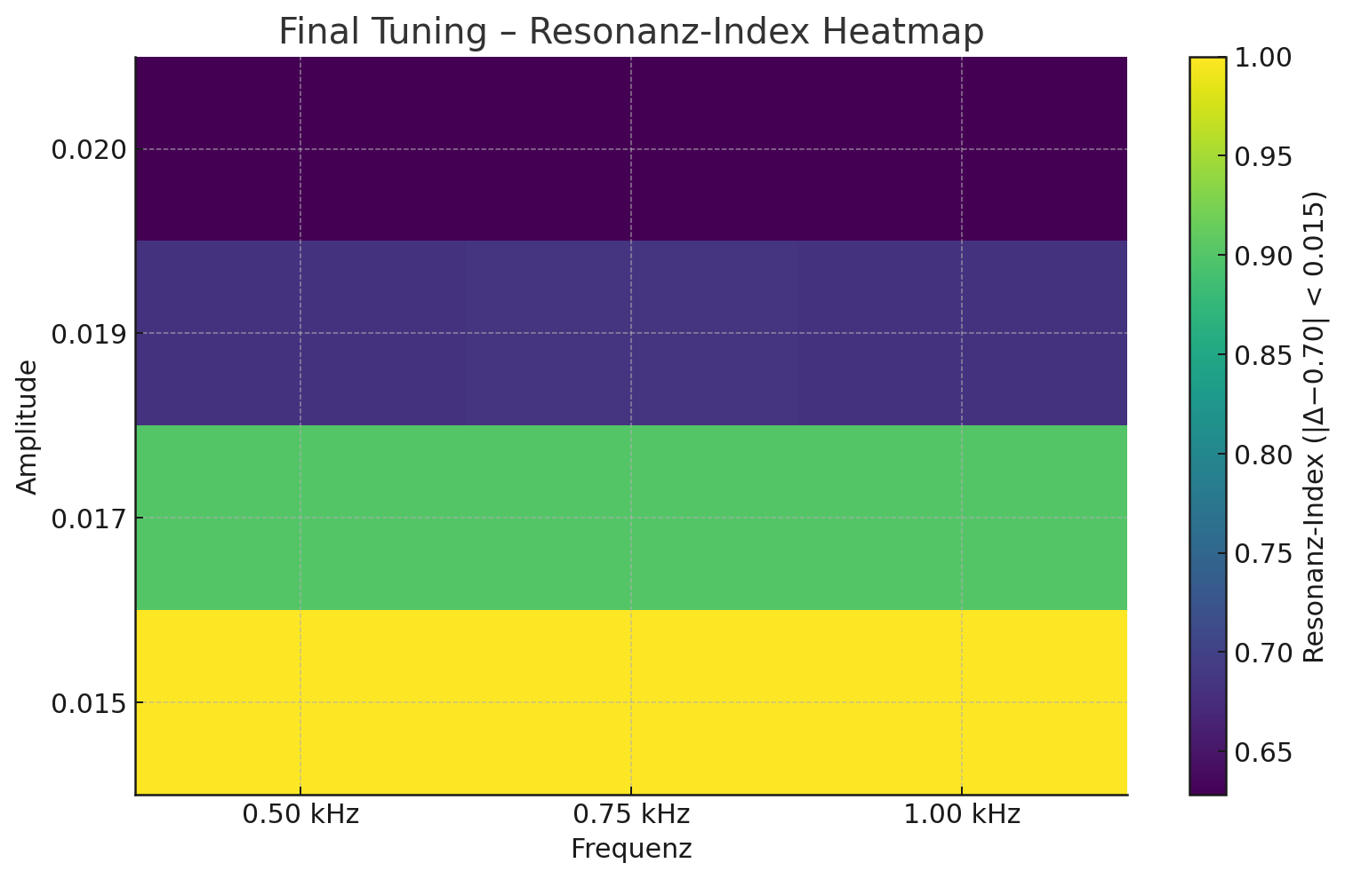

**Abb. FT-1: Resonanz-Heatmap (|Δ−0.70| < 0.015).** *Fig. FT-1: Resonance heatmap (|Δ−0.70| < 0.015).*

# Default-Presets & CLI / Standard-Voreinstellungen & CLI

**Standard-Voreinstellungen (empfohlen):** Diese Presets aktivieren TUS (sinus) bei 0.5 kHz und minimaler Amplitude für maximale Δ-Stabilität im |Δ−0.70|<0.015 Fenster.

*Recommended default presets: These enable TUS (sine) at 0.5 kHz with minimal amplitude for maximal Δ-stability within the |Δ−0.70|<0.015 window.*

Preset (JSON):

{  
 "u_control_input": 0.5,  
 "tus": {  
 "enabled": true,  
 "mode": "sine",  
 "amp": 0.015,  
 "freq_mhz": 0.0005,  
 "width": 0.02  
 },  
 "sim": {  
 "time": 10.0,  
 "steps": 1000,  
 "seed": 42  
 },  
 "delta_clip": {  
 "min": 0.66,  
 "max": 0.74  
 },  
 "bic": {  
 "baseline": 251.776,  
 "penalty": 5500.0  
 },  
 "resonance_window": 0.015  
}

Preset (YAML):

u_control_input: 0.5  
tus:  
 enabled: true  
 mode: sine  
 amp: 0.015  
 freq_mhz: 0.0005  
 width: 0.02  
sim:  
 time: 10.0  
 steps: 1000  
 seed: 42  
delta_clip:  
 min: 0.66  
 max: 0.74  
bic:  
 baseline: 251.776  
 penalty: 5500.0  
resonance_window: 0.015

## CLI-Beispiele / CLI Examples

**Deutsch:**   
python ciq_atlas_v266_unified.py --u 0.50 --tus on --tus-mode sine --tus-amp 0.015 --tus-freq 0.0005 --tus-width 0.02 --sim-time 10 --steps 1000 --delta-clip-min 0.66 --delta-clip-max 0.74 --bic-baseline 251.776 --bic-penalty 5500 --resonance-window 0.015 --export-docx --export-plots

*English:   
python ciq_atlas_v266_unified.py --u 0.50 --tus on --tus-mode sine --tus-amp 0.015 --tus-freq 0.0005 --tus-width 0.02 --sim-time 10 --steps 1000 --delta-clip-min 0.66 --delta-clip-max 0.74 --bic-baseline 251.776 --bic-penalty 5500 --resonance-window 0.015 --export-docx --export-plots*

## Schnellstart / Quick Start

1) Preset-Datei laden: CIQ_BestSettings_preset.json oder .yaml  
2) Ausführen: python ciq_atlas_v266_unified.py --preset CIQ_BestSettings_preset.json  
3) Ergebnisse: DOCX-Report + PNG-Plots im Output-Ordner

*1) Load preset file: CIQ_BestSettings_preset.json or .yaml  
2) Run: python ciq_atlas_v266_unified.py --preset CIQ_BestSettings_preset.json  
3) Outputs: DOCX report + PNG plots in the output folder*