Project: Smart Waste Management System of Canberra

Table of Contents
Part 2 — System Implementation 1
2.1 Overview of Implemented Components 1
2.2 Implemented Modules 1
2.2.1 User Authentication Module 1
2.2.2 Bin Monitoring and Status Module 1
2.2.3 Collection Route Display Module 1
2.2.4 Resident Reporting Module 2
2.3 User Interface 2
2.4 Algorithms and Logic 6
2.5 Architecture 6
2.6 Software Components and Tools 8
References 9

Part 2 — System Implementation

2.1 Overview of Implemented Components
The initial design of the Smart Waste Management System (SWMS) of Canberra defines the main architecture and the functional modules of the system. The first agile development in the iteration was the Iteration 1 aimed at the creation of a minimum viable product (MVP) that would illustrate the main data flows and user-friendly features of the system. Its implementation is organized into three layers a React-based frontend, a Node.js/Express backend REST API and a PostgreSQL relational database, in line with the principles of modern three-tier application architecture (Bass et al., 2021).

2.2 Implemented Modules

2.2.1 User Authentication Module
Authentication module has secure user registration, login and session management. Stateless sessions maintained via JSON Web Tokens (JWT) are a part of client-server interactions and eliminate session storage on the server-side and enable horizontal scalability (Shklar and Rosen, 2022). RBAC distinguishes the three user roles including Resident, Waste Collection Officer and Administrator. Role-based access is granted to each role, by limiting routes and dashboard views through middleware on the API layer.

2.2.2 Bin Monitoring and Status Module
This module is the main domain logic of the system. A system assigns each registered bin a unique identifier and matched with a GPS location, type of bin (general, recycling or organic) and fill-level status. Iteration 1: Data is simulated using a seeded dataset to recreate fill-level data, which is similar to IoT sensor input, which is recommended when the prototyping process is used when integrating physical hardware occurs at a later stage (Sommerville, 2016). The module reveals REST API endpoints to enable the frontend to query the status of bins in Canberra suburbs in real time, filter by fill level, and show bin alerts when reaching over 80% capacity.

2.2.3 Collection Route Display Module
The system put in place a read-only route display module, which would display the scheduled waste collection routes on an interactive map interface. The frontend uses Leaflet.js mapping library to draw the overlays of routes at the suburbs level. The database contains route data, accessed via API when the page loads. This module provides the basis to dynamic route optimisation, which will be implemented in Iteration 2.

2.2.4 Resident Reporting Module
Through an organized form, residents are able to report issues associated with waste collection like missed collections, overflowing cans or damaged infrastructure. The reports will include a capture of the suburb, type of issue, description and optional image upload. Reported data is stored in the database and made available in the Administrator dashboard to view and take action upon. There is input validation on the client side (React Hook Form) and the server side (Express Validator) to guarantee integrity of data (Mozilla Developer Network, 2023).

2.3 User Interface
The frontend was designed and built with React 18 and Tailwind CSS as an utility-first styling framework to create a responsive layout that can run on a desktop system and mobile viewport. The app is made up of the following major views:
- Login / Registration Page - processes input of credentials and role redirection after authentication.
- Resident Dashboard - shows an overview of the bin statuses around the house and provides an opportunity to report the issue.
- Administrator Dashboard — displays a table with all bin statuses, incoming reports, and system alerts.
- Interactive Map View - displays the location of bins and fill-level indicators on a map using Leaflet.js, markers with colours (green, amber, red) indicating low, medium and high fill-levels respectively.
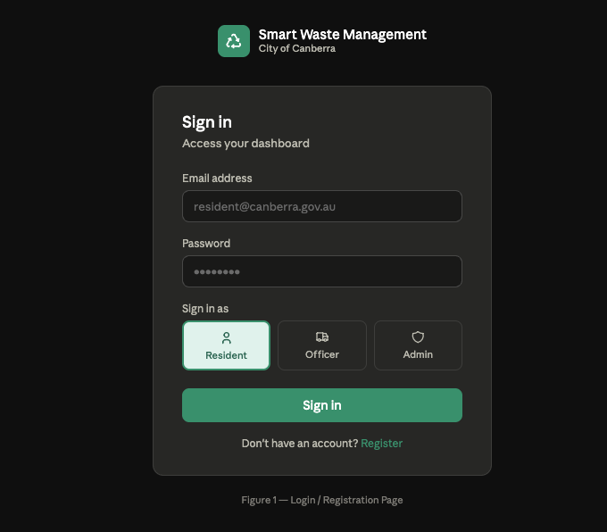
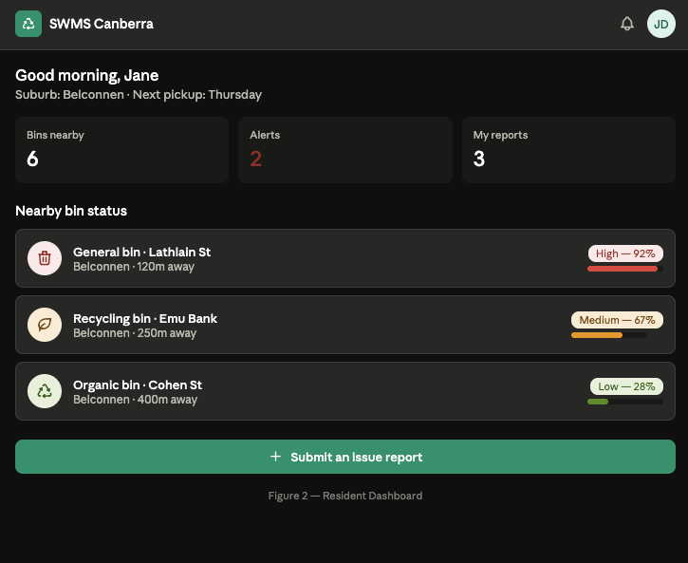
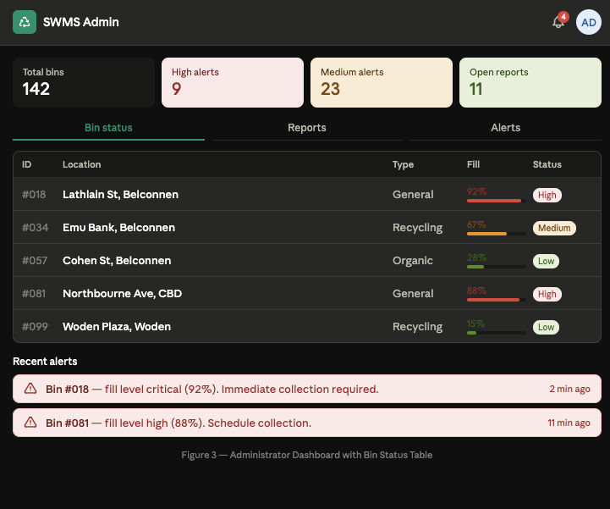
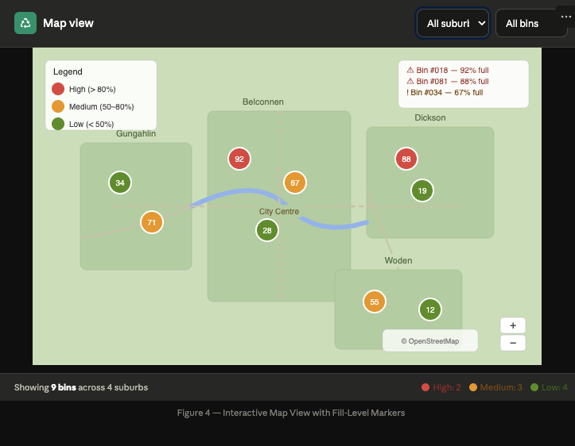

2.4 Algorithms and Logic
The main algorithm used in Iteration 1 is a threshold alert generation algorithm. Upon receiving fill-level information sent by the bin monitoring module, the system compares the fill-percent of each bin with pre-programmed fill-level thresholds (>80% high-priority alert; 50-80% medium-priority alert). Notifications are logged to a special notifications table and displayed on the administrator dashboard in real time through a polling of the database at 30-second intervals. The reason why this method was selected is that it is easy and can be used without the WebSocket infrastructure that will be introduced in a further version (Tanenbaum & Van Steen, 2017).

2.5 Architecture
The system is based on RESTful client-server architecture and separation of concerns between presentation, business logic and data layers. Communication of API is done on HTTP with the use of JSON payloads. The database schema was normalised to the third normal form (3NF) to have no data redundancy and referential integrity among entities such as Users, Bins, Routes, Reports and Alerts (Elmasri and Navathe, 2016).
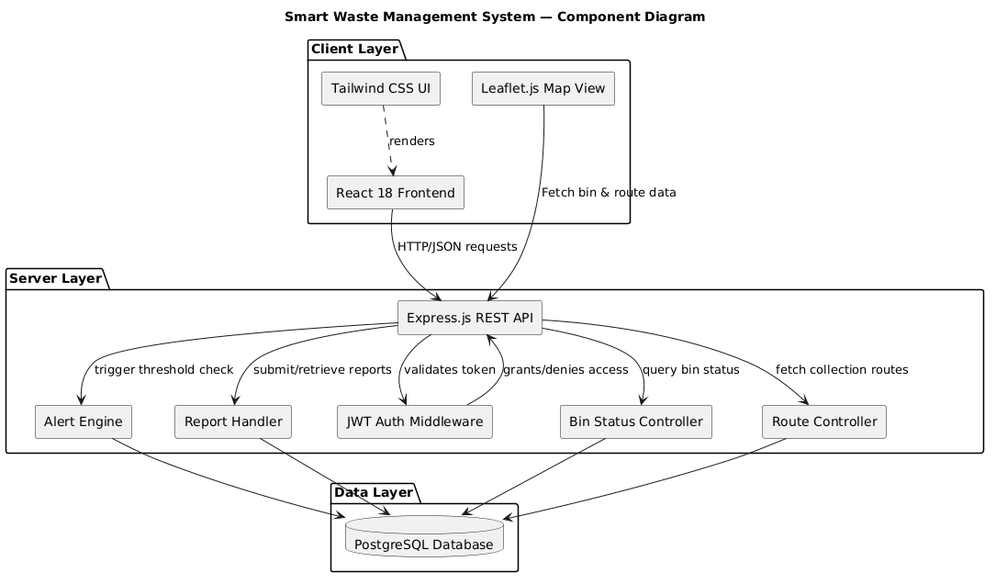
Figure 5 — UML Component Diagram: System Architecture
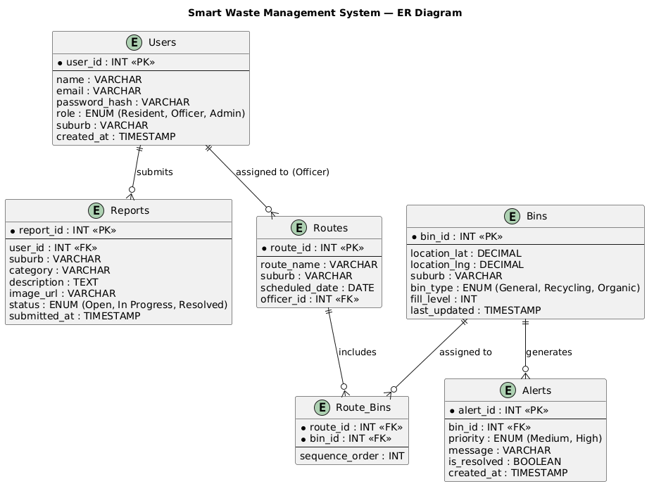
Figure 6 — UML Entity-Relationship Diagram: Database Schema

2.6 Software Components and Tools
Component | Technology
Frontend Framework | React 18, Tailwind CSS
Backend Framework | Node.js, Express.js
Database | PostgreSQL
Authentication | JWT, bcrypt
Mapping Library | Leaflet.js
Form Validation | React Hook Form, Express Validator
API Testing | Postman
Version Control | GitHub

References
Bass, L., Clements, P., & Kazman, R. (2021). Software architecture in practice (4th ed.). Addison-Wesley.
Elmasri, R., & Navathe, S. B. (2016). Fundamentals of database systems (7th ed.). Pearson.
Mozilla Developer Network. (2023). Client-side form validation. https://developer.mozilla.org/en-US/docs/Learn/Forms/Form_validation
Shklar, L., & Rosen, R. (2022). Web application architecture: Principles, protocols and practices (2nd ed.). Wiley.
Sommerville, I. (2016). Software engineering (10th ed.). Pearson.
Tanenbaum, A. S., & Van Steen, M. (2017). Distributed systems: Principles and paradigms (3rd ed.). Pearson.

