Model Validation Report

# Model Performance Metrics

This section includes generic model performance metrics.

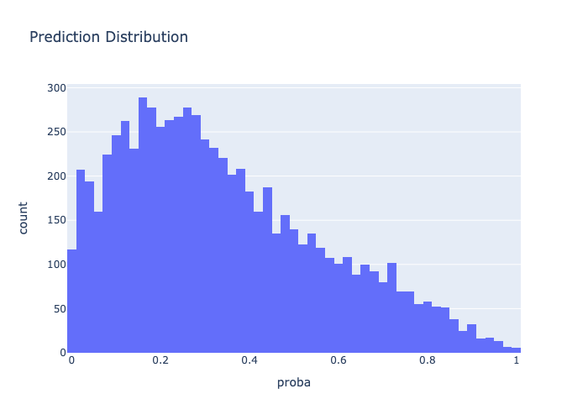

Accuracy: 0.7657174301829688   
 Precision: 0.01738122827346466   
 Recall: 0.8108108108108109   
 F1 Score: 0.03403289846851957

