1. **Add Product page**

Adding product provide a form to collect information of a product, including product name, product price and product image. The collected information is stored within ‘products’ table in MySQL database.

All input boxes are required to be not empty, or a prompting box will display next to the empty box to ask user fill it.

Each added product is assigned a random generated id string, and the uploaded image will be locate in ‘uploaded_files’ file. The table ‘products’ including attribute {“id”, “name”, “price”, “image”}, in which “id” is the random generated id; “name”, “price” are from user input; “image” is the file path.

1. **View Product page**

View product page displays all added products from table ‘products’. The information include the display image, name, price of item, the number wanted. And two buttons ‘Add To Cart’ and ‘Buy now’.

Display image and name are fetched from table ‘products’. The number wanted is a numerical input box, default to 1. ‘Add to cart’ button insert the product to ‘cart’ table, attribute include {“id”, “user_id”, “product_id”, “price”, “qty”}. ‘Buy now’ links to Checkout Summary page.

1. **Cart page**

Cart page display all products added to the cart, their image information, titles, price of item and the number wanted. User can adjust the number wanted and validate the change by click yellow button at the right, and delete a product from cart table.

There is a division calculate the total price of all products in cart, in which a ‘Empty Cart’ button can delete all products from cart; ‘Proceed to Checkout’ will links to Checkout Summary page.

1. **Checkout Summary page**

Checkout Summary page collect information from user to insert a record into table ‘order’. All input boxes need to be filled, or a prompting box will display next to the empty box to ask user fill it. The ‘Place Order’ is the submission button to execute insertion and link to My Orders page.

On the right side it display the information of items, including images, titles, prices of item and quantities, then a grand total price is computed to present.

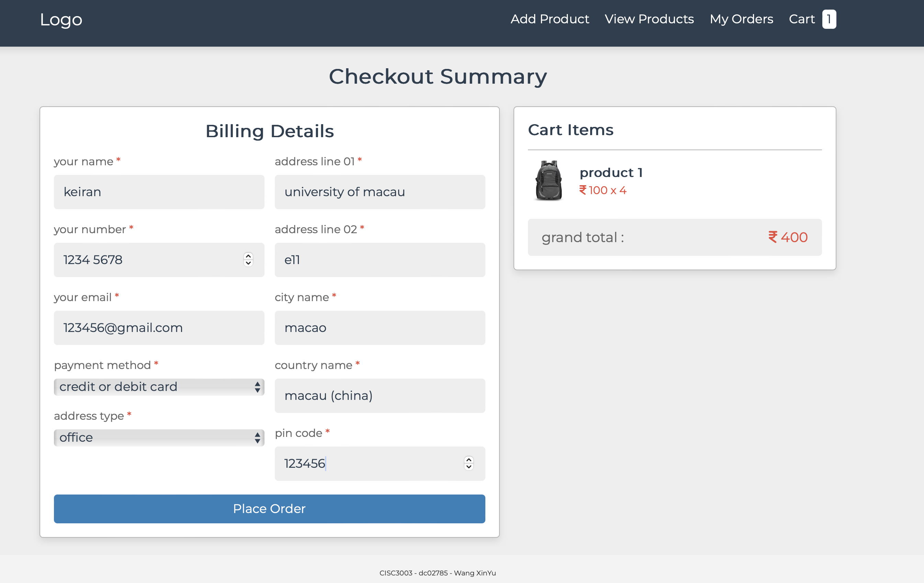

1. **My Orders page**

Display all records in table ‘order’, only product information is displayed here. Including the date time when order is made, product image, title, price of item and quantity, and the current process of order.

User can click a box to enter Order Details page, where all order information is represented. Including the date time when order is made, product image, title, price of item and quantity, total price, user name,

In Order Details page user can click ‘Cancel Order’ button to delete this record from table ‘order’, receiver name, phone number, email address, location.

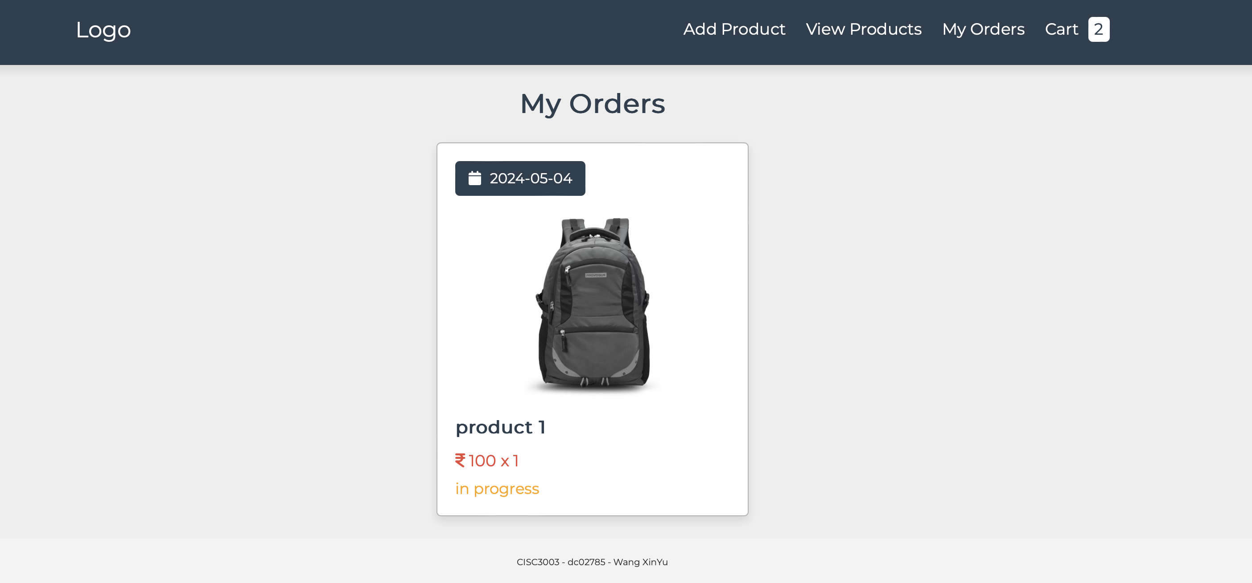

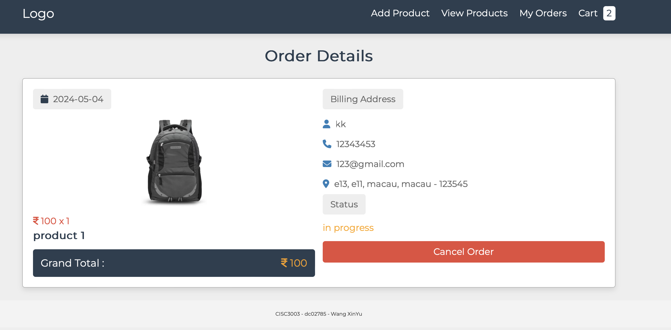

1. **Responsive Design**

This multi-page website follows the principle of responsive design.

The header navigation bar will be hidden when the width of screen is narrow, replaced by a hamburger icon which can be clicked and open the list of navigation bar.

And the in-line display box will be reorganized to fit the width of browser. They are then aligned in column.

