Metric | AS IS baseline | PoC result
Feed load, p95 each time | 38 ms | 96 ms
Keyword search, p95 time | N/A | 114 ms
Test requests | N/A | 11
Average search time | N/A | 72.2 ms
Publish time | N/A | 67 ms
Delete time | N/A | 78 ms
Dataset size and test computer | 1,000 synthetic SQL records; AMD Ryzen 5 5600G, 16 GB DDR4-2667 RAM, SATA SSD | 4 MongoDB memories; AMD Ryzen 5 5600G, 16 GB DDR4-2667 RAM, SATA SSD

Note. Both tests were conducted on the same computer equipped with an AMD Ryzen 5 5600G processor, 16 GB DDR4-2667 RAM, and a SATA SSD. The SQL baseline used 1,000 synthetic records, while the Sovara system used its MongoDB memory dataset. Since the dataset sizes differ, the measured response times should be interpreted as preliminary results rather than a direct performance comparison. The p95 values were calculated from 11 requests using the nearest-rank method.

Evidence | Location
Screenshot 1: running containers (docker compose ps) | 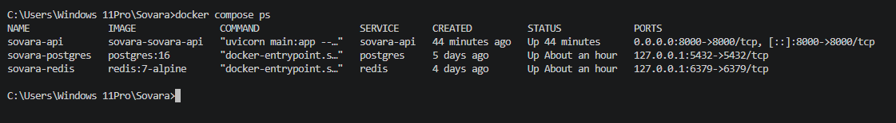
Screenshot 2: API page (https://localhost:800/docs) | 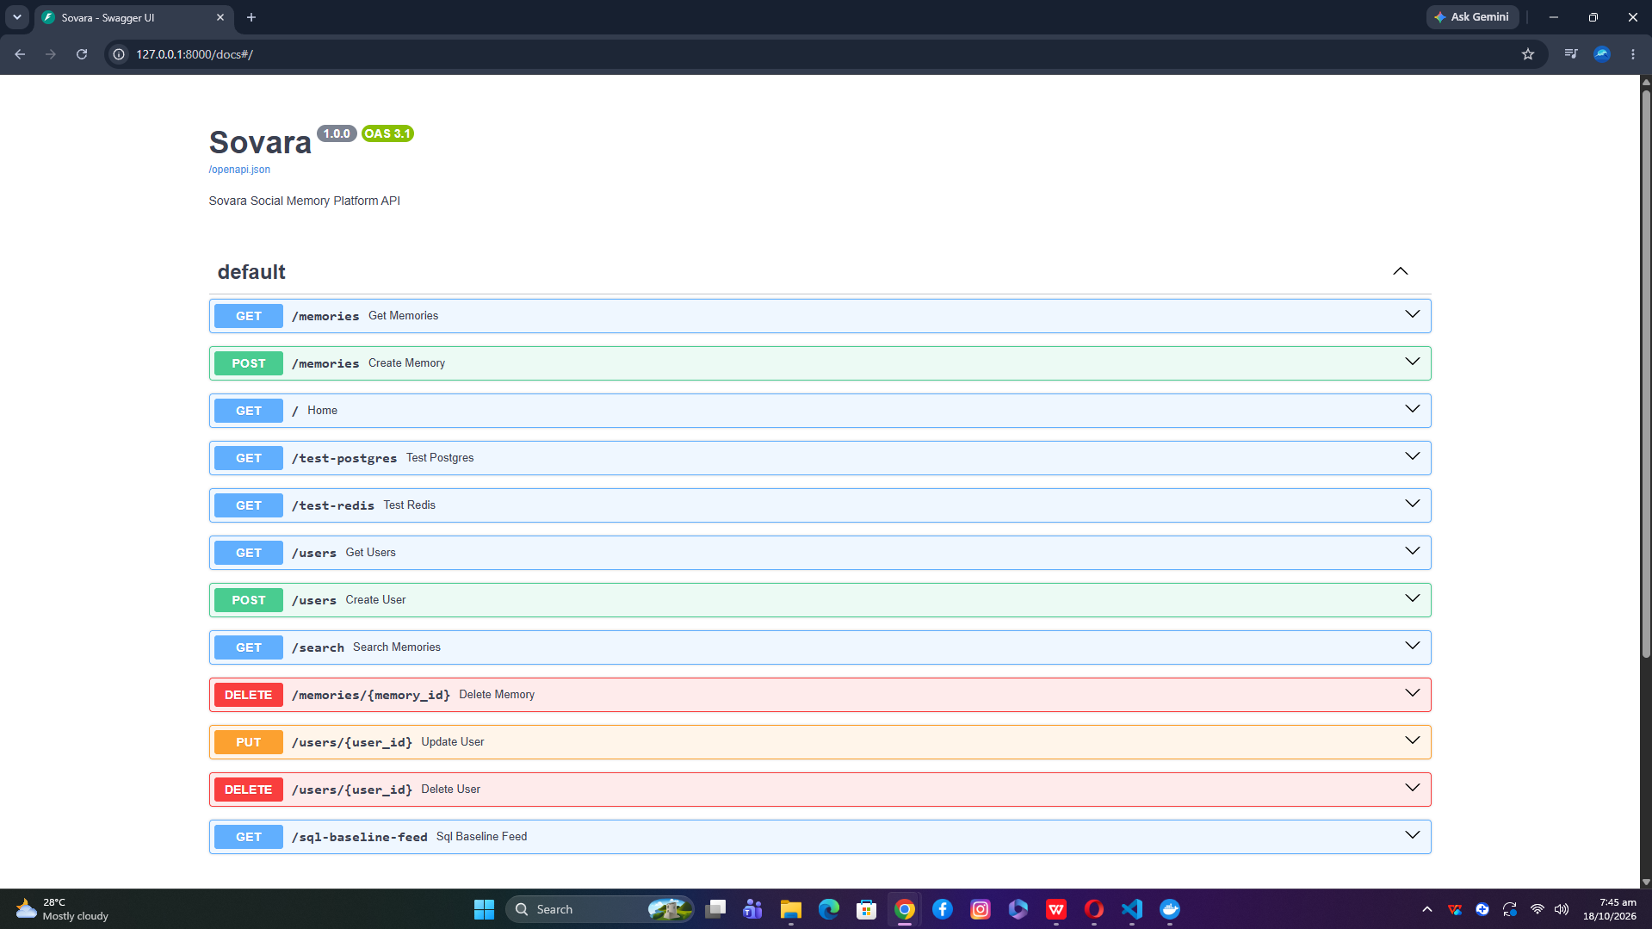
Screenshot 3: publish, search, and privacy filter in the demo output
Screenshot 4: delete saga (before and after) and audit log
Demo video (3 to 5 minutes)
GitHub repository

