SmartShelf Enterprise Platform
Comprehensive User Guide & Technical Operations Manual
Automated Expiry Alert & Intelligent Shelf Inventory System
Release v1.2.0 Enterprise | Desktop Web SaaS & Streamlit Dual Suite | October 2026

Table of Contents
1. Executive Summary & Core Capabilities
2. System Architecture & Dual Frontends
3. Technology Stack & Component Details
4. How to Launch & Run the Project
5. Stitch Enterprise UI Walkthrough (All 7 Screens with Screenshots)
5.1 Screen 1: Executive Inventory Dashboard
5.2 Screen 2: Inventory Catalog & Item Inspector
5.3 Screen 3: Register New Product Form
5.4 Screen 4: Edit Product & Lifecycle Manager
5.5 Screen 5: Alerts & Expiration Exception Hub
5.6 Screen 6: Reports & Data Export Center
5.7 Screen 7: System Audit Log & Governance Ledger
6. Secondary Python-Native Streamlit Interface
7. REST API Endpoints Specification
8. Expiration & Low-Stock Business Rules
9. SQLite Database Schema & Audit Persistence
10. Automated Test Suite & Verification
11. Troubleshooting & FAQ

1. Executive Summary & Core Capabilities
SmartShelf is an intelligent inventory monitoring, shelf-life analytics, and automated expiry alert platform. Engineered for retail supermarkets, hypermarkets, convenience stores, and pharmaceutical supply chains, SmartShelf eliminates inventory shrinkage by proactively flagging items nearing shelf expiration and automating stock reorder thresholds.

Core Capabilities:
- Automated Expiry Horizon Monitoring: Calculates remaining shelf life using ISO-8601 dates and categorizes batches into Expired, Expiring Soon (<= 7 days), or Stable (OK).
- Dual Stock Safety Protection: Detects Out-of-Stock (0 quantity) and Low Safety Stock (quantity <= minimum threshold) with instant visual indicators.
- B2B Enterprise Single Page Application: Built directly with Google Stitch desktop-first UI designs, Inter typography, and Material Symbols.
- Full Real-Time CRUD Operations: Add, View, Live Search, Inspect, Edit, and Safely Delete catalog items with instant SQLite synchronization.
- Immutable Governance Audit Trail: Every addition, modification, and deletion is recorded in a chronological audit ledger with exact timestamps and descriptions.
- Enterprise Data Reporting & CSV Exports: One-click downloads for complete inventory CSV datasets and text summaries.
[ARCHITECTURE HIGHLIGHT] SmartShelf operates on a unified SQLite database, allowing multiple frontends (Stitch Enterprise Web UI and Streamlit Analytics) to seamlessly share the same live inventory state.

2. System Architecture & Merged Single Application
SmartShelf is unified into a single enterprise application combining the Google Stitch UI frontend, a high-performance Python FastAPI backend, an SQLite database, and an integrated Streamlit analytics studio:
Tier | Component | Function & Access
Main Application | Google Stitch Enterprise UI | Primary desktop SaaS SPA served at http://localhost:5000
Backend Engine | Python with FastAPI (main.py) | High-performance REST API with automatic Swagger docs at /docs
Database Layer | SQLite 3 (smartshelf.db) | WAL-mode transactional database located at smartshelf/data/smartshelf.db
Integrated Backup | Streamlit Analytics Studio | Embedded directly in the Stitch UI and active at http://localhost:8501
Business Logic | inventory_logic.py | Pure deterministic rules for expiry horizons and safety stock thresholds

3. Technology Stack & Component Details
Technology | Version / Spec | Role in SmartShelf
FastAPI | v0.143+ (Python 3.11) | High-performance asynchronous REST backend, route handlers, and OpenAPI
Uvicorn | ASGI Web Server | High-throughput server running the unified main application on port 5000
HTML5 / Tailwind CSS | Tailwind v3.4 CDN | Responsive B2B SaaS UI styling, custom tokens, grid architecture
Google Stitch Suite | Enterprise UI Suite | 7 fully integrated screens for catalog, dashboard, alerts, and governance
Material Symbols | Google Fonts | Monoline vector iconography for all actions, navigation, and alerts
Inter & JetBrains Mono | Google Fonts | Inter for typography headings/body; JetBrains Mono for numeric tabular figures
SQLite 3 | Python Standard Library | ACID-compliant relational database with WAL (Write-Ahead Logging)
Streamlit | >= 1.35.0 | Secondary/backup data studio embedded directly inside the main UI
Pytest | >= 8.0.0 | Automated test runner verifying business logic rules (9/9 passed)

4. How to Launch & Run the Project
You can launch the SmartShelf platform through multiple convenient methods:

Method 1: One-Click Windows Launcher (Recommended)
Double-click the file run_enterprise.bat in the project root directory. This opens the server and hosts the application at http://localhost:5000.

Method 2: Command Line (PowerShell / Terminal)
Open PowerShell or Command Prompt in the project folder and run:
cd "d:\cppe kei project 1"
python server.py 5000

Method 3: NPM Script
npm start

Method 4: Launching Streamlit Interface (Optional)
cd "d:\cppe kei project 1\smartshelf"
streamlit run app.py
Opens automatically at http://localhost:8501

5. Stitch Enterprise UI Walkthrough (All 7 Screens)
The Stitch Enterprise Platform includes 7 interconnected, high-density SaaS screens. Each screen has been unified into a single application with persistent sidebar navigation and real-time SQLite interaction:

5.1 Screen 1: Executive Inventory Dashboard (#dashboard)
The executive landing screen provides at-a-glance operational awareness across all merchandise categories:
- 5 Real-Time KPI Cards: Catalog SKUs, Total Units, Gross Valuation in Rs, Expired Batches, and Low Stock Reorders.
- Dynamic Alert Banners: Critical notice highlighting expired goods and reorder recommendations.
- Units by Category Bar Chart: Horizontal percentage distribution across Dairy, Beverages, Bakery, Produce, Grocery, and Household.
- Stock Health Segmented Bar: Real-time visual ratio of In Stock vs. Low Stock vs. Out of Stock.
- Upcoming Shelf Expirations Table: Priority batches requiring FEFO (First-Expired, First-Out) rotation with days-remaining countdowns.
- Quick Action Triggers: Direct jump buttons to Register New Product and Download CSV.

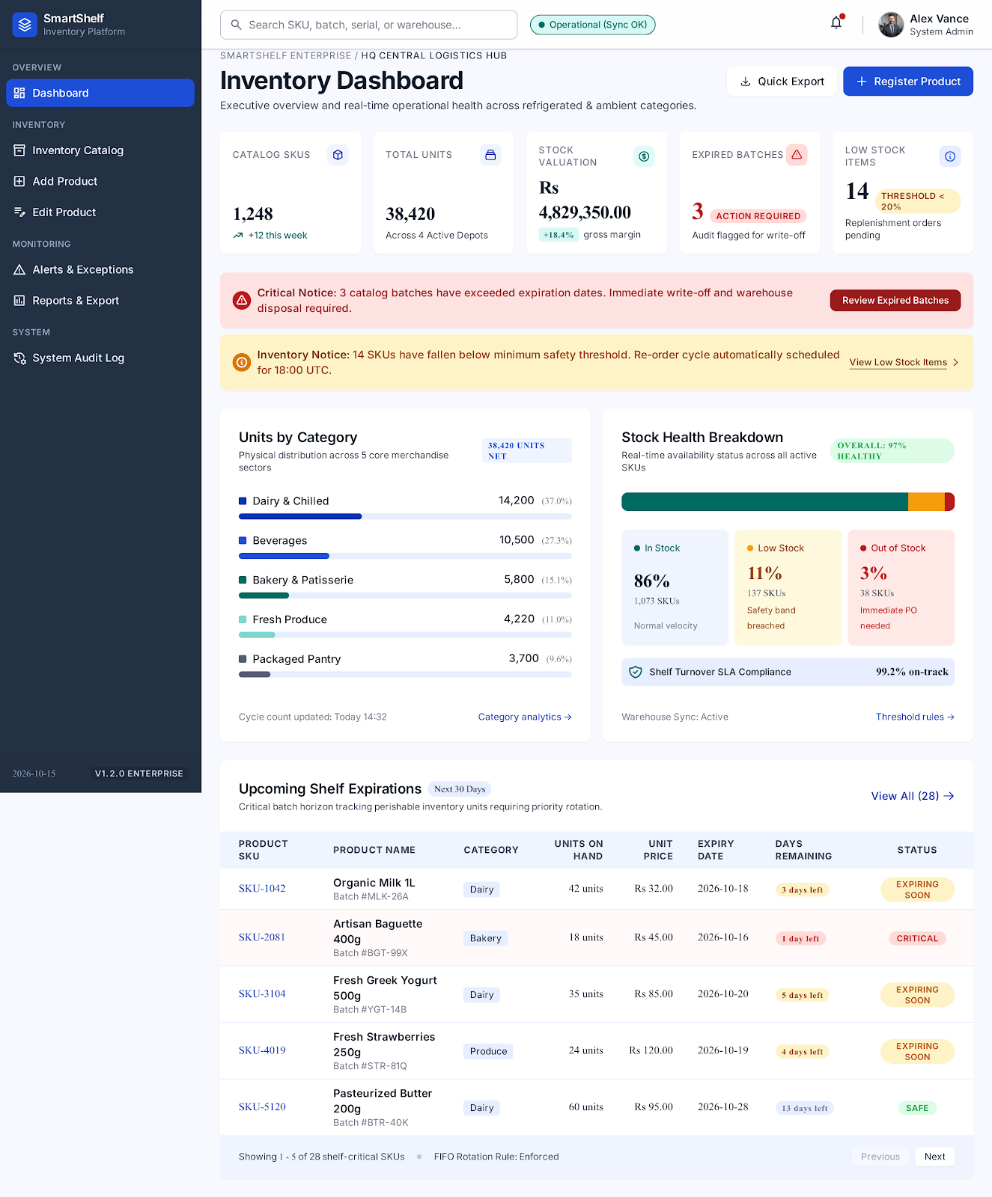
Figure: 5.1 Screen 1: Executive Inventory Dashboard Interface

5.2 Screen 2: Inventory Catalog & Item Inspector (#catalog)
The primary workspace for searching, filtering, and deeply inspecting product records:
- Multi-Filter Matrix: Real-time keyword search query, Category selector, Stock Level selector, and Expiry Lifecycle filter.
- Dense Product Table: Tabular records with SKU ID, Name, Category, Stock Units, Unit Price, Expiry Date, and color-coded status badges.
- Item Specification Inspector (Right Panel): Clicking any table row opens its full profile in the drawer, including product photo, threshold buffer progress bar, batch valuation, and expiry horizon.
- Direct Record Actions: 'Edit Product Record' pre-selects the item in the edit screen; 'Delete Product' triggers a confirmation modal.

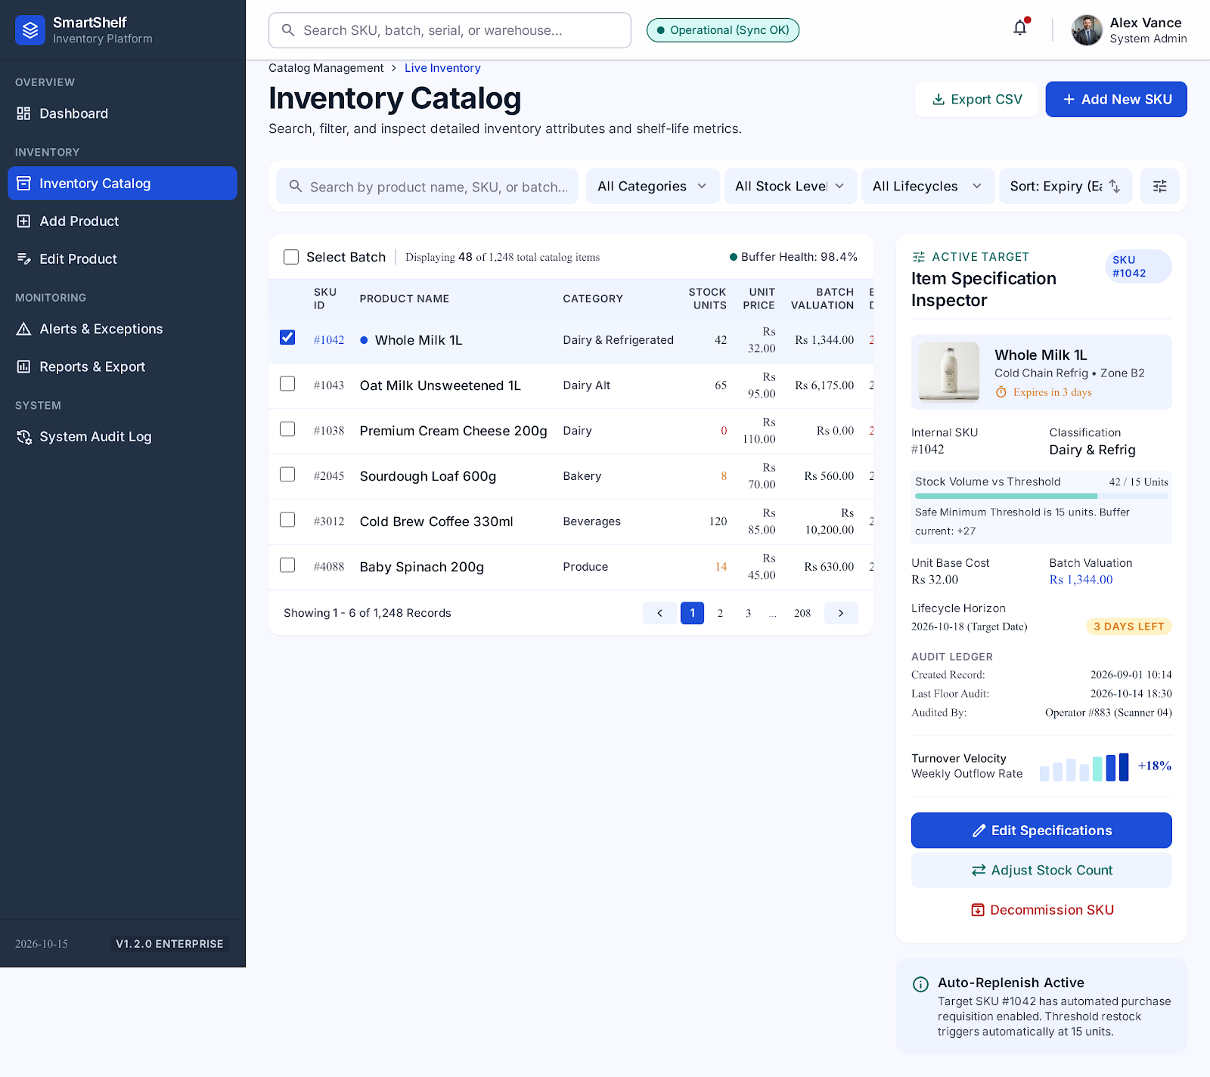
Figure: 5.2 Screen 2: Inventory Catalog & Item Inspector Interface

5.3 Screen 3: Register New Product Form (#register)
A guided catalog ingestion form with live preview and automatic valuation calculations:
- Product Identity: Trade name, category dropdown (with custom category support), and GS1 SKU reference.
- Inventory & Valuation: Real-time computation of batch valuation (Quantity x Unit Price) as numbers are typed.
- Lifecycle & Expiry Controls: Perishable checkbox toggle, date picker, and minimum safety threshold configuration.
- Live System Sync Card: Real-time card preview on the right side that updates simultaneously to reflect how the product will look in the catalog.
- Database Persistence: Saves to SQLite and appends an ADD entry to the audit log.

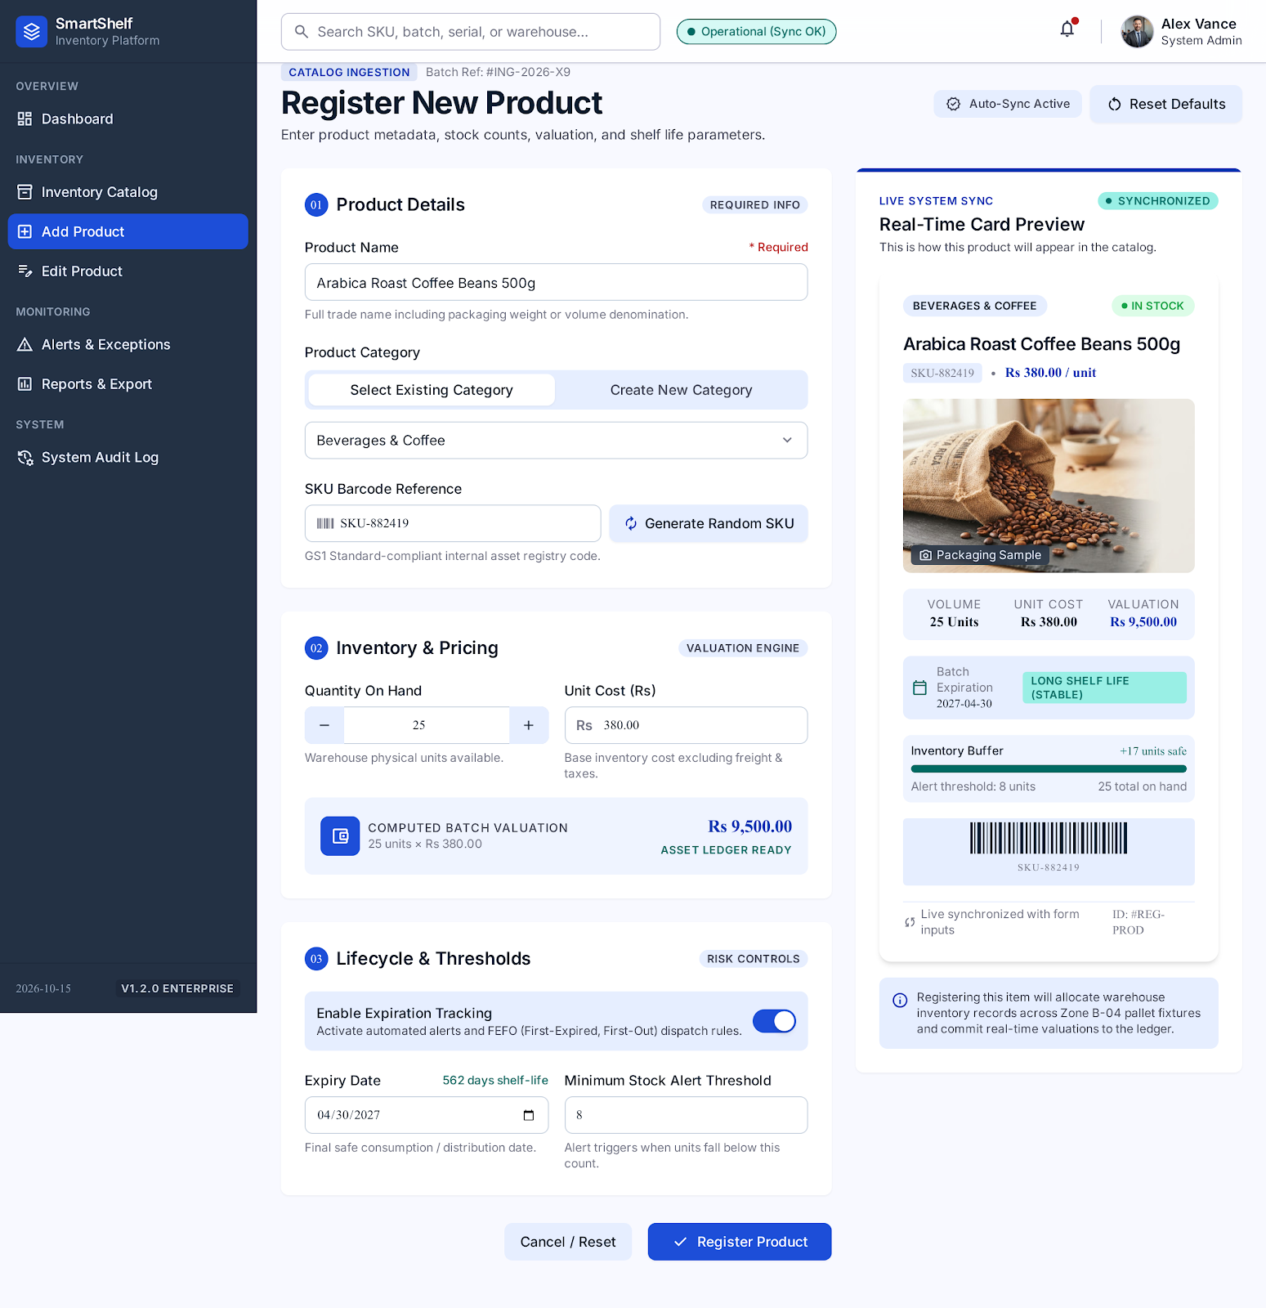
Figure: 5.3 Screen 3: Register New Product Form Interface

5.4 Screen 4: Edit Product & Lifecycle Manager (#edit)
Enables store managers to adjust stock counts, pricing, and expiry dates for existing inventory:
- Product Selector Dropdown: Searchable list of all catalog items by SKU and product name.
- Automatic Field Population: Selected product's current values populate immediately.
- Parameter Updates: Change stock quantity, unit price, threshold, or extend expiration date.
- Audit Logging: Generates an EDIT transaction in the system ledger upon saving.

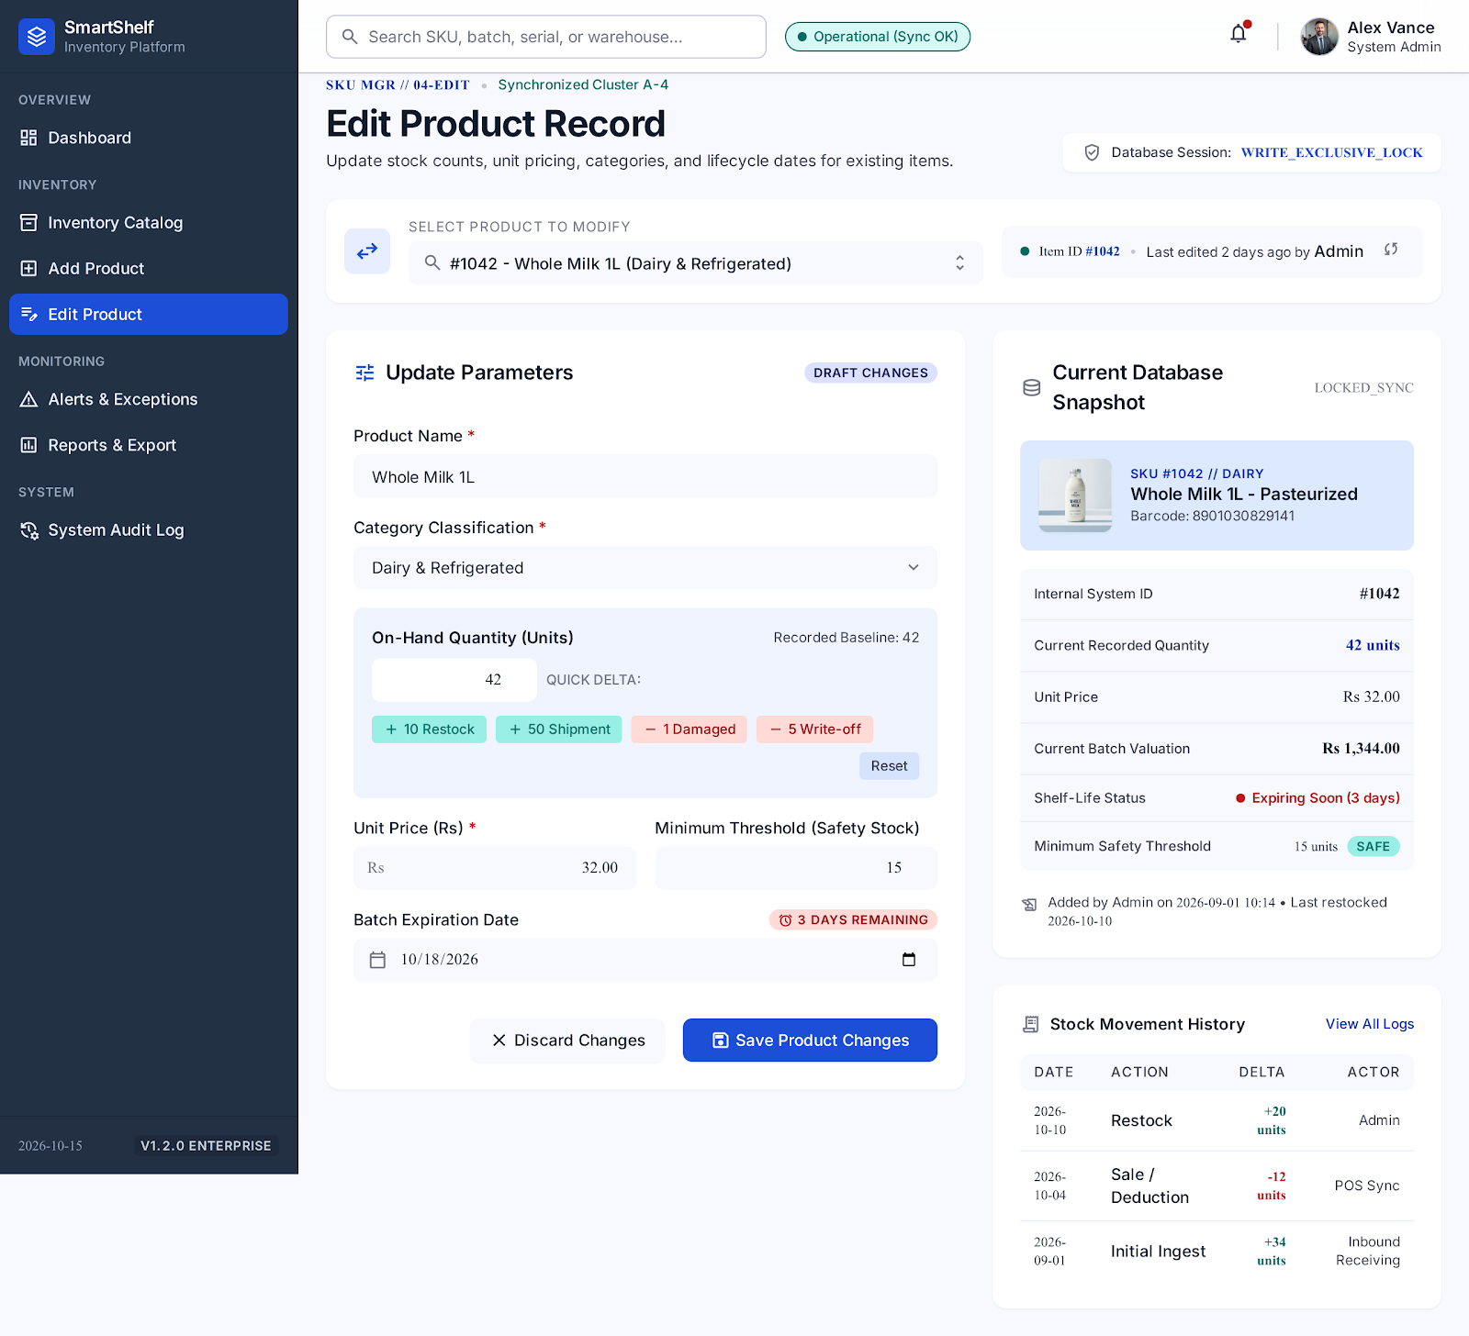
Figure: 5.4 Screen 4: Edit Product & Lifecycle Manager Interface

5.5 Screen 5: Alerts & Expiration Exception Hub (#alerts)
Dedicated exception dispatch center focused on preventing revenue loss and food waste:
- Bento Risk Trio: Expired Stock (with automated total write-off financial loss calculation), Impending Expirations (<= 7 days), and Depleted / Low Stock counts.
- Critical Expired Batches Table: Lists batches that have passed expiration date and must be removed from shelves immediately.
- Low Safety Stock Table: Lists depleted and low-inventory products requiring purchase order reorders.
- Alert Export: Dedicated button to export filtered exception data.

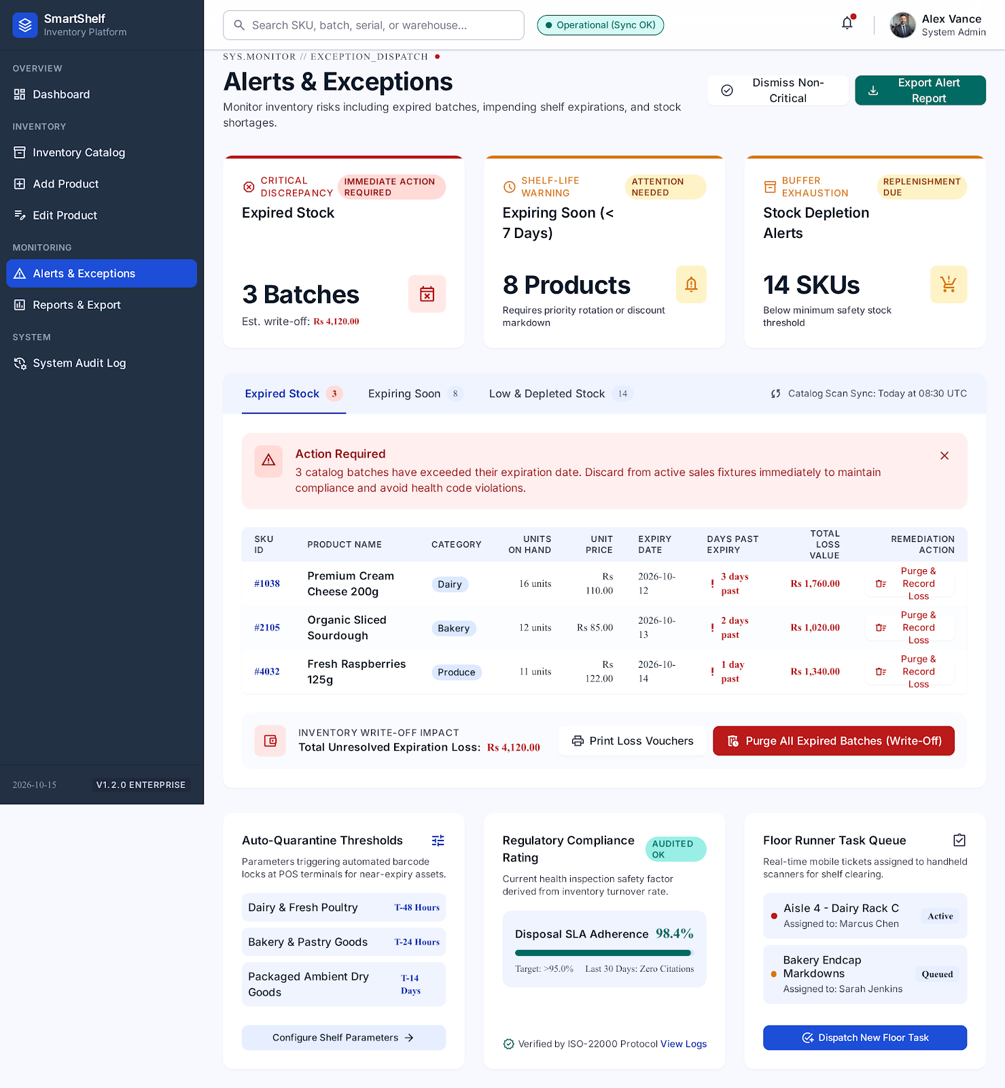
Figure: 5.5 Screen 5: Alerts & Expiration Exception Hub Interface

5.6 Screen 6: Reports & Data Export Center (#reports)
Analytics and external audit center for downloading full inventory datasets:
- Financial KPI Metrics: Total SKUs, Aggregate Units, Gross Inventory Valuation, and Expired Write-Off Loss.
- One-Click CSV Export: Downloads complete 'smartshelf_inventory.csv' formatted for Microsoft Excel or Google Sheets.
- One-Click Text Summary: Downloads formatted 'smartshelf_summary.txt' containing executive snapshot figures.

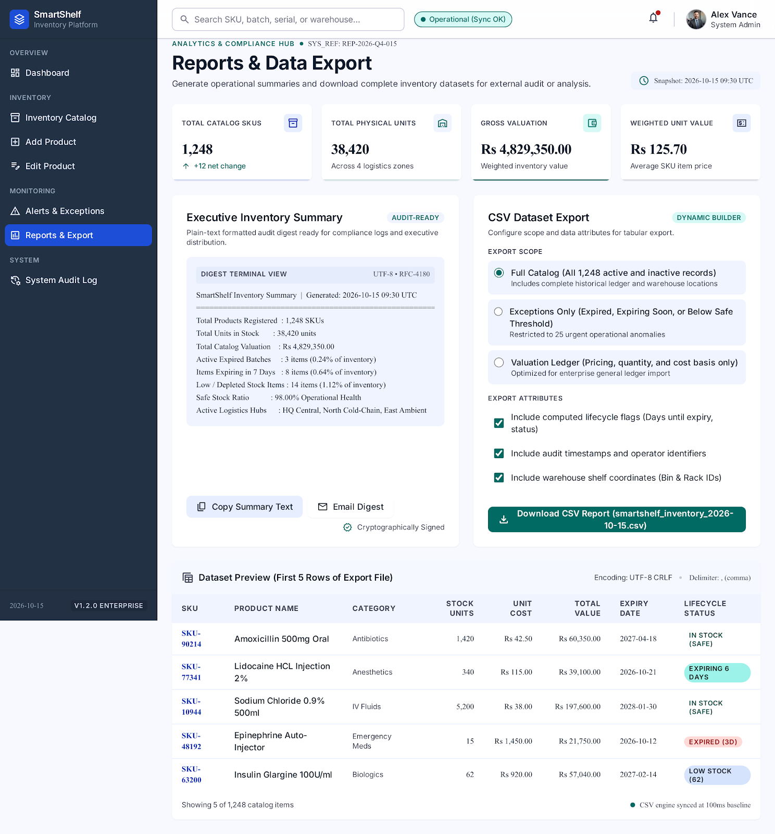
Figure: 5.6 Screen 6: Reports & Data Export Center Interface

5.7 Screen 7: System Audit Log & Governance Ledger (#audit)
Chronological event ledger providing complete compliance traceability:
- Immutable Record History: Every ADD, EDIT, and DELETE action is permanently stamped with timestamp, product ID, and event notes.
- Color-Coded Badges: Green ADD badges, Blue EDIT badges, and Red DELETE badges.
- Export Audit Log (JSON): Dedicated button to download the entire audit log as a JSON file.

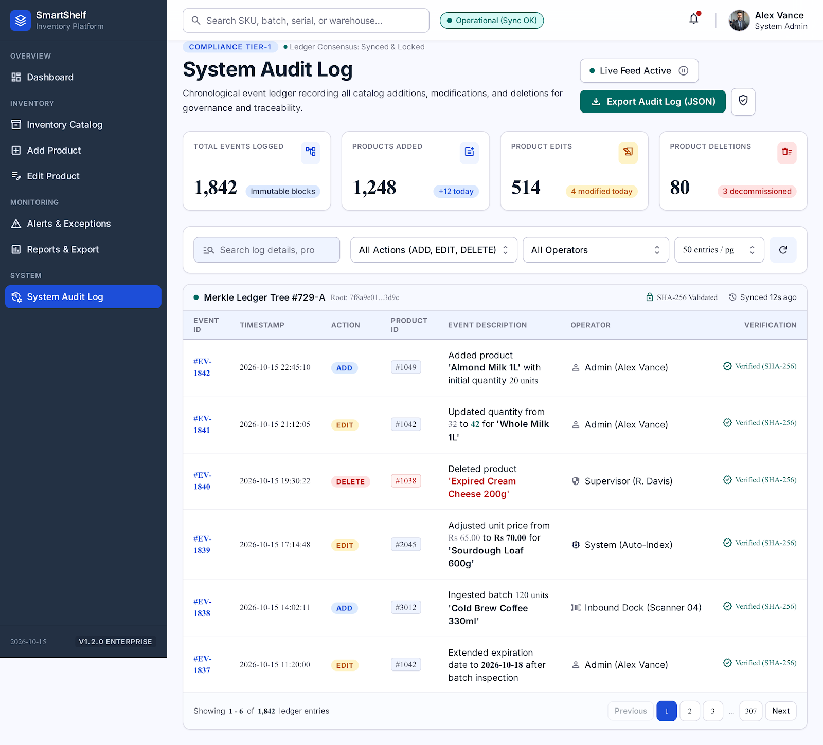
Figure: 5.7 Screen 7: System Audit Log & Governance Ledger Interface

6. Secondary Python-Native Streamlit Interface
For teams preferring a purely Python-based interface or running data science exploration, SmartShelf includes a fully configured Streamlit application in the smartshelf/ directory. It provides multi-page navigation via st.navigation and directly connects to the same SQLite database.
Streamlit Page | Function & Capabilities
pages/dashboard.py | KPI metric cards, category bar charts, stock health distribution.
pages/inventory.py | Catalog table with category/stock filters, search bar, and badge styling.
pages/add_product.py | Form with validation, non-perishable toggle, and SQLite insertion.
pages/edit_product.py | Item selector and in-place field updates with audit logging.
pages/delete_product.py | Confirmation checkbox and secure product deletion.
pages/alerts.py | Dedicated sections for expired and low-stock items.
pages/reports.py | CSV download button and summary text report generation.
pages/audit_log.py | Full audit log table with timestamps and action details.

7. REST API Endpoints Specification
The Python server (server.py) provides a complete RESTful JSON API accessible on port 5000:
Method | Endpoint | Parameters | Description
GET | /api/stats | None | Returns total SKUs, units, valuation, expired/low-stock counts, category breakdown.
GET | /api/products | q, category, stock_status, expiry_status | Returns list of products enriched with computed statuses.
GET | /api/products/<id> | id (URL path) | Returns single product details and calculations by SKU ID.
POST | /api/products | JSON payload | Registers a new product in SQLite and appends an ADD audit log.
PUT | /api/products/<id> | JSON payload | Updates an existing product in SQLite and appends an EDIT audit log.
DELETE | /api/products/<id> | id (URL path) | Deletes product from SQLite and appends a DELETE audit log.
GET | /api/alerts | None | Returns categorized lists of expired, expiring soon, and low-stock batches.
GET | /api/audit-log | None | Returns chronological list of recent audit transactions.
GET | /api/export/csv | None | Streams downloadable UTF-8 CSV inventory dataset.
GET | /api/export/summary | None | Streams downloadable formatted plain text summary report.
POST | /api/seed | None | Re-seeds the database with default enterprise demo products.

8. Expiration & Low-Stock Business Rules
All calculations are performed by deterministic pure functions in inventory_logic.py:

Expiry Horizon Rules (7-Day Warning Threshold):
Expiry Status | Mathematical Condition | Prescribed Operational Action
Expired | Expiry Date < Today's Date | Immediate removal from shelves; write-off disposal recorded.
Expiring Soon | 0 <= (Expiry Date - Today) <= 7 Days | Mark down price or prioritize for immediate sale/discount.
OK | (Expiry Date - Today) > 7 Days | Product is fresh; normal inventory rotation.
N/A | Expiry Date is None / Blank | Non-perishable item; expiry monitoring disabled.

Stock Threshold Rules:
Stock Status | Mathematical Condition | Prescribed Operational Action
Out of Stock | Quantity == 0 | Critical stockout; emergency purchase requisition required.
Low Stock | 0 < Quantity <= Min Stock Threshold | Replenishment reorder triggered (default threshold: 5).
In Stock | Quantity > Min Stock Threshold | Inventory buffer is healthy.

9. SQLite Database Schema & Audit Persistence
The database is auto-created in smartshelf/data/smartshelf.db with two primary tables:
CREATE TABLE products (
id INTEGER PRIMARY KEY AUTOINCREMENT,
name TEXT NOT NULL,
category TEXT NOT NULL,
quantity INTEGER NOT NULL CHECK(quantity >= 0),
unit_price REAL NOT NULL CHECK(unit_price >= 0),
expiry_date TEXT,
min_stock INTEGER NOT NULL DEFAULT 5 CHECK(min_stock >= 0),
created_at TEXT NOT NULL,
updated_at TEXT NOT NULL
);
CREATE TABLE audit_log (
id INTEGER PRIMARY KEY AUTOINCREMENT,
action TEXT NOT NULL, -- 'ADD', 'EDIT', 'DELETE'
product_id INTEGER,
details TEXT,
timestamp TEXT NOT NULL
);

10. Automated Test Suite & Verification
SmartShelf includes an automated Pytest test suite in smartshelf/tests/test_inventory_logic.py that executes 9 rigorous unit tests covering all edge cases (leap years, zero stock, threshold boundaries):
Test Function | Rule Verified | Result
test_expired | Correctly identifies past dates as 'Expired' | PASSED
test_expiring_soon | Correctly identifies dates within 7 days as 'Expiring Soon' | PASSED
test_ok | Correctly identifies dates > 7 days as 'OK' | PASSED
test_no_expiry | Handles None/empty dates as 'N/A' without errors | PASSED
test_low_stock_at_threshold | Flags quantity == min_stock as 'Low Stock' | PASSED
test_out_of_stock | Flags quantity == 0 as 'Out of Stock' | PASSED
test_in_stock | Flags quantity > min_stock as 'In Stock' | PASSED
test_enrich | Validates enrichment of dictionaries with all computed fields | PASSED
test_dashboard_counts | Verifies aggregate counts across all categories | PASSED

11. Troubleshooting & FAQ
Q1: How do I access the application if the browser does not open automatically?
Simply open your browser and navigate to http://localhost:5000 for the Stitch Enterprise Suite, or http://localhost:8501 for the Streamlit dashboard.
Q2: Port 5000 is already in use by another application. How can I change it?
You can specify any custom port when running server.py, for example: 'python server.py 8080'. The application will then be accessible at http://localhost:8080.
Q3: Are changes made in the Stitch UI reflected in Streamlit?
Yes! Both applications share the exact same SQLite database file (smartshelf/data/smartshelf.db). Any product added, edited, or deleted in one interface immediately updates the other.
Q4: How do I back up my inventory catalog?
You can click 'Download Inventory as CSV' on the Reports screen, or simply create a copy of the smartshelf/data/smartshelf.db file.
Q5: Can I reset the database to sample demo data?
Yes! You can invoke the REST API endpoint 'POST /api/seed' or delete smartshelf.db and restart the server, which will automatically re-populate the demo items.

