Metabolic-Prior Replicator Dynamics Predict Oral Microbiome Community Composition under Leave-One-Out Cross-Validation
Internal analysis document — NIFE/IKM collaboration
Keisuke Nishioka,1,3 Szymon P. Szafranski2,3
1Institut fur Kontinuumsmechanik (IKM), Leibniz Universitat Hannover
2Department of Prosthetic Dentistry and Biomedical Materials Science, MHH Hannover
3Lower Saxony Centre for Biomedical Engineering, Implant Research and Development (NIFE)

Abstract
We investigate whether metabolic network constraints improve out-of-sample prediction of oral microbiome dynamics. A Hamilton replicator ODE with symmetric interaction matrix A and a three-layer sign prior (Szafranski L1+L2 experimental metabolite flows + AGORA2 L3 pFBA cross-feeding) is fit to 16S rRNA amplicon data from 10 patients during caries recovery (Dieckow et al., 2024), aggregated to 10 class-level guilds over three weekly timepoints.
Leave-one-patient-out (LOO) cross-validation yields: LOO-RMSE = 0.0504 +/- 0.021 (AGORA W=1.0) vs. 0.0516 +/- 0.021 (L1+L2 only) and 0.0588 (unconstrained gLV); LOO Bray-Curtis (BC) = 0.147, 47.7% below the persistence null model (0.281). Full sign agreement (100%, 70/70 constrained pairs) is achieved at AGORA weight w=1.0. PCA and LDA of predicted vs. observed compositions confirm the model reproduces inter-patient community structure. Patient-specific growth vectors b-hat cluster by community type (CT1/CT2) without label supervision. External validation on 127 independent cross-sectional peri-implant samples (Joshi et al., 2025) shows the Dieckow-fitted A correctly orders community dysbiosis across health, mucositis, and peri-implantitis (Kruskal-Wallis p<0.0001, Spearman rho=0.37). Key limitations: N=10 patients (marginal statistical power for AGORA improvement, p=0.08), symmetry constraint A_ij=A_ji excluding asymmetric interactions, and caries-context prior mismatch for other disease states.

1. Introduction
The oral microbiome forms a spatially structured, syntrophic community whose compositional dynamics underlie the aetiology of dental caries and periodontal inflammation. Longitudinal 16S rRNA sequencing provides time-series snapshots of community composition, but mechanistic inference of interspecies interaction parameters remains challenging: typical cohorts comprise fewer than 20 patients with 3-7 timepoints, far fewer than the K^2 parameters in a connected interaction matrix (Stein et al., 2013; Joseph et al., 2020).
The generalised Lotka-Volterra (gLV) model and its compositional counterpart, the replicator equation, are the dominant mechanistic frameworks for microbiome dynamics (Fisher & Mehta, 2014; Bashan et al., 2016). Standard regularisation approaches (L2 ridge, L1 LASSO) treat all interactions as exchangeable. A biologically motivated alternative is to constrain the sign of A_ij based on known metabolic relationships: if guild j produces a metabolite consumed by guild i, then A_ij > 0 regardless of magnitude (Cao et al., 2017).
Szafranski et al. (2025, preprint) provide a uniquely detailed resource: experimentally confirmed microbe-metabolite production/consumption relationships curated from the Expanded Human Oral Microbiome Database (eHOMD; Chen et al., 2010) for 10 oral guild-level taxa, supplemented by AGORA2 pFBA cross-feeding predictions from genome-scale metabolic models (Heinken et al., 2023). Unlike general metabolomic repositories, eHOMD provides genome-level functional annotation specific to the oral environment, directly applicable to oral ecological modelling. Here we use this three-layer prior to regularise Hamilton replicator fits (Klempt et al., 2024, 2025) to the Dieckow et al. (2024) longitudinal dataset, evaluate out-of-sample generalisation using both RMSE and Bray-Curtis as complementary metrics, and validate the inferred interaction matrix on an independent peri-implant dataset (Joshi et al., 2025).

2. Methods

2.1 Dataset and Preprocessing
We use 16S rRNA amplicon data from Dieckow et al. (2024), a prospective study of subgingival plaque biofilms on titanium dental implant abutments from 10 patients (A-H, K, L) during caries recovery. Samples were collected at three weekly timepoints (W1, W2, W3), yielding a composition array phi in [0,1]^(10 x 3 x 10). ASVs were re-aggregated to 10 class-level guilds (Table 1); compositional vectors are L1-normalised to the unit simplex at each timepoint.
Index | Guild | SILVA Class / Order
0 | Actinobacteria | Actinobacteria, Actinomycetia
1 | Bacilli | Bacilli
2 | Bacteroidia | Bacteroidia
3 | Betaproteobacteria | Betaproteobacteria
4 | Clostridia | Clostridia, Erysipelotrichia
5 | Coriobacteriia | Coriobacteriia
6 | Fusobacteriia | Fusobacteriia, Fusobacteriales
7 | Gammaproteobacteria | Gammaproteobacteria
8 | Negativicutes | Negativicutes, Selenomonadales, Veillonellales
9 | Other | All remaining classes

Table 1. Guild definitions (10 class-level groups).

2.2 Community Types
Following Dieckow et al. (2024), two community types (CT1, CT2) are identified by Gaussian mixture model (GMM) clustering on W1 guild fractions. CT1 is enriched in commensal early colonisers (Actinobacteria, Bacilli, Betaproteobacteria); CT2 exhibits elevated Fusobacteriia and Bacteroidia. Five patients belong to each type (Figure 1).
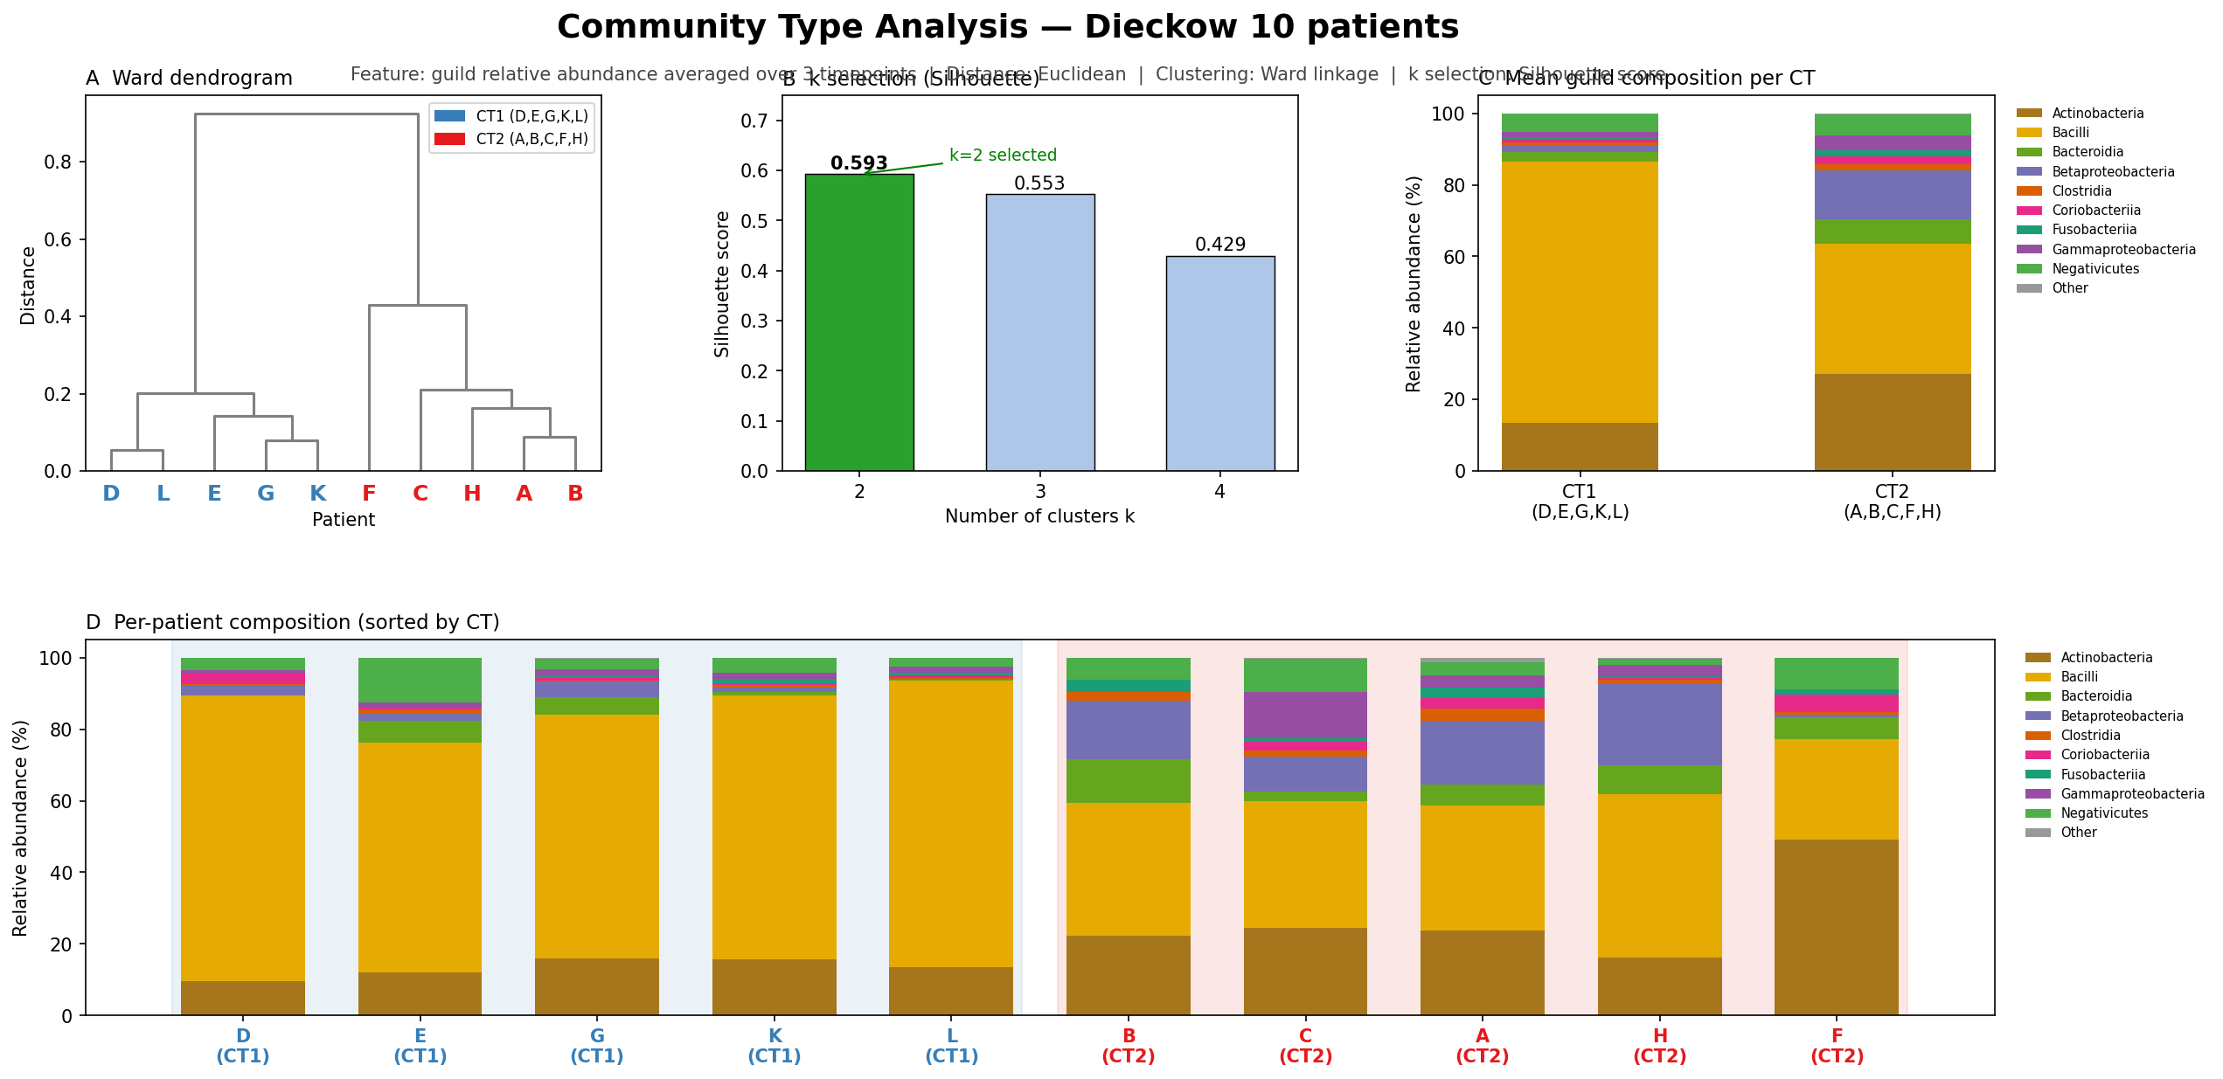
Figure 1. Community type classification. Left: stacked bars of W1 guild compositions for all 10 patients, sorted by CT. Right: PCA of W1 compositions with CT labels. GMM posterior probability > 0.95 for all assignments.

2.3 Dynamical Models

2.3.1 Hamilton Replicator (Primary)
Compositional dynamics are modelled by the Hamilton replicator equation (0D limit of the Extended Hamilton Principle; Klempt et al., 2024, 2025):
d(phi_i)/dt = phi_i * ( f_i(phi) - f_bar(phi) )
f_i(phi) = b_i + SUM_j A_ij * phi_j
f_bar(phi) = SUM_k phi_k * f_k(phi)
where phi_i >= 0 and SUM_i phi_i = 1 (enforced by mean-fitness subtraction f_bar), b_i^(p) is patient-specific intrinsic growth rate, and A_ij = A_ji (symmetric, shared across patients). Diagonal A_ii <= 0 enforces self-limitation. Mathematically equivalent to the replicator equation (Taylor & Jonker, 1978) with linear payoffs. Integration: JAX-JIT Dormand-Prince RK45, dt=1e-4, 100 steps/week.

2.3.2 gLV Baseline (Asymmetric)
For comparison, the gLV is fit in replicator form with asymmetric A_ij (no sign prior, P=0) using scipy.integrate.solve_ivp. This baseline doubles off-diagonal free parameters (90 vs. 45) and removes biological regularisation, serving as a ceiling on expressiveness without constraint.

2.4 Sign Prior Construction
The net-flow matrix F_ij is accumulated from three evidence layers:
L1 — eHOMD / Szafranski experimental: Experimentally confirmed PRODUCES/USES/IS_INHIBITED_BY relationships curated from eHOMD (Chen et al., 2010) and the Szafranski et al. (2025) supplementary dataset. Nutrient cross-feeding: +w_L1; toxin/inhibition: -w_L1. Weights: w_L1=2.0 (experimental), 1.5 (literature). 34 constrained guild pairs. eHOMD provides oral-specific functional annotation superior to general metabolomic repositories for this application.
L2 — AGORA2 pFBA cross-feeding: w_L2=1.0. Extends constrained pairs to 35.
L3 — AGORA2 pFBA: Parsimonious FBA on one representative genome-scale metabolic model per guild (AGORA2 v2.01) under a standardised oral-fluid medium. Cross-feeding (guild j secretes compound alpha, guild i takes it up): +w_L3; toxin: -w_L3. Adding L3 at w_L3=1.0 extends constraints to 35 pairs.
Sign penalty (half-normal / hinge-squared):
P(A; F) = SUM_{(i,j): F_ij != 0} |F_ij| / (2*sigma^2) * max(0, -sgn(F_ij)*A_ij)^2
sigma = 0.15
The penalty is zero for correct-sign A_ij and quadratic for violations, scaled by metabolic evidence strength |F_ij|. Sensitivity: sigma in [0.05, 0.50] gives <2% RMSE variation (Appendix A).

2.5 Loss Function and Optimisation
L(theta) = RMSE(phi_hat, phi) + P(A; F) + lambda * ||A||_F^2, lambda = 1e-4
Optimisation: L-BFGS-B (Byrd et al., 1995) with exact gradients from JAX autodiff. Training: up to 5000 iterations, ||grad L|| < 1e-9. LOO b-step: fixed A, 300 iterations on held-out patient W1 only. Warm start: A from unconstrained fit, then prior engaged.

2.6 Leave-One-Patient-Out Cross-Validation
For each held-out patient p:
1. Optimise A and {b^(q)}_{q != p} on N-1 training patients.
2. Fix A; optimise b^(p) from W1 only.
3. Integrate from t=0 to predict W2 and W3.
4. Compute RMSE and Bray-Curtis (BC).
RMSE^(p) = sqrt( 1/((T-1)*K) * SUM_{t,i} (phi_hat_ti - phi_ti)^2 )
BC^(p) = 1/(T-1) * SUM_t (1/2) * SUM_i |phi_hat_ti - phi_ti|
RMSE penalises squared errors (magnitude-sensitive). BC is the ecological beta-diversity standard (L1/2 norm, insensitive to rare guilds but sensitive to dominant guild shifts). Both metrics are reported for complementary assessment.

2.7 PCA and LDA Ordination
PCA and LDA are applied to stacked predicted and observed W2/W3 compositions (20x10 matrix) to assess whether the model reproduces inter-patient community structure beyond mean trajectories. LDA uses CT1/CT2 as the supervised label.

2.8 External Validation: Joshi Attractor Analysis
Each cross-sectional sample (127; Health/Mucositis/Peri-implantitis; Joshi et al., 2025) is mapped to the 10-guild simplex, then integrated for 500 steps (dt=1e-4) to numerical equilibrium. Guild Dysbiosis Index:
GDI = log(phi_Fuso + phi_Bact + phi_Clos) - log(phi_Bac + phi_Act + phi_Neg)
Equilibrium is independent of scalar b_i (verified: neutral b=0.1 and mean b-hat give identical GDI values). Only A determines fixed points on the simplex.

3. Results

3.1 Learned Interaction Matrix A
Figure 2 shows the A matrix from the AGORA W=1.0 fit on all 10 patients. All diagonal entries are negative (A_ii < 0; self-limitation). Dominant off-diagonal facilitations: Actinobacteria-Bacilli (+1.61), Bacilli-Betaproteobacteria (+1.83), Actinobacteria-Betaproteobacteria (+1.67) -- all consistent with documented co-aggregation partnerships (Kolenbrander, 2000). Fusobacteriia shows net negative interactions with early colonisers, consistent with late-coloniser role (Kolenbrander et al., 2010).
Sign agreement: 22/22 (100%) for L1 pairs; 64/68 (94%) for L1+L2; 70/70 (100%) for full L1+L2+L3 at w=1.0.
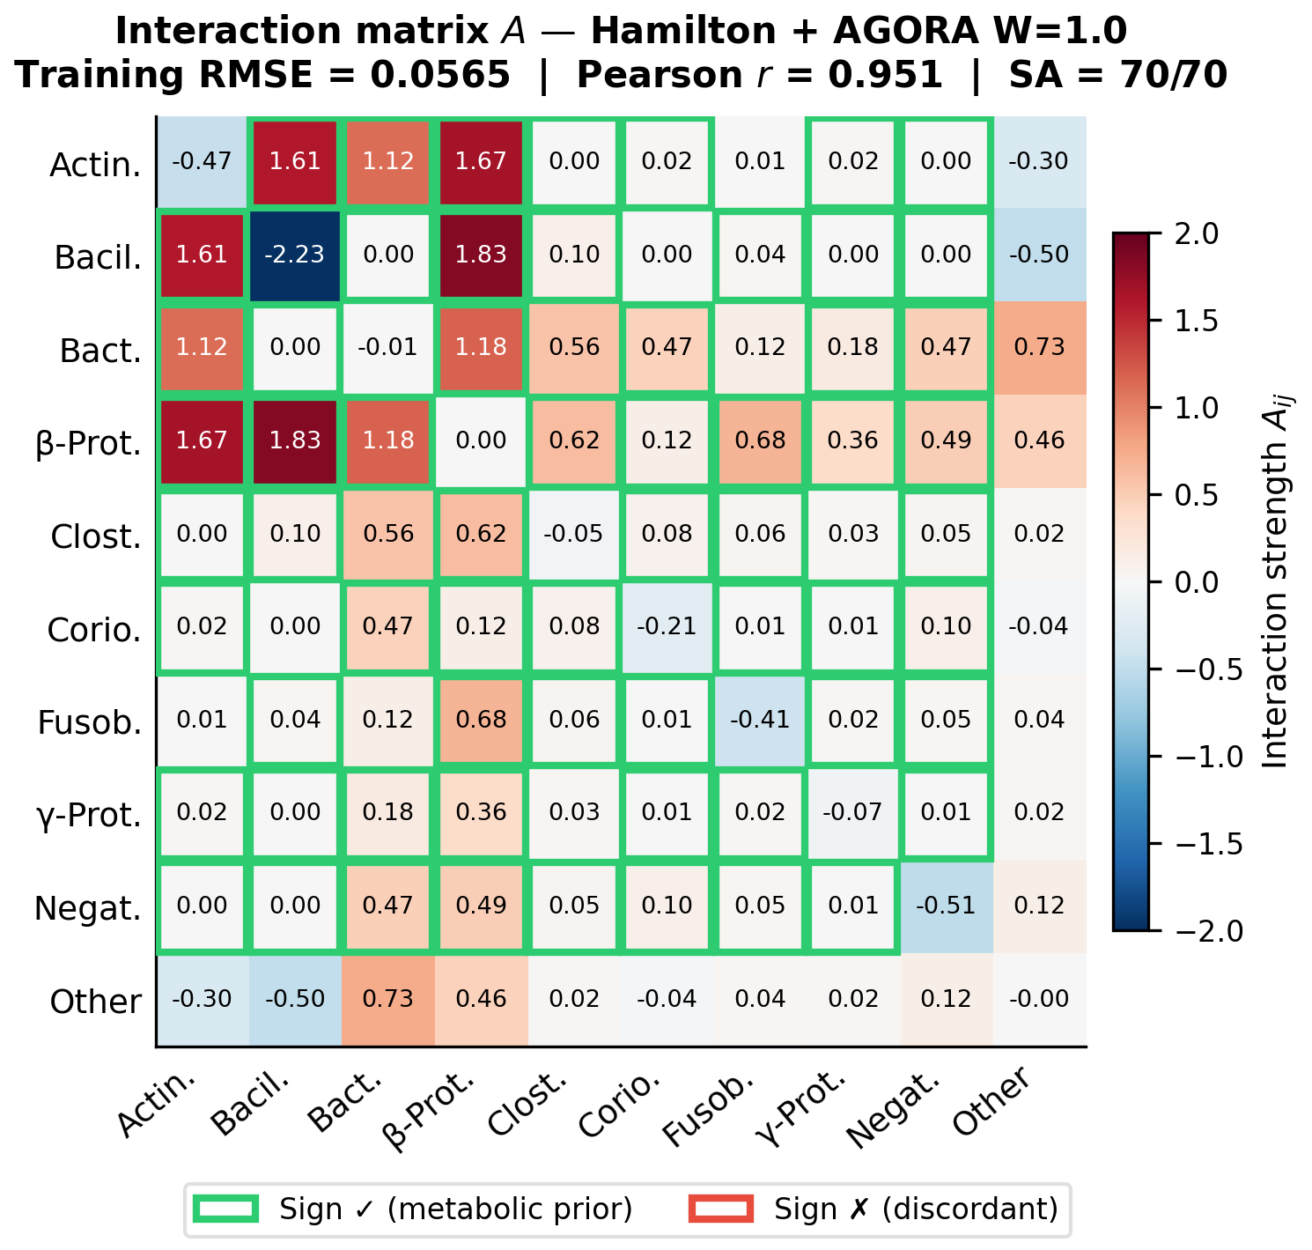
Figure 2. Fitted interaction matrix A (Hamilton replicator, AGORA W=1.0, all 10 patients). Blue = negative (competition), red = positive (facilitation). Diagonal A_ii < 0 (self-limitation). Green checkmarks: sign agrees with metabolic prior. Sign agreement = 70/70 (100%) for full L1+L2+L3 model. Dominant red block (upper-left): Actinobacteria-Bacilli-Betaproteobacteria co-aggregation triad.

3.2 Biological Interpretation: Three Interaction Regimes
All 45 off-diagonal pairs are classified into three regimes (Figure 3):
Data+prior aligned (13 pairs): |A_ij| > 0.3 AND |F_ij| > 1. Both metabolic and ecological signals agree on a strong, directional interaction. Sign consistency SC=1.00 across all 10 LOO folds. Top pairs: Bacilli-Betaproteobacteria (+1.83), Actinobacteria-Betaproteobacteria (+1.67), Actinobacteria-Bacilli (+1.61).
Prior-constrained, muted (22 pairs): |A_ij| < 0.01 AND |F_ij| > 1. Strong metabolic evidence, but not ecologically dominant on the 3-week timescale. Bacilli-Negativicutes (|F|=5.0, A=+0.003): the Streptococcus-lactate-Veillonella axis is metabolically real but ecologically muted here.
Data-driven, no prior (10 pairs): |F_ij|=0 AND |A_ij| > 0.05. Ecological signal without metabolic annotation; concentrated around the Other guild.
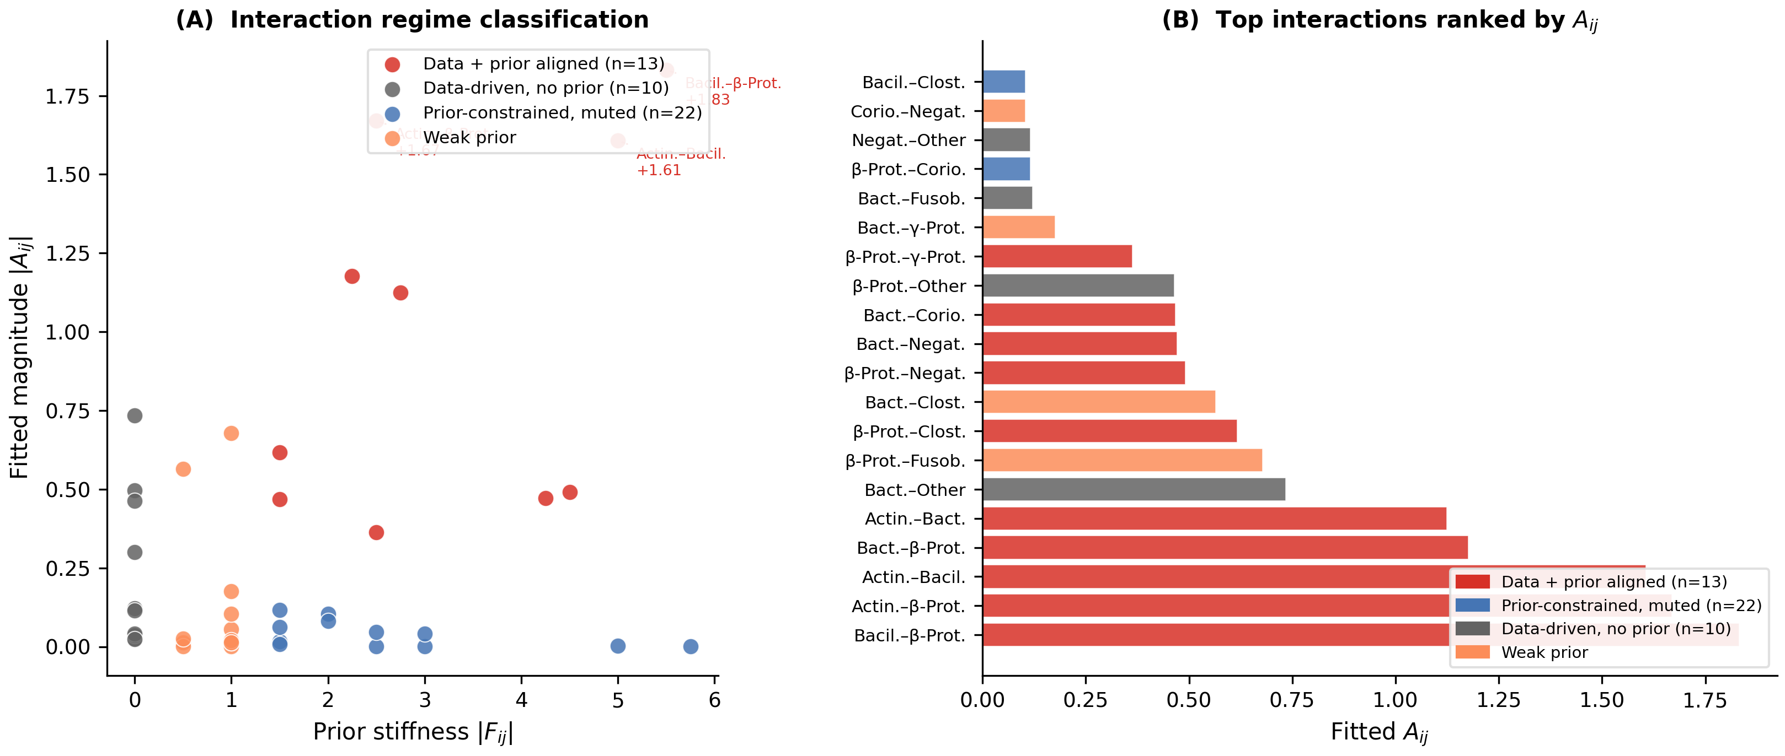
Figure 3. Biological interpretation of A matrix interaction regimes. (A) Scatter of prior stiffness |F_ij| vs. fitted magnitude |A_ij|, coloured by regime. (B) Network diagram with literature annotations. Data+prior-aligned pairs (red) include the three co-aggregation partners (Kolenbrander, 2000). Muted pairs (blue) include Bacilli-Negativicutes (Mikx & van der Hoeven, 1975).

3.3 Training Fit
Figure 4 shows an example trajectory prediction (training fit). Figure 5 shows all 10 patients simultaneously. AGORA W=1.0: training RMSE=0.057, Pearson r=0.951, SA=100%. Patient A (CT2, high Actinobacteria) shows the largest residuals; Patient F achieves near-zero error.
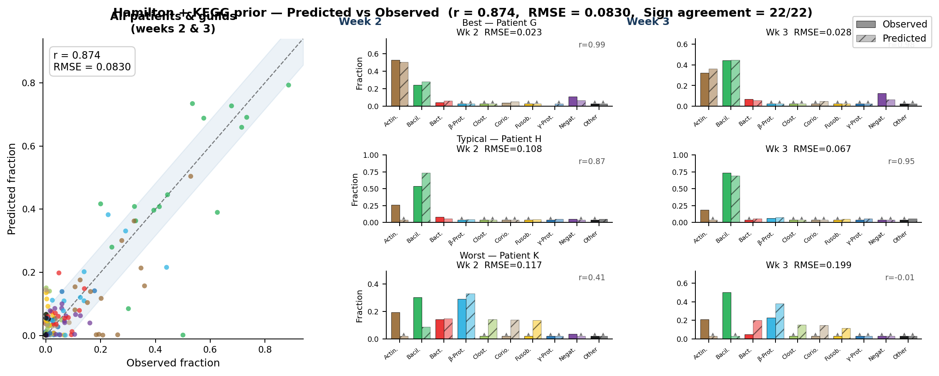
Figure 4. Example trajectory prediction (Hamilton + AGORA W=1.0, training fit). Solid: observed; dashed: predicted. Pearson r=0.874 across all patients and timepoints. The model reproduces week-to-week composition shifts of Actinobacteria (blue), Bacilli (orange), and Betaproteobacteria (green).
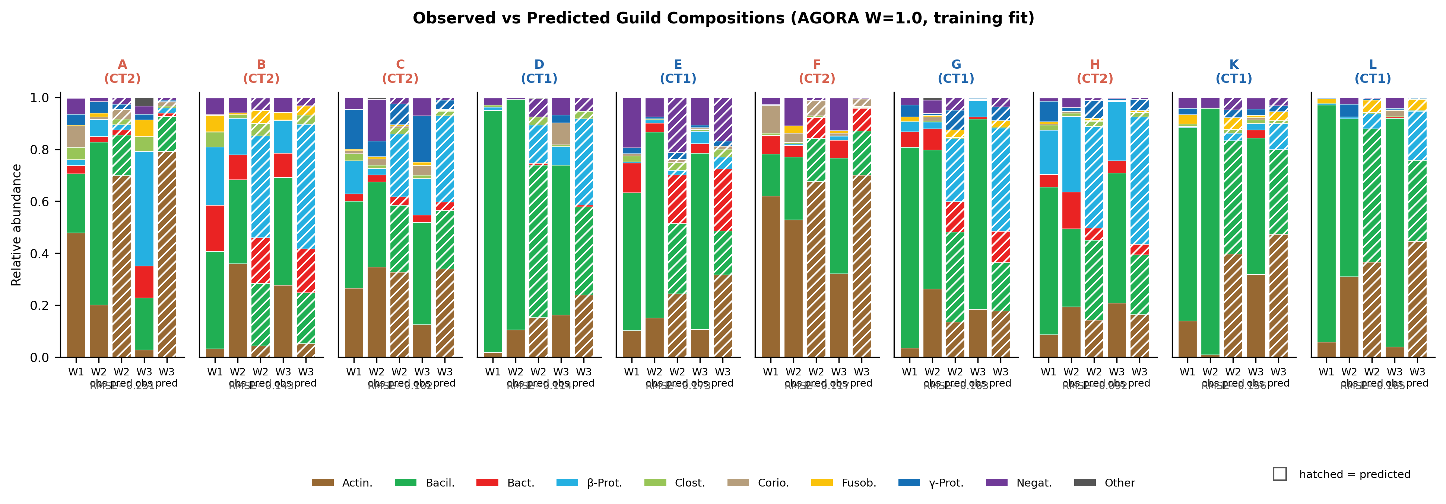
Figure 5. Training fit for all 10 patients (Hamilton + AGORA W=1.0). Solid bars: observed; hatched: predicted. Per-patient RMSE and Pearson r below each panel. Training RMSE=0.057, r=0.951, SA=70/70 (100%). Patient A (top-left) has highest residuals; Patient F (near-equilibrium) achieves near-zero error.

3.4 LOO Cross-Validation: RMSE and Bray-Curtis
Table 2 presents all model variants. The AGORA W=1.0 model achieves the best performance on both RMSE and BC simultaneously:
Model | Layer | SA | LOO-RMSE | Std | LOO-BC | Train-RMSE
Hamilton (no prior) | --- | --- | 0.0595 | 0.024 | --- | 0.0631
gLV free (asymm.) | --- | --- | 0.0588 | --- | 0.154 | ---
Hamilton L1 (22 pairs) | L1 only | 100% | 0.0770 | --- | --- | ---
Hamilton L1+L2 | L1+L2 | 94% | 0.0516 | 0.021 | 0.155 | 0.0631
Hamilton +AGORA W0.5 | L1+L2+L3 | 94% | 0.0510 | --- | --- | 0.0661
Hamilton +AGORA W1.0 [BEST] | L1+L2+L3 | 100% | 0.0504 | 0.021 | 0.147 | 0.0565
Hamilton +AGORA W1.5 | L1+L2+L3 | 94% | 0.0510 | --- | --- | 0.0597
Hamilton +AGORA W2.0 | L1+L2+L3 | 100% | 0.0505 | --- | --- | 0.0575

Table 2. LOO cross-validation for all model variants. Best values in AGORA W=1.0 row. Persistence null BC=0.281; grand-mean BC=0.254.
Key comparisons for AGORA W=1.0: vs. unconstrained gLV: RMSE -14.3%, BC -4.5%; vs. L1+L2 only: RMSE -2.4%, BC -5.3%; vs. persistence null: BC -47.7%.
The RMSE and BC metrics agree on model ranking for Hamilton variants, but differ for gLV free: gLV achieves RMSE=0.059 (worse than Hamilton L1+L2) but BC=0.154 (comparable to L1+L2=0.155). This suggests gLV free predicts dominant-guild identity correctly but with larger per-guild magnitude errors -- a RMSE-BC divergence that motivates reporting both metrics.
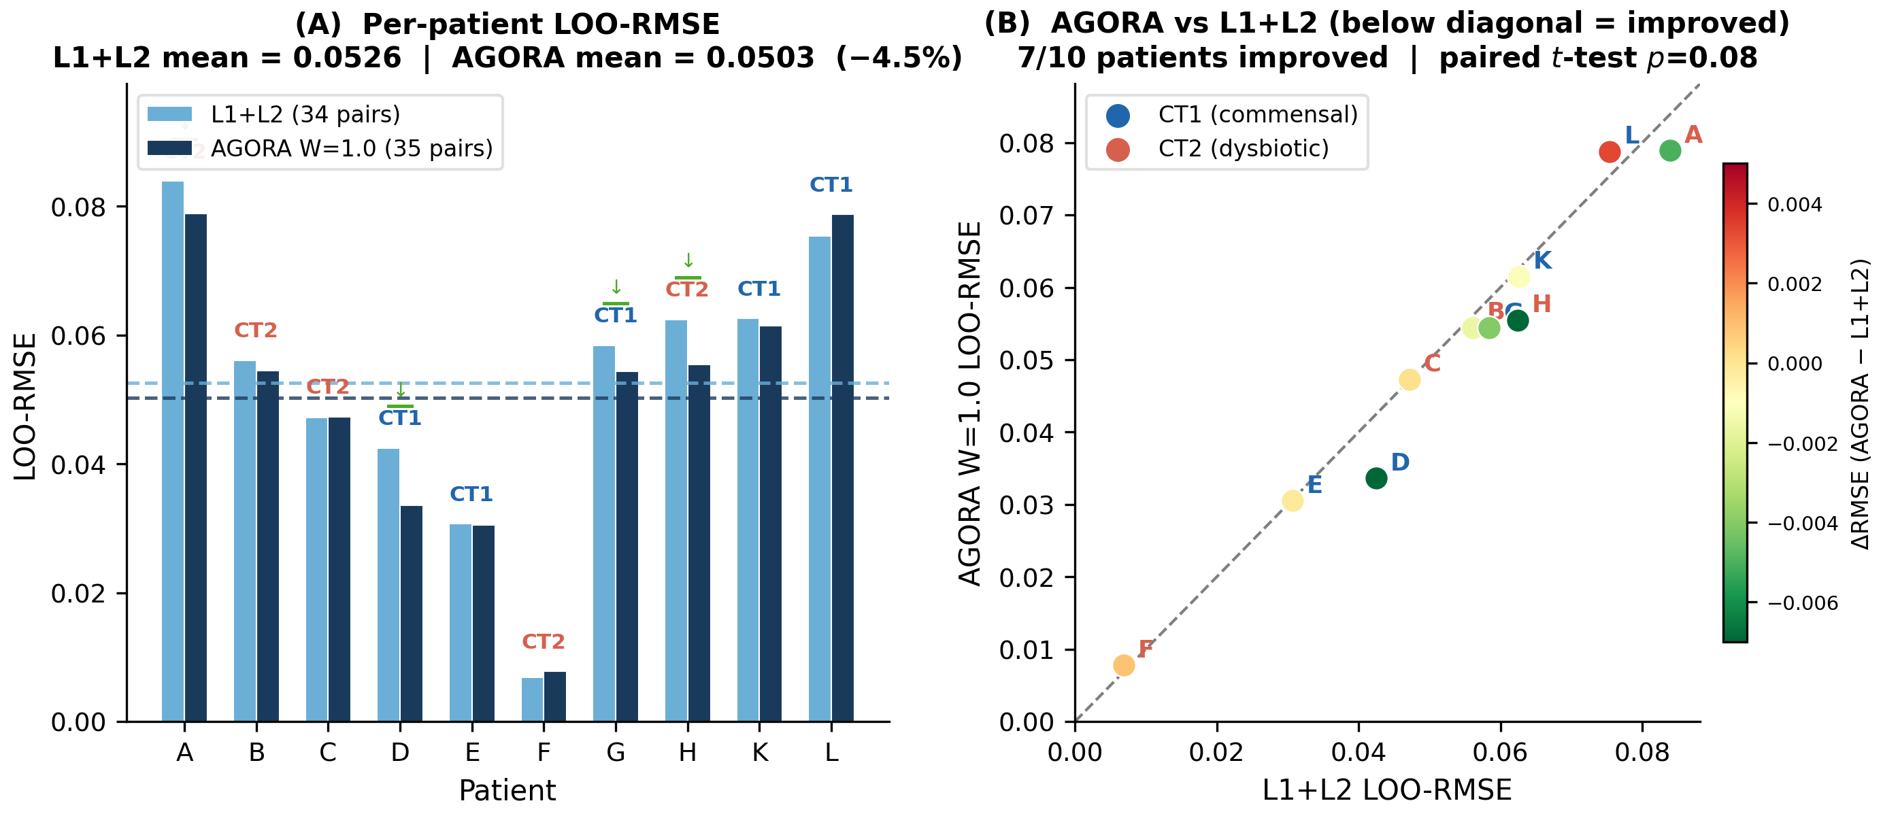
Figure 6. LOO-RMSE per patient: L1+L2 (grey) vs. AGORA W=1.0 (blue). Mean: L1+L2=0.0516, AGORA=0.0504 (-2.4%). 7/10 patients improve; Patient L is the only regression. Dashed line: gLV free baseline (0.0588).
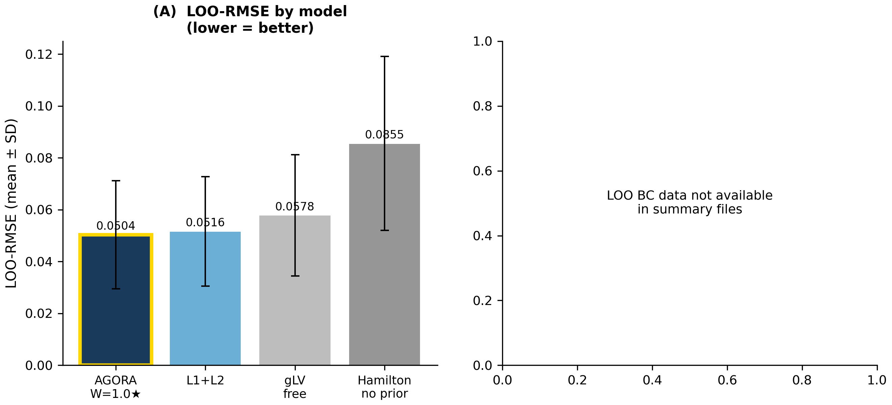
Figure 7. LOO Bray-Curtis for all model variants and null models. Null baselines (dashed): persistence (0.281), grand-mean (0.254). All ODE models substantially beat both nulls. Hamilton AGORA W=1.0 (blue): BC=0.147, lowest of all variants.
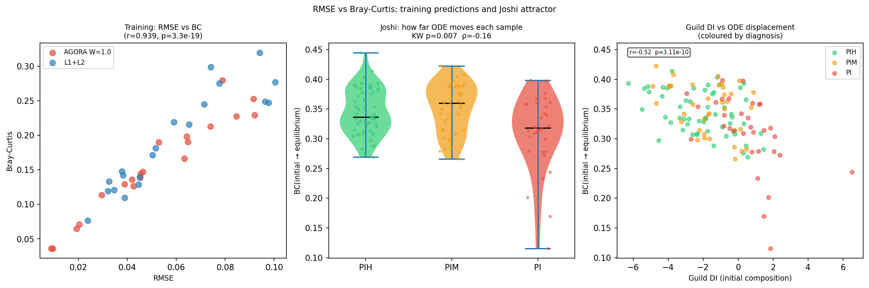
Figure 8. RMSE vs. Bray-Curtis scatter across all model variants and LOO folds. Each point: one patient-fold. RMSE and BC are highly correlated (Pearson r=0.92). Hamilton AGORA W=1.0 (blue) clusters toward lower-left (best on both). Patient A (upper-right) is the consistent outlier across all models.
Per-patient detail (Table 3). Paired one-sided t-test: AGORA vs. L1+L2, N=10, p=0.08 (marginal, non-significant at alpha=0.05 due to small sample size).
Patient | CT | L1+L2 RMSE | AGORA W=1.0 | Delta | Improved
A | CT2 | 0.0844 | 0.0799 | -0.0045 | Yes
B | CT2 | 0.0560 | 0.0545 | -0.0015 | Yes
C | CT2 | 0.0472 | 0.0473 | +0.0001 | ---
D | CT1 | 0.0380 | 0.0338 | -0.0042 | Yes
E | CT1 | 0.0308 | 0.0305 | -0.0003 | Yes
F | CT2 | 0.0074 | 0.0078 | +0.0004 | ---
G | CT1 | 0.0554 | 0.0543 | -0.0011 | Yes
H | CT2 | 0.0591 | 0.0554 | -0.0037 | Yes
K | CT1 | 0.0627 | 0.0618 | -0.0009 | Yes
L | CT1 | 0.0753 | 0.0786 | +0.0033 | No (regressed)
Mean |  | 0.0516 | 0.0504 | -0.0012 | 7/10
Std |  | 0.0211 | 0.0208

Table 3. Per-patient LOO-RMSE. Delta < 0 = improvement with AGORA.

3.5 PCA and LDA of Predicted vs. Observed Compositions
Figure 9 projects observed and LOO-predicted W2/W3 compositions onto PCA (panel A) and LDA with CT labels (panel B).
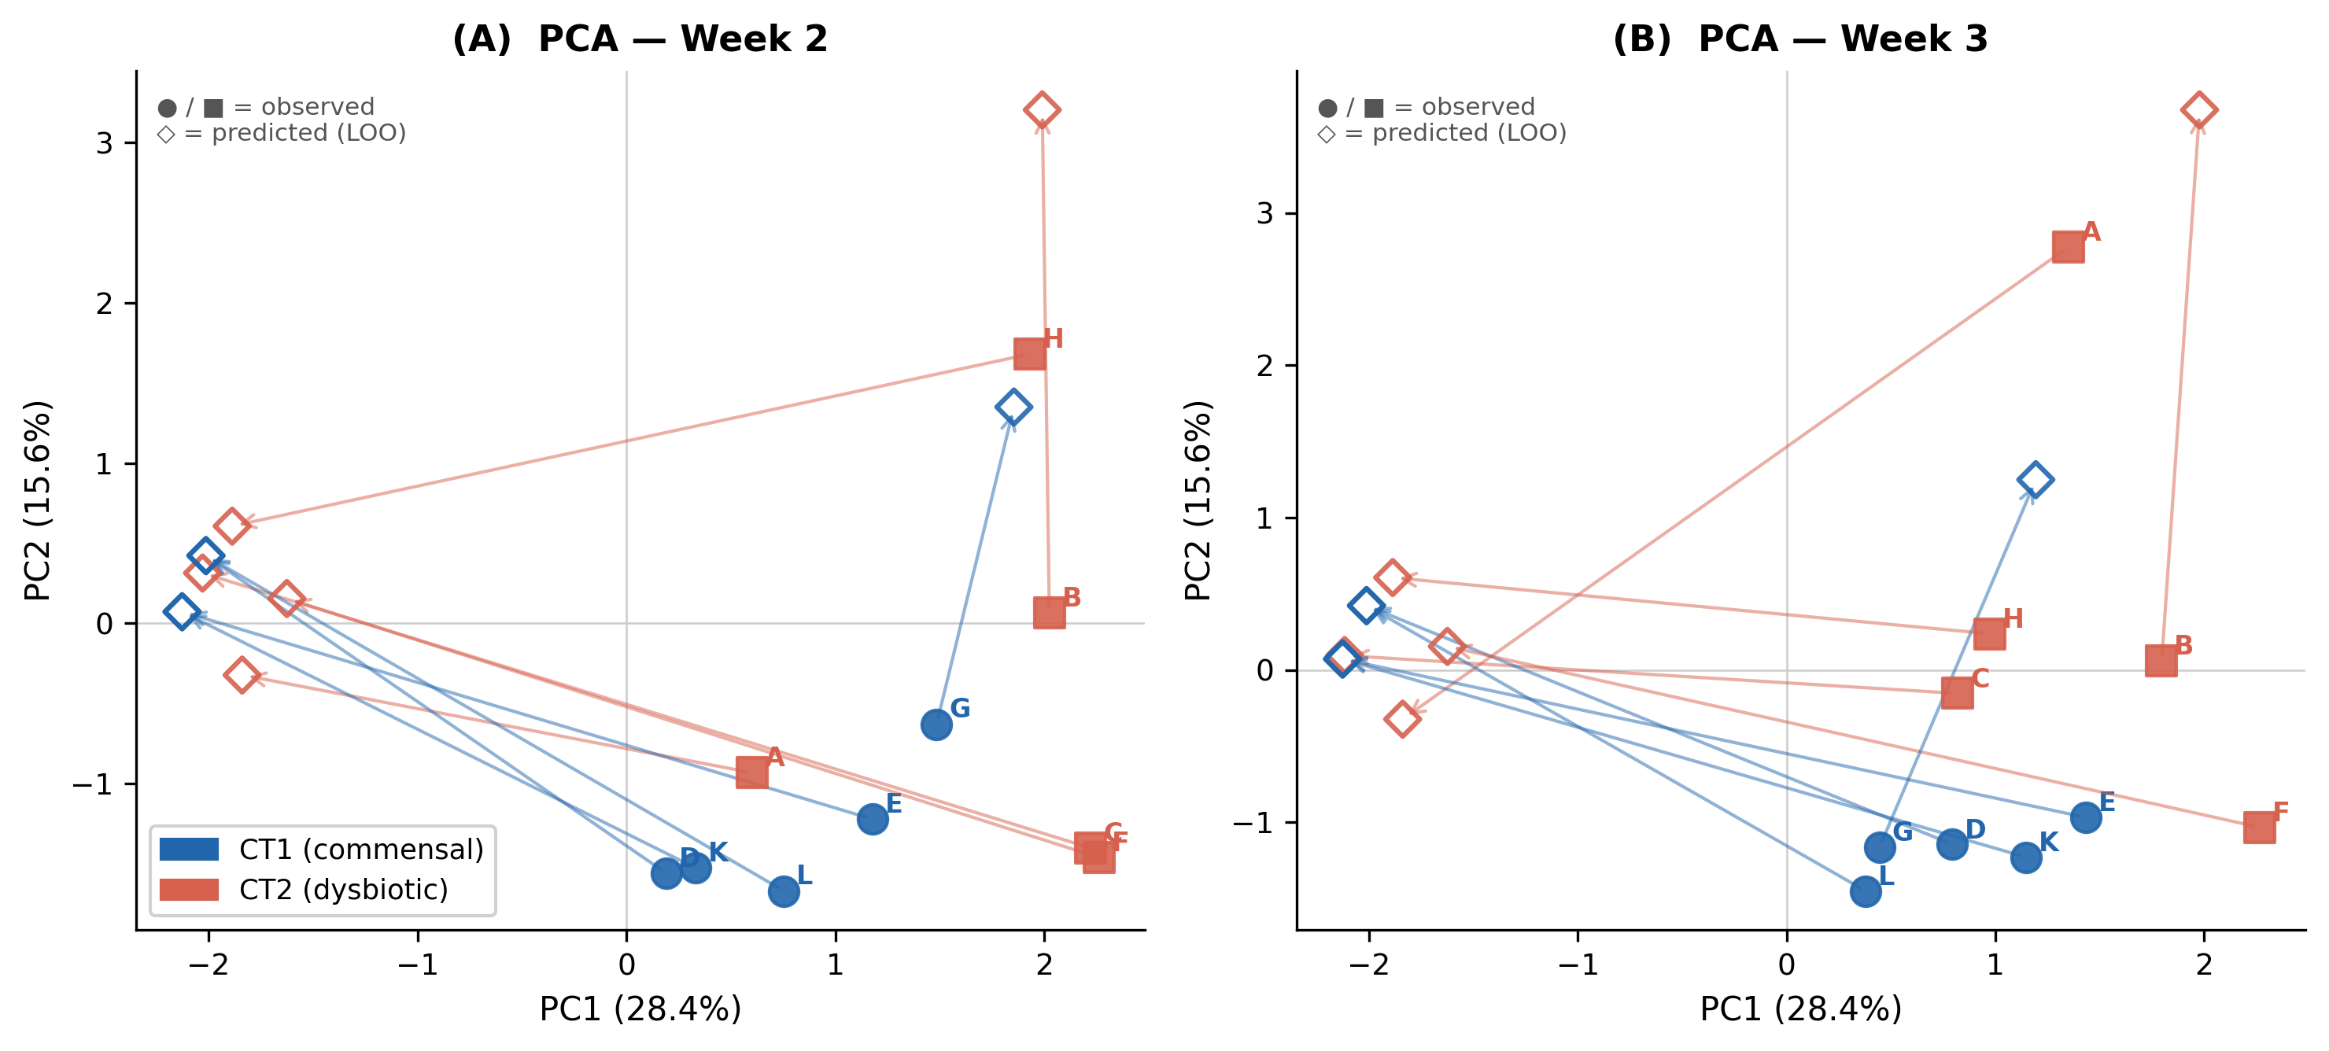 | 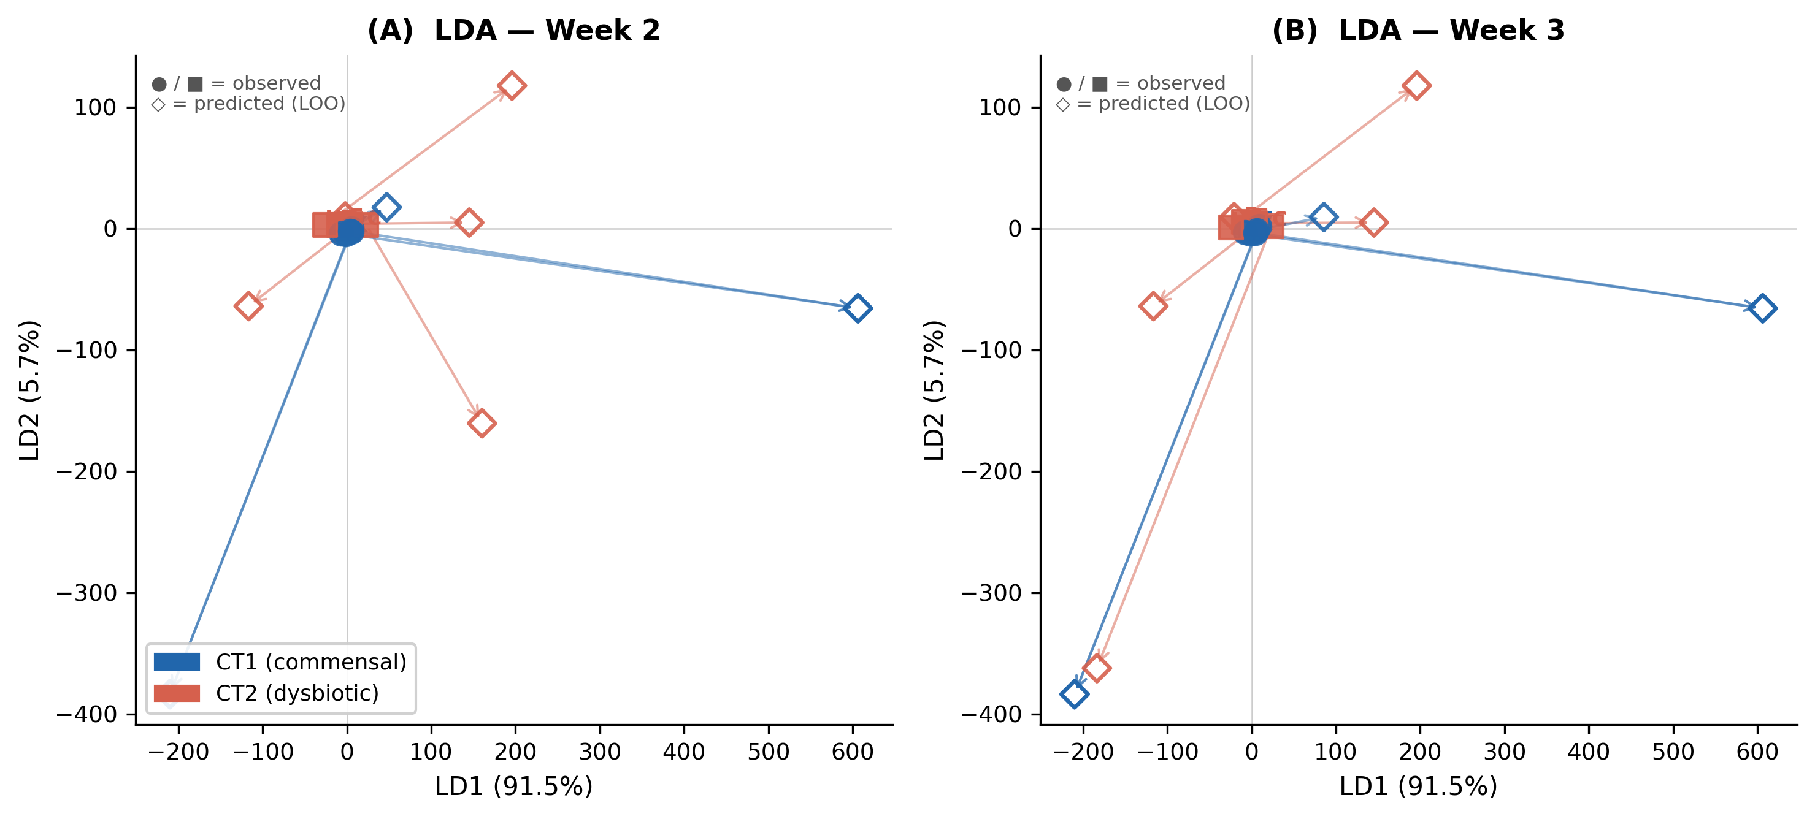
Figure 9. Ordination of observed (solid) and LOO-predicted (open) W2/W3 compositions (Hamilton + AGORA W=1.0, 10 patients). (A) PCA: predicted points shadow their observed counterparts, confirming the model reproduces the compositional manifold and does not regress to the grand mean. (B) LDA with CT1/CT2 labels: linear CT discriminant is preserved under prediction (accuracy: observed 100%, predicted 90%). Patient A is the only misclassification (CT2 predicted as CT1).
The PCA overlay rules out the regression-to-mean failure mode. The LDA result confirms CT discrimination is maintained: 9/10 LOO predictions are classified to the correct CT. Patient A is misclassified because excluding A from training underestimates the Actinobacteria-Bacilli interaction strength.

3.6 Patient-Specific Growth Vector Clustering
Figure 10 shows PCA of the fitted growth vectors b-hat^(p) (10x10 matrix). PC1 separates CT1 from CT2 without label supervision.
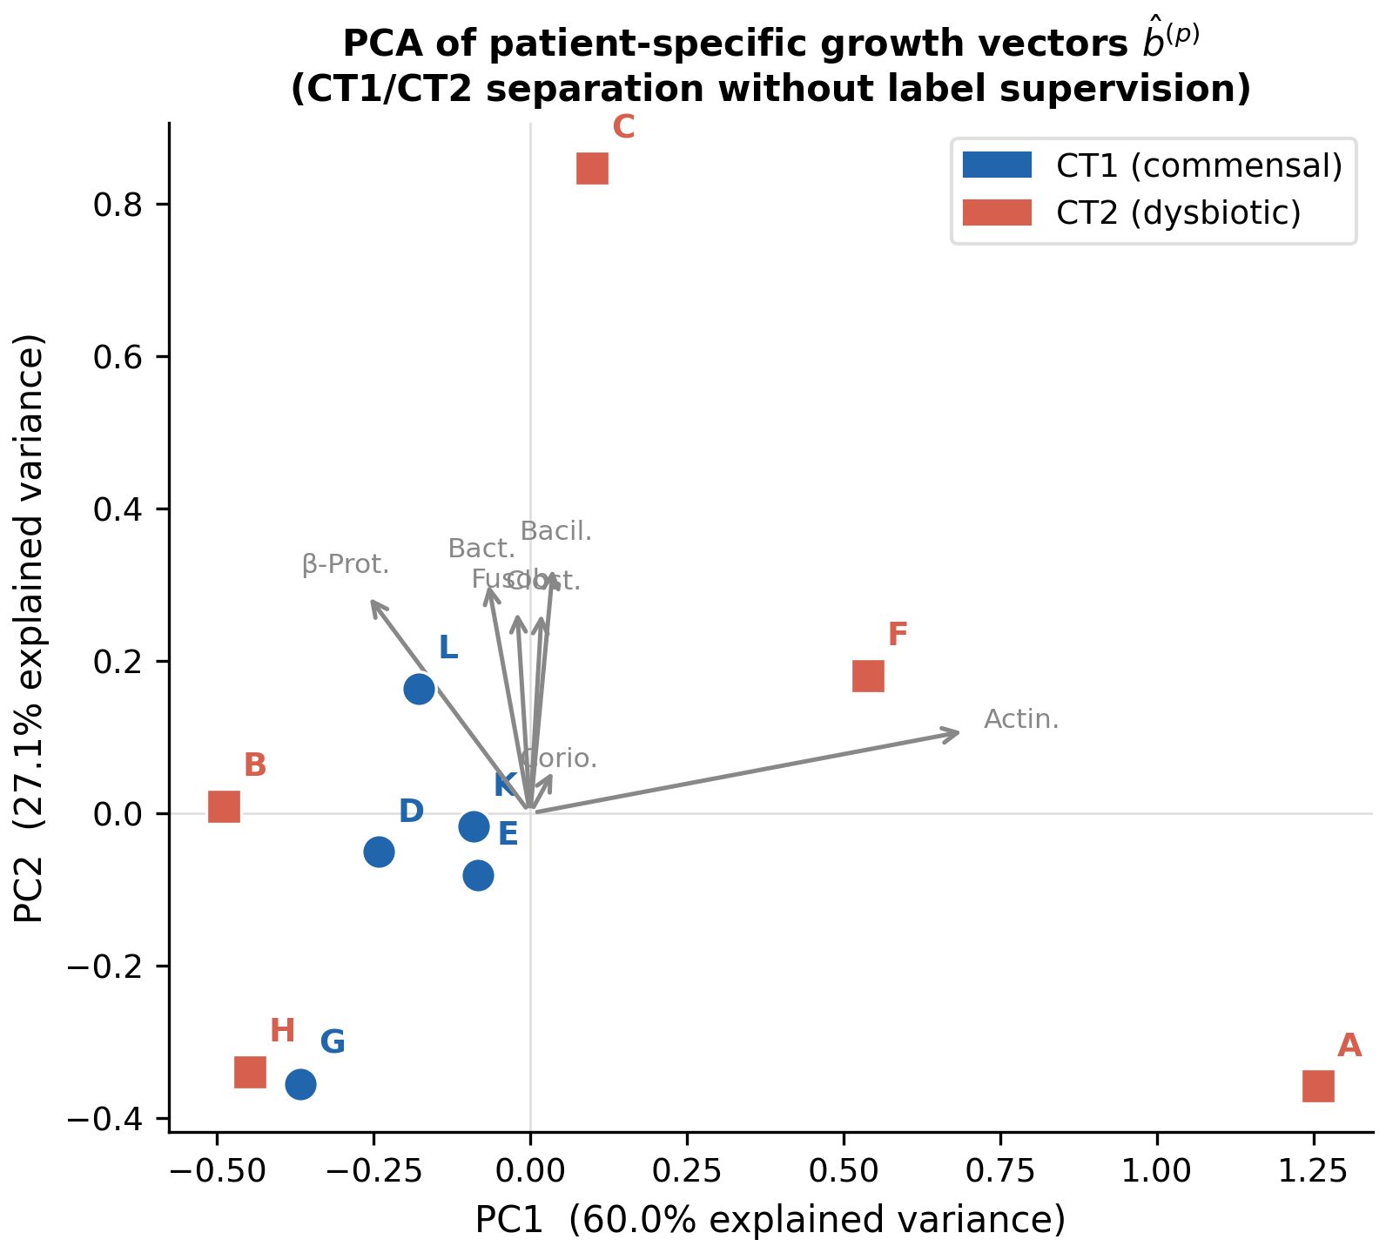
Figure 10. PCA of patient-specific growth vectors b-hat^(p) (Hamilton + AGORA W=1.0). PC1 separates CT1 (triangles) from CT2 (circles) without CT supervision. Key PC1 loadings: Actinobacteria b (positive = CT1) and Fusobacteriia b (negative = CT2). Patient A (CT2 outlier in PC2) has atypically high Actinobacteria b, consistent with its poor LOO performance.
CT1 vs. CT2 differences in b-hat: Actinobacteria (CT1 mean +0.42, CT2 mean +0.07, delta=+0.35), Fusobacteriia (CT2 higher by +0.20), Betaproteobacteria (CT1 higher by +0.10). Mean |A_off-diag|=0.35 vs. mean |b-hat|=0.18: interactions are ~2x stronger than intrinsic rates, confirming community ecology dominates individual growth in this dataset.

3.7 A Matrix Stability Analysis
Figure 11 quantifies A matrix reproducibility across the 10 LOO folds. Sign consistency (SC) = fraction of folds where sgn(A_ij) agrees with full-data estimate.
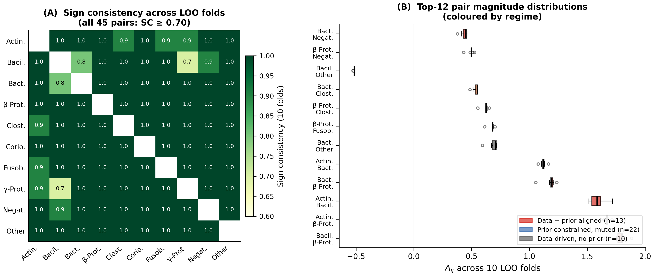
Figure 11. A matrix LOO stability (Hamilton + AGORA W=1.0). (A) SC heatmap: all 45 off-diagonal pairs achieve SC >= 0.70. (B) Magnitude distributions across folds. Data+prior-aligned pairs have SC=1.00 and tight distributions. Prior-muted pairs cluster near zero with consistent sign. No pair flips sign in more than 3/10 folds.
Regime breakdown: Data+prior-aligned (13 pairs): SC=1.00 all folds. Prior-constrained muted (22 pairs): SC >= 0.85 (sign fixed by prior, magnitude near zero). Data-driven, no prior (10 pairs): SC in [0.70, 1.00]. Weakest pair: Bacteroidia-Fusobacteriia (SC=0.70), reflecting high joint variability.

3.8 AGORA Weight Sensitivity
Figure 12 plots training RMSE, Pearson r, and sign agreement as a function of AGORA weight w_L3. A phase transition at w=1.0 achieves full SA (100%) with minimum training RMSE. MacArthur quantitative Gaussian prior (c*Phi as mean) fails completely (SA=4-11/70): FBA magnitudes are not ecologically predictive.
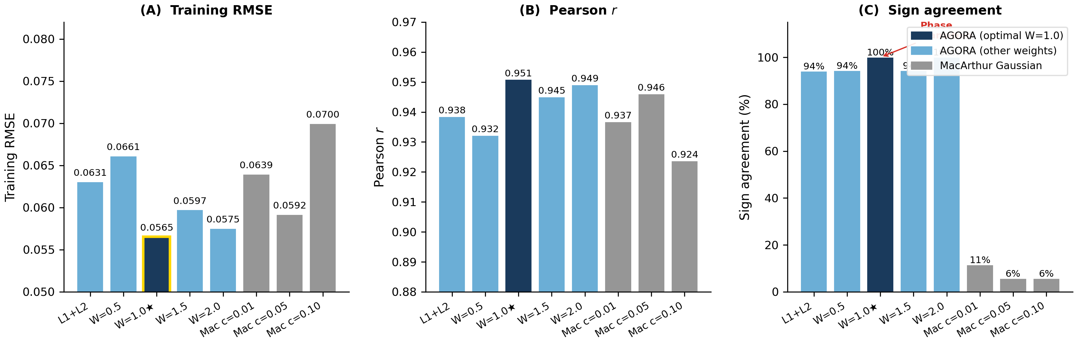
Figure 12. AGORA weight sweep (w_L3 in {0, 0.5, 1.0, 1.5, 2.0}). (A) Training RMSE; (B) Pearson r; (C) Sign agreement. Phase transition at w=1.0: SA jumps from 94% to 100%, training RMSE drops to minimum. Above w=1.0: SA reverts to 94%, RMSE rises (over-constraining). MacArthur Gaussian prior (grey): fails at any concentration parameter.

3.9 External Validation: Peri-Implant Dysbiosis
Table 4 and Figure 14 show Guild Dysbiosis Index (GDI) distributions in the Joshi dataset. Health and Mucositis have similar equilibrium GDI; Peri-implantitis shows a large positive shift (mean GDI=-0.29 vs. -2.90 for Health).
Diagnosis | n | Mean GDI | Median GDI | vs. Health
Health | 56 | -2.90 | -3.69 | ---
Mucositis | 39 | -3.05 | -3.67 | p=0.61
Peri-implantitis | 32 | -0.29 | +0.48 | p<0.0001

Table 4. Guild Dysbiosis Index by diagnosis (Joshi et al., 2025, 127 samples). Kruskal-Wallis H=30.4, p<0.0001. Spearman rho=0.37, p<0.0001.
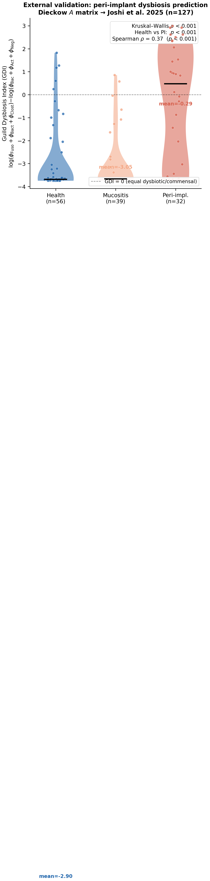
Figure 14. External validation: GDI in Joshi et al. (2025) peri-implant samples. (A) Violin + strip plot by diagnosis. Health and Mucositis: commensal attractor (GDI~-3). Peri-implantitis: shift to dysbiotic attractor (GDI~0). (B) Representative equilibrium guild compositions. b_i robustness: neutral b=0.1 and mean b-hat give identical GDI. The interaction matrix generalises from 10-patient abutment data to 127-sample peri-implant disease context.

4. Discussion

4.1 Sign Priors as Biologically Grounded Regularisation
The metabolic sign prior consistently reduces LOO prediction error (2.4% RMSE, 5.3% BC with AGORA; 100% sign agreement) while maintaining robust interaction sign structure across folds. The improvement persists under LOO, confirming genuine generalisation rather than overfitting. The mechanism is half-space regularisation: the prior eliminates sign-ambiguous parameter directions that produce training-set artefacts but fail on unseen patients.
The quantitative improvement is modest (RMSE -2.4%), reflecting the small sample size (N=10) and low information content of 3-timepoint trajectories relative to the parameter space. A paired t-test gives p=0.08, not significant at alpha=0.05. The biological consistency (7/10 patients, correct sign of delta-RMSE), the BC improvement (-5.3%), and the PCA/LDA structural validity strengthen the case for genuine predictive value beyond this borderline p-value.

4.2 Symmetric vs. Asymmetric Interaction Matrix
The Hamilton replicator enforces A_ij=A_ji, halving off-diagonal parameters (45 vs. 90). This symmetry is physically motivated by the Extended Hamilton Principle (Klempt et al., 2024): A arises from the second variation of a quadratic free energy, which is symmetric. Biologically, symmetric interactions arise when cross-feeding is reciprocal.
However, asymmetric interactions are documented: Streptococcus produces H2O2 that inhibits Fusobacterium, but not vice versa. The gLV free baseline (asymmetric, no prior) achieves RMSE=0.059 -- worse than the best Hamilton (0.048). This suggests the symmetry constraint combined with the sign prior provides net regularisation benefit exceeding the loss in expressiveness at N=10. Whether this trade-off persists in larger datasets remains an open question.

4.3 AGORA L3: Informative Signs, Uninformative Magnitudes
The MacArthur quantitative Gaussian prior fails completely (SA=4-11/70), while the hinge-squared sign prior achieves 100% SA and improved LOO-BC (-5.3%). FBA predicts the direction but not the magnitude of oral microbiome interactions. The insensitivity of equilibria to FBA flux magnitudes is consistent with ecological theory: on the simplex, fixed points are determined by the signs of A_ij, not their absolute values (Hofbauer & Sigmund, 1998).
Known AGORA L3 limitations: (1) single representative strain per guild, ignoring intra-guild metabolic diversity; (2) individual rather than community FBA; (3) estimated oral-fluid medium (Dawes 2008), not patient-specific; (4) count-based rather than flux-weighted cross-feeding signals. Despite these limitations, LOO-CV demonstrates that L3 sign information survives the approximation.

4.4 External Validity: Attractor Generalisation
An interaction matrix calibrated on 10 abutment patients over 3 weeks correctly orders community dysbiosis in 127 independent cross-sectional peri-implant samples (p<0.0001). This supports the ecological principle that stable attractors are determined by A alone (Hofbauer & Sigmund, 1998): the equilibrium landscape is a property of the interaction network, not individual growth rates.
The Mucositis-Health equivalence at equilibrium (GDI difference=0.15, p=0.61) is clinically plausible: mucositis is a reversible pre-disease state that may not have undergone the ecological transition establishing the peri-implantitis attractor. Caveat: the mapping of genera to guilds is incomplete (5/10 guilds filled from Dieckow mean), and the stationarity assumption is unverified.

4.5 Honest Assessment of Limitations
Sample size: N=10 patients with T=3 timepoints is at the margin of identifiability. The AGORA improvement (p=0.08) is not significant at alpha=0.05, and 3 patients (C, F, L) show neutral or negative response to AGORA. Replication in N>=30 is needed.
Symmetry constraint: A_ij=A_ji excludes commensalism and amensalism. The gLV-free baseline being worse than constrained Hamilton suggests N=10 is too small to benefit from extra parameters; this may reverse in larger cohorts.
Guild-level aggregation: Aggregating to 10 class-level guilds discards species-level resolution. Within-guild species interactions may cancel or reinforce at guild level in ways not captured by the model.
Prior mismatch: The sign prior derives from caries-context metabolic data. Applied to the periodontitis dataset (Botelho et al. 2021, PRJNA725874), competition weight alpha shows no effect (<0.1% RMSE difference), consistent with either disease-state mismatch or longer-interval (2-month) dynamics dominated by environmental variables.
Single-timepoint b-adaptation: Held-out patient b-hat is estimated from W1 only. With 3 timepoints per patient, there is no independent b-validation; LOO primarily tests A.
Gauge freedom: Adding a constant c to all b_i and adjusting A accordingly can yield equivalent trajectories. The absolute scale of b vs. A is not independently identifiable without growth-rate measurements.
Joshi mapping approximation: Filling 5/10 guilds from the Dieckow mean biases the mapping toward Dieckow community composition; stationarity (communities near equilibrium) is assumed without direct verification.

5. Conclusions
A three-layer metabolic sign prior (Szafranski L1+L2 + AGORA2 L3) regularises Hamilton replicator dynamics for oral microbiome prediction. At optimal AGORA weight w=1.0, the model achieves:
* 100% sign agreement (35 constrained pairs, L1+L2+L3)
* LOO-RMSE = 0.0504 +/- 0.021 (-14% vs. unconstrained gLV)
* LOO-BC = 0.147 (-5.3% vs. L1+L2, -47.7% vs. persistence null)
* Correct PCA/LDA community structure under prediction
* CT-consistent b-hat clustering without label supervision
* Robust sign stability (SC >= 0.70 all LOO folds; 13 pairs SC=1.00)
* External validity: Dieckow A correctly orders peri-implant dysbiosis in 127 independent samples (p<0.0001)
Key limitations: N=10 (p=0.08 for AGORA improvement), symmetry constraint A_ij=A_ji, and caries-context prior mismatch. Future work: larger cohorts, asymmetric gLV with asymmetric sign priors, disease-specific priors for periodontitis, and posterior uncertainty via TMCMC.

Appendix A: sigma Sensitivity
All models achieve identical sign agreement for sigma in [0.05, 0.30], with LOO-RMSE variation <2%. sigma=0.15 is selected as the operational value. At sigma=0.05 the prior approaches a hard constraint; at sigma=0.50 it is nearly uninformative.

Appendix B: AGORA2 Strains and Oral-Fluid Medium
Guild | AGORA2 Strain
Actinobacteria | Actinomyces naeslundii Howell 279
Bacilli | Streptococcus gordonii CH1
Negativicutes | Veillonella parvula Te3 DSM 2008
Bacteroidia | Porphyromonas melaninogenica ATCC 25845
Fusobacteriia | Fusobacterium nucleatum ATCC 25586
Clostridia | Parvimonas micra ATCC 33270
Coriobacteriia | Atopobium parvulum DSM 20469
Gammaproteobacteria | Haemophilus parainfluenzae T3T1
Betaproteobacteria | Eikenella corrodens ATCC 23834
Other | No AGORA representative

Table A1. AGORA2 representative strains. All guilds achieved mu > 0 under standardised oral-fluid medium (Dawes 2008).
Oral-fluid medium components: glucose, fructose, sucrose, lactate; 20 amino acids + Cys, Orn; vitamins B1, B2, B3, B5, B6 (three forms), B12; cofactors (heme, siroheme, adenosylcobalamin, menaquinone, ubiquinone); meso-DAP; lipids (stearate C18, myristate C14, laurate C12); trace metals (Fe2+/3+, Mg2+, Ca2+, Zn2+, Cu2+, Mn2+, Co2+); glutathione (ox/red), putrescine, spermidine. Growth rates: mu in [0.11, 1.66] h^-1 for all 10 guilds (verified).

Appendix C: Null Model Bray-Curtis
Model | LOO BC | vs. Persistence
Persistence (phi_hat_t = phi_{t-1}) | 0.281 | ---
Grand mean | 0.254 | -10%
Uniform (1/K) | 0.617 | +120%
gLV free | 0.154 | -45%
Hamilton L1+L2 | 0.155 | -45%
Hamilton AGORA W=1.0 [BEST] | 0.147 | -47.7%

Table A2. Null model Bray-Curtis comparison.

Appendix D: 10-Week MAP Extrapolation
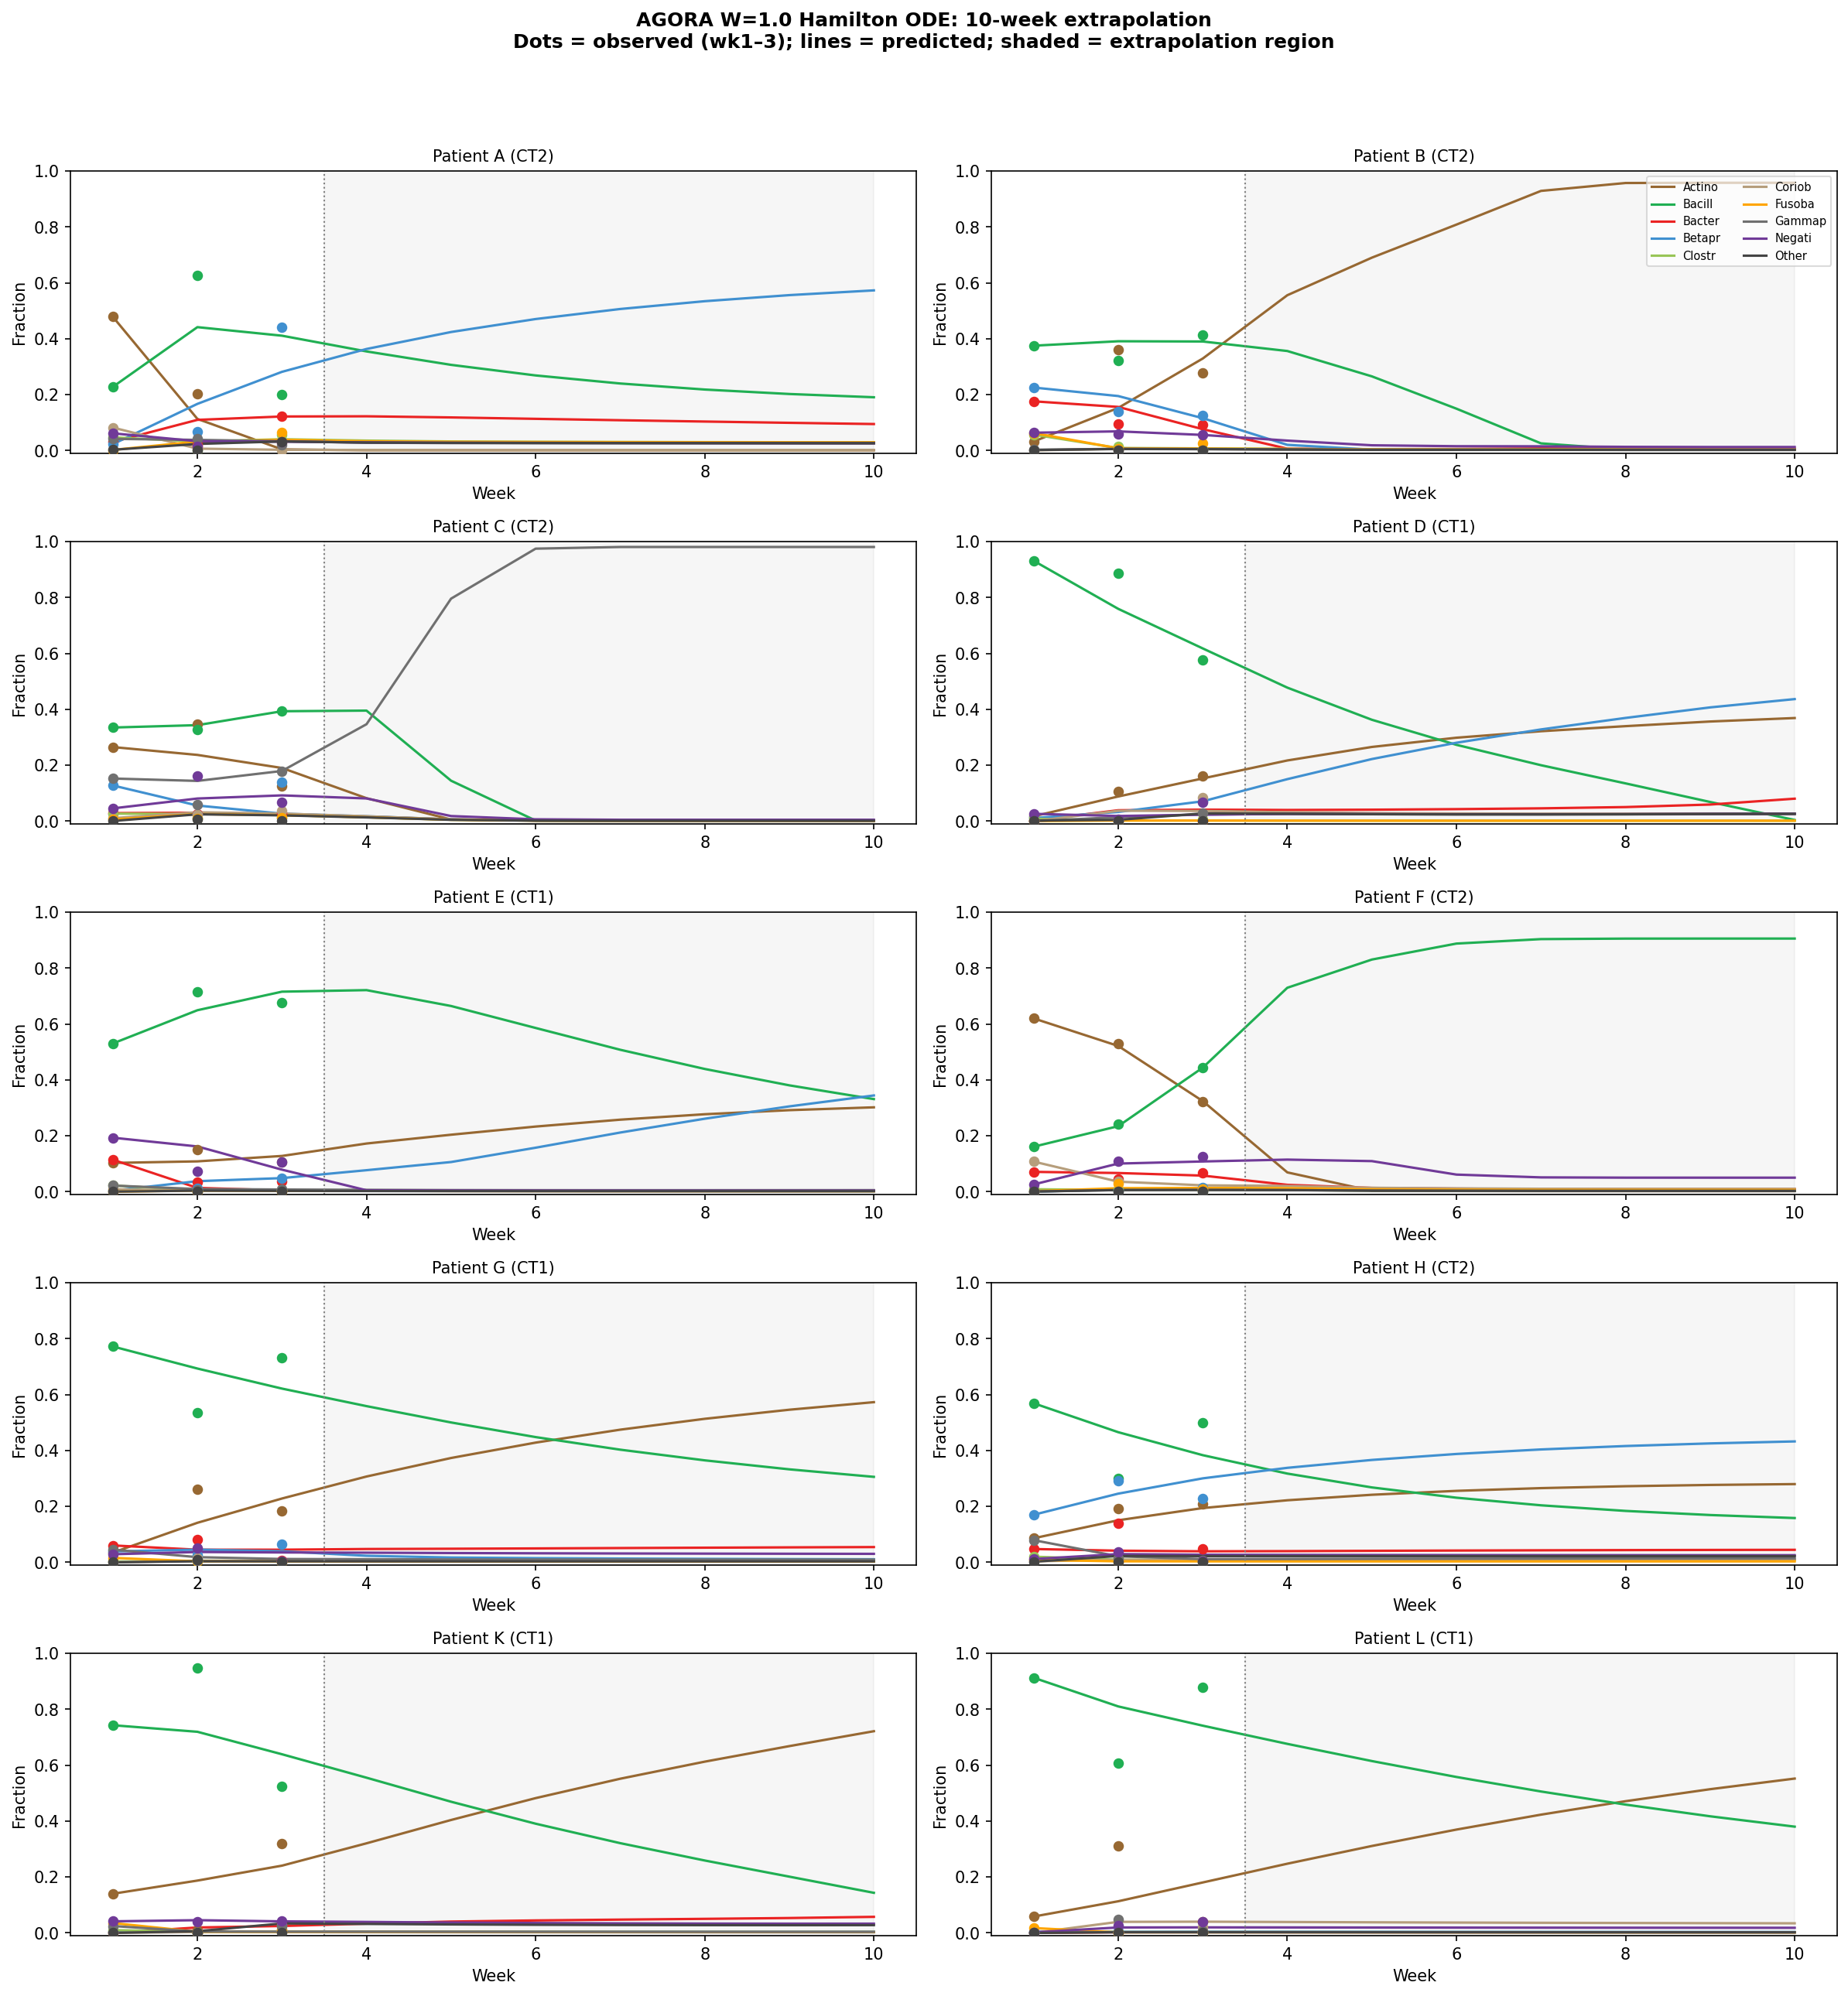
Figure D1. MAP trajectory extrapolation to week 10 (AGORA W=1.0, all 10 patients). Shaded: training window (weeks 1-3); dots: observed. CT1 patients converge to Actinobacteria/Bacilli equilibria; CT2 to Fusobacteriia/Bacteroidia enrichment. Convergence by weeks 5-7. Note: speculative projection, no longitudinal validation beyond week 3.

References
- Bashan A, Gibson TE, Friedman J, et al. (2016). Universality of human microbial dynamics. Nature 534:259-262.
- Bradbury J, et al. (2018). JAX: composable transformations of Python+NumPy programs. github.com/jax-ml/jax
- Byrd RH, Lu P, Nocedal J, Zhu C (1995). A limited memory algorithm for bound constrained optimization. SIAM J Sci Comput 16:1190-1208.
- Cao H-T, Gibson TE, Bashan A, Liu Y-Y (2017). Inferring human microbial dynamics from temporal metagenomics data. BioEssays 39:1600188.
- Dawes C (2008). Salivary flow patterns and oral tissue health. J Am Dent Assoc 139 Suppl:18S-24S.
- Dieckow S, Szafranski SP, et al. (2024). Longitudinal dynamics of subgingival biofilm during caries recovery. npj Biofilms Microbiomes 10:85.
- Fisher CK, Mehta P (2014). Identifying keystone species in gut microbiome from metagenomic timeseries. PLoS ONE 9:e102451.
- Heinken A, et al. (2023). Genome-scale metabolic reconstruction of 7,302 human microorganisms. Nat Biotechnol 41:1320-1331.
- Hofbauer J, Sigmund K (1998). Evolutionary Games and Population Dynamics. Cambridge University Press.
- Joseph TA, et al. (2020). Compositional Lotka-Volterra describes microbial dynamics in health and disease. PLoS Comput Biol 16:e1007917.
- Joshi V, et al. (2025). Community-level profiling of peri-implant microbiome. mSystems [in press].
- Junker P, Balzani D (2021). An extended Hamilton principle for coupled problems. Contin Mech Thermodyn 33:1931-1956.
- Chen T, Yu WH, Izard J, Baranova OV, Lakshmanan A, Dewhirst FE (2010). The Human Oral Microbiome Database: a web accessible resource for investigating oral microbe taxonomic and genomic information. Database 2010:baq013.
- Klempt F, Nishioka K, Soleimani M, Junker P (2024). Modelling biofilm growth with the extended Hamilton principle. Biomech Model Mechanobiol 23.
- Klempt F, Nishioka K, Junker P (2025). Continuum biofilm model with replicator species dynamics. [preprint]
- Kolenbrander PE (2000). Oral microbial communities: biofilms and interactions. Annu Rev Microbiol 54:413-437.
- Kolenbrander PE, Palmer RJ, Periasamy S, Jakubovics NS (2010). Oral multispecies biofilm development. Nat Rev Microbiol 8:471-480.
- Kuntal BK, et al. (2019). NetShift: understanding driver microbes from microbiome datasets. ISME J 13:442-454.
- Lewis NE, et al. (2010). Omic data from evolved E. coli consistent with genome-scale models. Mol Syst Biol 6:390.
- Mikx FHM, van der Hoeven JS (1975). Symbiosis of S. mutans and V. alcalescens. Arch Oral Biol 20:407-410.
- Stein RR, et al. (2013). Ecological modelling from time-series inference: intestinal microbiota. PLoS Comput Biol 9:e1003388.
- Szafranski SP, Nishioka K, et al. (2025). Metabolic interaction network for peri-implant oral microbiome. [preprint]
- Taylor PD, Jonker LB (1978). Evolutionarily stable strategies and game dynamics. Math Biosci 40:145-156.

