Data from bistatic radar observation

Nov. 17, 2023 A. Kumamoto

1. A measurement using bistatic radar

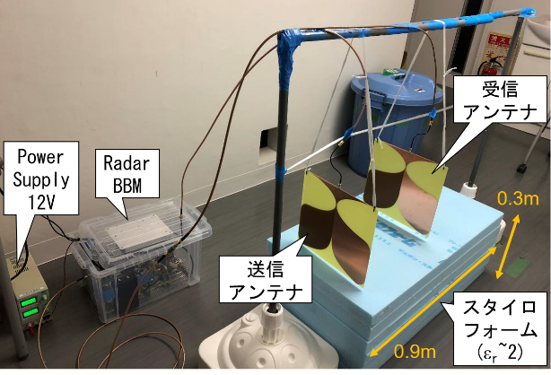 

Fig.1: Photo of measurement experiment Fig.2: Block diagram of the radar

Parameters of measurements and instrument are as follows:

[Antenna locations]

Horizontal interval of antenna locations (1, 2, …, 5): 0.2 m

TX antenna location: 5 (fixed)

RX antenna location: 1-4 (changed)

[VCO&DAC]

Bandwidth of chirp: 0.3-1.2 GHz

Pulse duration: 1 s

[ADC&PC]

Sampling frequency: 16 kHz

Sampling number: 32768

Output: CSV files

Col. 1: Time [s]

Col. 2: Voltage applied to VCO [V]

Col. 3: IF output [V]

1. Suggestions for the analyses

Ex-1. Estimate the permittivity of the Styloform.

Ex-2. Estimate the depth of the boundary between the Styloform and floor.

You can determine RMS velocity  and vertical delay *tn* up to the bottom of the n-th subsurface layer from the peaks of cross correlation function *F*(, *t*):

, (1)

where *fi* and *fj* are A-scan obtained from different combinations of TX and RX antenna locations, *Li* and *Lj* are horizontal distance between TX and RX antenna locations.

After  and *tn*, are determined, velocity *Vn* within n-th subsurface layer n can be derived using Dix formula as

 (2)

[Hint]

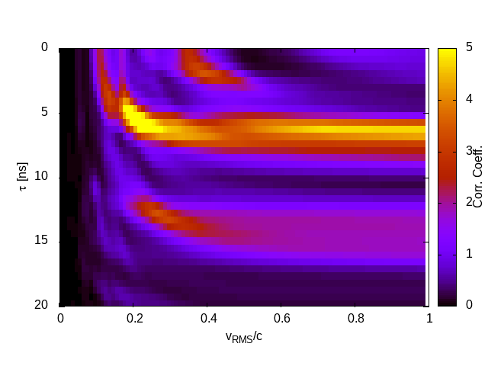

Fig.3: *F*(, *t*)