Midterm: Movie recommendation system proposal

Dawen Liang
University of the Potomac
COMP713: Advanced Artificial Intelligence
Dr. Jimmy Tsai
1/28/2026

Abstract
This proposal outlines a two-stage movie recommendation system, aiming to overcome the limitations of LLM (Large Language Model) context Windows while providing personalized and interpretable recommendations.
Key Innovation: Unlike traditional Recommendation systems, this solution does not directly use various vector calculations such as cosine similarity or collaborative filtering like ALS. Instead, it only employs embedding for semantic analysis and recommendation. Combining the Claude supported Skills currently released by Anthropic (which are now ready to become the standard for LLM Agents), the heavy data processing (offline) and user interaction (online) are separated, thereby achieving rich recommendations without overwhelming the LLM context.

Problem Statement
Large Language Models have limited context length. If we use the processing method of big data with Spark on clusters like CDH (Cloudera Distribution Including Apache Hadoop) and directly load thousands of movies and user ratings into conversations, either the context will be extremely long or the context will need condensation, which will lead to semantic loss. Thus, it is impractical. At the same time, the cold start problem must be carefully thought about. New users may have no rating history, so the system needs other features, such as demographics, current sentiment or declared preferences, to provide meaningful suggestions. The user also wants to know why a movie is recommended, rather than just receiving a movie list. This proposal addresses these three challenges through a two-stage approach, separating heavy data processing from real-time user interaction.
Solution Overview
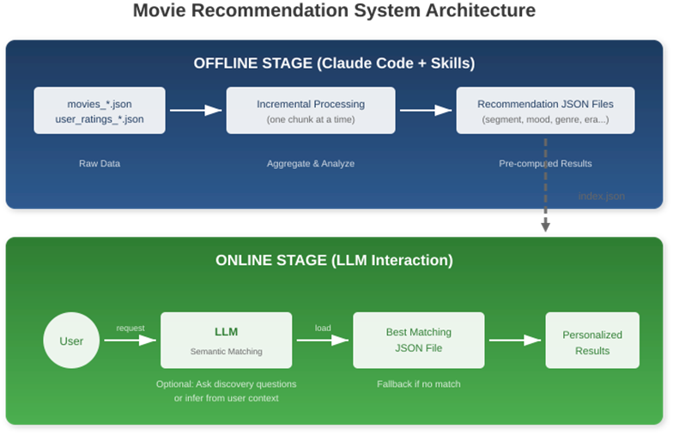
The system divides the workload into two different stages. In the offline stage, the operator will use the Claude Code manually to uses custom Skill increments to process raw movie and user rating data, generating pre-computed recommended JSON files organized by user segmentation, mood, type, and era. During the online phase, a lightweighted LLMs that keep low latency interact with users, semantically match their preferences with pre-generated files, and return personalized recommendations with explanations. An LLM might ask some discovery questions, or it might directly infer preferences from a user's request without asking any questions at all.
The offline stage uses Claude Code with a custom Skill (SKILL.md) to process chunked input data. The key design principle is incremental processing: never load all data at once. Instead, process one chunk of movies or user ratings at a time, save intermediate state, and continue. This prevents context overflow regardless of dataset size.
The data generation of this Skills is the greatest innovation of this project - the standard of Skills will not emerge until the end of 2025, and it is also the biggest risk - if the Skills call fails, this solution will lose its novelty.
To control risks, the author has first used Skills, combined with the mock data generated by lightweighted LLMs, to build a directory of shared_recommendations in advance, and has generated the json recommendation files to be used.
Data Structure Design
Input Data (Chunked Files)
Data is split into chunks to enable incremental processing without exceeding context limits.
- movies_001.json ~ movies_nnn.json: Each chunk contains ~200 movies with item_id, title, year, content (description/director/cast), and tags (genre/mood/era)
- user_ratings_001.json ~ user_ratings_nnn.json: Each chunk contains ~200 users with user tags (gamer, student, parent, etc.) and their movie ratings

Movie Object Schema
{ "item_id": "M001", "title": "Vertigo", "year": 1958, "content": "A retired detective becomes obsessed...", "tags": { "genre": ["Thriller", "Mystery", "Romance"], "mood": ["Suspenseful", "Psychological"], "era": "Classic" } }

User Rating Object Schema
{ "id0001": { "tags": ["gamer", "millennial"], "scores": [ {"item_id": "M014", "title": "The Matrix", "score": 4.8, "comment": "..."} ] } }

Movie data (movies_001.json, movies_002.json, ...) contains basic information plus tags for genre, mood, and era. User rating data (user_ratings_001.json, ...) contains user demographic tags (like "gamer", "parent", "student") and their movie scores. Both are split into chunks to enable incremental processing.

Implementation Checklist
Offline Skill Execution
The Skill first indexes all movies by genre, mood, and era. Then it processes user ratings to understand which user segments prefer which types of movies. Finally, it generates recommendation JSON files: one for each user segment (gamers, parents, students, etc.), one for each mood (exciting, thoughtful, relaxing, etc.), one for each genre, and one for each era. Fallback files are also generated for users who don't match any specific profile.
Each recommendation file contains: metadata with match keywords, optional discovery questions the online LLM can ask, and a ranked list of movies with explanations. An index.json file catalogs all generated files so the online LLM knows what's available.
Online Stage: LLM Interaction
When a user requests movie recommendations, the LLM first loads index.json to understand available recommendation categories. It then uses semantic matching to determine the best file to load based on the user's request. For example, if a user says "I want something thought-provoking," the LLM matches this to keywords like "philosophical" or "mind-bending" and loads the corresponding mood file.
The LLM may optionally ask discovery questions ("Are you in the mood for something intense or relaxing?") to refine the match, but this is not required. If the user's intent is clear from their initial request, the LLM can proceed directly. If no strong match is found, the LLM falls back to a "popular movies" file that works for everyone.
Key Design Decisions
Incremental processing with state files. By processing one chunk at a time and saving intermediate state, the system can handle arbitrarily large datasets without hitting context limits.
Multi-dimensional tagging. Movies are tagged by segment, mood, genre, and era, allowing flexible matching from multiple angles.
Semantic matching over exact keywords. The online LLM uses natural language understanding, so users don't need to use specific terms. "Something deep" maps to "philosophical" automatically.
Graceful fallback. Pre-generated fallback files ensure every user gets useful recommendations, even when no specific profile matches.
Explainable recommendations. Each movie includes a "why_recommended" field so the LLM can explain its suggestions transparently.

References
Rothman, D. (2020). Artificial intelligence by example (2nd ed.). Packt Publishing.
Artasanchez, A., & Joshi, P. (2020). Artificial intelligence with Python: Your complete guide to building intelligent apps using Python 3.x and TensorFlow 2 (2nd ed.). Packt Publishing.

