
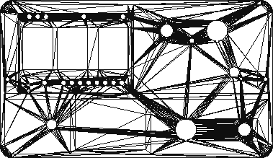
LAUNCH
OFF ON
RF Link Bank Pad
Battery
Charger
Remote
Armed
1 2 3 4 5 6 7 8
Igniter Continuity
Bank/Pad Select
TeleLaunch
Launch Control System
ARM

SAFE
Add/Remove
Drag Race
Normal

