CEBU INSTITUTE OF TECHNOLOGY - UNIVERSITY
COLLEGE OF COMPUTER STUDIES

Software Requirements Specification (SRS)
APEER
an
AI Self and Peer Evaluation System

Team Members:
Bajamunde, Louie V.
Magpatoc, Mark Andrew G.
Queddeng, James Adriane S.
Rigodon, Keith Yancy A.
Tabungar, Steven Jan M.

Date of Submission: November 03, 2025
Document Version: 3.0
Change History: Initial Draft

Table of Contents
1. Introduction
1.1 Purpose
1.2 Scope
1.3 Definitions, Acronyms, and Abbreviations
1.4 References
2. Overall Description
2.1 Product Perspective
2.2 Modular Decomposition
2.3 User Characteristics
2.4 Constraints
2.5 Assumptions and Dependencies
3. Specific Requirements
3.1 External Interface Requirements
3.2 Functional Requirements
3.3 Non-Functional Requirements

1. Introduction
1.1 Purpose
The AI Self and Peer Evaluation System (APEER) aims to provide a fair, efficient, and intelligent evaluation process for students in academic settings. This document specifies the functional and non-functional requirements of the AI Self and Peer Evaluation System (APEER). It serves as a baseline for system design, development, testing, and evaluation.
1.2 Scope
APEER is a web-based platform where students conduct self- and peer-evaluations, and teachers access summarized reports. The system features:
- AI Modules that analyze comments, classify quality, compute sentiment/usefulness, and produce concise summaries.
- Dashboards for students to view personal feedback and teachers to monitor class performance.
- Integration with Google APIs for secure authentication and cloud storage.
1.3 Definitions, Acronyms and Abbreviations
- SRS – Software Requirements Specification
- NLP – Natural Language Processing
- AI – Artificial Intelligence
- CIT-U – Cebu Institute of Technology – University
- JWT – JSON Web Token
- OAuth2 – Open Authorization 2.0
1.4 References
- Kulkarni, C., et al. (2024). EvaluMate: Using AI to support students’ feedback provision...
- Ma, Y., et al. (2022). PeerBERT: Automated characterization of peer review comments.
- Topping, K., et al. (2025). Enhancing peer assessment with artificial intelligence.
- Philippine Data Privacy Act of 2012 (RA 10173).

2. Overall Description
2.1 Product Perspective APEER is a modular web-based platform composed of AI microservices and dashboard modules. It integrates with Google OAuth2 for authentication and cloud storage. The system processes peer evaluation text, classifies comments, performs sentiment/usefulness analysis, and generates summaries for teacher and student review.
2.2 Modular Decomposition
- Module 1: AI Comment Classification
- Module 2: Sentiment and Usefulness Analysis
- Module 3: AI Feedback Summarization
- Module 4: Student Dashboard
- Module 5: Teacher Dashboard
- Module 6: Evaluation Management and Reporting
- Module 7: Authentication and Security
- Module 8: System User Monitoring (Administrative)
2.3 User Characteristics
- Students: Grade- and course-level learners who will provide and receive peer/self-evaluations.
- Teachers: Educators who will create evaluation activities, monitor feedback quality, and export reports.
- Administrators: Users who manage system settings and institution-level integrations.
2.4 Constraints
- Requires stable internet connectivity.
- AI accuracy relies on the quality of the training data.
- Integration requires Google API access for OAuth and storage.

3. Specific Requirements
3.1 External Interface Requirements
- Hardware: Compatible with desktops, laptops, and tablets with at least 2GB RAM.
- Software: Frontend (React.js), Backend (Spring Boot), Database (PostgreSQL), AI (Python).
- Communications: RESTful APIs over HTTPS with JWT-based session management.
3.2 Functional Requirements

Module 1: AI Comment Classification
Transaction 1.1: Automated Comment Tagging
- Case Diagram:
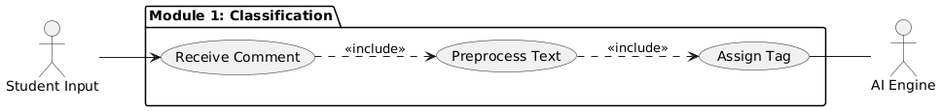
- Use Case Description: The system automatically preprocesses student comments upon submission to detect relevance and quality. It tags comments with labels such as constructive, vague, or off-topic using NLP models.
- Use Case Example:
  - Student submits a peer review.
  - System tokenizes the text.
  - System assigns the tag "Constructive" to the comment.
- Activity Diagram:

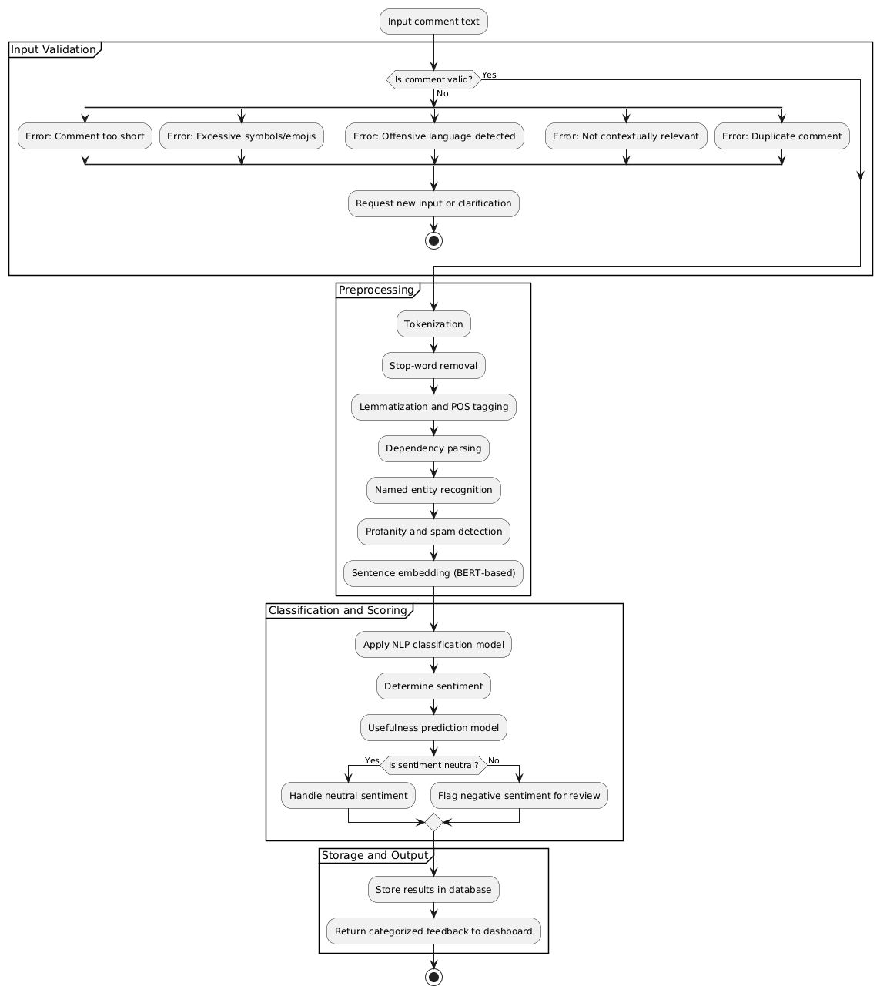
- Wireframe:
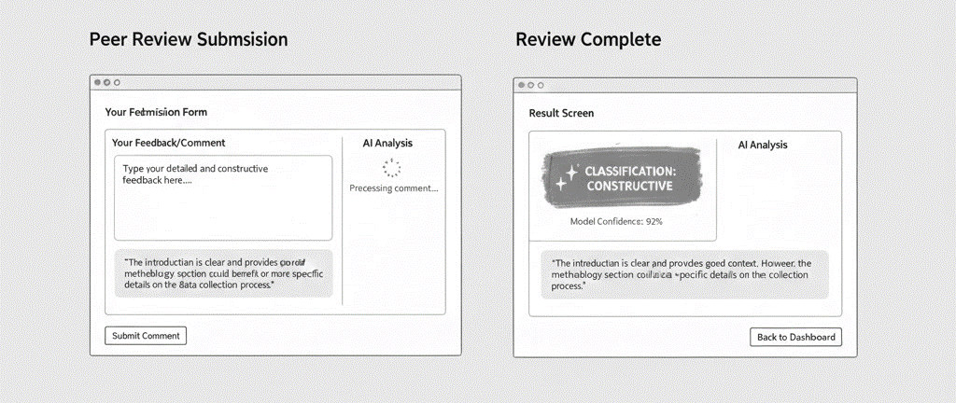

Module 2: Sentiment and Usefulness Analysis
Transaction 2.1: Quality Scoring & Filtering
- Case Diagram:
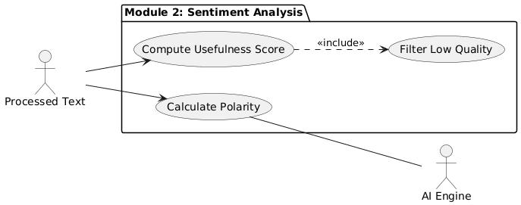
- Use Case Description: The system evaluates every individual comment to determine its emotional tone (Sentiment) and constructive quality (Usefulness Score). Low-quality comments are automatically filtered out or flagged for teacher review.
- Use Case Example:
  - System analyzes text polarity.
  - System calculates a Usefulness Score (e.g., 85/100).
  - If score < 40, comment is flagged as "Low Usefulness".
- Activity Diagram:
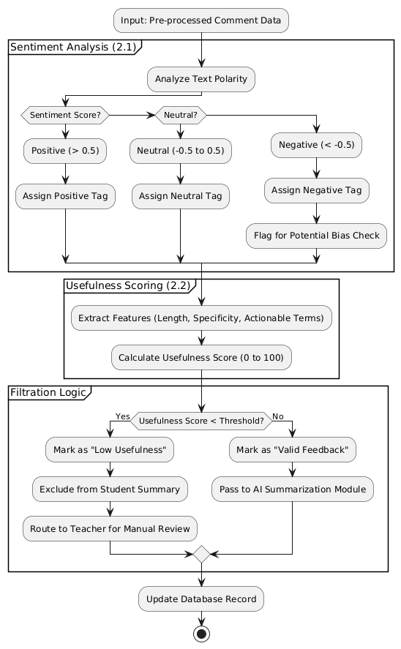
- Wireframe:
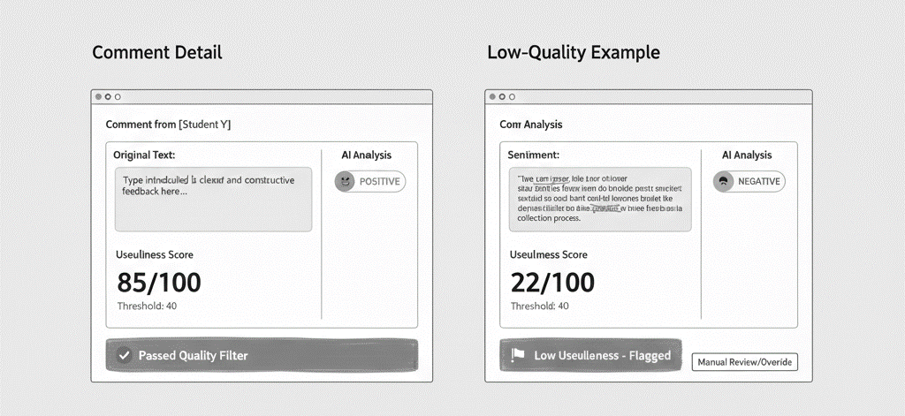

Module 3: AI Feedback Summarization
Transaction 3.1: Feedback Aggregation
- Case Diagram:
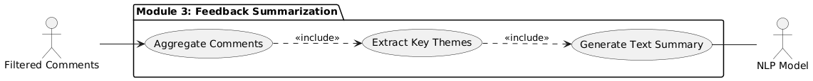
- Use Case Description: The system aggregates all qualified comments for a specific student and uses Natural Language Processing to generate a single cohesive report, categorizing insights into Strengths, Weaknesses, and Common Themes.
- Use Case Example:
  - System retrieves 20 comments for Student A.
  - AI identifies that 15 comments mention "Good Leadership."
  - System generates the summary sentence: "Peers consistently praised your leadership skills."
- Activity Diagram:
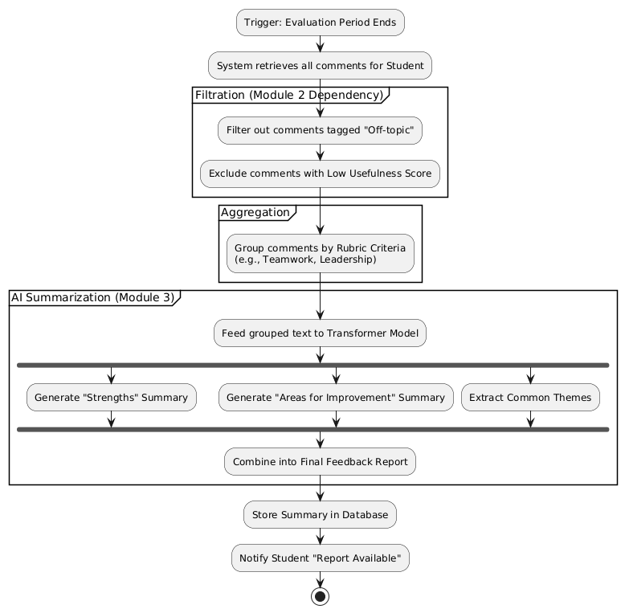
- Wireframe:
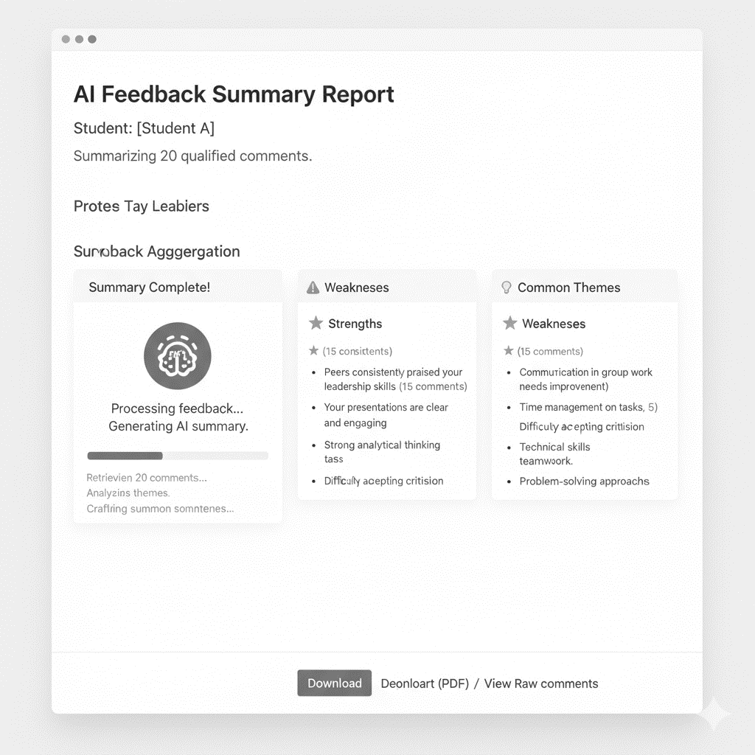

Module 4: Student Dashboard
Transaction 4.1: Performance View
- Use Case Diagram:
- 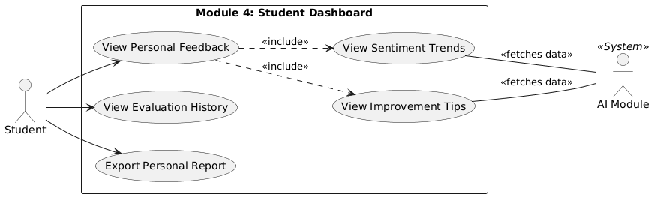Use Case Description: Students view their personal feedback summaries, sentiment trends, and AI-generated improvement suggestions in a centralized dashboard.
- Use Case Example:
  - Student logs in.
  - Student views "Evaluation History."
  - Student expands the "AI Insights" card to read specific improvement tips.
- Activity Diagram:
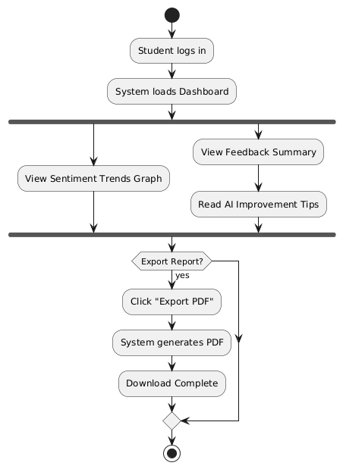
- Wireframe:
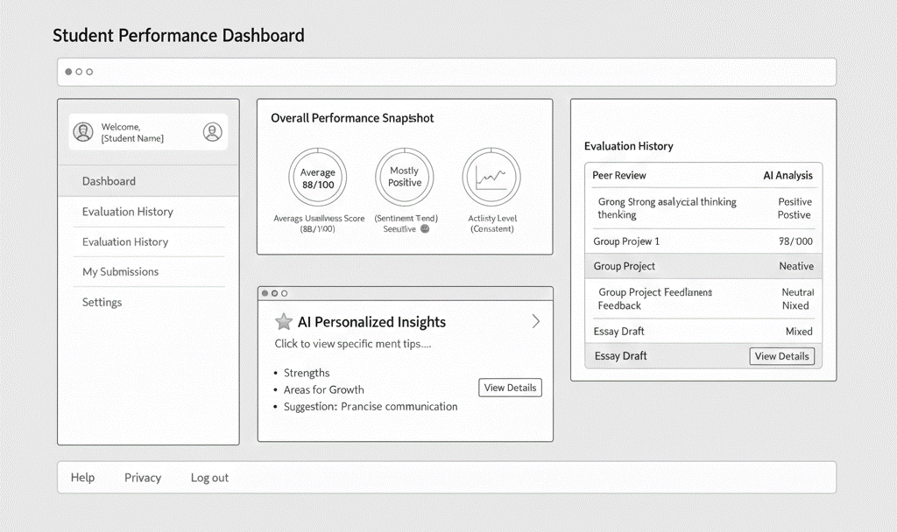

Module 5: Teacher Dashboard
Transaction 5.1: Class Analytics
- Use Case Diagram:
- 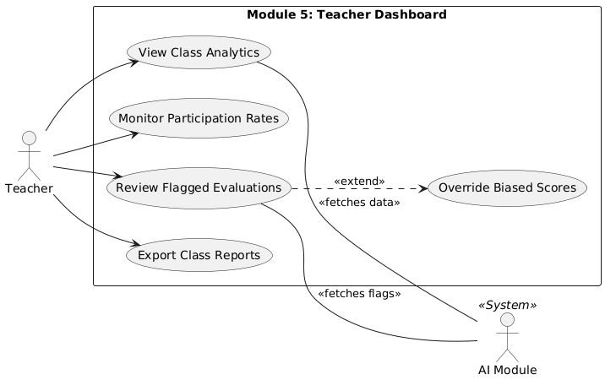Use Case Description: Teachers monitor class performance, view bias detection flags, and analyze sentiment distribution across the class to ensure fair grading.
- Use Case Example:
  - Teacher navigates to "Class Analytics."
  - Teacher views the "Participation Rate" chart.
  - System highlights 3 evaluations as "Potentially Biased."
- Wireframe:
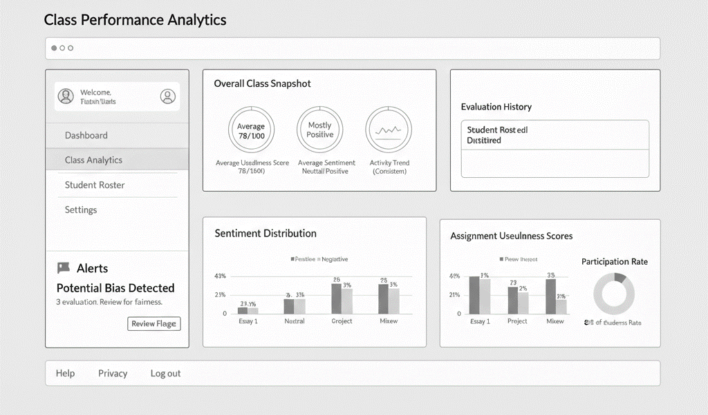

Module 6: Evaluation Management
Transaction 6.1: Activity Creation
- Use Case Diagram:
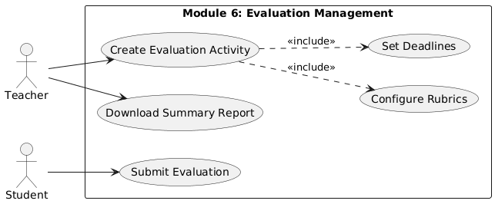
- Use Case Description: Teachers create and configure peer evaluation activities by setting titles, deadlines, rubrics, and assigning student groups.
- Use Case Example:
  - Teacher clicks "Create Evaluation."
  - Teacher selects "Teamwork Rubric."
  - Teacher sets deadline to "Nov 20" and publishes the activity.
- Wireframe (Teacher View):
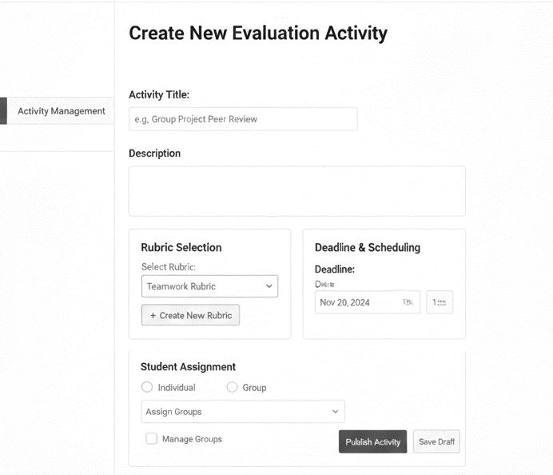
Transaction 6.2: Submission (Student View)
- Wireframe (Student View):
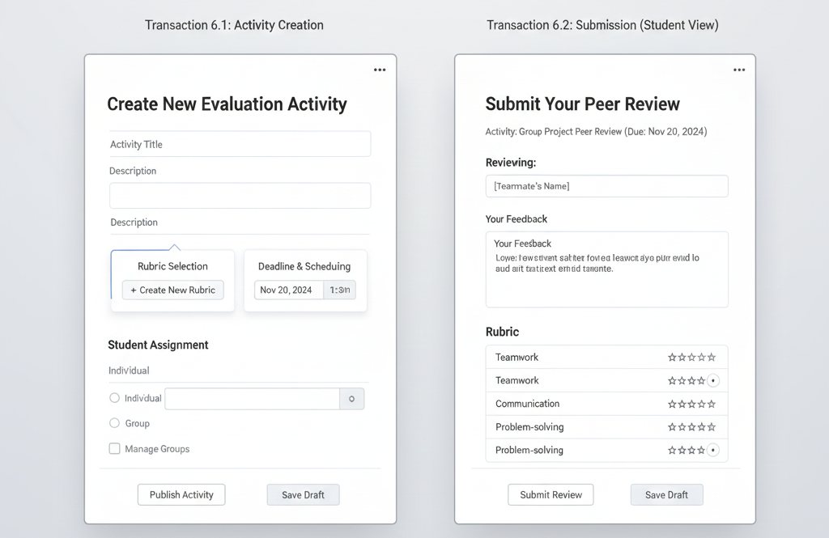

Module 7: Authentication and Security
Transaction 7.1: User Access & Registration
- Use Case Diagram:
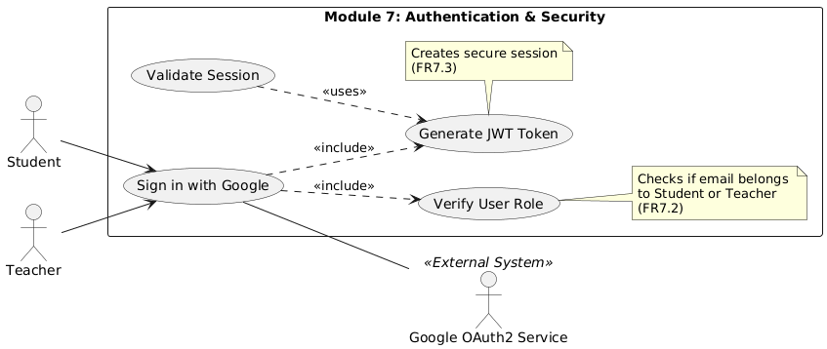
- Use Case Description: Secure access control allowing students and teachers to register and login using their Google Workspace credentials via OAuth2. The system verifies roles (Student vs. Teacher) automatically.
- Use Case Example:
  - User clicks "Sign in with Google."
  - System authenticates via Google API.
  - System checks email domain and redirects user to the correct dashboard.
- Activity Diagram:
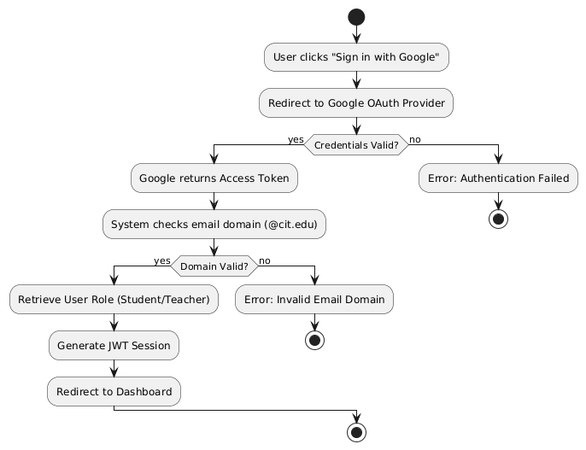
- Wireframe:
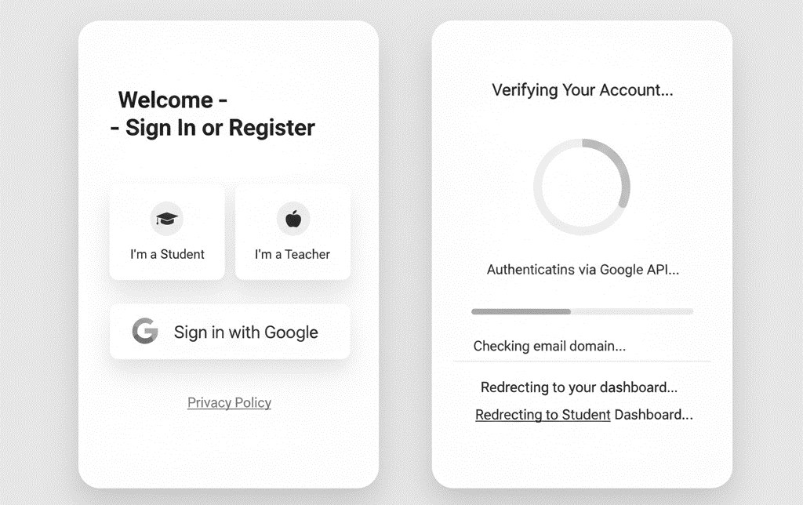

Module 8: System User Monitoring
Transaction 8.1: Administrative / Maintenance
- Use Case Diagram: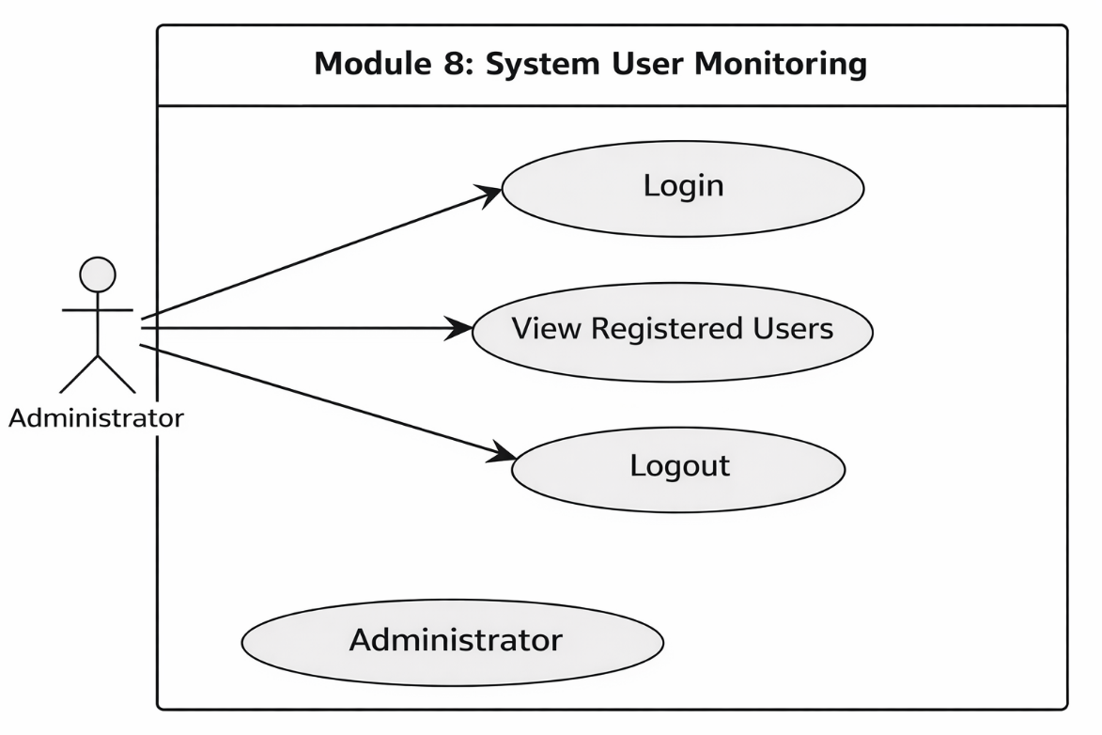

- Use Case Description: This use case allows the administrator to monitor registered users within the system for maintenance and access control purposes. The administrator can view a list of students and instructors who have accessed or are registered in the system. No evaluation data or AI-generated content is accessible.
- Use Case Example:
  - The administrator logs into the system using valid credentials.
  - The system verifies the administrator’s identity and role.
  - The system displays a list of registered users, including students and instructors.
  - The administrator reviews user information such as name, role, and account status.
  - The administrator logs out of the system.
- Activity Diagram: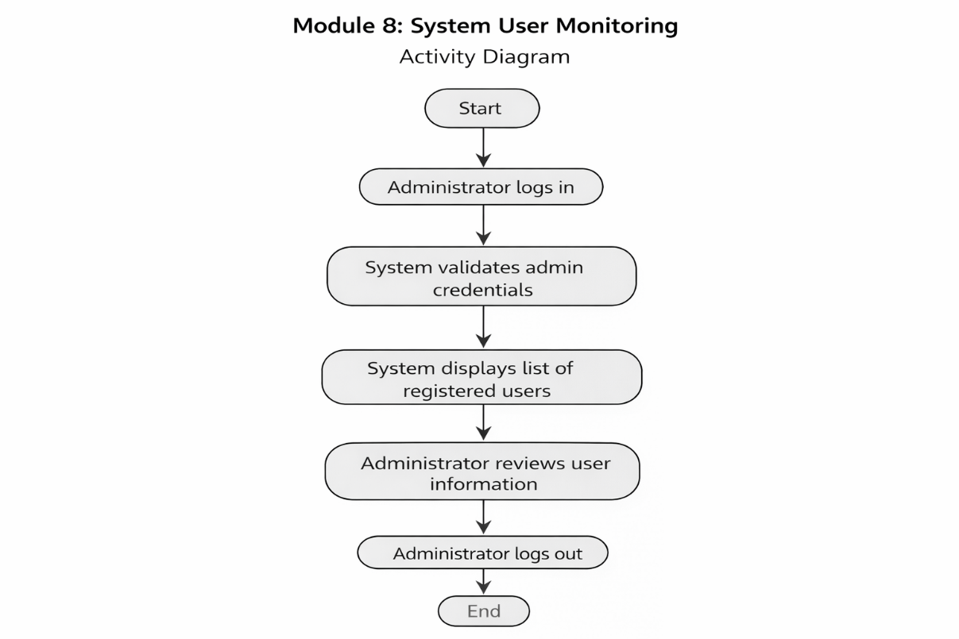

- Wireframe: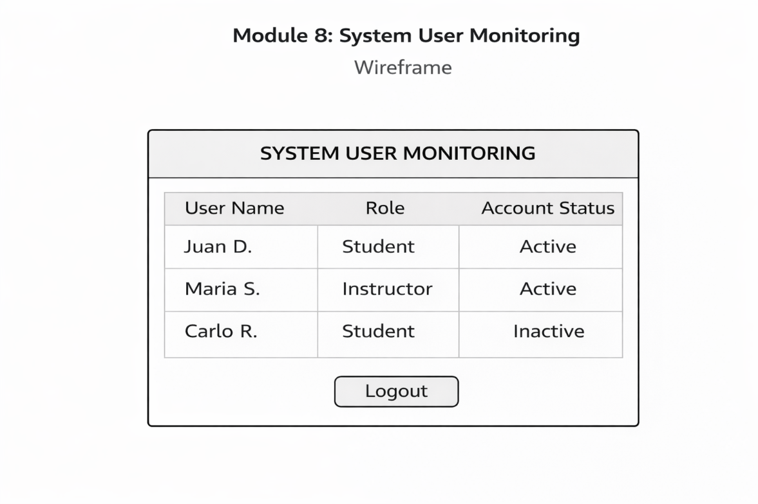

3.3 Non-Functional Requirements
Performance
- System response time under 2 seconds for standard operations.
- Support 500+ concurrent users; AI microservices auto-scale.
Security
- Role-Based Access Control (RBAC): Strict separation between Admin, Teacher, and Student data.
- Encryption: TLS/SSL for data in transit; encryption at rest.
- Compliance: Full compliance with the Philippine Data Privacy Act (RA 10173).
Reliability
- The system shall maintain at least 99% uptime during academic terms.

