The final project is coded in Google Colab, Please modify the working path at the very beginning and then read the data. Train and test csv are too large which can’t be uploaded on the repository. The data can be found in Kaggle.

1. I tried one A Dense network with a single hidden layer and a much more complicated CNN (with 1input layer, 12 convolutional layers, 12 batch normalization layers, 12 leaky re_lu layers, 5 Max Pooling layers, 1 flatten layer, 2 dense layers, and 1 dropout layer.) The complicated CNN works better.
2. 80；Due to capacity constraints, I chose a small but reasonable EPOCH number during the training process.
3. I used the default learning rate.
4. Due to my computer capacity, I can't finish the model fit part. But we can change ‘adam’ to RMSprop or SGD, we will get different results and justify which works better.

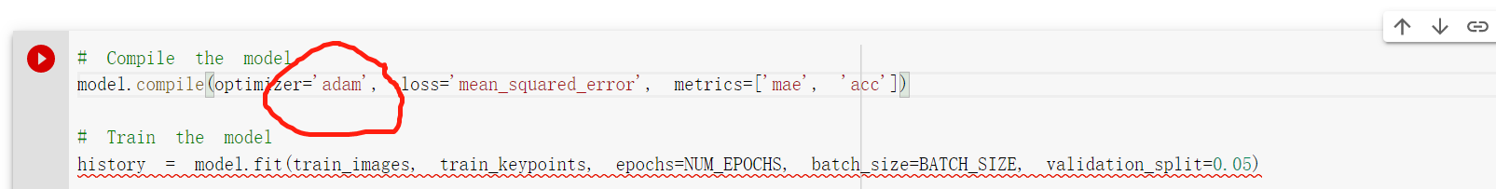

1. Due to my computer capacity, I am stuck in training the model. But I have coded for implementing the result in the ‘submission.csv’. By uploading the csv file, I will get my Kaggle’s grade.
2. 